**Computer Network**Study Note

**Table of contents**

**MODULE 1 4**

2 Mark Questions 5

5 Mark Questions 14

15 Mark Questions 17

**MODULE 2 29**

2 Mark Questions 30

5 Mark Questions 32

15 Mark Questions 41

**MODULE 3 64**

2 Mark Questions 65

5 Mark Questions 69

15 Mark Questions 102

**MODULE 4 133**

2 Mark Questions 134

5 Mark Questions 152

15 Mark Questions 219

**MODULE 5 238**

2 Mark Questions 239

Essay Questions 243

**2018-QP 270**

2 Mark Questions 271

5 Mark Questions 277

15 Mark Questions 287

**2019-QP 300**

2 Mark Questions 301

5 Mark Questions 304

15 Mark Questions 315

**2020-QP 321**

2 Mark Questions 322

5 Mark Questions 330

15 Mark Questions 341

**2021-QP 355**

2 Mark Questions 356

5 Mark Questions 358

15 Mark Questions 378

**2022-QP 389**

2 Mark Questions 390

5 Mark Questions 392

15 Mark Questions 414

**2023-QP 428**

2 Mark Questions 429

5 Mark Questions 432

15 Mark Questions 445

# MODULE 1

## 2 Mark Questions

## 

### 1. What do you mean by data communication?

The word data refers to information presented in whatever form is agreed upon by the

parties creating and using the data. Data communications are the exchange of data

between two devices via some form of transmission medium such as a wire cable. For data

communications to occur, the communicating devices must be part of a communication

system made up of a combination of hardware (physical equipment) and software

(programs). The effectiveness of a data communications system depends on four

fundamental characteristics: delivery, accuracy, timeliness, and jitter.

### 2. What are the fundamental characteristics of data communication?

A data communications system depends on four fundamental characteristics: delivery,

accuracy, timeliness, and jitter.

**Delivery:** The system must deliver data to the correct destination. Data must be received by the intended device or user and only by that device or user.

**Accuracy:** The system must deliver the data accurately. Data that have been altered in

transmission and left uncorrected are unusable.

**Timeliness:** The system must deliver data in a timely manner. Data delivered late is useless. In the case of video and audio, timely delivery means delivering data as they are produced, in the same order that they are produced, and without significant delay. This kind of delivery is called real-time transmission.

**Jitte:** Jitter refers to the variation in the packet arrival time. It is the uneven delay in the

delivery of audio or video packets. For example, let us assume that video packets are sent every 3D ms. If some of the packets arrive with 3D-ms delay and others with 4D-ms delay, an uneven quality in the video is the result.

### 3. What are the components of data communication?

A data communications system has five components.

**Message:** The message is the information (data) to be communicated. Popular forms of

information include text, numbers, pictures, audio, and video.

**Sender:** The sender is the device that sends the data message. It can be a computer,

workstation, telephone handset, video camera, and so on.

**Receiver:** The receiver is the device that receives the message. It can be a computer,

workstation, telephone handset, television, and so on.

**Transmission medium :** The transmission medium is the physical path by which a

message travels from sender to receiver. Some examples of transmission media include

twisted-pair wire, coaxial cable, fiber optic cable, and radio waves.

**Protocol:** A protocol is a set of rules that govern data communications. It represents an

agreement between the communicating devices. Without a protocol, two devices may be

connected but not communicating, just as a person speaking French cannot be understood by a person who speaks only Japanese.

### 4. Which are the different representations of data?

Information today comes in different forms such as text, numbers, images, audio, and

Video.

**Text:** In data communications, text is represented as a bit pattern, a sequence of bits (Os or Is). Different sets of bit patterns have been designed to represent text symbols. Each set is called a code, and the process of representing symbols is called coding.

Today, the prevalent coding system is called Unicode, which uses 32 bits to represent a symbol or character used in any language in the world. The American Standard Code for Information Interchange (ASCII), developed some decades ago in the United States, now constitutes the first 127 characters in Unicode and is also referred to as Basic Latin. Appendix A includes part of the Unicode.

**Numbers:** Numbers are also represented by bit patterns. However, a code such as ASCII is not used to represent numbers; the number is directly converted to a binary number to simplify mathematical operations. Appendix B discusses several different numbering systems.

**Images:** Images are also represented by bit patterns. In its simplest form, an image is composed of a matrix of pixels (picture elements), where each pixel is a small dot. The size of the pixel depends on the resolution. For example, an image can be divided into 1000 pixels or 10,000 pixels. In the second case, there is a better representation of the image (better resolution), but more memory is needed to store the image.

**Audio:** Audio refers to the recording or broadcasting of sound or music. Audio is by

Nature is different from text, numbers, or images. It is continuous, not discrete.

**Video:** Video refers to the recording or broadcasting of a picture or movie. Video can

either be produced as a continuous entity (e.g., by a TV camera), or it can be a combination of images, each a discrete entity, arranged to convey the idea of motion. Again we can change video to a digital or an analog signal.

### 5. Explain simple data flow?

In simplex mode, the communication is unidirectional, as on a one-way street. Only one of the two devices on a link can transmit; the other can only receive . Keyboards and

Traditional monitors are examples of simplex devices. The keyboard can only introduce

input; the monitor can only accept output. The simplex mode can use the entire capacity of the channel to send data in one direction.

### 6. Explain half duplex data flow?

In half-duplex mode, each station can both transmit and receive, but not at the same time. When one device is sending, the other can only receive, and vice versa. The half-duplex mode is like a one-lane road with traffic allowed in both directions. When cars are traveling in one direction, cars going the other way must wait. In a half-duplex

transmission, the entire capacity of a channel is taken over by whichever of the two

devices are transmitting at the time. Walkie-talkies and CB (citizens band) radios are both half-duplex systems. The half-duplex mode is used in cases where there is no need for communication in both directions at the same time; the entire capacity of the channel can be utilized for each direction.

### 7. Explain full duplex data flow?

In full-duplex (also called duplex), both stations can transmit and receive simultaneously. The full duplex mode is like a two way street with traffic flowing in both directions at the same time. In full duplex mode, signals going in one direction share the capacity of the link with signals going in the other direction. This sharing can occur in two ways: Either the link must contain two physically separate transmission paths, one for sending and the other for receiving; or the capacity of the channel is divided between signals traveling in both directions.

### 8. What is meant by a computer network?

A computer network is a collection of devices that are connected and can share resources and data with each other. These devices can be connected by wires or wireless signals, and they use communication protocols to send information. Computer networking refers to interconnected computing devices that can exchange data and share resources with each other. These networked devices use a system of rules, called communications protocols, to transmit information over physical or wireless technologies.

### 9. Which are the three different network criteria? Explain it.

There are a lot of criteria that make a network better than others, but; there are three basic yet important criteria to be fulfilled for a network:

**Performance**

**Reliability**

**Security**

**Performance**

It measures how well a network can support communication between two nodes in the Network or with nodes of other networks in the global scope. The two major tasks in a network are the Transmission and reception of information. We need to focus on how fast a message is transmitted and how fast a node can receive a request and find the needed information. Hence, to measure the performance of a network, here are the major factors to be considered: transmit time, response time, throughput ,bandwidth, delay.

**Reliability**

It is the degree to which a network is trustworthy, consistent, and dependable. The Reliability of a network is measured by the frequency of failures it is undergoing and the time it takes to recover from the failures. Overall, the Robustness of the Network at times of catastrophic events is measured to check how reliable the Network is.

**Security**

It measures how the Network secures the data amid failures and attacks and the policies and procedures it implements to protect itself from damages and unauthorized access. In Reliability, the frequency of failures is checked. In Security, network attacks and data breaches are checked.

### 10. What do you mean by LAN?

A local area network (LAN) is usually privately owned and links the devices in a single

office, building, or campus. Depending on the needs of an organization and the type of

technology used, a LAN can be as simple as two PCs and a printer in someone's home office or it can extend throughout a company and include audio and video peripherals.

Currently, LAN size is limited to a few kilometers.

LANs are designed to allow resources to be shared between personal computers or

workstations. The resources to be shared can include hardware (e.g., a printer), software

(e.g., an application program), or data. A common example of a LAN, found in many

business environments, links a workgroup of task-related computers, for example,

engineering workstations or accounting PCs. One of the computers may be given a

large capacity disk drive and may become a server to clients. Software can be stored on this central server and used as needed by the whole group.

In this example, the size of the LAN may be determined by licensing restrictions on the number of users per copy of software, or by restrictions on the number of users licensed to access the operating system. In addition to size, LANs are distinguished from other types of networks by their transmission media and topology. In general, a given LAN will use only one type of transmission medium. The most common LAN topologies are bus, ring, and star. Early LANs had data rates in the 4 to 16 megabits per second (Mbps) range. Today, however, speeds are normally 100 or 1000 Mbps.

### 11. What do you mean by WAN?

A wide area network (WAN) provides long-distance transmission of data, image, audio, and video information over large geographic areas that may comprise a country, a continent, or even the whole world. A WAN can be as complex as the backbones that connect the Internet or as simple as a dial-up line that connects a home computer to the Internet.

We normally refer to the first as a switched WAN and to the second as a point-to-point WAN. The switched WAN connects the end systems, which usually comprise a router (internetworking connecting device) that connects to another LAN or WAN. The point-to-point WAN is normally a line leased from a telephone or cable TV provider that connects a home computer or a small LAN to an Internet service provider (lSP). This type of WAN is often used to provide Internet access.

### 12. What do you mean by MAN?

A metropolitan area network (MAN) is a network with a size between a LAN and a WAN. It

normally covers the area inside a town or a city. It is designed for customers who need a

high-speed connectivity, normally to the Internet, and have endpoints spread over a city or part of the city. A good example of a MAN is the part of the telephone company network that can provide a high-speed DSL line to the customer. Another example is the cable TV network that originally was designed for cable TV, but today can also be used for high speed data connection to the Internet.

### 13. What do you mean by protocols?

In computer networks, communication occurs between entities in different systems. For

communication to occur, the entities must agree on a protocol. A protocol is a set of rules

that govern data communications. A protocol defines what is communicated, how it is

communicated, and when it is communicated. The key elements of a protocol are **syntax, semantics, and timing.**

**Syntax:** The term syntax refers to the structure or format of the data, meaning the order

in which they are presented. For example, a simple protocol might expect the first 8 bits of

data to be the address of the sender, the second 8 bits to be the address of the receiver, and the rest of the stream to be the message itself.

**Semantics:** The word semantics refers to the meaning of each section of bits. How is a

particular pattern to be interpreted, and what action is to be taken based on that

interpretation? For example, does an address identify the route to be taken or the final

destination of the message.

**Timing:** The term timing refers to two characteristics: when data should be sent and how

fast they can be sent. For example, if a sender produces data at 100 Mbps but the receiver

can process data at only 1 Mbps, the transmission will overload the receiver and some data will be lost.

### 14. What are the terms analog data and and digital data refers to?

Data can be analog or digital. The term analog data refers to information that is continuous; digital data refers to information that has discrete states. For example, an analog clock that has hour, minute, and second hands gives information in a continuous form the movements of the hands are continuous. On the other hand, a digital clock that reports the hours and the minutes will change suddenly from 8:05 to 8:06. Analog data, such as the sounds made by a human voice, take on continuous values. When someone speaks, an analog wave is created in the air. This can be captured by a microphone and converted to an analog signal or sampled and converted to a digital signal.

Digital data takes on discrete values. For example, data is stored in computer memory in the form of Os and 1s. They can be converted to a digital signal or modulated into an analog signal for transmission across a medium. Data can be analog or digital. Analog data are continuous and take continuous values. Digital data have discrete states and take discrete values.

### 15. What are the terms analog signal and digital signal refer to?

Like the data they represent, signals can be either analog or digital. An analog signal has

infinitely many levels of intensity over a period of time. As the wave moves from value A to

value B, it passes through and includes an infinite number of values along its path. A digital signal, on the other hand, can have only a limited number of defined values. Although each value can be any number, it is often as simple as 1 and O. The simplest way to show signals is by plotting them on a pair of perpendicular axes. The vertical axis represents the value or strength of a signal. The horizontal axis represents time.

### 16. What are periodic signals and non periodic signals?

## 

Both analog and digital signals can take one of two forms: periodic or nonperiodic

(sometimes referred to as aperiodic, because the prefix a in Greek means "non"). A periodic signal completes a pattern within a measurable time frame, called a period, and repeats that pattern over subsequent identical periods. The completion of one full pattern is called a cycle. A nonperiodic signal changes without exhibiting a pattern or cycle that repeats over time. Both analog and digital signals can be periodic or nonperiodic. In data communications, we commonly use periodic analogue signals (because they need less bandwidth) and non periodic digital signals (because they can represent variation in data).

### 17. Define Amplitude, period, frequency of wave forms?

The peak amplitude of a signal is the absolute value of its highest intensity, proportional to the energy it carries. For electric signals, peak amplitude is normally measured in volts.

Period refers to the amount of time, in seconds, a signal needs to complete 1 cycle. Frequency refers to the number of periods in I s. Note that period and frequency are just one characteristic defined in two ways.Period is the inverse of frequency, and frequency is the inverse of period, as the following formulas show. f=-(1/T) and T=(1/f ) Frequency and period are the inverse of each other.

### 18. Define the term phase?

The term phase describes the position of the waveform relative to time O. If we think of the wave as something that can be shifted backward or forward along the time axis, phase describes the amount of that shift. It indicates the status of the first cycle.

### 

### 19. Define the term wavelength?

Wavelength is a characteristic of a signal traveling through a transmission medium.

Wavelength binds the period or the frequency of a simple sine wave to the propagation

speed of the medium. While the frequency of a signal is independent of the medium, the

wavelength depends on both the frequency and the medium. Wavelength is a property of

any type of signal. In data communications, we often use wavelength to describe the

transmission of light in an optical fiber. The wavelength is the distance a simple signal can travel in one period. Wavelength =propagation speed x period

### 20. Define composite signals?

Simple sine waves have many applications in daily life. We can send a single sine wave to

carry electric energy from one place to another. For example, the power company sends a single sine wave with a frequency of 60 Hz to distribute electric energy to houses and

businesses. As another example, we can use a single sine wave to send an alarm to a

security center when a burglar opens a door or window in the house. In the first case, the sine wave is carrying energy.

In the second, the sine wave is a signal of danger. If we had only one single sine wave to convey a conversation over the phone, it would make no sense and carry no information. We would just hear a buzz. As we need to send a composite signal to communicate data. A composite signal is made of many simple sine waves. A composite signal can be periodic or nonperiodic. A periodic composite signal can be decomposed into a series of simple sine waves with discrete frequencies.

If the composite signal is periodic, the decomposition gives a series of signals with discrete frequencies; if the composite signal is nonperiodic, the decomposition gives a combination of sine waves with continuous frequencies.

### 21. Explain Bandwidth?

The range of frequencies contained in a composite signal is its bandwidth. The bandwidth

is normally a difference between two numbers. For example, if a composite signal contains frequencies between 1000 and 5000, its bandwidth is 5000 - 1000, or 4000. The bandwidth of a composite signal is the difference between the highest and the lowest frequencies contained in that signal.

### 22. Explain bit rate?

Most digital signals are nonperiodic, and thus period and frequency are not appropriate characteristics. Another term-bit rate (instead frequency)-is used to describe digital signals. The bit rate is the number of bits sent in one second, expressed in bits per second (bps).

### 23. Explain baud rate?

Baud rate is a measure of how many signal changes, or symbols, are transmitted per

second through a communication channel or transmission medium. It is often used to

describe the rate of information transfer in electronics that use serial communication.

### 

### 24. Explain bit length?

## 

The bit length is the distance one bit occupies on the transmission medium.

**Bit length = propagation speed x bit duration**

## 5 Mark Questions

### 25. What is baseband transmission?

Baseband transmission means sending a digital signal over a channel without changing the digital signal to an analogue signal.

Baseband transmission requires that we have a low-pass channel, a channel with a

bandwidth that starts from zero. This is the case if we have a dedicated medium with a

bandwidth constituting only one channel. For example, the entire bandwidth of a cable

connecting two computers is one single channel. As another example, we may connect

several computers to a bus, but not allow more than two stations to communicate at a time. Again, we have a low-pass channel, and we can use it for baseband communication.

### 26. Explain Broadband transmission?

## 

Broadband transmission or modulation means changing the digital signal to an analogue signal for transmission. Modulation allows us to use a bandpass channel-a channel with a bandwidth that does not start from zero. This type of channel is more available than a lowpass channel. If the available channel is a bandpass channel~ we cannot send the digital signal directly to the channel; we need to convert the digital signal to an analogue signal before transmission.

An example of broadband transmission using modulation is the sending of computer data through a telephone subscriber line, the line connecting a resident to the central telephone office. These lines, installed many years ago, are designed to carry voice (analogue signal) with a limited bandwidth (frequencies between 0 and 4 kHz). Although this channel can be used as a low-pass channel, it is normally considered a bandpass channel. One reason is that the bandwidth is so narrow (4 kHz) that if we treat the channel as low-pass and use it for baseband transmission, the maximum bit rate can be only 8 kbps. The solution is to consider the channel a bandpass channel, convert the digital signal from the computer to an analogue signal, and send the analogue signal. We can install two converters to change the digital signal to analogue and vice versa at the receiving end. The converter, in this case, is called a modem (modulator/demodulator).

### 27. Explain the different transmission impairment?

Signals travel through transmission media, which are not perfect. The imperfection causes signal impairment. This means that the signal at the beginning of the medium is not the same as the signal at the end of the medium. What is sent is not what is received. Three causes of impairment are attenuation, distortion, and noise.

**Attenuation** means a loss of energy. When a signal, simple or composite, travels through a medium, it loses some of its energy in overcoming the resistance of the medium. That is why a wire carrying electric signals gets warm, if not hot, after a while. Some of the electrical energy in the signal is converted to heat. To compensate for this loss, amplifiers are used to amplify the signal.

**Distortion** means that the signal changes its form or shape. Distortion can occur in a composite signal made of different frequencies. Each signal component has its own propagation speed through a medium and, therefore, its own delay in arriving at the final destination. Differences in delay may create a difference in phase if the delay is not exactly the same as the period duration. In other words, signal components at the receiver have phases different from what they had at the sender. The shape of the composite signal is therefore not the same.

Noise is another cause of impairment. Several types of noise, such as thermal noise, induced noise, crosstalk, and impulse noise, may corrupt the signal. Thermal noise is the random motion of electrons in a wire which creates an extra signal not originally sent by the transmitter. Induced noise comes from sources such as motors and appliances. These devices act as a sending antenna, and the transmission medium acts as the receiving antenna.

**Crosstalk** is the effect of one wire on the other. One wire acts as a sending antenna and the other as the receiving antenna. Impulse noise is a spike (a signal with high energy in a very short time) that comes from power lines, lightning, and so on.

### 28. Explain Physical address, logical address, port address and specific address?

**Physical Addresses:** The physical address, also known as the link address, is the address of a node as defined by its LAN or WAN. It is included in the frame used by the data link layer. It is the lowest-level address. The physical addresses have authority over the network (LAN or WAN). The size and format of these addresses vary depending on the network. For example, Ethernet uses a 6-byte (48-bit) physical address that is imprinted on the network interface card (NIC). Local Talk (Apple), however, has an I-byte dynamic address that changes each time the station comes up.

**Logical addresses:** are necessary for universal communications that are independent of

underlying physical networks. Physical addresses are not adequate in an internetwork

environment where different networks can have different address formats. A universal

an addressing system is needed in which each host can be identified uniquely, regardless of the underlying physical network. The logical addresses are designed for this purpose. A logical address in the Internet is currently a 32-bit address that can uniquely define a host connected to the Internet. No two publicly addressed and visible hosts on the Internet can have the same IP address.

**Port Addresses:** The IP address and the physical address are necessary for a quantity of data to travel from a source to the destination host. However, arrival at the destination host is not the final objective of data communications on the Internet. A system that sends nothing but data from one computer to another is not complete. Today, computers are devices that can run multiple processes at the same time. The end objective of Internet communication is a process communicating with another process. For example, computer A can communicate with computer C by using TELNET. At the same time, computer A communicates with computer B by using the File Transfer Protocol (FTP). For these processes to receive data simultaneously, we need a method to label the different processes. In other words, they need addresses. In the TCP IP architecture, the label assigned to a process is called a port address. A port address in TCP/IP is 16 bits in length.

**Specific Addresses:** Some applications have user-friendly addresses that are designed for that specific address. Examples include the email address (for example, forouzan@fhda.edu) and theUniversal Resource Locator (URL) (for example, www.mhhe.com). The first defines the recipient of an email, the second is used to find a document on the World Wide Web . These addresses, however, get changed to the corresponding port and logical addresses by the sending computer.

## 15 Mark Questions

### 29. Explain different network topologies?

There are four basic topologies possible: mesh, star, bus, and ring.

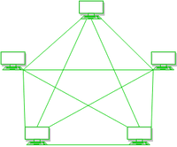

**Mesh topology:** In a mesh topology, every device has a dedicated point-to-point link to every other device. The term dedicated means that the link carries traffic only between the two devices it connects. To find the number of physical links in a fully connected mesh network with n nodes, we first consider that each node must be connected to every other node. Node 1 must be connected to n - I nodes, node 2 must be connected to n - 1 nodes, and finally node n must be connected to n - 1 nodes. We need n(n - 1) physical links. However, if each physical link allows communication in both directions (duplex mode), we can divide the number of links by 2. In other words, we can say that in a mesh topology, we need n (n -1) /2 duplex-mode links.

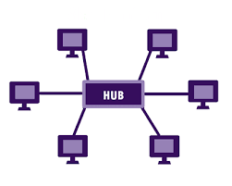

**Star Topology:** In a star topology, each device has a dedicated point-to-point link only to a central controller, usually called a hub. The devices are not directly linked to one another. Unlike a mesh topology, a star topology does not allow direct traffic between devices. The controller acts as an exchange: If one device wants to send data to another, it sends the data to the controller, which then relays the data to the other connected device. A star topology is less expensive than a mesh topology. In a star, each device needs only one link and one I/O port to connect it to any number of others. This factor also makes it easy to install and reconfigure. Far less cabling needs to be housed, and additions, moves, and deletions involve only one connection: between that device and the hub. Other advantages include robustness. If one link fails, only that link is affected. All other links remain active.

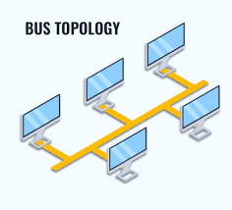

**Bus Topology:** The preceding examples all describe point-to-point connections. A bus topology, on the other hand, is multipoint. One long cable acts as a backbone to link all the devices in a network. Nodes are connected to the bus cable by drop lines and taps. A drop line is a connection running between the device and the main cable. A tap is a connector that either splices into the main cable or punctures the sheathing of a cable to create a contact with the metallic core. As a signal travels along the backbone, some of its energy is transformed into heat. Therefore, it becomes weaker and weaker as it travels farther and farther. For this reason, there is a limit on the number of taps a bus can support and on the distance between those taps. Advantages of a bus topology include ease of installation. Backbone cable can be laid along the most efficient path, then connected to the nodes by drop lines of various lengths.

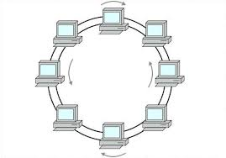

**Ring Topology :** In a ring topology, each device has a dedicated point-to-point connection with only the two devices on either side of it. A signal is passed along the ring in one direction, from device to device, until it reaches its destination. Each device in the ring incorporates a repeater. When a device receives a signal intended for another device, its repeater regenerates the bits and passes them along. A ring is relatively easy to install and reconfigure. Each device is linked to only its immediate neighbors (either physically or logically). To add or delete a device requires changing only two connections. The only constraints are media and traffic considerations (maximum ring length and number of devices). In addition, fault isolation is simplified. Generally, in a ring, a signal is circulating at all times. If one device does not receive a signal within a specified period, it can issue an alarm. The alarm alerts the network operator to the problem and its location.

### 30. Write a short note on the internet?

The Internet has revolutionized many aspects of our daily lives. It has affected the way we do business as well as the way we spend our leisure time. Count the ways you've used the Internet recently. Perhaps you've sent electronic mail (e-mail) to a business associate, paid a utility bill, read a newspaper from a distant city, or looked up a local movie schedule-all by using the Internet. Or maybe you researched a medical topic, booked a hotel reservation, chatted with a fellow Trekkie, or comparison-shopped for a car. The Internet is a communication system that has brought a wealth of information to our fingertips and organized it for our use. A network is a group of connected communicating devices such as computers and printers. An internet (note the lowercase letter i) is two or more networks that can communicate with each other. The most notable internet is called the Internet (uppercase letter I), a collaboration of more than hundreds of thousands of interconnected networks. Private individuals as well as various organizations such as government agencies, schools, research facilities, corporations, and libraries in more than 100 countries use the Internet. Millions of people are users. Yet this extraordinary communication system only came into being in 1969.

The Internet has come a long way since the 1960s. The Internet today is not a simple hierarchical structure. It is made up of many wide- and local-area networks joined by connecting devices and switching stations. It is difficult to give an accurate representation of the Internet because it is continually changing-new networks are being added, existing networks are adding addresses, and networks of defunct companies are being removed. Today most end users who want Internet connection use the services of Internet service providers (lSPs). There are international service providers, national service providers, regional service providers, and local service providers. The Internet today is run by private companies, not the government.

### 31. Explain OSI reference models?

Established in 1947, the International Standards Organization (ISO) is a multinational body

dedicated to worldwide agreement on international standards. An ISO standard that covers all aspects of network communications is the Open Systems Interconnection model. It was first introduced in the late 1970s. An open system is a set of protocols that allows any two different systems to communicate regardless of their underlying architecture. The purpose of the OSI model is to show how to facilitate communication between different systems without requiring changes to the logic of the underlying hardware and software.

The OSI model is not a protocol; it is a model for understanding and designing a network architecture that is flexible, robust, and interoperable. ISO is the organization. OSI is the model. The OSI model is a layered framework for the design of network systems that allows communication between all types of computer systems. It consists of seven separate but related layers, each of which defines a part of the process of moving information across a network. An understanding of the fundamentals of the OSI model provides a solid basis for exploring data communications.

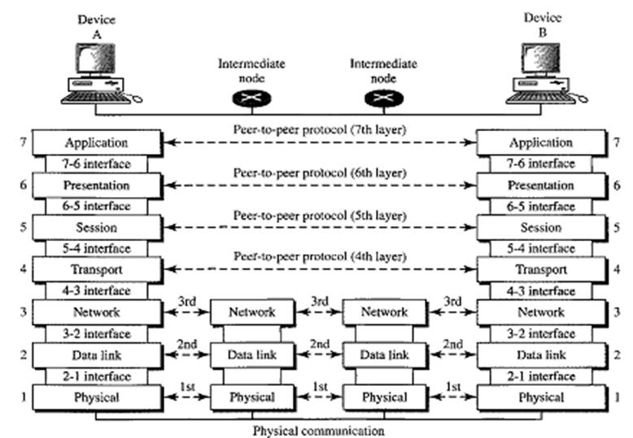

The OSI (Open Systems Interconnection) Model is a conceptual framework used to understand and standardize the functions of a telecommunication or networking system, independent of its underlying internal structure and technology. The OSI model divides these functions into seven distinct layers, each with specific responsibilities. These layers interact with the layers directly above and below them, passing data and ensuring that information is transmitted and received effectively.

The seven layers of the OSI model are:

**1-Physical Layer**

* This is the first and lowest layer of the OSI model. The physical layer is responsible for the transmission of raw binary data over a communication channel. It manages the physical connection between network devices, including the hardware components (cables, switches, etc.) and the transmission media (electrical signals, light, radio waves).
* Important functions include defining cables, connectors, signaling, and hardware interfaces.
* Key standards include Ethernet, USB, and Bluetooth.

**2-Data Link Layer**

* The data link layer is responsible for node-to-node data transfer and error detection/correction. It ensures that data sent from the physical layer is free of errors and manages how devices on a network share the physical medium.
* This layer is divided into two sublayers:
  + **Logical Link Control (LLC):** Manages communication between the network layer and the physical layer and provides flow and error control.
  + **Media Access Control (MAC):** Controls how devices in a network gain access to data and permission to transmit it.
* Protocols include Ethernet, PPP (Point-to-Point Protocol).

**3-Network Layer**

* The network layer is responsible for determining the best path for data to travel from source to destination. It also handles logical addressing (such as IP addresses), routing, packet forwarding, and congestion control.
* This layer ensures that the data packets are delivered across various networks (internetworking) and handles the division of data into smaller packets for transmission.
* Key protocols include IP (Internet Protocol), ICMP (Internet Control Message Protocol), and IPsec

**4-Transport Layer**

* The transport layer provides reliable or unreliable delivery of data between devices, depending on the protocol used. It segments data from the application layer, ensures that it is transmitted correctly, and reassembles it at the destination.
* Key functions include flow control, error detection and correction, and retransmission of lost or damaged packets.
* Common protocols include:
  + **TCP (Transmission Control Protocol):** Ensures reliable data transfer with flow control and error recovery.
  + **UDP (User Datagram Protocol):** Provides a connectionless and unreliable service, suitable for time-sensitive applications such as live broadcasts or online gaming

**5-Session Layer**

* The session layer manages and controls the dialogues (sessions) between two computers or network devices. It establishes, maintains, and terminates communication sessions.
* It provides mechanisms for organizing and synchronizing data exchange between devices.
* Protocols in this layer include NetBIOS and RPC (Remote Procedure Call).

**6-Presentation Layer**

* The presentation layer is responsible for the translation, encryption, and compression of data. It ensures that the data being sent is in a format that the receiving application can understand.
* Key functions include:
  + **Translation:** Converts data between the format used by the application layer and the format used by the network (e.g., EBCDIC to ASCII).
  + **Encryption:** Ensures secure transmission by encrypting data before transmission and decrypting upon receipt.
  + **Compression:** Reduces the size of the data for faster transmission.
* Examples include JPEG, MPEG, and SSL/TLS (for encryption).

**7-Application Layer**

* The application layer is the closest to the end user and directly interacts with software applications. It provides services such as email, file transfer, and remote access.
* This layer is responsible for identifying communication partners, determining resource availability, and ensuring that both communication partners are ready for data transmission.
* Some common protocols include HTTP (Hypertext Transfer Protocol), FTP (File Transfer Protocol), SMTP (Simple Mail Transfer Protocol), and DNS (Domain Name System).

### 32. Explain TCP/IP network model?

The TCP/IP protocol suite is a set of communication protocols used to connect network devices on the internet and other similar networks. The architecture of the TCP/IP model, also known as the Internet Protocol Suite, defines a layered framework that facilitates the process of sending and receiving data across diverse network infrastructures. It was designed to enable scalable and interoperable communications between systems that use different hardware and software configurations.

The TCP/IP model is built on a five-layer structure. Each layer has a specific role in the communication process, and each higher layer builds on the functionality provided by the lower layers. The five layers are:

**1-Physical Layer**

This is the lowest layer of the TCP/IP model. While TCP/IP doesn't define specific protocols for the physical layer, it supports different physical technologies and hardware that are responsible for the transmission of raw bit streams (0s and 1s) over the physical medium, such as electrical or optical cable, radio frequencies, or fiber-optics.

**Purpose:** This layer converts the data into signals that can be transmitted across a physical medium (such as copper wires, fiber-optics, or radio waves). It also deals with the data rate, physical connectors, and electrical properties.

**Example Technologies:** Ethernet cables, Wi-Fi, optical fiber, coaxial cable, and other hardware.

Despite its crucial role in transmission, this layer is often vendor-specific, and its implementation may vary widely based on hardware.

**2-Data Link Layer**

The second layer in the TCP/IP protocol suite is responsible for framing the data into packets for transmission over the network, ensuring error detection and correction, and controlling access to the physical transmission medium. It provides node-to-node data transfer—a direct link between two physical devices on the same network (for example, between a computer and a switch).

**Purpose:** The data link layer prepares data frames, detects and corrects errors, and manages access to the shared media.

**Protocols & Technologies:**

* **Ethernet:** One of the most widely used data link technologies, especially for local area networks (LANs).
* **Point-to-Point Protocol (PPP):** Used in point-to-point connections, especially for WAN connections.
* **MAC (Media Access Control):** Defines how devices on a network uniquely identify themselves.

This layer ensures that packets are transferred between two nodes that are directly connected and verifies the integrity of data through mechanisms such as Cyclic Redundancy Check (CRC) for error detection.

**3-Network Layer (Internet Layer)**

This is one of the most critical layers in the TCP/IP model, as it handles the end-to-end transmission of data across the network. The Network Layer is primarily responsible for routing data packets across different networks and ensuring that they are delivered to their destination. It provides logical addressing (IP addresses) and manages the movement of packets through routers and switches in an internetwork.

**Purpose:** Ensures the correct routing of data packets across a network by establishing logical paths from the source to the destination. It also fragments and reassembles packets based on network constraints.

**Key Protocols:**

**IP (Internet Protocol):** The most fundamental protocol at this layer, responsible for addressing and routing packets. IP exists in two main versions:

* **IPv4:** The older but still widely used protocol, providing 32-bit addressing (about 4.3 billion addresses).
* **IPv6:** A newer version with 128-bit addressing, supporting an exponentially larger number of devices.

**ARP (Address Resolution Protocol):** Resolves logical IP addresses to physical MAC addresses within the same network.

**ICMP (Internet Control Message Protocol):** Used for diagnostic and error-reporting purposes (e.g., ping command).

**IGMP (Internet Group Management Protocol):** Manages multicast group memberships, allowing efficient delivery of multicast messages.

The Network Layer is responsible for packet forwarding, which includes routing through different routers and handling congestion or fragmentation if needed.

**4-Transport Layer**

The transport layer is responsible for ensuring reliable communication between hosts over a network. It controls the flow of data between two end systems and ensures that the data arrives error-free, in sequence, and without losses or duplications.

**Purpose:** This layer provides process-to-process communication and ensures that data is transferred reliably between hosts on a network.

**Key Protocols:**

* **TCP (Transmission Control Protocol):** Provides a connection-oriented, reliable communication channel between two devices. It ensures that data is delivered without errors and in the correct order, and it retransmits lost packets if necessary.
  + TCP also includes mechanisms like error-checking, data acknowledgment, and flow control to ensure reliability.
* **UDP (User Datagram Protocol):** Provides a connectionless service that is faster but less reliable. It is often used for applications where speed is more critical than reliability, such as live video streaming or VoIP (Voice over IP).
* **SCTP (Stream Control Transmission Protocol):** Combines features of both TCP and UDP, supporting multiple streams within a single connection for more efficient data transfer. It is used for specialized applications such as telephony over IP networks.

While TCP provides reliable transmission, ensuring data integrity and sequence, UDP is suitable for applications where speed and reduced latency are more critical than perfect reliability.

**5-Application Layer**

The Application Layer is the topmost layer of the TCP/IP protocol suite, where high-level protocols and user applications reside. It defines how applications interact with the network to send and receive data. This layer facilitates services like file transfer, email, and web browsing. Unlike the OSI model, which separates the application, presentation, and session layers, the TCP/IP model combines all these functionalities into a single Application Layer.

**Purpose:** Provides services to the end user and enables applications to communicate over a network.

**Key Protocols:**

* HTTP/HTTPS (Hypertext Transfer Protocol/Secure): The protocol used for accessing web pages.
* FTP (File Transfer Protocol): A protocol for transferring files over a network.
* SMTP (Simple Mail Transfer Protocol): Used to send emails.
* DNS (Domain Name System): Resolves domain names (e.g., www.example.com) into IP addresses.
* Telnet/SSH (Secure Shell): Used for remote login to network devices or servers.

The application layer is what users typically interact with, as it provides services that make it possible for applications to utilize the underlying network for communications.

# MODULE 2

## 2 Mark Questions

### 1. Define multiplexing ?

Multiplexing is the set of techniques that allows the simultaneous transmission of multiple signals across a single data link. As data and telecommunications use increases, so does traffic. We can accommodate this increase by continuing to add individual links each time a new channel is needed or we can install higher bandwidth links and use each to carry multiple signals. Each has a bandwidth far in excess of that needed for the average transmission signal. If the bandwidth of a link is greater than the bandwidth needs of the devices connected to it, the bandwidth is wasted.

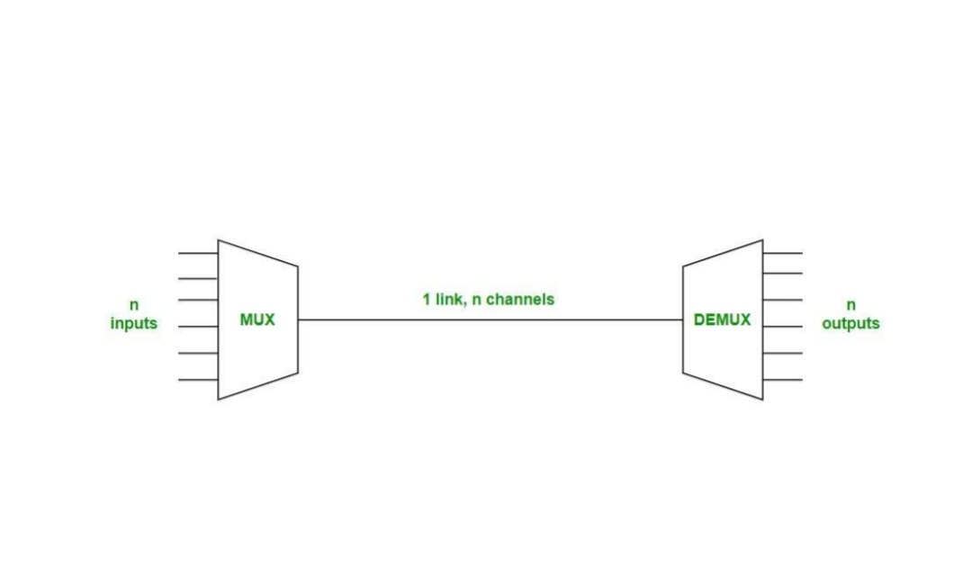

There are three basic multiplexing techniques:

* **Frequency-division multiplexing**
* **Wavelength-division multiplexing**
* **Time-division multiplexing**

The first two are techniques designed for analog signals, the third, for digital signal

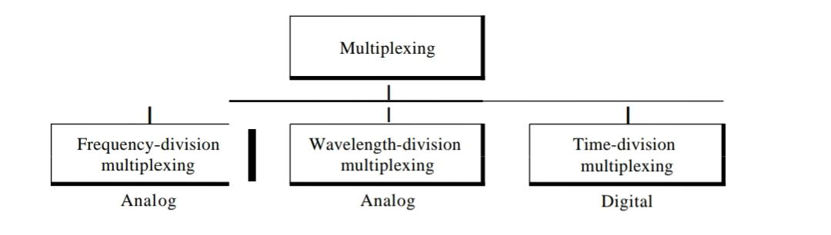

### 

### 2. Define demultiplexing?

At the receiver site, the relationship is one-to-many and requires demultiplexing.

The transport layer receives datagrams from the network layer. After error checking and dropping of the header, the transport layer delivers each message to the appropriate process based on the port number to the appropriate process based on the port number.

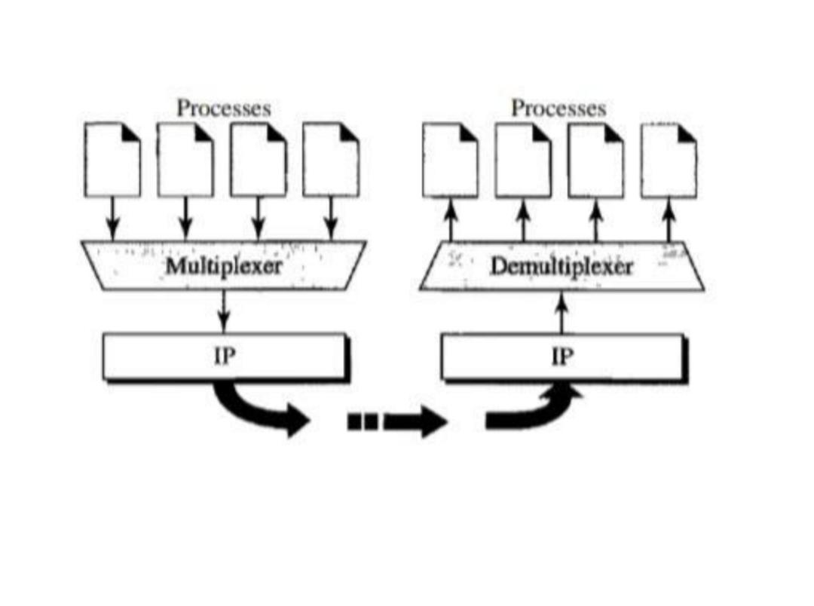

### 3. What is Multilevel multiplexing ?

Multilevel multiplexing is a technique used when the data rate of an input line is a multiple of others. Consider we have two inputs of 20 kbps and three inputs of 40 kbps. The first two input lines can be multiplexed together to provide a data rate equal to the last three. A second level of multiplexing can create an output of 160 kbps.

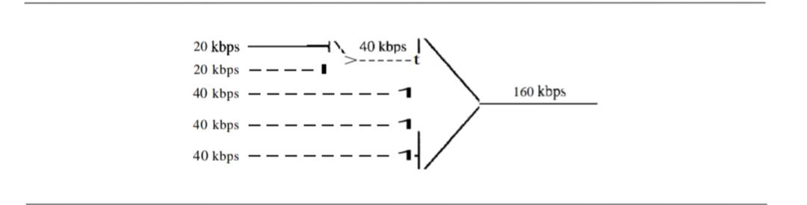

### 4. What is Multiple slot allocation?

Sometimes it is more efficient to allot more than one slot in a frame to a single input line. For example, we might have an input line that has a data rate that is a multiple of another input.the input line with a 5O-kbps data rate can be given two slots in the output. We insert a serial-to-parallel converter in the line to make two inputs out of one.

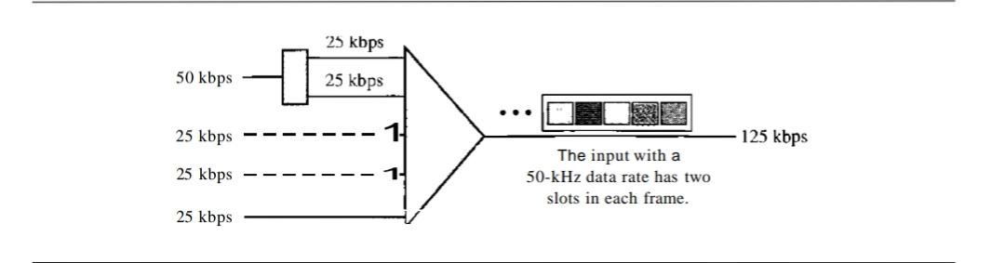

### 

### 5. What is Pulse Stuffing ?

Sometimes the bit rates of sources are not multiple integers of each other. Therefore, neither of the above two techniques can be applied. One solution is to make the highest input data rate the dominant data rate and then add dummy bits to the input lines with lower rates. This will increase their rates. This technique is called pulse stuffing, bit padding, or bit stuffing. The input with a data rate of 46 is pulse-stuffed to increase the rate to 50 kbps. Now multiplexing can take place.

### 6. What is Frame Synchronization ?

The implementation of TDM is not as simple as that of FDM. Synchronization between the multiplexer and demultiplexer is a major issue. If the multiplexer and the demultiplexer are not synchronized, a bit belonging to one channel may be received by the wrong channel. For this reason, one or more synchronization bits are usually added to the beginning of each frame. These bits, called framing bits, follow a pattern, frame to frame, that allows the demultiplexer to synchronize with the incoming stream so that it can separate the time slots accurately. In most cases, this synchronization information consists of 1 bit per frame, alternating between 0 and I.

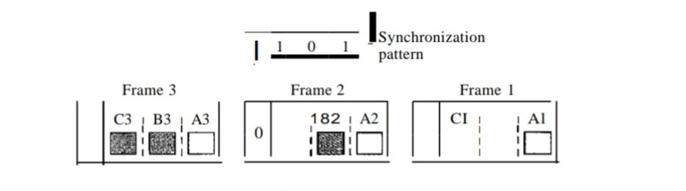

## 5 Mark Questions

### 7. Define Frequency division multiplexing ?

Frequency-division multiplexing (FDM) is an analog technique that can be applied when the bandwidth of a link (in hertz) is greater than the combined bandwidths of the signals to be transmitted.

In FDM, signals generated by each sending device modulate different carrier frequencies. These modulated signals are then combined into a single composite signal that can be transported by the link. Carrier frequencies are separated by sufficient bandwidth to accommodate the modulated signal. These bandwidth ranges are the channels through which the various signals travel. Channels can be separated by strips of unused bandwidth-guard bands-to prevent signals from overlapping. Carrier frequencies must not interfere with the original data frequencies.

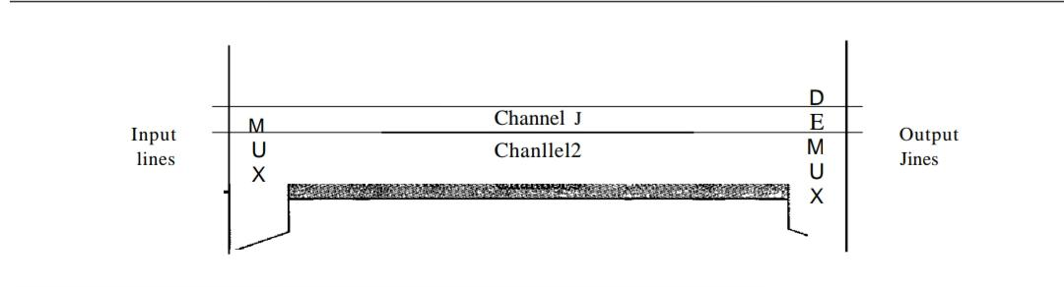

We consider FDM to be an analog multiplexing technique; however, this does not mean that FDM cannot be used to combine sources sending digital signals. A digital signal can be converted to an analog signal before FDM is used to multiplex them.

**Multiplexing process**

Each source generates a signal of a similar frequency range.

Inside the multiplexer, these similar signals modulate different carrier frequencies (/1,12, andh). The resulting modulated signals are then combined into a single composite signal that is sent out over a media link that has enough bandwidth to accommodate it.

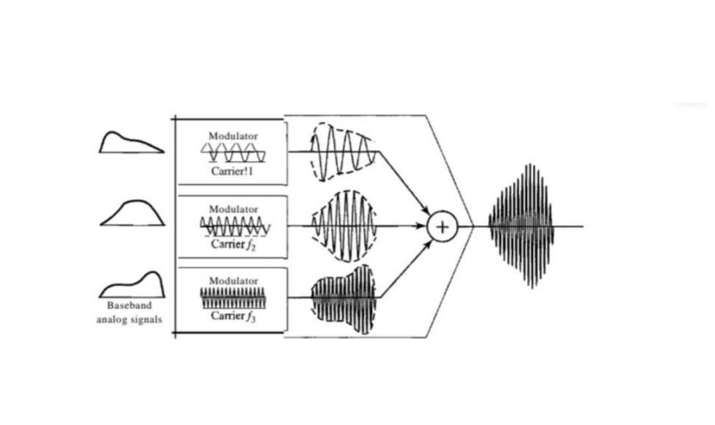

**Demultiplexing Process**

The demultiplexer uses a series of filters to decompose the multiplexed signal into its constituent component signals. The individual signals are then passed to a demodulator that separates them from their carriers and passes them to the output lines.

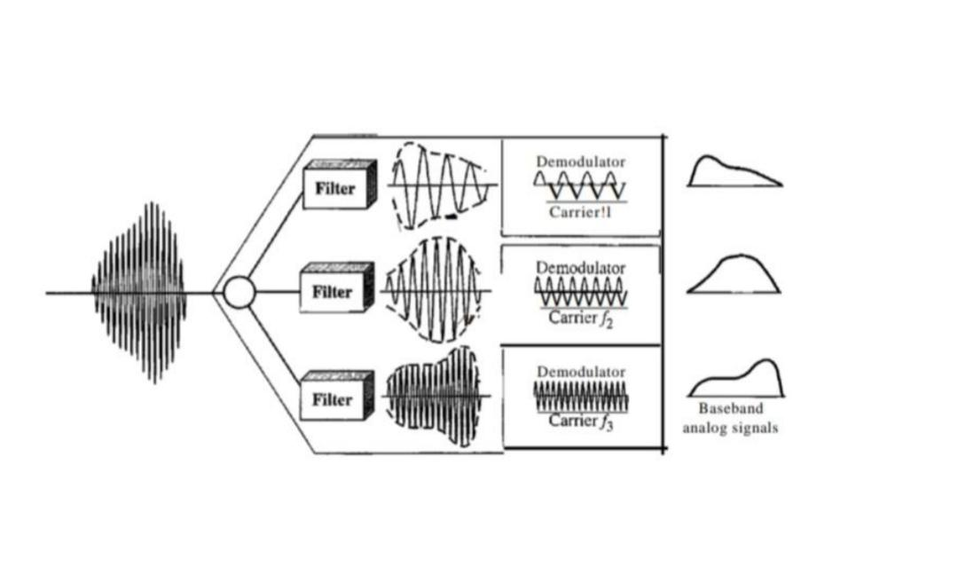

**Application of FDM**

* A very common application of FDM is AM and FM radio broadcasting.
* Another common use of FDM is in television broadcasting.
* The first generation of cellular telephones (still in operation) also uses FDM.

### 8. Define Wavelength division multiplexing ?

Wavelength-division multiplexing (WDM) is designed to use the high-data-rate capability of fiber-optic cable. The optical fiber data rate is higher than the data rate of metallic transmission cable. Using a fiber-optic cable for one single line wastes the available bandwidth. Multiplexing allows us to combine several lines into one. WDM is conceptually the same as FDM, except that the multiplexing and demultiplexing involve optical signals transmitted through fiber-optic channels. The idea is the same: We are combining different signals of different frequencies. The difference is that the frequencies are very high.

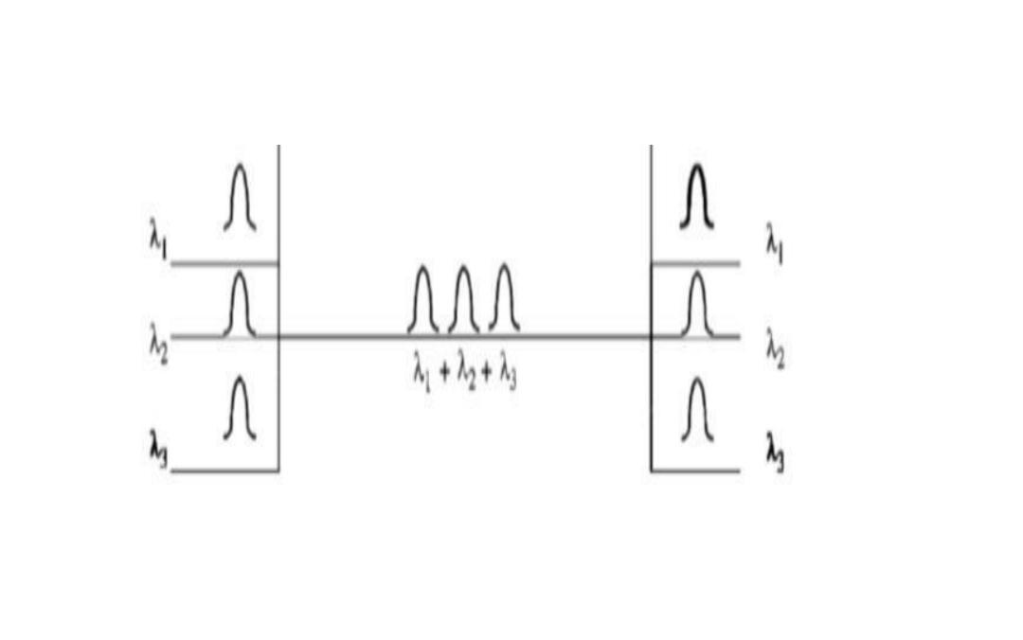

Although WDM technology is very complex, the basic idea is very simple. We want to combine multiple light sources into one single light at the multiplexer and do the reverse at the demultiplexer. The combining and splitting of light sources are easily handled by a prism. Recall from basic physics that a prism bends a beam of light based on the angle of incidence and the frequency. Using this technique, a multiplexer can be made to combine several input beams of light, each containing a narrow band of frequencies, into one output beam of a wider band of frequencies. A demultiplexer can also be made to reverse the process.

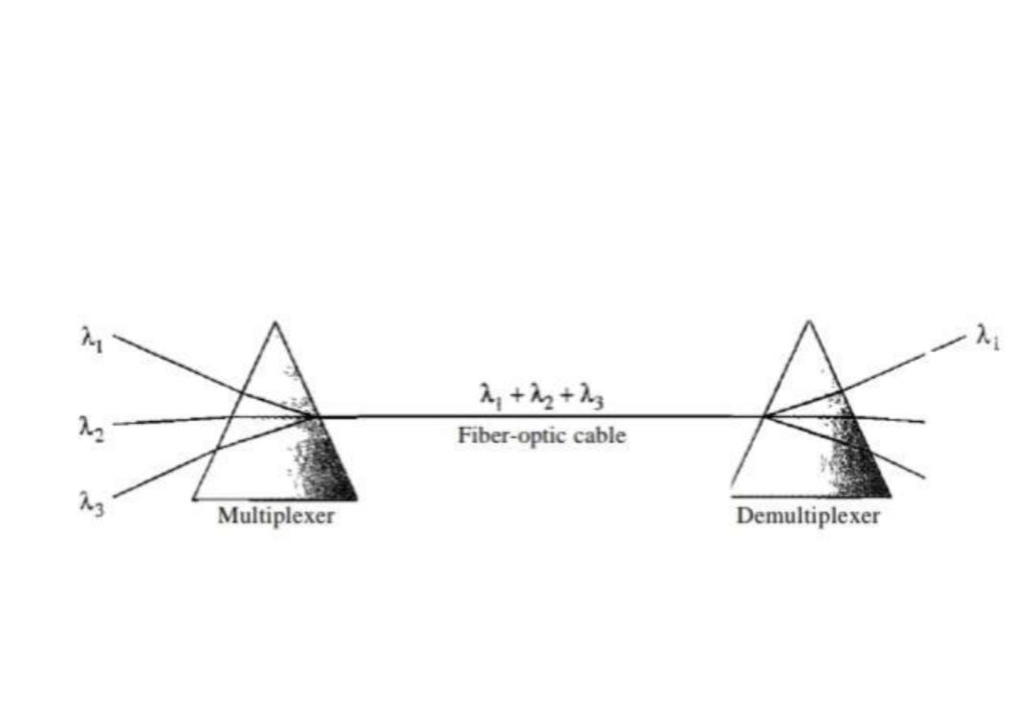

**Application of WDM**

* One application of WDM is the SONET network in which multiple optical fiber lines are multiplexed and demultiplexed.
* A new method, called dense WDM (DWDM), can multiplex a very large number of channels by spacing channels very close to one another. It achieves even greater efficiency.

### 9. Define Synchronous Time division multiplexing?

**Time-Division Multiplexing**

Time-division multiplexing (TDM) is a digital process that allows several connections to share the high bandwidth of a link. Instead of sharing a portion of the bandwidth as in FDM, time is shared. Each connection occupies a portion of time in the link.

TDM is, in principle, a digital multiplexing technique.Digital data from different sources are combined into one time shared link. However, this does not mean that the sources cannot produce analog data; analog data can be sampled, changed to digital data, and then multiplexed by using TDM.

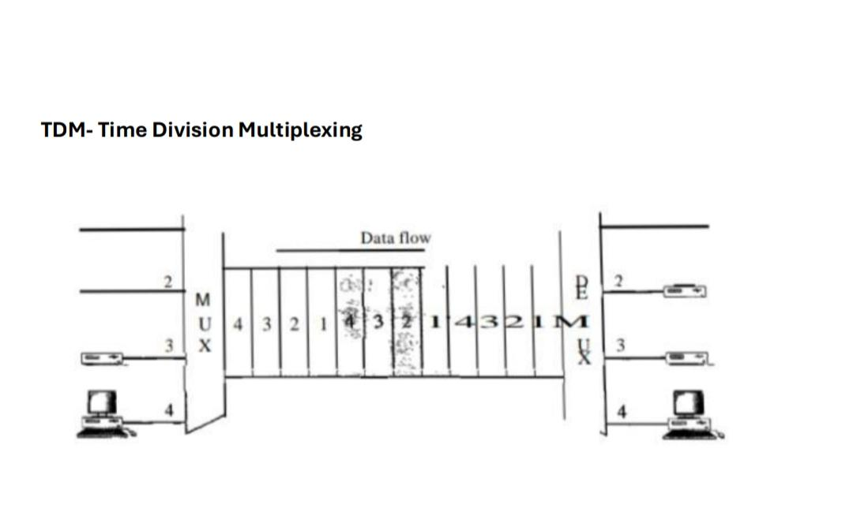

We can divide TDM into two different schemes: synchronous and statistical. In synchronous TDM, each input connection has an allotment in the output even if it is not sending data.

**Synchronous Time-Division Multiplexing**

In synchronous TDM, the data flow of each input connection is divided into units, where each input occupies one input time slot. A unit can be 1 bit, one character, or one block of data. Each input unit becomes one output unit and occupies one output time slot.

However, the duration of an output time slot is n times shorter than the duration of an input time slot. If an input time slot is T s, the output time slot is Tin s, where n is the number of connections. In other words, a unit in the output connection has a shorter duration and travels faster.

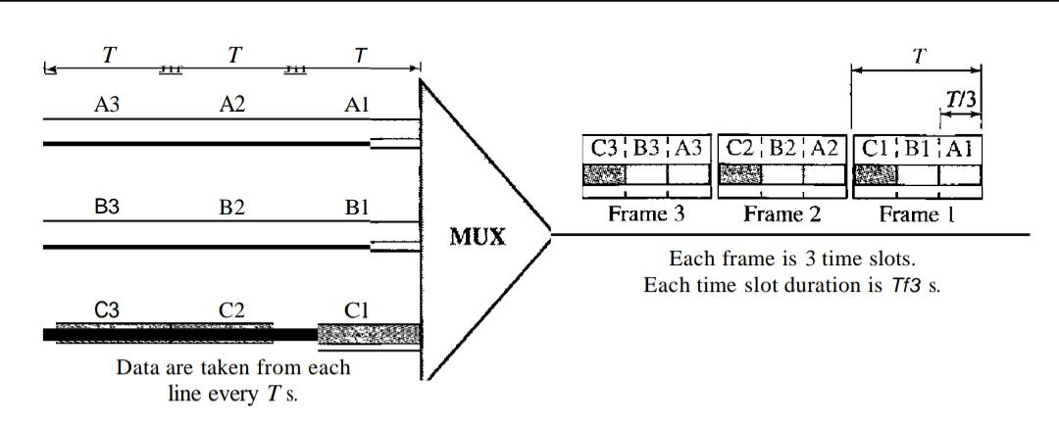

In synchronous TDM, a round of data units from each input connection is collected into a frame (we will see the reason for this shortly). If we have n connections, a frame is divided into n time slots and one slot is allocated for each unit, one for each input line. If the duration of the input unit is T, the duration of each slot is Tin and the duration of each frame is T.

Time slots are grouped into frames. A frame consists of one complete cycle of time slots, with one slot dedicated to each sending device. In a system with n input lines, each frame has n slots, with each slot allocated to carrying data from a specific input line.

### 10. Define Statistical Time-Division Multiplexing?

In statistical time-division multiplexing, slots are dynamically allocated to improve bandwidth efficiency. Only when an input line has a slot's worth of data to send is it given a slot in the output frame.

In statistical multiplexing, the number of slots in each frame is less than the number of input lines. The multiplexer checks each input line in round-robin fashion; it allocates a slot for an input line if the line has data to send; otherwise,it skips the line and checks the next line.

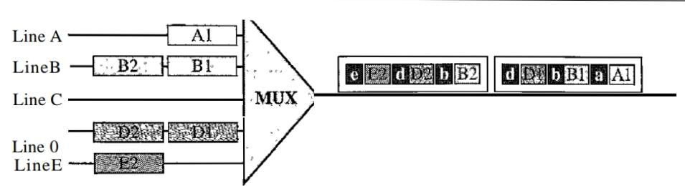

In statistical TDM, a slot needs to carry data as well as the address of the destination.

In statistical multiplexing, there is no fixed relationship between the inputs and outputs because there are no preassigned or reserved slots. We need to include the address of the receiver inside each slot to show where it is to be delivered. The addressing in its simplest form can be n bits to define N different output lines with n=10g2 N. For example, for eight different output lines, we need a 3-bit address.

Since a slot carries both data and an address in statistical TDM, the ratio of the data size to address size must be reasonable to make transmission efficient. The frames in statistical TDM need not be synchronized, so we do not need synchronization bits. In statistical TDM, the capacity of the link is normally less than the sum of the capacities of each channel.

The designers of statistical TDM define the capacity of the link based on the statistics of the load for each channel. If on average only x percent of the input slots are filled, the capacity of the link reflects this. Of course, during peak times, some slots need to wait.

### 

### 11. Define Frequency Hopping Spread Spectrum (FHSS)?

The frequency hopping spread spectrum (FHSS) technique uses M different carrier frequencies that are modulated by the source signal. At one moment, the signal modulates one carrier frequency; at the next moment, the signal modulates another carrier frequency. Although the modulation is done using one carrier frequency at a time,M frequencies are used in the long run. The bandwidth occupied by a source after spreading is BpHSS »B.

A pseudorandom code generator,called pseudorandom noise (PN), creates a k-bit pattern for every hopping period Th. The frequency table uses the pattern to find the frequency to be used for this hopping period and passes it to the frequency synthesizer.The frequency synthesizer creates a carrier signal of that frequency, and the source signal modulates the carrier signal.

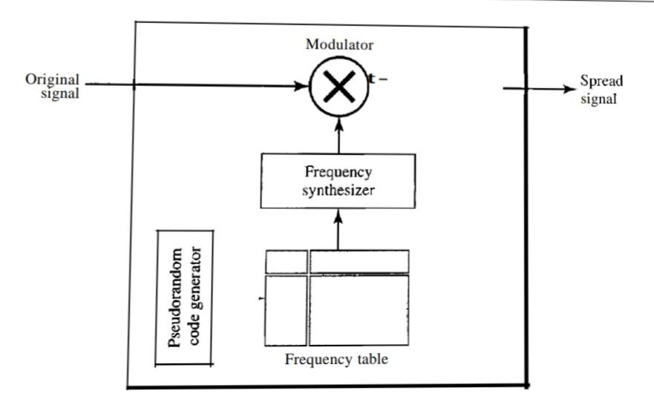

Suppose we have decided to have eight hopping frequencies. This is extremely low for real applications and is just for illustration. In this case, Mis 8 and k is 3. The pseudo random code generator will create eight different 3-bit patterns. These are mapped to eight different frequencies in the frequency table.

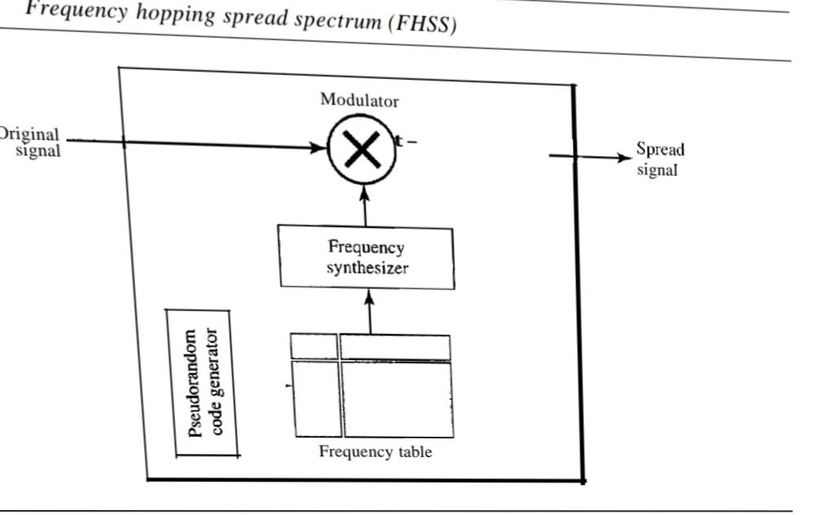

The pattern for this station is 101, 111, 001, 000, 010, all, 100. Note that the pattern is pseudorandom; it is repeated after eight hoppings. This means that at hopping period 1, the pattern is 101. The frequency selected is 700 kHz; the source signal modulates this carrier frequency. The second k-bit pattern selected is 111, which selects the 900-kHz carrier; the eighth pattern is 100, the frequency is 600 kHz. After eight hoppings, the pattern repeats, starting from 101 again.

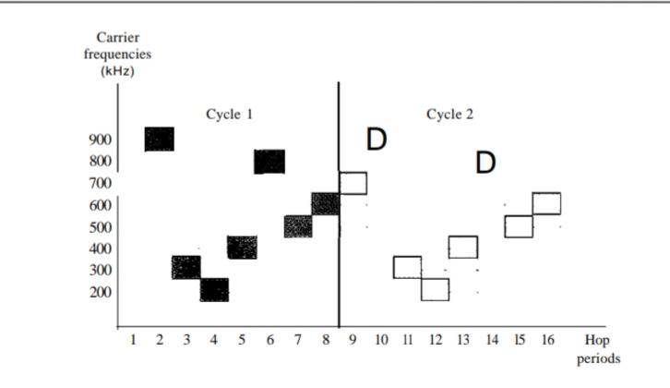

It can be shown that this scheme can accomplish the previously mentioned goals. If there are many k-bit patterns and the hopping period is short, a sender and receiver can have privacy. If an intruder tries to intercept the transmitted signal, she can only access a small piece of data because she does not know the spreading sequence to quickly adapt herself to the next hop. The scheme also has an anti jamming effect. A malicious sender may be able to send noise to jam the signal for one hopping period (randomly), but not for the whole period.

**Bandwidth Sharing**

If the number of hopping frequencies is M, we can multiplex M channels into one by using the same Bss bandwidth. This is possible because a station uses just one frequency in each hopping period; M - 1 other frequencies can be used by other M - 1 stations. In other words, M different stations can use the same Bss if an appropriate modulation technique such as multiple FSK (MFSK) is used. In FDM, each station uses 11M of the bandwidth, but the allocation is fixed; in FHSS, each station uses 11M of the bandwidth, but the allocation changes from hop to hop.

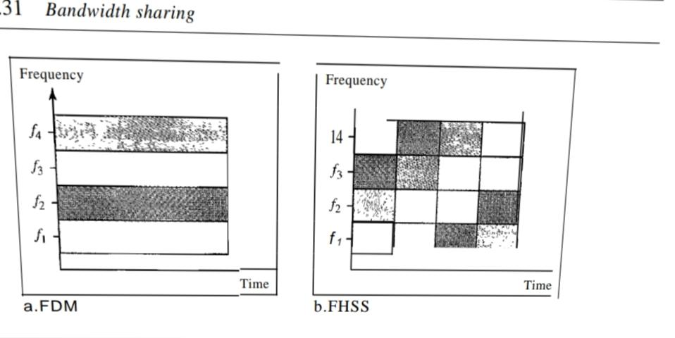

### 

### 12. Define Direct Sequence Spread Spectrum?

The direct sequence spread spectrum (DSSS) technique also expands the bandwidth of the original signal, but the process is different. In DSSS, we replace each data bit with 11 bits using a spreading code. In other words, each bit is assigned a code of 11 bits,called chips, where the chip rate is 11 times that of the data bit.

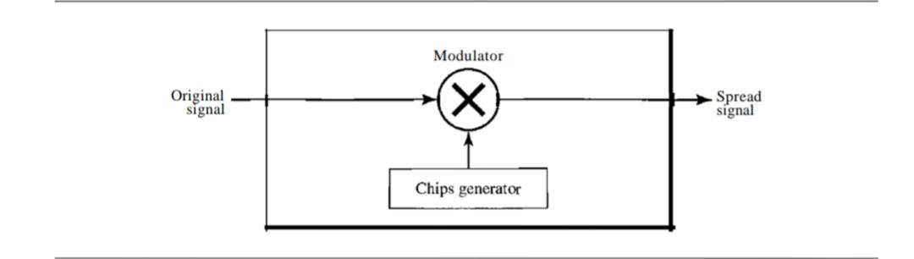

As an example, let us consider the sequence used in a wireless LAN, the famous Barker sequence where 11 is 11. We assume that the original signal and the chips in the chip generator use polar NRZ encoding.

If the original signal rate is N, the rate of the spread signal is lIN. This means that the required bandwidth for the spread signal is 11 times larger than the bandwidth of the original signal. The spread signal can provide privacy if the intruder does not know the code. It can also provide immunity against interference if each station uses a different code.

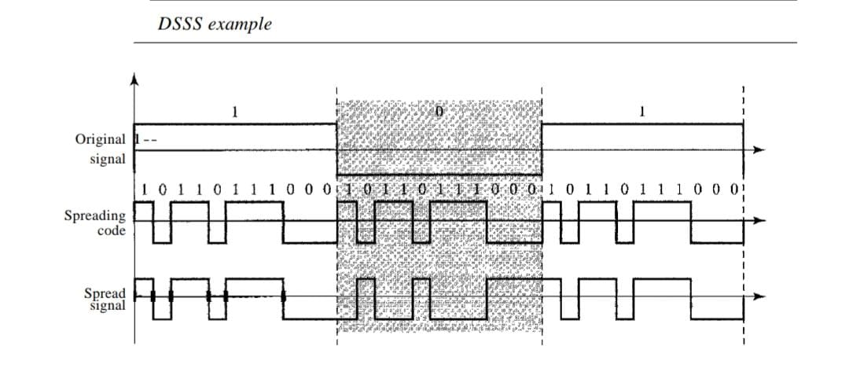

**Bandwidth Sharing**

If we use a spreading code that spreads signals (from different stations) that cannot be combined and separated, we cannot share a bandwidth. For example, some wireless LANs use DSSS and the spread bandwidth cannot be shared. However, if we use a special type of sequence code that allows the combining and separating of spread signals, we can share the bandwidth. A special spreading code allows us to use DSSS in cellular telephony and share a bandwidth between several users.

## 15 Mark Questions

### 13. Explain Spread Spectrum ?

Multiplexing combines signals from several sources to achieve bandwidth efficiency; the available bandwidth of a link is divided between the sources. In the spread spectrum , we also combine signals from different sources to fit into a larger bandwidth, but our goals are somewhat different. Spread spectrum is designed to be used in wireless applications (LANs and WANs). In these types of applications, we have some concerns that outweigh bandwidth efficiency. In wireless applications, all stations use air (or a vacuum) as the medium for communication. Stations must be able to share this medium without interception by an eavesdropper and without being subject to jamming from a malicious intruder (in military operations, for example).

To achieve these goals, spread spectrum techniques add redundancy;they spread the original spectrum needed for each station. If The required bandwidth for each station is B, spread spectrum expands it to Bss' such that Bss » B. The expanded bandwidth allows the source to wrap its message in a protective envelope for a more secure transmission. An analogy is the sending of a delicate, expensive gift. We can insert the gift in a special box to prevent it from being damaged during transportation, and we can use a superior delivery service to guarantee the safety of the package.

Spread spectrum achieves its goal through two principles:

**1.** The bandwidth allocated to each station needs to be, by far, larger than what is needed. This allows redundancy.

**2.** The expanding of the original bandwidth B to the bandwidth Bss must be done by a process that is independent of the original signal. In other words, the spreading process occurs after the signal is created by the source.

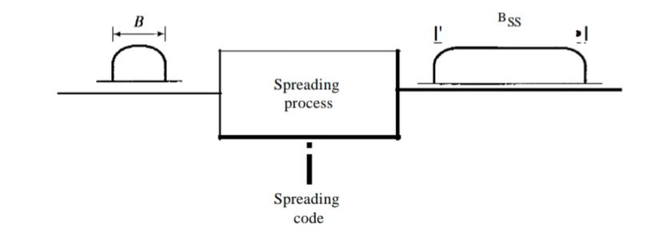

After the signal is created by the source, the spreading process uses a spreading code and spreads the bandwidth. The figure shows the original bandwidth B and the spreaded bandwidth Bss. The spreading code is a series of numbers that look random, but are actually a pattern.

There are two techniques to spread the bandwidth: frequency hopping spread spectrum (FHSS) and direct sequence spread spectrum (DSSS).

**Frequency hopping spread spectrum (FHSS)**

The frequency hopping spread spectrum (FHSS) technique uses M different carrier frequencies that are modulated by the source signal. At one moment, the signal modulates one carrier frequency; at the next moment, the signal modulates another carrier frequency. Although the modulation is done using one carrier frequency at a time,M frequencies are used in the long run. The bandwidth occupied by a source after spreading is BpHSS »B.

A pseudorandom code generator,called pseudorandom noise (PN), creates a k-bit pattern for every hopping period Th. The frequency table uses the pattern to find the frequency to be used for this hopping period and passes it to the frequency synthesizer.The frequency synthesizer creates a carrier signal of that frequency, and the source signal modulates the carrier signal.



Suppose we have decided to have eight hopping frequencies. This is extremely low for real applications and is just for illustration. In this case, Mis 8 and k is 3. The pseudo random code generator will create eight different 3-bit patterns. These are mapped to eight different frequencies in the frequency table.



The pattern for this station is 101, 111, 001, 000, 010, all, 100. Note that the pattern is pseudorandom; it is repeated after eight hoppings. This means that at hopping period 1, the pattern is 101. The frequency selected is 700 kHz; the source signal modulates this carrier frequency. The second k-bit pattern selected is 111, which selects the 900-kHz carrier; the eighth pattern is 100, the frequency is 600 kHz. After eight hoppings, the pattern repeats, starting from 101 again.



It can be shown that this scheme can accomplish the previously mentioned goals. If there are many k-bit patterns and the hopping period is short, a sender and receiver can have privacy. If an intruder tries to intercept the transmitted signal, she can only access a small piece of data because she does not know the spreading sequence to quickly adapt herself to the next hop. The scheme also has an anti jamming effect. A malicious sender may be able to send noise to jam the signal for one hopping period (randomly), but not for the whole period.

**Bandwidth Sharing**

If the number of hopping frequencies is M, we can multiplex M channels into one by using the same Bss bandwidth. This is possible because a station uses just one frequency in each hopping period; M - 1 other frequencies can be used by other M - 1 stations. In other words, M different stations can use the same Bss if an appropriate modulation technique such as multiple FSK (MFSK) is used. In FDM, each station uses 11M of the bandwidth, but the allocation is fixed; in FHSS, each station uses 11M of the bandwidth, but the allocation changes from hop to hop.



**Direct sequence spread spectrum (DSSS)**

The direct sequence spread spectrum (DSSS) technique also expands the bandwidth of the original signal, but the process is different. In DSSS, we replace each data bit with 11 bits using a spreading code. In other words, each bit is assigned a code of 11 bits,called chips, where the chip rate is 11 times that of the data bit.



As an example, let us consider the sequence used in a wireless LAN, the famous Barker sequence where 11 is 11. We assume that the original signal and the chips in the chip generator use polar NRZ encoding.

If the original signal rate is N, the rate of the spread signal is lIN. This means that the required bandwidth for the spread signal is 11 times larger than the bandwidth of the original signal. The spread signal can provide privacy if the intruder does not know the code. It can also provide immunity against interference if each station uses a different code.



**Bandwidth Sharing**

If we use a spreading code that spreads signals (from different stations) that cannot be combined and separated, we cannot share a bandwidth. For example, some wireless LANs use DSSS and the spread bandwidth cannot be shared. However, if we use a special type of sequence code that allows the combining and separating of spread signals, we can share the bandwidth. A special spreading code allows us to use DSSS in cellular telephony and share a bandwidth between several users.

### 14. Explain Transmission Media?

A transmission medium can be broadly defined as anything that can carry information from a source to a destination. For example, the transmission medium for two people having a dinner conversation is the air. The air can also be used to convey the message in a smoke signal or semaphore. The transmission medium is usually free space, metallic cable,or fiber-optic cable. The information is usually a signal that is the result of a conversion of data from another form.

In telecommunications, transmission media can be divided into two broad categories: guided and unguided. Guided media include twisted-pair cable, coaxial cable, and fiber-optic cable. Unguided medium is free space.

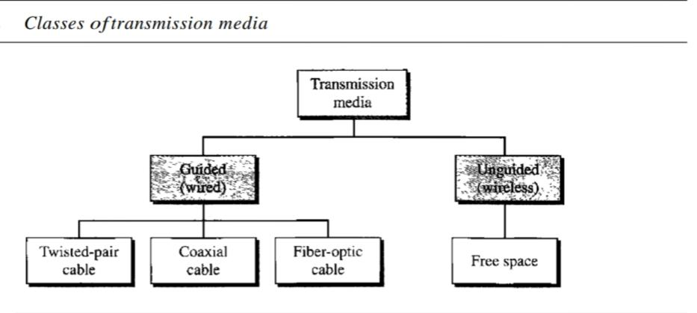

**Guided media**

Guided media, which are those that provide a conduit from one device to another, include twisted-pair cable, coaxial cable, and fiber-optic cable. A signal traveling along any of these media is directed and contained by the physical limits of the medium. Twisted-pair and coaxial cable use metallic (copper) conductors that accept and transport signals in the form of electric current. Optical fiber is a cable that accepts and transports signals in the form of light.

**1-Twisted-Pair Cable**

A twisted pair consists of two conductors (normally copper), each with its own plastic insulation, twisted together.

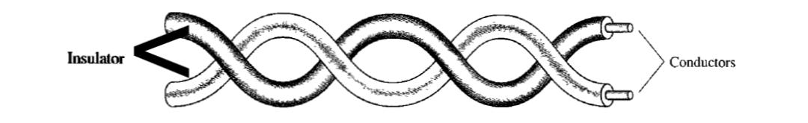

One of the wires is used to carry signals to the receiver, and the other is used only as a ground reference. The receiver uses the difference between the two.In addition to the signal sent by the sender on one of the wires, interference (noise) and crosstalk may affect both wires and create unwanted signals.If the two wires are parallel, the effect of these unwanted signals is not the same in both wires because they are at different locations relative to the noise or crosstalk sources (e,g., one is closer and the other is farther). This results in a difference at the receiver.

By twisting the pairs, a balance is maintained. For example, suppose in one twist, one wire is closer to the noise source and the other is farther; in the next twist, the reverse is true. Twisting makes it probable that both wires are equally affected by external influences (noise or crosstalk). This means that the receiver, which calculates the difference between the two, receives no unwanted signals. The unwanted signals are mostly canceled out. From the above discussion, it is clear that the number of twists per unit of length (e.g., inch) has some effect on the quality of the cable.

**Unshielded Versus Shielded Twisted-Pair Cable :**

The most common twisted-pair cable used in communications is referred to as unshielded twisted-pair (UTP). IBM has also produced a version of twisted-pair cable for its use called shielded twisted-pair (STP). STP cable has a metal foil or braided mesh covering that encases each pair of insulated conductors. Although metal casing improves the quality of cable by preventing the penetration of noise or crosstalk, it is bulkier and more expensive.

The Electronic Industries Association (EIA) has developed standards to classify unshielded twisted-pair cable into seven categories. Categories are determined by cable quality, with 1 as the lowest and 7 as the highest. Each EIA category is suitable for specific uses.

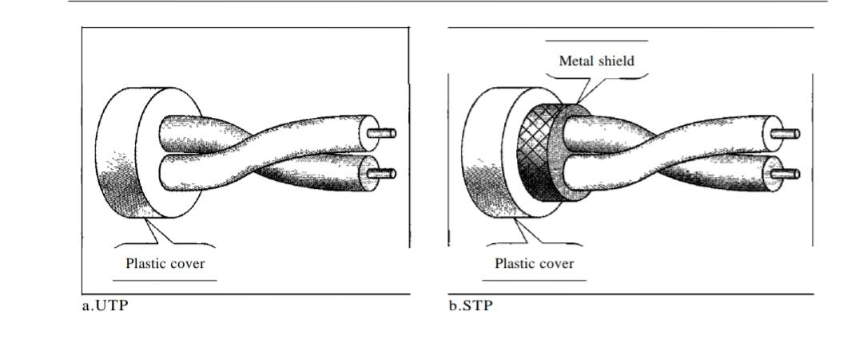

**Applications**

* Twisted-pair cables are used in telephone lines to provide voice and data channels. The local loop-the line that connects subscribers to the central telephone office commonly consists of unshielded twisted-pair cables.
* The DSL lines that are used by the telephone companies to provide high-data rate connections also use the high-bandwidth capability of unshielded twisted pair cables.
* Local-area networks, such as lOBase-T and lOOBase-T, also use twisted-pair cables.

**2-Coaxial Cable**

Coaxial cable (or coax) carries signals of higher frequency ranges than those in twisted pair cable, in part because the two media are constructed quite differently. Instead of having two wires, coax has a central core conductor of solid or stranded wire (usually copper) enclosed in an insulating sheath, which is, in turn, encased in an outer conductor of metal foil, braid, or a combination of the two. The outer metallic wrapping serves both as a shield against noise and as the second conductor, which completes the circuit. This outer conductor is also enclosed in an insulating sheath, and the whole cable is protected by a plastic cover.

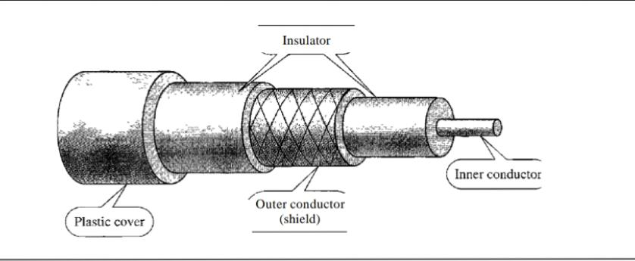

**Applications**

* Coaxial cable was widely used in analog telephone networks where a single coaxial network could carry 10,000 voice signals. Later it was used in digital telephone networks where a single coaxial cable could carry digital data up to 600 Mbps. However, coaxial cable in telephone networks has largely been replaced today with fiber-optic cable.
* Cable TV networks also use coaxial cables. In the traditional cable TV network, the entire network used coaxial cable.
* Another common application of coaxial cable is in traditional Ethernet LANs.

**3-Fiber-Optic Cable**

A fiber-optic cable is made of glass or plastic and transmits signals in the form of light. Optical fibers use reflection to guide light through a channel. A glass or plastic core is surrounded by a cladding of less dense glass or plastic. The difference in density of the two materials must be such that a beam of light moving through the core is reflected off the cladding instead of being refracted into it.

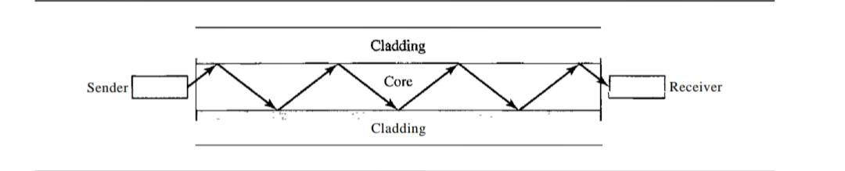

Current technology supports two modes (multimode and single mode) for propagating light along optical channels, each requiring fiber with different physical characteristics.

Multi-mode can be implemented in two forms: step-index or graded-index.

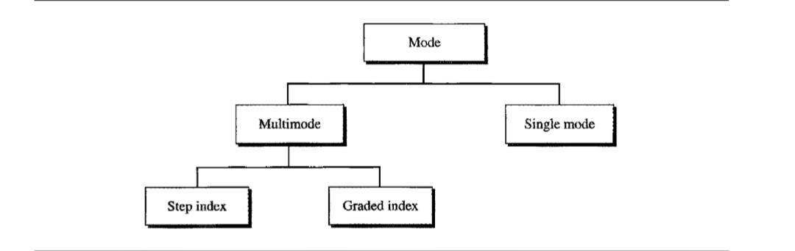

Multimode is so named because multiple beams from a light source move through the core in different paths. In multimode step-index fiber, the density of the core remains constant from the center to the edges. A beam of light moves through this constant density in a straight line until it reaches the interface of the core and the cladding. At the interface, there is an abrupt change due to a lower density; this alters the angle of the beam's motion. The term step index refers to the suddenness of this change, which contributes to the distortion of the signal as it passes through the fiber.

A second type of fiber, called multimode graded-index fiber, decreases this distortion of the signal through the cable. The word index here refers to the index of refraction. The index of refraction is related to density. A graded-index fiber,therefore, is one with varying densities. Density is highest at the center of the core and decreases gradually to its lowest at the edge.

Single-mode uses step-index fiber and a highly focused source of light that limits beams to a small range of angles, all close to the horizontal. The single-mode fiber itself is manufactured with a much smaller diameter than that of multimode fiber, and with substantiallY lower density (index of refraction). The decrease in density results in a critical angle that is close enough to 90° to make the propagation of beams almost horizontal. In this case, propagation of different beams is almost identical, and delays are negligible. All the beams arrive at the destination "together" and can be recombined with little distortion to the signal.

**Applications**

* Fiber-optic cable is often found in backbone networks because its wide bandwidth is cost-effective.
* Some cable TV companies use a combination of optical fiber and coaxial cable, thus creating a hybrid network.
* Local-area networks such as 100Base-FX network (Fast Ethernet) and 1000Base-X also use fiber-optic cable.

**Unguided media: wireless**

Unguided media transport electromagnetic waves without using a physical conductor.This type of communication is often referred to as wireless communication. Signals are normally broadcast through free space and thus are available to anyone who has a device capable of receiving them.

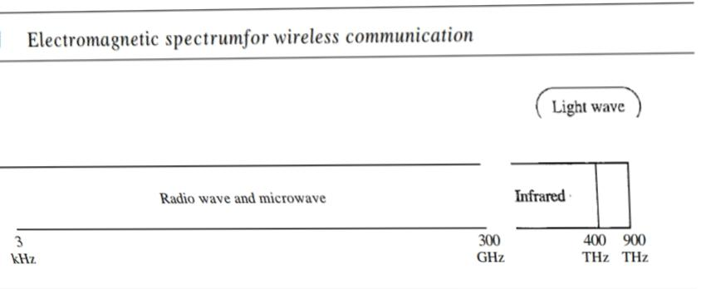

Unguided signals can travel from the source to destination in several ways: ground propagation, sky propagation, and line-of-sight propagation.The section of the electromagnetic spectrum defined as radio waves and microwaves is divided into eight ranges, called bands, each regulated by government authorities.These bands are rated from very low frequency (VLF) to extremely high frequency (EHF).

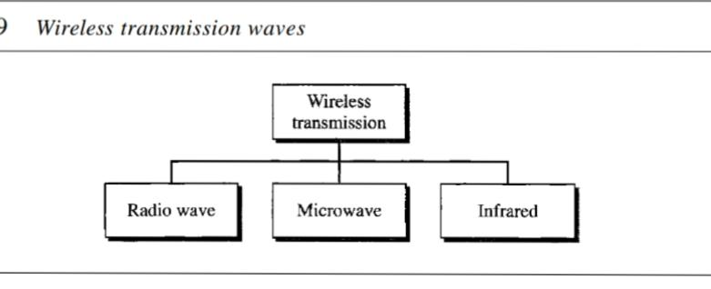

**1-Radio Waves**

Although there is no clear-cut demarcation between radio waves and microwaves, electromagnetic waves ranging in frequencies between 3 kHz and 1 GHz are normally called radio waves; waves ranging in frequencies between 1 and 300 GHz are called microwaves.

Radio waves, for the most part, are omnidirectional. When an antenna transmits radio waves, they are propagated in all directions. This means that the sending and receiving antennas do not have to be aligned. A sending antenna sends waves that can be received by any receiving antenna. The omnidirectional property has a disadvantage, too. The radio waves transmitted by one antenna are susceptible to interference by another antenna that may send signals using the same frequency or band.Radio waves, particularly those waves that propagate in the sky mode, can travel long distances. This makes radio waves a good candidate for long-distance broadcasting such as AM radio.

Radio waves, particularly those of low and medium frequencies, can penetrate walls.This characteristic can be both an advantage and a disadvantage. It is an advantage because, for example, an AM radio can receive signals inside a building. It is a disadvantage because we cannot isolate communication just inside or outside a building. The radio wave band is relatively narrow, just under 1 GHz, compared to the microwave band. When this band is divided into subbands, the subbands are also narrow, leading to a low data rate for digital communications. Almost the entire band is regulated by authorities (e.g., the FCC in the United States). Using any part of the band requires permission from the authorities.

**Application**

The omnidirectional characteristics of radio waves make them useful for multicasting, in which there is one sender but many receivers. AM and FM radio, television, maritime radio, cordless phones, and paging are examples of multicasting.

**2-Microwaves**

Electromagnetic waves having frequencies between I and 300 GHz are called microwaves.Microwaves are unidirectional. When an antenna transmits microwave waves, they can be narrowly focused. This means that the sending and receiving antennas need to be aligned. The unidirectional property has an obvious advantage. A pair of antennas can be aligned without interfering with another pair of aligned antennas.

The following describes some characteristics of microwave propagation:

* Microwave propagation is line-of-sight. Since the towers with the mounted antennas need to be in direct sight of each other, towers that are far apart need to be very tall.The curvature of the earth as well as other blocking obstacles do not allow two short towers to communicate by using microwaves. Repeaters are often needed for long-distance communication.
* Very high-frequency microwaves cannot penetrate walls. This characteristic can be a disadvantage if receivers are inside buildings.
* The microwave band is relatively wide, almost 299 GHz. Therefore wider subbands can be assigned, and a high data rate is possible
* Use of certain portions of the band requires permission from authorities.

**Application**

Microwaves, due to their unidirectional properties, are very useful when unicast (one-to-one) communication is needed between the sender and the receiver. They are used in cellular phones, satellite networks , and wireless LANs.

**3-Infrared**

Infrared waves, with frequencies from 300 GHz to 400 THz (wavelengths from 1 mm to 770 nm), can be used for short-range communication. Infrared waves, having high frequencies, cannot penetrate walls. This advantageous characteristic prevents interference between one system and another; a short-range communication system in one room cannot be affected by another system in the next room. When we use our infrared remote control, we do not interfere with the use of the remote by our neighbors. However, this same characteristic makes infrared signals useless for long range communication. In addition, we cannot use infrared waves outside a building because the sun's rays contain infrared waves that can interfere with the communication.

**Applications**

The infrared band, almost 400 THz, has an excellent potential for data transmission.Such a wide bandwidth can be used to transmit digital data with a very high data rate.The Infrared Data Association (IrDA), an association for sponsoring the use of infrared waves, has established standards for using these signals for communication between devices such as keyboards, mice, PCs, and printers. For example, some manufacturers provide a special port called the IrDA port that allows a wireless keyboard to communicate with a PC. The standard originally defined a data rate of 75 kbps for a distance up to 8 m. The recent standard defines a data rate of 4 Mbps.Infrared signals defined by IrDA transmit through line of sight; the IrDA port on the keyboard needs to point to the PC for transmission to occur.

### 15. Explain Switching?

A switched network consists of a series of interlinked nodes, called switches. Switches are devices capable of creating temporary connections between two or more devices linked to the switch. In a switched network, some of these nodes are connected to the end systems (computers or telephones, for example). Others are used only for routing.

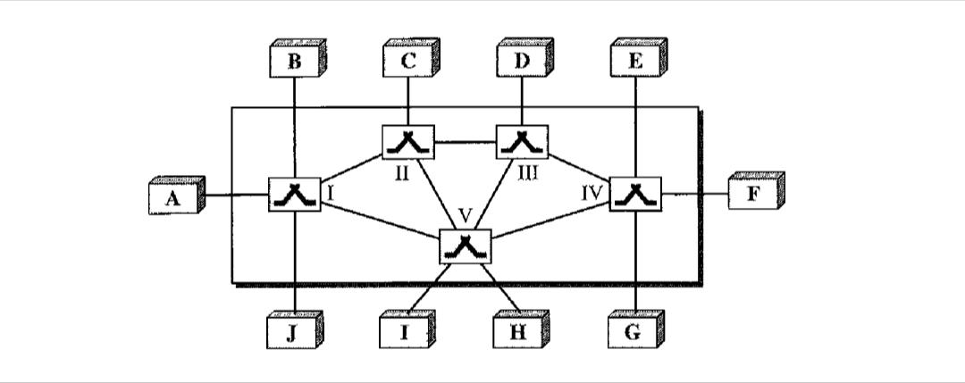

Traditionally, three methods of switching have been important:circuit switching,packet switching, and message switching.The first two are commonly used today. The third has been phased out in general communications but still has networking applications.

We can then divide today's networks into three broad categories: circuit-switched networks, packet-switched networks, and message-switched. Packet-switched networks can further be divided into two subcategories-virtual-circuit networks and datagram networks

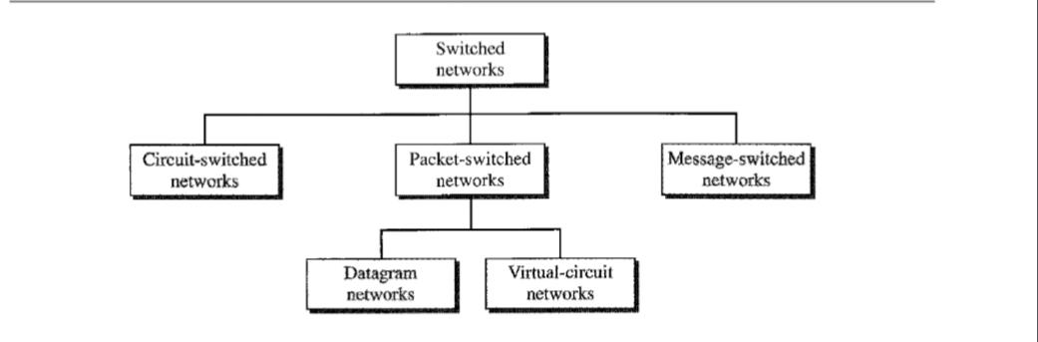

**Circuit switching**

A circuit-switched network consists of a set of switches connected by physical links.A connection between two stations is a dedicated path made of one or more links. However, each connection uses only one dedicated channel on each link. Each link is normally divided into n channels by using FDM or TDM.

The end systems, such as computers or telephones, are directly connected to a switch. We have shown only two end systems for simplicity. When end system A needs to communicate with end system M, system A needs to request a connection to M that must be accepted by all switches as well as by M itself. This is called the setup phase ;a circuit (channel) is reserved on each link, and the combination of circuits or channels defines the dedicated path. After the dedicated path made of connected circuits (channels) is established, data transfer can take place. After all data has been transferred, the circuits are torn down.

* Circuit switching takes place at the physical layer.
* Before starting communication, the stations must make a reservation for the resources to be used during the communication. These resources, such as channels (bandwidth in FDM and time slots in TDM), switch buffers, switch processing time, and switch input/output ports, must remain dedicated during the entire duration of data transfer until the teardown phase.
* Data transferred between the two stations are not packetized (physical layer transfer of the signal). The data are a continuous flow sent by the source station and received by the destination station, although there may be periods of silence.
* There is no addressing involved during data transfer. The switches route the data based on their occupied band (FDM) or time slot (TDM). Of course, there is end-to-end addressing used during the setup phase.

**Three Phases**

The actual communication in a circuit-switched network requires three phases: connection **setup, data transfer, and connection teardown.**

**Setup Phase**

Before the two parties (or multiple parties in a conference call) can communicate, a dedicated circuit (combination of channels in links) needs to be established. The end systems are normally connected through dedicated lines to the switches, so connection setup means creating dedicated channels between the switches.

**Data Transfer Phase**

After the establishment of the dedicated circuit (channels), the two parties can transfer data.

**Teardown Phase**

When one of the parties needs to disconnect, a signal is sent to each switch to release the resources.

**Efficiency**

It can be argued that circuit-switched networks are not as efficient as the other two types of networks because resources are allocated during the entire duration of the connection.

**Delay**

Although a circuit-switched network normally has low efficiency, the delay in this type of

network is minimal. During data transfer the data are not dela

**Packet switching:**

It is divided into two subcategories: **virtual-circuit networks** and **datagram networks**

**Datagram networks:**

In data communications, we need to send messages from one end system to another. If the message is going to pass through a packet-switched network, it needs to be divided into packets of fixed or variable size. The size of the packet is determined by the network and the governing protocol.

In packet switching, there is no resource allocation for a packet. This means that there is no reserved bandwidth on the links, and there is no scheduled processing time for each packet. Resources are allocated on demand. The allocation is done on a first come, first-served basis. When a switch receives a packet, no matter what is the source or destination, the packet must wait if there are other packets being processed. As with other systems in our daily life, this lack of reservation may create delay. For example, if we do not have a reservation at a restaurant, we might have to wait.

In a datagram network, each packet is treated independently of all others. Even if a packet is part of a multi packet transmission, the network treats it as though it existed alone. Packets in this approach are referred to as datagrams.Datagram switching is normally done at the network layer.

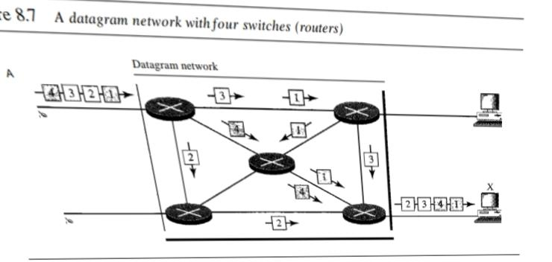

In this example, all four packets (or datagrams) belong to the same message, but may travel different paths to reach their destination. This is so because the links may be involved in carrying packets from other sources and do not have the necessary bandwidth available to carry all the packets from A to X. This approach can cause the datagrams of a transmission to arrive at their destination out of order with different delays between the packets. Packets may also be lost or dropped because of a lack of resources. In most protocols, it is the responsibility of an upper-layer protocol to reorder the datagrams or ask for lost datagrams before passing them on to the application.The datagram networks are sometimes referred to as connectionless networks. The term connectionless here means that the switch (packet switch) does not keep information about the connection state. There are no setup or teardown phases. Each packet is treated the same by a switch regardless of its source or destination.

**Routing Table**

If there are no setup or teardown phases, how are the packets routed to their destinations in a datagram network? In this type of network, each switch (or packet switch) has a routing table which is based on the destination address. The routing tables are dynamic and are updated periodically. The destination addresses and the corresponding forwarding output ports are recorded in the tables.

**Destination Address**

Every packet in a datagram network carries a header that contains, among other information, the destination address of the packet. When the switch receives the packet, this destination address is examined; the routing table is consulted to find the corresponding port through which the packet should be forwarded.

**Efficiency**

The efficiency of a datagram network is better than that of a circuit-switched network; resources are allocated only when there are packets to be transferred. If a source sends a packet and there is a delay of a few minutes before another packet can be sent, the resources can be reallocated during these minutes for other packets from other sources.

**Delay**

There may be greater delay in a datagram network than in a virtual-circuit network. Although there are no setup and teardown phases, each packet may experience a wait at a switch before it is forwarded. In addition, since not all packets in a message necessarily travel through the same switches, the delay is not uniform for the packets of a message.

**Datagram Networks in the Internet**

The Internet has chosen the datagram approach to switching at the network layer. It uses the universal addresses defined in the network layer to route packets from the source to the destination.

**Virtual-circuit network:**

A virtual-circuit network is a cross between a circuit-switched network and a datagram network.

It has some characteristics of both.

**1.** As in a circuit-switched network, there are setup and teardown phases in addition to the data transfer phase.

**2.** Resources can be allocated during the setup phase, as in a circuit-switched network, or on demand, as in a datagram network.

**3.** As in a datagram network, data is packetized and each packet carries an address in the header. However, the address in the header has local jurisdiction (it defines what should be the next switch and the channel on which the packet is being carried), not end-to-end jurisdiction.

**4.** As in a circuit-switched network, all packets follow the same path established during the connection.

**5.** A virtual-circuit network is normally implemented in the data link layer, while a circuit-switched network is implemented in the physical layer and a datagram network in the network layer. But this may change in the future.

**Addressing**

In a virtual-circuit network, two types of addressing are involved: global and local (virtual-circuit identifier).

**Global Addressing**

A source or a destination needs to have a global address-an address that can be unique in the scope of the network or internationally if the network is part of an international network. However, we will see that a global address in virtual-circuit networks is used only to create a virtual-circuit identifier

**Virtual-Circuit Identifier**

The identifier that is actually used for data transfer is called the virtual-circuit identifier (Vci). A vci, unlike a global address, is a small number that has only switch scope; it is used by a frame between two switches. When a frame arrives at a switch, it has a VCI; when it leaves, it has a different VCl.

**Three Phases**

We first discuss the data transfer phase, which is more straightforward; we then talk about the setup and teardown phases.

**Data Transfer Phase**

To transfer a frame from a source to its destination, all switches need to have a table entry for this virtual circuit. The table, in its simplest form, has four columns. This means that the switch holds four pieces of information for each virtual circuit that is already set up. We show later how the switches make their table entries, but for the moment we assume that each switch has a table with entries for all active virtual circuits. The data transfer phase is active until the source sends all its frames to the destination. The procedure at the switch is the same for each frame of a message. The process creates a virtual circuit, not a real circuit, between the source and destination.

**Setup Phase**

In the setup phase, a switch creates an entry for a virtual circuit. For example, suppose source A needs to create a virtual circuit to B. Two steps are required: the setup request and the acknowledgment.

**a.** Source A sends a setup frame to switch 1.

**b.** Switch 1 receives the setup request frame. It knows that a frame going from A to B goes out through port 3. The switch creates an entry in its table for this virtual circuit, but it is only able to fill three of the four columns. The switch assigns the incoming port (1) and chooses an available incoming VCI (14) and the outgoing port (3). It does not yet know the outgoing VCI, which will be found during the acknowledgment step. The switch then forwards the frame through port 3 to switch 2.

**c.** Switch 2 receives the setup request frame. The same events happen here as at switch 1; three columns of the table are completed: in this case, incoming port (l), incoming VCI (66), and outgoing port (2).

**d.** Switch 3 receives the setup request frame. Again, three columns are completed: incoming port (2), incoming VCI (22), and outgoing port (3). e. Destination B receives the setup frame, and if it is ready to receive frames from A, it assigns a VCI to the incoming frames that come from A, in this case 77. This VCI lets the destination know that the frames come from A, and not other sources.

**Acknowledgment**

A special frame, called the acknowledgment frame, completes the entries in the switching tables.

**a.** The destination sends an acknowledgment to switch 3. The acknowledgment carries the global source and destination addresses so the switch knows which entry in the table is to be completed. The frame also carries VCI 77, chosen by the destination as the incoming VCI for frames from A. Switch 3 uses this VCI to complete the outgoing VCI column for this entry. Note that 77 is the incoming VCI for destination B, but the outgoing VCI for switch 3.

**b.** Switch 3 sends an acknowledgment to switch 2 that contains its incoming VCI in the table, chosen in the previous step. Switch 2 uses this as the outgoing VCI in the table.

**c.** Switch 2 sends an acknowledgment to switch 1 that contains its incoming VCI in the table, chosen in the previous step. Switch 1 uses this as the outgoing VCI in the table.

**d.** Finally switch 1 sends an acknowledgment to source A that contains its incoming VCI in the table, chosen in the previous step.

**e.** The source uses this as the outgoing VCI for the data frames to be sent to destination B.

**Teardown Phase**

In this phase, source A, after sending all frames to B, sends a special frame called a teardown request. Destination B responds with a teardown confirmation frame. All switches delete the corresponding entry from their tables.

**Efficiency**

As we said before, resource reservation in a virtual-circuit network can be made during the setup or can be on demand during the data transfer phase. In the first case, the delay for each packet is the same; in the second case, each packet may encounter different delays. There is one big advantage in a virtual-circuit network even if resource allocation is on demand. The source can check the availability of the resources, without actually reserving it.

**Delay in Virtual-Circuit Networks**

In a virtual-circuit network, there is a one-time delay for setup and a one-time delay for teardown. If resources are allocated during the setup phase, there is no wait time for individual packets.

# MODULE 3

## 2 Mark Questions

### 1.Define single bit error

Single-bit error: A single-bit error means only one bit in a given data unit is changed

from 1 to 0 or vice versa.

### 2.Define burst error

Burst error: A burst error involves two or more bits in the data unit being altered. The length of the burst is measured from the first to the last corrupted bit.

### 3.Define Redundancy

Redundancy is the process of adding extra bits for error detection or correction.

### 4. Define forward error correction

Forward error correction refers to the process where the receiver uses redundant bits to guess and correct errors in the original message.

### 5. Define Retransmission

When an error is detected, the receiver requests that the sender retransmit the message.

### 

### 6. What is Hamming distance

The Hamming distance between two codewords is the number of differing bits.

### 7.Define Minimum Hamming distance for error detection and error correction

Minimum Hamming distance for error detection ,To detect up to s errors, the minimum Hamming distance should be d_min = s + 1. To guarantee correction of up-to t errors in all cases, the minimum Hamming distance in a block code

must be d_min == 2t+ 1

### 8. Define Simple parity check

This method adds a parity bit to ensure the total number of 1s is even or odd.

### 9. Define Block codes

Block codes involve dividing data into blocks and adding redundant bits to allow error detection.

### 10.Define Linear block codes

Linear block codes ensure that the XOR of two valid codewords is another valid codeword.

### 

### 11. Define Two-dimensional parity check

This method uses both row and column parity bits, allowing detection of multiple errors.

### 12. define Framing

In the data link layer, framing separates a message from one source to its destination by adding addresses.

### 13.Define Fixed-size framing

Fixed-size framing uses frame size as the delimiter, such as ATM cells.

### 14. Define Variable-sized framing

This type of framing uses a delimiter to define the boundaries between frames.

### 15. Define Character-oriented protocol and Bit-oriented protocol:

Character-oriented protocol :This protocol handles data in 8-bit characters, adding special characters to delimit frames. A bit-oriented protocol: it handles data as sequences of bits, using flags to delimit frames.

### 16. Define Bit and byte stuffing

**Byte stuffing:** Adds an extra byte (ESC) to prevent data from being interpreted as a frame boundary.

**Bit stuffing:** Adds a 0 bit after five consecutive 1s in the data to prevent confusion with a flag.

### 17. Define Flow control

Flow control manages the amount of data a sender can send before receiving an acknowledgment to avoid overwhelming the receiver.

### 

### 18. Define Error control

Error control involves detecting and correcting errors in transmission, primarily using automatic repeat request (ARQ) methods.

### 19. Define Noiseless channel

A noiseless channel assumes an ideal transmission without errors, where protocols like the Simplest Protocol are used.

### 20. Define Piggybacking

Piggybacking combines data and acknowledgment in one frame to improve transmission efficiency.

### 21. Define Random Access Protocol

In random access methods, no station is superior, and any station can send data at any time, which can lead to collisions. Examples include ALOHA and CSMA .

### 22. Define Controlled Access Protocol

In controlled access methods, stations consult each other to decide which one can send data at a time. Examples include reservation, polling, and token passing .

### 23. Define Channelization Protocol

Channelization involves dividing the available bandwidth into separate channels for different stations. Techniques include FDMA, TDMA, and CDMA .

### 24. Define Throughput of a Channel

Throughput is the actual amount of data successfully transmitted over a network. It is generally less than the bandwidth due to various inefficiencies .

### 25. Define Vulnerable Timing in CSMA Protocol

In CSMA, the vulnerable time is the period during which a collision can occur while a station is transmitting a frame. It is equal to the propagation delay of the frame across the network .

### 26. Define One-persistent, Non-persistent, and P-persistent Protocols:

**One-persistent:** The station sends data immediately when the channel is idle, with a high chance of collision.

**Non-persistent:** The station waits for a random amount of time before trying again if the channel is busy, reducing collisions but being less efficient.

**P-persistent:** The station sends with probability p if the channel is idle and waits with probability 1-p .

### 27. Define Reservation Method

In the reservation method, a station reserves a time slot for transmission before sending data. It ensures that no collision occurs .

### 28. Define Polling

In polling, a primary device controls access to the channel by allowing secondary devices to send data only when it is their turn .

### 29. Define Token Passing Method

In this method, stations are organized in a logical ring. A token circulates in the network, and a station can only send data when it has the token.

## 5 Mark Questions

### 

### 30. Define Types of Errors

Types of Errors Whenever bits flow from one point to another, they are subject to unpredictable changes because of interference. This interference can change the shape of the signal. In a single-bit error, a 0 is changed to a 1 or a 1 to an O. In a burst error, multiple bits are changed. For example, a 11100 s burst of impulse noise on a transmission with a data rate of 1200 bps might change all or some of the12 bits of information. Single-Bit Error The term single-bit error means that only 1 bit of a given data unit (such as a byte, character, or packet) is changed from 1 to 0 or from 0 to 1. In a single bit error, only 1 bit in the data unit has changed.

Burst Error The term burst error means that 2 or more bits in the data unit have changed from 1 to 0 or from 0 to 1. A burst error means that 2 or more bits in the data unit have changed. A burst error is more likely to occur than a single-bit error. The duration of noise is normally longer than the duration of 1 bit, which means that when noise affects data, it affects a set of bits. The number of bits affected depends on the data rate and duration of noise. For example, if we are sending data at I kbps, a noise of 11100 s can affect 10 bits; if we are sending data at I Mbps, the same noise can affect 10,000 bits

### 31. Error Detection vs. Error Correction

Error detection involves detecting if an error occurred during transmission. The receiver only checks for discrepancies between the transmitted and received data. An error-detecting code can detect only the types of errors for which it is designed; other types of errors may remain undetected.

Error correction involves not only detecting errors but also locating and fixing the corrupted bits. This process is more complex since it requires finding which bits are erroneous. Two main error correction methods include forward error correction, where the receiver uses redundant bits to guess the correct message, and retransmission, where the receiver requests the sender to resend the message until it is received error-free.

### 32. Hamming Distance Method

Hamming Distance is One of the central concepts in coding for error control is the idea of the Hamming distance. The Hamming distance between two words (of the same size) is the number of differences between the corresponding bits. We show the Hamming distance between two words x and y as d(x, y). The Hamming distance can easily be found if we apply the XOR operation on the two words and count the number of Is in the result. Note that the Hamming distance is a value greater than zero. The Hamming distance between two words is the number of differences between corresponding bits. The minimum Hamming distance is the smallest Hamming distance between all possible pairs in a set of words.

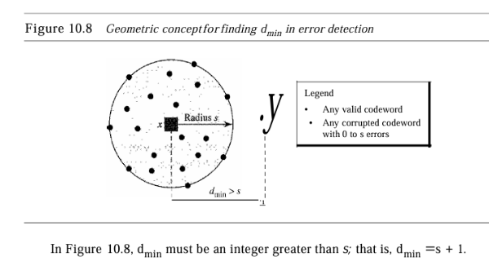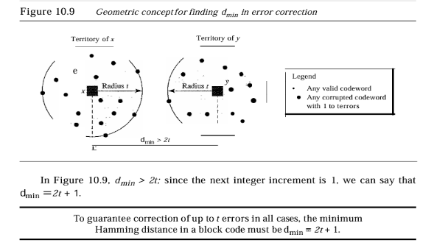

Minimum Hamming distance for error detection ,To detect up to s errors, the minimum Hamming distance should be d_min = s + 1. To guarantee correction of up-to t errors in all cases, the minimum Hamming distance in a block code must be d_min == 2t+ 1

### 33. Cyclic Redundancy Check (CRC)

CRC or Cyclic Redundancy Check is a method of detecting accidental changes/errors in the communication channel. CRC uses Generator Polynomial which is available on both sender and receiver side. An example generator polynomial is of the form like x 3 + x + 1. This generator polynomial represents key 1011. Another example is x 2 + 1 that represents key 101.

n : Number of bits in data to be sent from the sender side.

k : Number of bits in the key obtained from the generator polynomial.

**Sender Side (Generation of Encoded Data from Data and Generator Polynomial (or Key)):**

**1.** The binary data is first augmented by adding k-1 zeros in the end of the data

**2.** Use modulo-2 binary division to divide binary data by the key and store the remainder of division.

**3.** Append the remainder at the end of the data to form the encoded data and send the same

**Receiver Side (Check if there are errors introduced in transmission)**

Perform modulo-2 division again and if the remainder is 0, then there are no errors.

In this article we will focus only on finding the remainder i.e. check word and the code word.

**Modulo 2 Division:**

The process of modulo-2 binary division is the same as the familiar division process we use for decimal numbers. Just that instead of subtraction, we use XOR here.

* In each step, a copy of the divisor (or data) is XORed with the k bits of the dividend (or key).
* The result of the XOR operation (remainder) is (n-1) bits, which is used for the next step after 1 extra bit is pulled down to make it n bits long.
* When there are no bits left to pull down, we have a result. The (n-1)-bit remainder which is appended at the sender side.

### 

### 34. Parity Check Method

A simple parity check involves adding a parity bit to the data to ensure the total number of 1s is either even or odd. The receiver checks if the number of 1s matches the expected parity. If not, it detects an error. Parity checks can detect single-bit errors but may fail with multiple errors, especially those that result in an even number of errors that cancel each other out.

In this code, a k-bit dataword is changed to an n-bit codeword where n = k + 1. The extra bit, called the parity bit, is selected to make the total number of Is in the codeword even. Although some implementations specify an odd number of Is, we discuss the even case. The minimum Hamming distance for this category is d_min =2, which means that the code is a single-bit error-detecting code; it cannot correct any error. A simple parity-check code is a single-bit error-detecting code in which n =k + 1 with d_min =2.

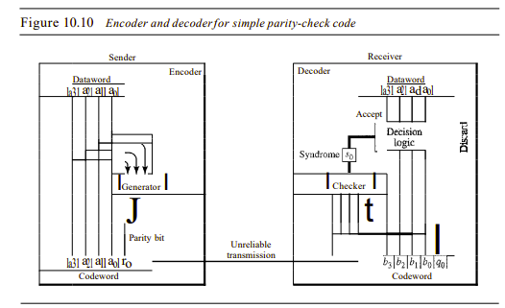

### 35 . Checksum Method

Checksum is the error detection method used by upper layer protocols and is considered to be more reliable than LRC, VRC and CRC. This method makes use of the Checksum Generator on Sender side and Checksum Checker on the Receiver side.

At the Sender side, the data is divided into equal subunits of n bit length by the checksum generator. This bit is generally of 16-bit length. These subunits are then added together using one’s complement method. This sum is of n bits. The resultant bit is then complemented. This Complemented sum which is called checksum is appended to the end of the original data unit and is then transmitted to the receiver.

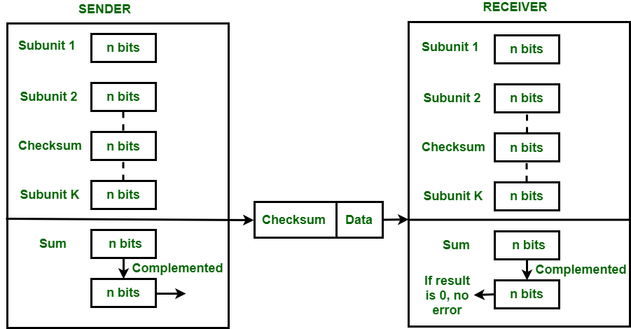

The Receiver after receiving data + checksum passes it to checksum checker. Checksum checker divides this data unit into various subunits of equal length and adds all these subunits. These subunits also contain checksum as one of the subunits. The resultant bit is then complemented. If the complemented result is zero, it means the data is error-free. If the result is non-zero it means the data contains an error and the Receiver rejects it.

### 36. Framing

Framing in the data link layer separates a message from one source to a destination, or from other messages to other destinations, by adding a sender address and a destination address. The destination address defines where the packet is to go; the sender address helps the recipient acknowledge the receipt. Although the whole message could be packed in one frame, that is not normally done. One reason is that a frame can be very large, making flow and error control very inefficient. When a message is carried in one very large frame, even a single-bit error would require the retransmission of the whole message. When a message is divided into smaller frames, a single-bit error affects only that small frame.

There are two types of framing: **fixed size and variable size framing.**

**Fixed-Size Framing:** Frames can be of fixed or variable size. In fixed-size framing, there is no need for defining the boundaries of the frames; the size itself can be used as a delimiter. Example: ATM wide-area network.

**Variable-Size Framing:** Our main discussion in this chapter concerns variable-size framing, prevalent in local area networks. In variable-size framing, we need a way to define the end of the frame and the beginning of the next.two approaches were used for this purpose: a character-oriented approach and a bit-oriented approach.

**1.**Character/Byte Stuffing: Used when frames consist of characters. If data contains ED then, a byte is stuffed into data to differentiate it from ED.

Let ED = “$” –> if data contains ‘$’ anywhere, it can be escaped using ‘\O’ character.

–> if data contains ‘\O$’ then, use ‘\O\O\O$'($ is escaped using \O and \O is escaped using \O).

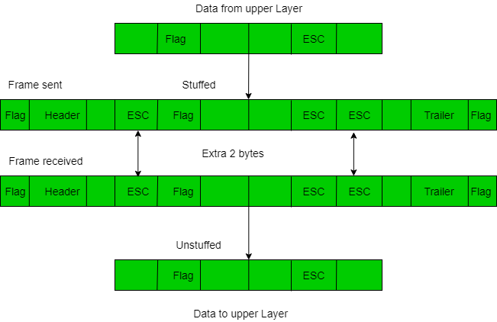

**Disadvantage** – It is a very costly and obsolete method.

**2.** Bit Stuffing: Let ED = 01111 and if data = 01111

* Sender stuffs a bit to break the pattern i.e. here appends a 0 in data = 011101.
* Receiver receives the frame.
* If data contains 011101, the receiver removes the 0 and reads the data.

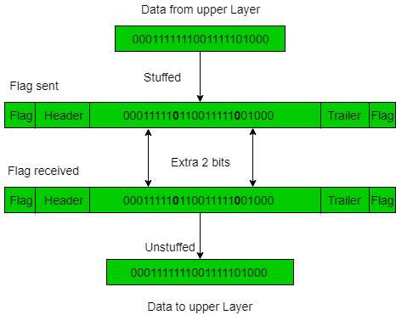

### 

### 37. Simplest Protocol

**Noiseless Channel :**An idealistic channel in which no frames are lost, corrupted or duplicated. The protocol does not implement error control in this category. There are two protocols for the noiseless channel as follows.

**Simplest Protocol :**We consider here that the receiver can maintain any frame received with insignificant processing time. The receiver’s data link layer immediately removes the header from the frame and assigns the data packet to its network layer, which can also accept the packet immediately. That is to say, the receiver can never be overwhelmed with forthcoming frames.

**Design :** The data link layer at the sender site gets data from its network layer, makes a frame out of the data, and sends it. The data link layer(receiver site) receives a frame from its physical layer, extracts data from the frame, and conveys the data to its network layer. The data link layers of the sender and receiver provide communication/transmission services for their network layers. The data link layers utilization the services provided by their physical layers for the physical transmission of bits

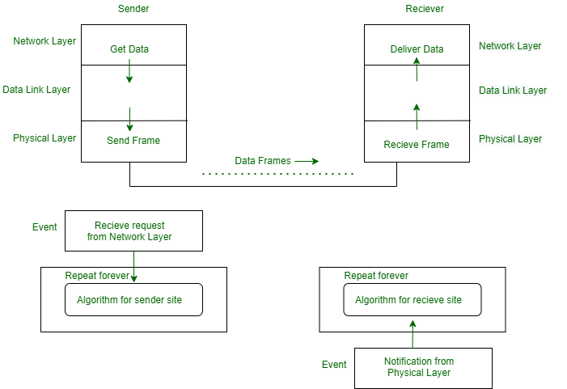

Design of Simplest Protocol with no error control or flow

**Sender-site algorithm :**

| **while(true) //Repeat forever {   waitForEvent(); //sleep until an event occur  if (Event(RequestToSend)) //there is a packet to send  {  GetData();  MakeFrame();  SendFrame(); //send the frame  } }** |
| --- |

**Receivers algorithm :**

| while(true) //Repeat forever {   waitForEvent(); //sleep until an event occur  if (Event(ArrivalNotification)) //data frame arrived  {  ReceiveFrame();  ExtractData();  DeliverData(); //Deliver data to network layer  } } |
| --- |

**Flow Diagram :**

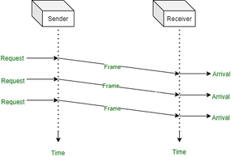

### 38. Stop and Wait Protocol

In the Stop and Wait protocol, the sender sends one frame at a time and waits for an acknowledgment (ACK) from the receiver before sending the next frame. This method ensures that the receiver successfully receives and processes each frame, making it reliable for data transmission but slower due to idle time while waiting for ACKs.

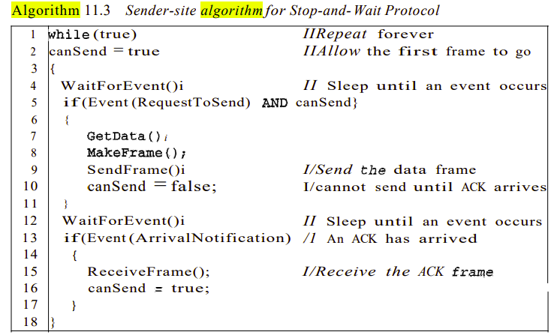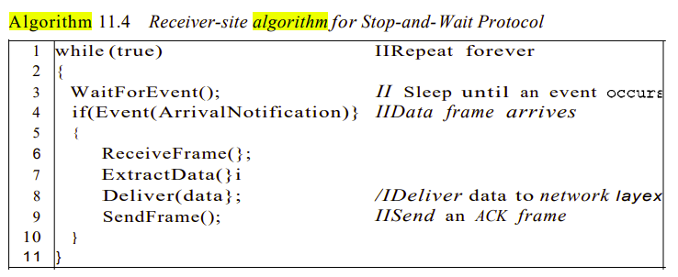

**Flow Diagram :**

This figure shows an example of communication using the Stop-and-wait protocol. It is still straightforward. The sender sends a frame and waits for a response from the receiver. When ACK(acknowledged) will arrive from the receiver side then send the next frame and so on. Keep it in mind when two frames will be there the sender will be involved in four events and the receivers will be involved in two events.

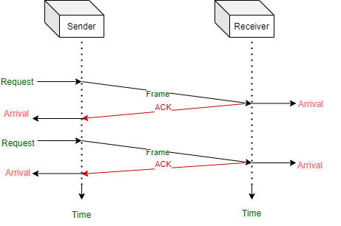

### 39. Stop and Wait ARQ (Automatic Repeat Request)

Stop-and-Wait Automatic Repeat Request(ARQ) is a common type of error control protocol widely used in computer networks to ensure reliable data transmission. This protocol works by transmitting a single data packet and waiting for an acknowledgement before sending the next packet. In this ARQ protocol, the sender sends a data packet to the receiver and waits for an acknowledgement from the receiver side. The receiver, after receiving the packet, sends an acknowledgement back to the sender indicating that the packet has been successfully received. If the sender does not receive an acknowledgement from the receiver side within a specified time frame then the sender retransmits the packet. So, this protocol is called “stop-and-wait” because the sender must wait for the acknowledgement before sending the next packet. For that reason the protocol became relatively slow, as it does not allow for pipelining or sending multiple packets at once. This protocol is commonly used in such situations where data loss is not frequent or where the cost of retransmitting a lost packet is low.

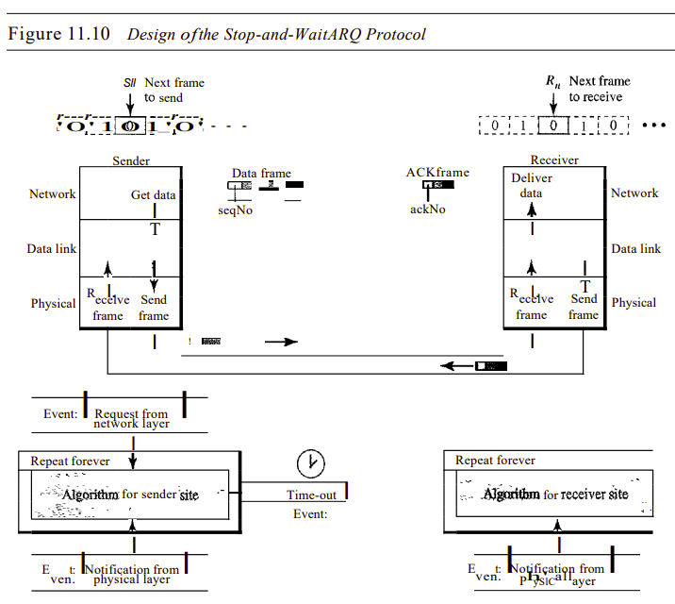

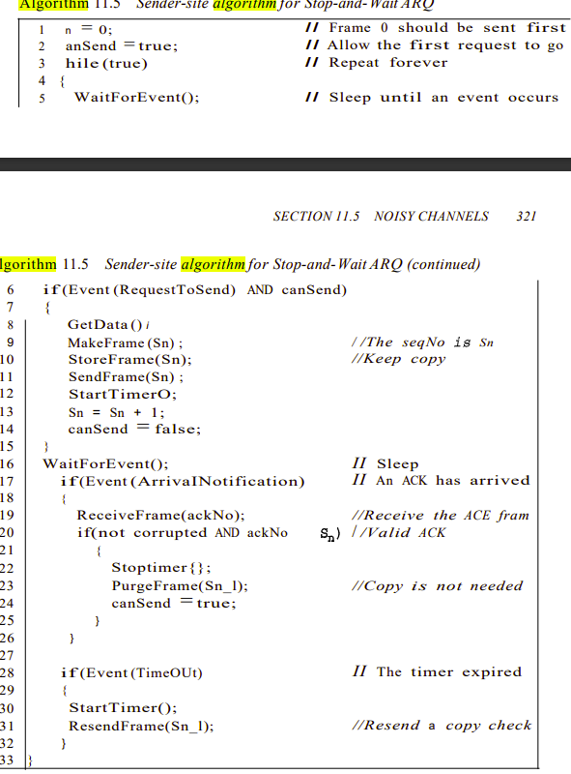

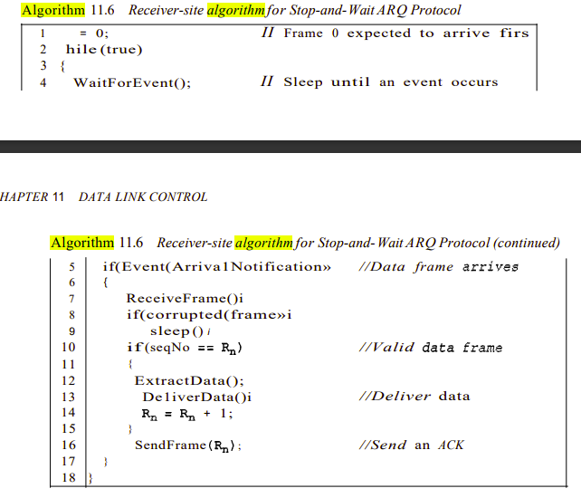

### 40. Go-Back-N Automatic Repeat Request

Go-Back-N Automatic Repeat Request(ARQ) is also an error control protocol used in computer networks to ensure reliable data transmission. In this protocol the sender is allowed to transmit multiple packets before waiting for an acknowledgement which improves the efficiency of data transmission. In this protocol the sender sends multiple numbers of packets to the receiver without waiting for an acknowledgement for each packet. The receiver receives the data packets and sends an acknowledgement for the last correctly received packet only. If the sender does not receive an acknowledgement from the receiver end within a specified time frame then sender retransmits all packets starting from the last unacknowledged packet. So, this protocol is called “go-back-n” because the sender must go back and retransmit all the packets that were not acknowledged. This means that if a single packet is lost then all the subsequent packets must be retransmitted and this can lead to inefficient use of network resources. This protocol is commonly used in situations where data loss is moderate and network resources are not limited.

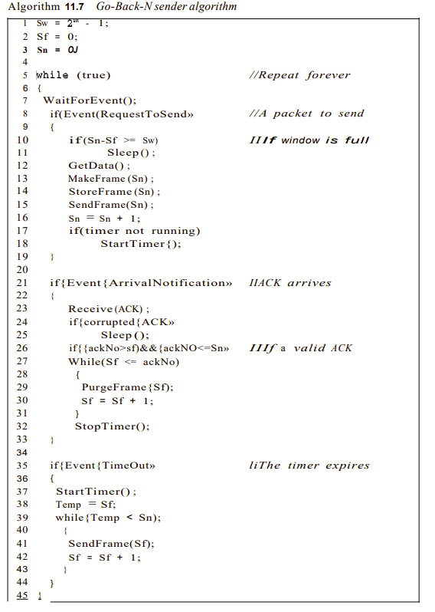

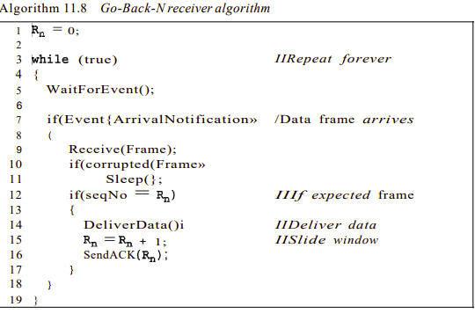

### 41. Selective Repeat Automatic repeat Request

The selective repeat ARQ is like the Go-Back-N ARQ, which lets the user transmit multiple data packets before they receive any acknowledgment from the server side. But, there is a small difference in this mechanism, unlike the Go-Back-N ARQ, which informs the user to retransmit the entire window of packets sent to it, if any one packet is found erroneous. The Selective Repeat ARQ doesn’t inform the user to retransmit the entire window, as it checks each of the packets one by one and if found any error, then it only retransmits only those faulty packages, not the entire window. In this protocol, the client (packet sender) maintains a timer for each window of packets, now after the successful transmission of packets, if the sender doesn’t receive the ACK package in between a certain time, then the sender retransmits those packets only. Now on the receiver side, if the receiver receives the expected packet properly then it sends back an ACK packet to the sender for the next packet. But if there is any error, then the receiver sends a NAK (Negative Acknowledgement) packet to the sender and asks to retransmit that packet only.

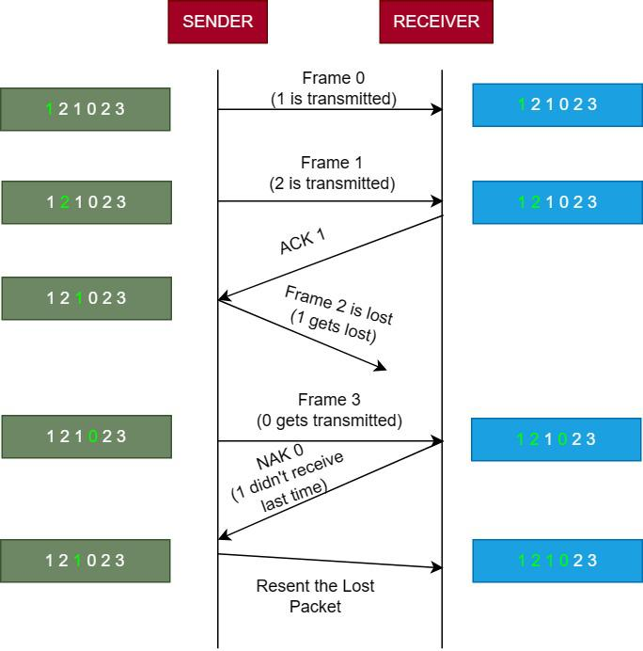

### 42. Piggybacking

The three protocols we discussed in this section are all unidirectional: data frames flow in only one direction although control information such as ACK and NAK frames can travel in the other direction. In real life, data frames are normally flowing in both directions: from node A to node B and from node B to node A. This means that the control information also needs to flow in both directions. A technique called piggybacking is used to improve the efficiency of the bidirectional protocols. When a frame is carrying data from A to B, it can also carry control information about arrived (or lost) frames from B; when a frame is carrying data from B to A, it can also carry control information about the arrived (or lost) frames from A.

We show the design for a Go-Back-N ARQ using piggybacking in Figure . Note that each node now has two windows: one send window and one receive window. Both also need to use a timer. Both are involved in three types of events: request, arrival, and time-out. However, the arrival event here is complicated; when a frame arrives, the site needs to handle control information as well as the frame itself. Both of these concerns must be taken care of in one event, the arrival event. The request event uses only the send window at each site; the arrival event needs to use both windows. An important point about piggybacking is that both sites must use the same algorithm. This algorithm is complicated because it needs to combine two arrival events into one.

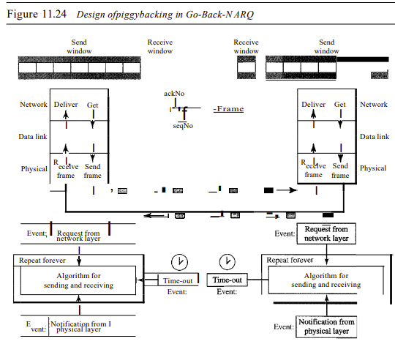

### 43. explain ALOHA protocols

Aloha is a type of Random access protocol it was developed at the University of Hawaii in early 1970, it is a LAN-based protocol this type there are more chances of occurrence of collisions during the transmission of data from any source to the destination, Aloha has two types one **Pure Aloha** and another **Slotted Aloha.**

**Pure Aloha**

Pure Aloha can be termed as the main Aloha or the original Aloha. Whenever any frame is available, each station sends it, and due to the presence of only one channel for communication, it can lead to the chance of collision. In the case of the pure aloha, the user transmits the frame and waits till the receiver acknowledges it, if the receiver does not send the acknowledgment, the sender will assume that it has not been received and the sender resends the acknowledgment.

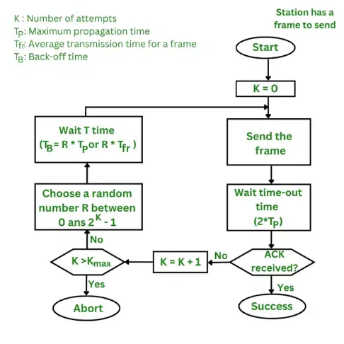

Pure ALOHA vulnerable time = 2 x Tfr

The throughput for pure ALOHA is S =G x e-2G.

The maximum throughput Smax =0.184 when G =(1/2).

**Slotted Aloha**

Slotted Aloha is simply an advanced version of pure Aloha that helps in improving the communication network. A station is required to wait for the beginning of the next slot to transmit. The vulnerable period is halved as opposed to Pure Aloha.Slotted Aloha helps in reducing the number of collisions by properly utilizing the channel and this basically results in the somehow delay of the users. In Slotted Aloha, the channel time is separated into particular time slots.

The throughput for slotted ALOHA is S =: G x e-G.

The maximum throughput Smax == 0.368 when G =1.

Slotted ALOHA vulnerable time = Tfr.

### 44. Carrier Sense Multiple Access (CSMA)

Carrier Sense Multiple Access (CSMA) is a method used in computer networks to manage how devices share a communication channel to transfer the data between two devices. In this protocol, each device first senses the channel before sending the data. If the channel is busy, the device waits until it is free.

This helps reduce collisions, where two devices send data at the same time, ensuring smoother communication across the network. CSMA is commonly used in technologies like Ethernet and Wi-Fi.This method was developed to decrease the chances of collisions when two or more stations start sending their signals over the data link layer. Carrier Sense multiple access requires that each station first check the state of the medium before sending.

**Vulnerable time** is the short period when there’s a chance that two devices on a network might send data at the same time and cause a collision.In networks like Wi-Fi or Ethernet, devices first listen to see if the network is clear before sending their data. However, after a device checks and finds the network free, there’s a small delay before it starts sending data. During this time, another device might also try to send data, which can lead to both data packets crashing into each other (a collision). This period, where a collision might happen, is called the vulnerable time.

Vulnerable time = Propagation time (Tp)

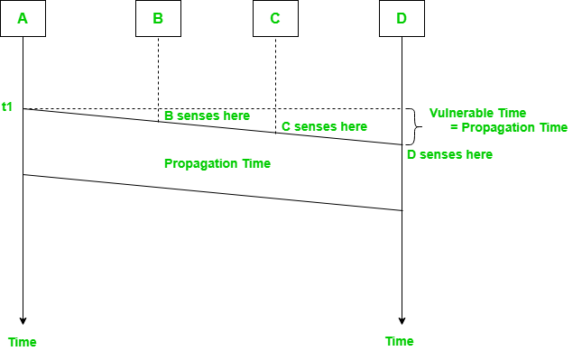

Types of CSMA Protocol: **CSMA/CD** and **CSMA/CA**

### 45. Carrier Sense Multiple Access with Collision Detection (CSMA/CD)

In this method, a station monitors the medium after it sends a frame to see if the transmission was successful. If successful, the transmission is finished, if not, the frame is sent again.

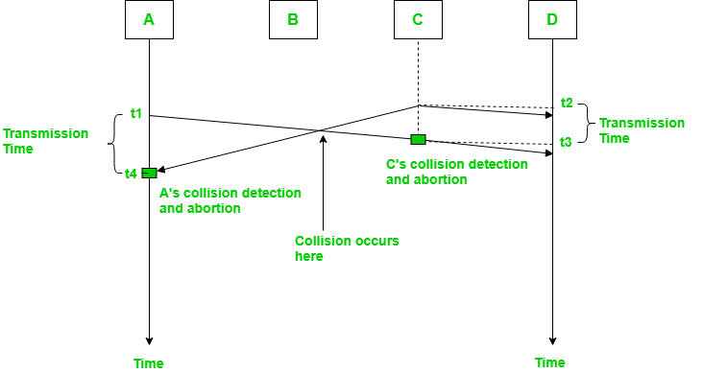

In the diagram, starts sending the first bit of its frame at t1 and since C sees the channel idle at t2, starts sending its frame at t2. C detects A’s frame at t3 and aborts transmission. A detects C’s frame at t4 and aborts its transmission. Transmission time for C’s frame is, therefore, t3-t2 and for A’s frame is t4-t1

So, the frame transmission time (Tfr) should be at least twice the maximum propagation time (Tp). This can be deduced when the two stations involved in a collision are a maximum distance apart.

Process: The entire process of collision detection can be explained as follows:

Throughput and Efficiency: The throughput of CSMA/CD is much greater than pure or slotted ALOHA.

• For the 1-persistent method, throughput is 50% when G=1.

• For the non-persistent method, throughput can go up to 90%.

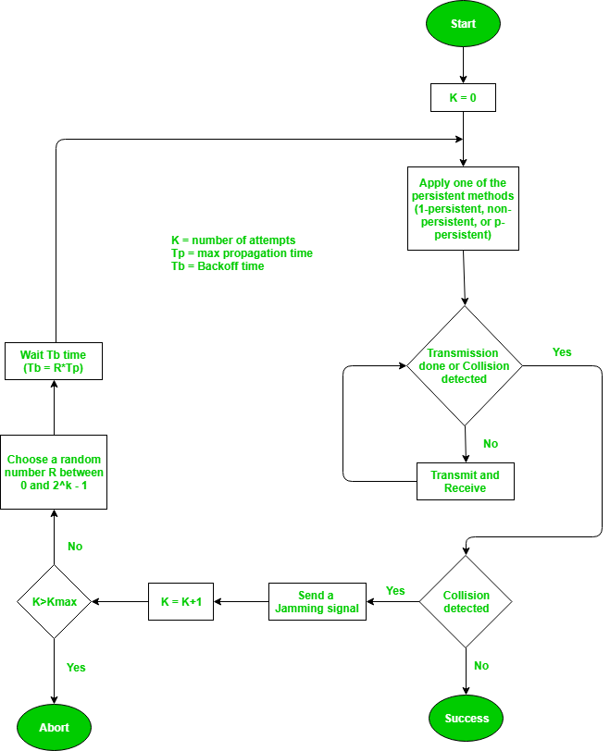

### 46. Carrier Sense Multiple Access with Collision Avoidance (CSMA/CA)

The basic idea behind CSMA/CA is that the station should be able to receive while transmitting to detect a collision from different stations. In wired networks, if a collision has occurred then the energy of the received signal almost doubles, and the station can sense the possibility of collision. In the case of wireless networks, most of the energy is used for transmission, and the energy of the received signal increases by only 5-10% if a collision occurs. It can’t be used by the station to sense collision. Therefore CSMA/CA has been specially designed for wireless networks.

These are three types of strategies:

* **InterFrame Space (IFS):** When a station finds the channel busy it senses the channel again, when the station finds a channel to be idle it waits for a period of time called IFS time. IFS can also be used to define the priority of a station or a frame. Higher the IFS lower is the priority.
* **Contention Window:** It is the amount of time divided into slots. A station that is ready to send frames chooses a random number of slots as wait time.
* Acknowledgments: The positive acknowledgments and time-out timer can help guarantee a successful transmission of the frame.

**Characteristics of CSMA/CA**

* **Carrier Sense:** The device listens to the channel before transmitting, to ensure that it is not currently in use by another device.
* **Multiple Access:** Multiple devices share the same channel and can transmit simultaneously.
* **Collision Avoidance:** If two or more devices attempt to transmit at the same time, a collision occurs. CSMA/CA uses random backoff time intervals to avoid collisions.
* **Acknowledgment (ACK):** After successful transmission, the receiving device sends an ACK to confirm receipt.
* **Fairness:** The protocol ensures that all devices have equal access to the channel and no single device monopolizes it.
* **Binary Exponential Backoff:** If a collision occurs, the device waits for a random period of time before attempting to retransmit. The backoff time increases exponentially with each retransmission attempt.
* **Interframe Spacing:** The protocol requires a minimum amount of time between transmissions to allow the channel to be clear and reduce the likelihood of collisions.
* **RTS/CTS Handshake:** In some implementations, a Request-To-Send (RTS) and Clear-To-Send (CTS) handshake is used to reserve the channel before transmission. This reduces the chance of collisions and increases efficiency.
* **Wireless Network Quality:** The performance of CSMA/CA is greatly influenced by the quality of the wireless network, such as the strength of the signal, interference, and network congestion.
* **Adaptive Behavior:** CSMA/CA can dynamically adjust its behavior in response to changes in network conditions, ensuring the efficient use of the channel and avoiding congestion.

Process: The entire process of collision avoidance can be explained as follows:

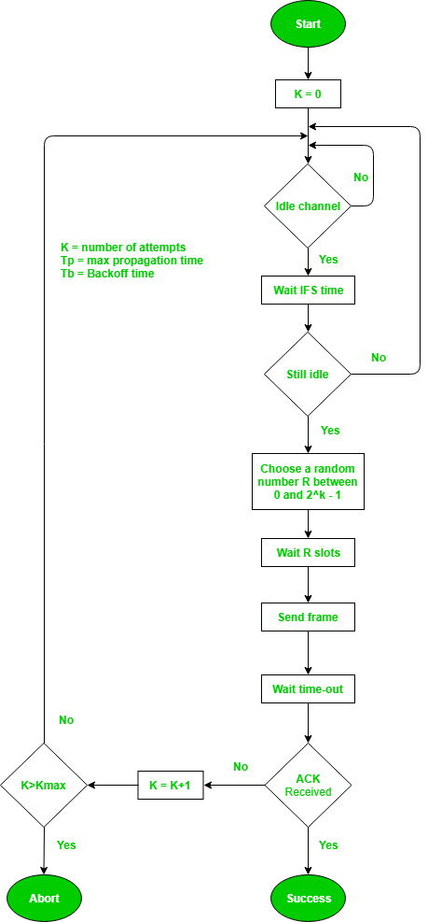

### 47. Reservation Protocol

In controlled access, the stations seek data from one another to find which station has the right to send. It allows only one node to send at a time, to avoid the collision of messages on a shared medium. Reservation is one of the method used in this

**Reservation**

Reservation In the reservation method, a station needs to make a reservation before sending data. Time is divided into intervals. In each interval, a reservation frame precedes the data frames sent in that interval .If there are N stations in the system, there are exactly N reservation minislots in the reservation frame. Each minislot belongs to a station. When a station needs to send a data frame, it makes a reservation in its own minislot. The stations that have made reservations can send their data frames after the reservation frame. The below Figure shows a situation with five stations and a five-minislot reservation frame. In the first interval, only stations 1, 3, and 4 have made reservations. In the second interval, only station 1 has made a reservation.

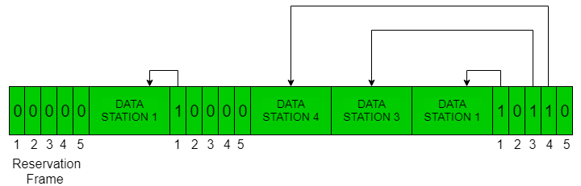

### 48. Polling

Polling process is similar to the roll-call performed in class. Just like the teacher, a controller sends a message to each node in turn.In this, one acts as a primary station(controller) and the others are secondary stations. All data exchanges must be made through the controller.The message sent by the controller contains the address of the node being selected for granting access.Although all nodes receive the message the addressed one responds to it and sends data if any. If there is no data, usually a “poll reject”(NAK) message is sent back.Problems include high overhead of the polling messages and high dependence on the reliability of the controller.

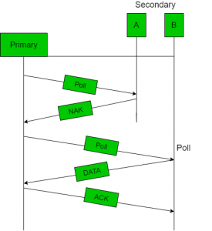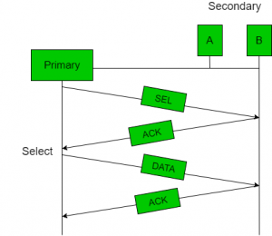

**Advantages of Polling**

* The maximum and minimum access time and data rates on the channel are fixed and predictable.
* It has maximum efficiency and maximum bandwidth and No slot is wasted in polling.

**Disadvantages of Polling**

* It consumes more time.
* Since every station has an equal chance of winning in every round, link sharing is biased.
* Only some stations might run out of data to send.

**Efficiency**

Let Tpoll be the time for polling and Tt be the time required for transmission of data. Then,

Efficiency = Tt/(Tt + Tpoll)

### 49. Token Passing

Token Passing In the token-passing method, the stations in a network are organized in a logical ring. In other words, for each station, there is a predecessor and a successor. The predecessor is the station which is logically before the station in the ring; the successor is the station which is after the station in the ring. The current station is the one that is accessing the channel now. The right to this access has been passed from the predecessor to the current station. The right will be passed to the successor when the current station has no more data to send. But how is the right to access the channel passed from one station to another? In this method, a special packet called a token circulates through the ring. The possession of the token gives the station the right to access the channel and send its data. When a station has some data to send, it waits until it receives the token from its predecessor.

It then holds the token and sends its data. When the station has no more data to send, it releases the token, passing it to the next logical station in the ring. The station cannot send data until it receives the token again in the next round. In this process, when a station receives the token and has no data to send, it just passes the data to the next station. Token management is needed for this access method. Stations must be limited in the time they can have possession of the token. The token must be monitored to ensure it has not been lost or destroyed. For example, if a station that is holding the token fails, the token will disappear from the network. Another function of token management is to assign priorities to the stations and to the types of data being transmitted. And finally, token management is needed to make low-priority stations release the token to high priority stations. performance of token ring can be concluded by 2 parameters:-

**Delay** is a measure of time between when a packet is ready and when it is delivered. So, the average time (delay) required to send a token to the next station = a/N.

**Throughput,** which is a measure of successful traffic.

### 50. Channelization

Channelization is a multiple-access method in which the available bandwidth of a link is shared in time, frequency, or through code, between different stations. In this section, we discuss three channelization protocols: FDMA, TDMA, and CDMA.

**Frequency-Division Multiple Access (FDMA) :** In this, the available bandwidth is divided into frequency bands. Each station is allocated a band to send its data. In other words, each band is reserved for a specific station, and it belongs to the station all the time. Each station also uses a bandpass filter to confine the transmitter frequencies. To prevent station interferences, the allocated bands are separated from one another by small guard bands.

FDMA specifies a predetermined frequency band for the entire period of communication. This means that stream data can easily be used with FDMA. We need to emphasize that although FDMA and FDM conceptually seem similar, there are differences between them. FDM, is a physical layer technique that combines the loads from low-bandwidth channels and transmits them by using a high-bandwidth channel. The channels that are combined are low-pass. The multiplexer modulates the signals, combines them, and creates a bandpass signal. The bandwidth of each channel is shifted by the multiplexer. FDMA, on the other hand, is an access method in the data link layer. The data link layer in each station tells its physical layer to make a bandpass signal from the data passed to it. The signal must be created in the allocated band. There is no physical multiplexer at the physical layer. The signals created at each station are automatically bandpass-filtered. They are mixed when they are sent to the common channel.

**Time-Division Multiple Access (TDMA):** In this, the stations share the bandwidth of the channel in time. Each station is allocated a time slot during which it can send data. Each station transmits its data in its assigned time slot. The main problem with TDMA lies in achieving synchronization between the different stations. Each station needs to know the beginning of its slot and the location of its slot. This may be difficult because of propagation delays introduced in the system if the stations are spread over a large area. To compensate for the delays, we can insert guard times. Synchronization is normally accomplished by having some synchronization bits at the beginning of each slot. In TDMA, the bandwidth is just one channel that is time shared between different stations. TDM, is a physical layer technique that combines the data from slower channels and transmits them by using a faster channel. The process uses a physical multiplexer that interleaves data units from each channel. TDMA, on the other hand, is an access method in the data link layer. The data link layer in each station tells its physical layer to use the allocated time slot. There is no physical multiplexer at the physical layer.

**Code-Division Multiple Access (CDMA):** Recent advances in electronic technology have finally made its implementation possible. CDMA differs from FDMA because only one channel occupies the entire bandwidth of the link. It differs from TDMA because all stations can send data simultaneously; there is no timesharing. In CDMA, one channel carries all transmissions simultaneously.For example, if there are many people in a room all speaking at the same time, then also perfect reception of data is possible if only two people speak the same language. Similarly, data from different stations can be transmitted simultaneously in different code languages.

### 51. Ethernet

Ethernet is the most widely used LAN technology and is defined under IEEE standards 802.3. The reason behind its wide usability is that Ethernet is easy to understand, implement, and maintain, and allows low-cost network implementation. Also, Ethernet offers flexibility in terms of the topologies that are allowed. Ethernet generally uses a bus topology. Ethernet operates in two layers of the OSI model, the physical layer and the data link layer. For Ethernet, the protocol data unit is a frame since we mainly deal with DLLs. In order to handle collisions, the Access control mechanism used in Ethernet is CSMA/CD.

Although Ethernet has been largely replaced by wireless networks, wired networking still uses Ethernet more frequently. Wi-Fi eliminates the need for cables by enabling users to connect their smartphones or laptops to a network wirelessly. The 802.11ac Wi-Fi standard offers faster maximum data transfer rates when compared to Gigabit Ethernet. However, wired connections are more secure and less susceptible to interference than wireless networks. This is the main justification for why so many companies and organizations continue to use Ethernet

**Key Features of Ethernet**

1. **Speed:** Ethernet is capable of transmitting data at high speeds, with current Ethernet standards supporting speeds of up to 100 Gbps.
2. **Flexibility:** Ethernet is a flexible technology that can be used with a wide range of devices and operating systems. It can also be easily scaled to accommodate a growing number of users and devices.
3. **Reliability:** Ethernet is a reliable technology that uses error-correction techniques to ensure that data is transmitted accurately and efficiently.
4. **Cost-effectiveness:** Ethernet is a cost-effective technology that is widely available and easy to implement. It is also relatively low-maintenance, requiring minimal ongoing support.
5. **Interoperability:** Ethernet is an interoperable technology that allows devices from different manufacturers to communicate with each other seamlessly.
6. **Security:** Ethernet includes built-in security features, including encryption and authentication, to protect data from unauthorized access.
7. **Manageability:** Ethernet networks are easily managed, with various tools available to help network administrators monitor and control network traffic.
8. **Compatibility:** Ethernet is compatible with a wide range of other networking technologies, making it easy to integrate with other systems and devices.

### 52. Wireless Local Area Network

**WLAN** stands for **Wireless Local Area Network**. WLAN is a local area network that uses radio communication to provide mobility to the network users while maintaining the connectivity to the wired network. A WLAN basically, extends a wired local area network. WLAN’s are built by attaching a device called the access point(AP) to the edge of the wired network. Clients communicate with the AP using a wireless network adapter which is similar in function to an ethernet adapter. It is also called a LAWN is a Local area wireless network.

The performance of WLAN is high compared to other wireless networks. The coverage of WLAN is within a campus or building or that tech park. It is used in the mobile propagation of wired networks. The standards of WLAN are HiperLAN, Wi-Fi, and IEEE 802.11. It offers service to the desktop laptop, mobile application, and all the devices that work on the Internet. WLAN is an affordable method and can be set up in 24 hours. WLAN gives users the mobility to move around within a local coverage area and still be connected to the network. Most latest brands are based on IEEE 802.11 standards, which are the WI-FI brand name.

A WLAN is a collection of nodes interconnected with each other for the purpose of data sharing, transmitting messages over the internet, connecting for peer-2-peer connection etc. As discussed above in types, it can be created in following 2 ways :-

**1.** Connecting through one base station and that could be the router that acts as a doorway to the internet, and every other node (devices like computer, smartphones) can connect to the internet and to each other through it.

**2.** Peer-2-Peer connection using the wifi direct technology. This is more suitable for situations when we require to connect two or more devices without the internet and only for the purpose of data exchange, connecting over a same local network.

**Characteristics of WLAN**

1. Seamless operation,Low power for battery use.
2. Simple management, easy to use for everyone.
3. Protection of investment in wired networks and Robust transmission technology.

**Advantages of WLAN**

1. Installation speed and simplicity.
2. Installation flexibility.
3. Reduced cost of ownership.
4. Reliability, Mobility, Robustness.

**Disadvantages of WLAN**

1. Slower bandwidth and Less capacity
2. Security for wireless LANs is the prime concern.
3. Wireless devices emit low levels of RF which can be harmful to our health.

### 53. Bluetooth

Bluetooth is a wireless technology that lets devices like phones, tablets, and headphones connect to each other and share information without needing cables. Bluetooth simply follows the principle of transmitting and receiving data using radio waves. It can be paired with the other device which also has Bluetooth but it should be within the estimated communication range to connect. When two devices start to share data, they form a network called piconet which can further accommodate more than five devices.

**Architecture**

Bluetooth defines two types of networks: piconet and scatternet.

**Piconets**

A Bluetooth network is called a piconet, or a small net. A piconet can have up to eight stations, one of which is called the primary;the rest are called secondaries. All the secondary stations synchronize their clocks and hopping sequence with the primary. Note that a piconet can have only one primary station. The communication between the primary and the secondary can be one-to-one or one-to-many. Although a piconet can have a maximum of seven secondaries, an additional eight secondaries can be in the parked state. A secondary in a parked state is synchronized with the primary, but cannot take part in communication until it is moved from the parked state. Because only eight stations can be active in a piconet, activating a station from the parked state means that an active station must go to the parked state.

**Scatternet**

piconets can be combined to form what is called a scatternet. A secondary station in one piconet can be the primary in another piconet. This station can receive messages from the primary in the first piconet (as a secondary) and, acting as a primary, deliver them to secondaries in the second piconet. A station can be a member of two piconets.

**Bluetooth Protocol Stack**

**Radio (RF) Layer:** It specifies the details of the air interface, including frequency, the use of frequency hopping and transmit power. It performs modulation/demodulation of the data into RF signals. It defines the physical characteristics of Bluetooth transceivers. It defines two types of physical links: connection-less and connection-oriented.

**Baseband Link Layer:** The baseband is the digital engine of a Bluetooth system and is equivalent to the MAC sublayer in LANs. It performs the connection establishment within a piconet, addressing, packet format, timing and power control.

**Link Manager Protocol Layer:** It performs the management of the already established links which includes authentication and encryption processes. It is responsible for creating the links, monitoring their health, and terminating them gracefully upon command or failure.

**Logical Link Control and Adoption (L2CAP) Protocol Layer:** It is also known as the heart of the Bluetooth protocol stack. It allows the communication between upper and lower layers of the Bluetooth protocol stack. It packages the data packets received from upper layers into the form expected by lower layers. It also performs segmentation and multiplexing.

**Service Discovery Protocol (SDP) Layer:** It is short for Service Discovery Protocol. It allows discovering the services available on another Bluetooth-enabled device.

**RF Comm Layer:** It is a cabal replacement protocol. It is short for Radio Frontend Component. It provides a serial interface with WAP and OBEX. It also provides emulation of serial ports over the logical link control and adaptation protocol(L2CAP). The protocol is based on the ETSI standard TS 07.10.

**OBEX:** It is short for Object Exchange. It is a communication protocol to exchange objects between 2 devices.

**WAP:** It is short for Wireless Access Protocol. It is used for internet access.

**TCS:** It is short for Telephony Control Protocol. It provides telephony service. The basic

function of this layer is call control (setup & release) and group management for the gateway serving multiple devices.

**Application Layer:** It enables the user to interact with the application.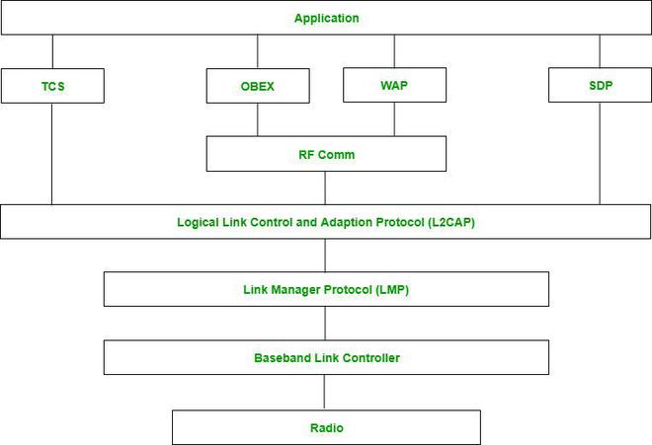

### 54. Cellular telephony

It is designed to provide communications between two moving units, called mobile stations (MSs), or between one mobile unit and one stationary unit, often called a land unit. A service provider must be able to locate and track a caller, assign a channel to the call, and transfer the channel from base station to base station as the caller moves out of range. To make this tracking possible, each cellular service area is divided into small regions called cells. Each cell contains an antenna and is controlled by a solar or AC powered network station, called the base station (BS).

Each base station, in tum, is controlled by a switching office, called a mobile switching center (MSC). The MSC coordinates communication between all the base stations and the telephone central office. It is a computerized center that is responsible for connecting calls, recording call information, and billing (see Figure 16.1). Cell size is not fixed and can be increased or decreased depending on the population of the area. The typical radius of a cell is 1 to 12 mi. High-density areas require more, geographically smaller cells to meet traffic demands than do low-density areas. Once determined, cell size is optimized to prevent the interference of adjacent cell signals. The transmission power of each cell is kept low to prevent its signal from interfering with those of other cells

### 55. Different connecting devices

Network Devices: Network devices, also known as networking hardware, are physical devices that allow hardware on a computer network to communicate and interact with one another. For example **Repeater, Hub, Bridge, Switch, Routers, Gateway,etc.**

**1- Repeater –** A repeater operates at the physical layer. Its job is to amplify (i.e., regenerates) the signal over the same network before the signal becomes too weak or corrupted to extend the length to which the signal can be transmitted over the same network. When the signal becomes weak, they copy it bit by bit and regenerate it at its star topology connectors connecting following the original strength. It is a 2-port device.

**2-Hub –**  A hub is a basically multi-port repeater. A hub connects multiple wires coming from different branches, for example, the connector in star topology which connects different stations. Hubs cannot filter data, so data packets are sent to all connected devices. Also, they do not have the intelligence to find out the best path for data packets which leads to inefficiencies and wastage.

**Types of Hub**

* **Active Hub:-** These are the hubs that have their power supply and can clean, boost, and relay the signal along with the network. It serves both as a repeater as well as a wiring center. These are used to extend the maximum distance between nodes.
* **Passive Hub:-** These are the hubs that collect wiring from nodes and power supply from the active hub. These hubs relay signals onto the network without cleaning and boosting them and can’t be used to extend the distance between nodes.

**3-Bridge –** A bridge operates at the data link layer. A bridge is a repeater, with add on the functionality of filtering content by reading the MAC addresses of the source and destination. It is also used for interconnecting two LANs working on the same protocol. It has a single input and single output port, thus making it a 2 port device.

**Types of Bridges**

* **Transparent Bridges:-** These are the bridges in which the stations are completely unaware of the bridge’s existence i.e. whether or not a bridge is added or deleted from the network, reconfiguration of the stations is unnecessary. These bridges make use of two processes i.e. bridge forwarding and bridge learning.
* **Source Routing Bridges:-** In these bridges, routing operation is performed by the source station and the frame specifies which route to follow. The host can discover the frame by sending a special frame called the discovery frame, which spreads through the entire network using all possible paths to the destination.

**4-Switch –** A switch is a multiport bridge with a buffer and a design that can boost its efficiency(a large number of ports imply less traffic) and performance. A switch is a data link layer device. The switch can perform error checking before forwarding data, which makes it very efficient as it does not forward packets that have errors and forward good packets selectively to the correct port only. In other words, the switch divides the collision domain of hosts, but the broadcast domain remains the same.

**Types of Switches:** Unmanaged switches, Managed switches, Smart switches, Layer 2 and 3 switches, PoE switches, Gigabit switches, Modular switches.

**5-Routers –** A router is a device like a switch that routes data packets based on their IP addresses. The router is mainly a Network Layer device. Routers normally connect LANs and WANs and have a dynamically updating routing table based on which they make decisions on routing the data packets. The router divides the broadcast domains of hosts connected through it.

**6-Gateway –** A gateway, as the name suggests, is a passage to connect two networks that may work upon different networking models. They work as messenger agents that take data from one system, interpret it, and transfer it to another system. Gateways are also called protocol converters and can operate at any network layer. Gateways are generally more complex than switches or routers.

## 15 Mark Questions

### 56. Explain functionalities of data link layer

The data link layer is the second layer from the bottom in the OSI (Open System Interconnection) network architecture model. It is responsible for the node-to-node delivery of data. Its major role is to ensure error-free transmission of information. DLL is also responsible for encoding, decoding, and organizing the outgoing and incoming data.This is considered the most complex layer of the OSI model as it hides all the underlying complexities of the hardware from the other layers above.

**Sub-Layers of The Data Link Layer:** Logical Link Control (LLC) and Media Access Control (MAC)

**Functions of The Data-link Layer:**

**Framing**

Framing in the data link layer separates a message from one source to a destination, or from other messages to other destinations, by adding a sender address and a destination address. The destination address defines where the packet is to go; the sender address helps the recipient acknowledge the receipt. Although the whole message could be packed in one frame, that is not normally done. One reason is that a frame can be very large, making flow and error control very inefficient. When a message is carried in one very large frame, even a single-bit error would require the retransmission of the whole message. When a message is divided into smaller frames, a single-bit error affects only that small frame.

There are two types of framing: **fixed size** and **variable size framing.**

**Fixed-Size Framing:** Frames can be of fixed or variable size. In fixed-size framing, there is no need for defining the boundaries of the frames; the size itself can be used as a delimiter. Example: ATM wide-area network.

**Variable-Size Framing:** Our main discussion in this chapter concerns variable-size framing, prevalent in local area networks. In variable-size framing, we need a way to define the end of the frame and the beginning of the next.two approaches were used for this purpose: a character-oriented approach and a bit-oriented approach.

**1.Character/Byte Stuffing:** Used when frames consist of characters. If data contains ED then, a byte is stuffed into data to differentiate it from ED.

Let ED = “$” –> if data contains ‘$’ anywhere, it can be escaped using ‘\O’ character.

–> if data contains ‘\O$’ then, use ‘\O\O\O$'($ is escaped using \O and \O is escaped using \O).



**Disadvantage** – It is a very costly and obsolete method.

**2. Bit Stuffing:** Let ED = 01111 and if data = 01111

* Sender stuffs a bit to break the pattern i.e. here appends a 0 in data = 011101.
* Receiver receives the frame.
* If data contains 011101, the receiver removes the 0 and reads the data.



**Addressing**

The data link layer encapsulates the source and destination’s MAC address/ physical address in the header of each frame to ensure node-to-node delivery. MAC address is the unique hardware address that is assigned to the device while manufacturing.

**Error Control**

Data-link layer uses the techniques of error control simply to ensure and confirm that all the data frames or packets, i.e. bit streams of data, are transmitted or transferred from sender to receiver with certain accuracy. Using or providing error control at this data link layer is an optimization, it was never a requirement. It is basically a process in the data link layer of detecting or identifying and re-transmitting data frames that might be lost or corrupted during transmission. In both of these cases, the receiver or destination does not receive the correct data frame and sender or source does not even know anything about any such loss regarding data frames. Therefore, in such types of cases, both sender and receiver are provided with some essential protocols that are required to detect or identify such types of errors as loss of data frames. The Data-link layer follows a technique known as re-transmission of frames to detect or identify transit errors and also to take necessary actions that are required to reduce or remove such errors. Each and every time an error is detected during transmission, particular data frames are retransmitted and this process is known as ARQ (Automatic Repeat Request).

Ways of doing Error Control : There are basically two ways of doing Error control as given below :

**1. Error Detection :** Error detection, as the name suggests, simply means detection or identification of errors. These errors may occur due to noise or any other impairments during transmission from transmitter to the receiver, in the communication system. It is a class of techniques for detecting garbled i.e. unclear and distorted data or messages.

**Error Detection Methods**

To detect errors, a common technique is to introduce redundancy bits that provide additional information. Various techniques for error detection include:

**1- Simple Parity Check**

**2- Two-Dimensional Parity Check**

**3- Checksum**

**4- Cyclic Redundancy Check (CRC)**

**1- Simple Parity Check**

Simple-bit parity is a simple error detection method that involves adding an extra bit to a data transmission. It works as:

• 1 is added to the block if it contains an odd number of 1’s, and

• 0 is added if it contains an even number of 1’s

This scheme makes the total number of 1’s even, that is why it is called even parity checking.

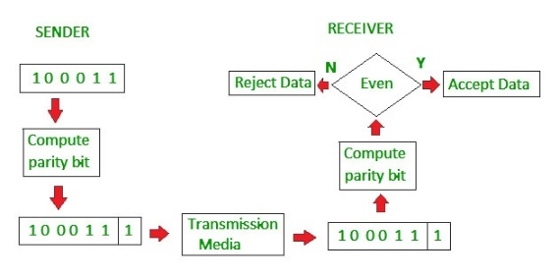

**Advantages of Simple Parity Check**

* Simple parity check can detect all single bit error.
* Simple parity check can detect an odd number of errors.
* **Implementation:** Simple Parity Check is easy to implement in both hardware and software.
* **Minimal Extra Data:** Only one additional bit (the parity bit) is added per data unit (e.g., per byte).
* **Fast Error Detection:** The process of calculating and checking the parity bit is quick, which allows for rapid error detection without significant delay in data processing or communication.
* **Single-Bit Error Detection:** It can effectively detect single-bit errors within a data unit, providing a basic level of error detection for relatively low-error environments.
* Disadvantages of Simple Parity Check
* Single Parity check is not able to detect even no. of bit error.
* For example, the Data to be transmitted is 101010. Codeword transmitted to the receiver is 1010101 (we have used even parity).

Let’s assume that during transmission, two of the bits of code word flipped to 1111101.

On receiving the code word, the receiver finds the no. of ones to be even and hence no error, which is a wrong assumption.

**2- Two-Dimensional Parity Check**

Two-dimensional Parity check bits are calculated for each row, which is equivalent to a simple parity check bit. Parity check bits are also calculated for all columns, then both are sent along with the data. At the receiving end, these are compared with the parity bits calculated on the received data.

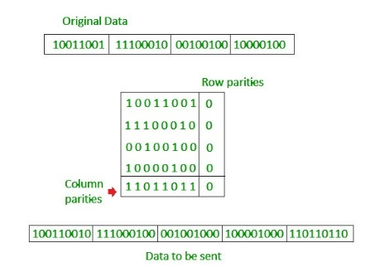

**Advantages of Two-Dimensional Parity Check**

* Two-Dimensional Parity Check can detect and correct all single bit errors.
* Two-Dimensional Parity Check can detect two or three bit errors that occur anywhere in the matrix.

**Disadvantages of Two-Dimensional Parity Check**

* Two-Dimensional Parity Check can not correct two or three bit errors. It can only detect two or three bit errors.
* If we have an error in the parity bit then this scheme will not work.

**3- Checksum**

Checksum error detection is a method used to identify errors in transmitted data. The process involves dividing the data into equally sized segments and using a 1’s complement to calculate the sum of these segments. The calculated sum is then sent along with the data to the receiver. At the receiver’s end, the same process is repeated and if all zeroes are obtained in the sum, it means that the data is correct.

**Checksum – Operation at Sender’s Side**

* Firstly, the data is divided into k segments each of m bits.
* On the sender’s end, the segments are added using 1’s complement arithmetic to get the sum. The sum is complemented to get the checksum.
* The checksum segment is sent along with the data segments.

**Checksum – Operation at Receiver’s Side**

* At the receiver’s end, all received segments are added using 1’s complement arithmetic to get the sum. The sum is complemented.
* If the result is zero, the received data is accepted; otherwise discarded.

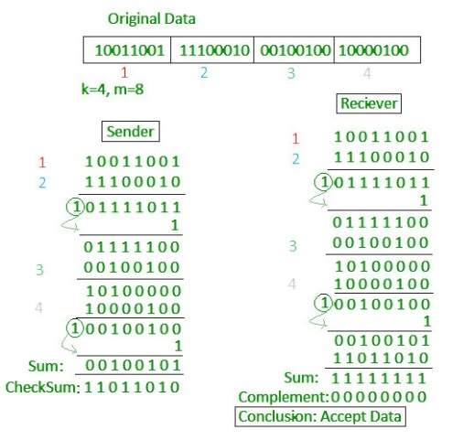

**4- Cyclic Redundancy Check (CRC)**

* Unlike the checksum scheme, which is based on addition, CRC is based on binary division.
* In CRC, a sequence of redundant bits, called cyclic redundancy check bits, are appended to the end of the data unit so that the resulting data unit becomes exactly divisible by a second, predetermined binary number.
* At the destination, the incoming data unit is divided by the same number. If at this step there is no remainder, the data unit is assumed to be correct and is therefore accepted.
* A remainder indicates that the data unit has been damaged in transit and therefore must be rejected.

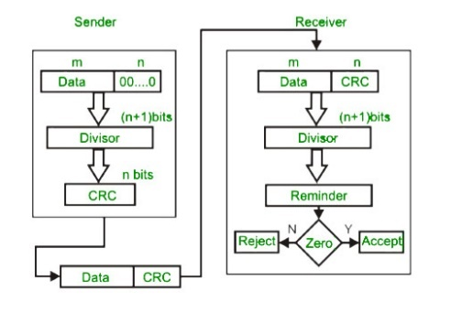

**CRC Working**

We have given a dataword of length n and divisor of length k.

**Step 1:** Append (k-1) zero’s to the original message

**Step 2:** Perform modulo 2 division

**Step 3:** Remainder of division = CRC

**Step 4:** Code word = Data with append k-1 zero’s + CRC

***Note:***

***• CRC must be k-1 bits***

***• Length of Code word = n+k-1 bits***

Example: Let’s data to be sent is 1010000 and the divisor in the form of a polynomial is x3+1. CRC method discussed below.

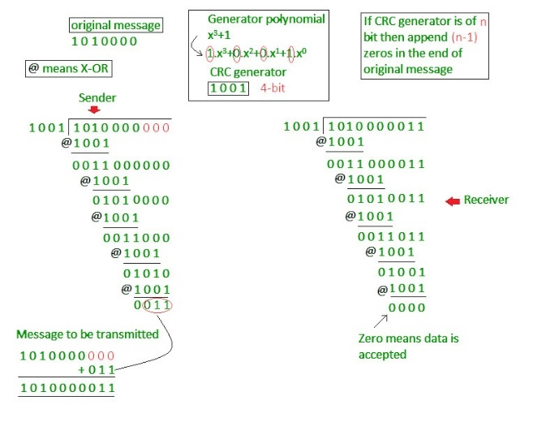

Example: Previous year GATE questions based on error detection: [GATE CS 2009 Question 48](https://www.geeksforgeeks.org/questions/gate-gate-cs-2009-question-48/) [GATE CS 2007 Question 68.](https://www.geeksforgeeks.org/questions/gate-gate-cs-2007-question-68/)

**Advantages of Error Detection**

* Increased Data Reliability: Error detection ensures that the data transmitted over the network is reliable, accurate, and free from errors. This ensures that the recipient receives the same data that was transmitted by the sender.
* Improved Network Performance: Error detection mechanisms can help to identify and isolate network issues that are causing errors. This can help to improve the overall performance of the network and reduce downtime
* Enhanced Data Security: Error detection can also help to ensure that the data transmitted over the network is secure and has not been tampered with.
* Overhead: Error detection requires additional resources and processing power, which can lead to increased overhead on the network. This can result in slower network performance and increased latency.
* False Positives: Error detection mechanisms can sometimes generate false positives, which can result in unnecessary retransmission of data. This can further increase the overhead on the network.
* Limited Error Correction: Error detection can only identify errors but cannot correct them. This means that the recipient must rely on the sender to retransmit the data, which can lead to further delays and increased network overhead.

**2. Error Correction :** Once the errors are detected in the network, the deviated bits sequence needs to be replaced with the right bit sequence so that the receiver can accept the data and process it. This method is called Error Correction. We can correct the errors in the Network in two different ways which are listed below:

**Forward Error Correction:** In this Error Correction Scenario, the receiving end is responsible for correcting the network error. There is no need for retransmission of the data from the sender’s side.

**In Backward Error Correction,** the sender is responsible for retransmitting the data if errors are detected by the receiver. The receiver signals the sender to resend the corrupted data or the entire message to ensure accurate delivery.

However, there is one of the most widely used Error Correction methods which is called ‘Hamming Code’ which was designed by R.W.Hamming. Let us have a quick look at it.

**Hamming Code Error Correction**

In this method, extra parity bits are appended to the message which are used by the receiver to correct the single bit error and multiple bit error. Consider the below example to understand this method in a better way.

Suppose the sender wants to transmit the message whose bit representation is ‘1011001.’ In this message:

Total number of bits(d) = 7

Total of redundant bits(r) = 4 (This is because the message has four 1’s in it)

Thus, total bits(d+r) = 7 + 4 = 11

Also, by convention, the redundant bits are always placed in the places which are powers of Now, this message will take the format as shown below:

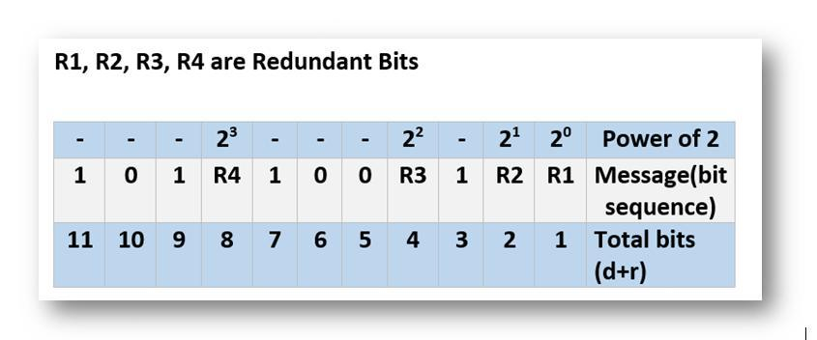

Therefore, we have R1, R2, R3, and R4 as redundant bits which will be calculated according to the following rules:

R1 includes all the positions whose binary representation has 1 in their least significant bit. Thus, R1 covers positions 1, 3, 5, 7, 9, 11.

R2 includes all the positions whose binary representation has 1 in the second position from the least significant bit. Thus, R2 covers positions 2,3,6,7,10,11.

R3 includes all the positions whose binary representation has 1 in the third position from the least significant bit. Hence, R3 covers positions 4, 5, 6, 7.

R4 includes all the positions whose binary representation has 1 in the fourth position from the least significant bit due to which R4 covers positions 8,9,10,11.

These rules are illustrated below:

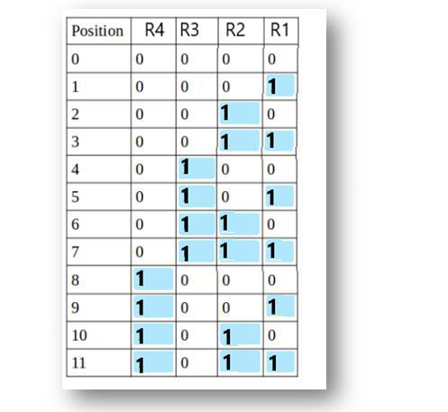

Now, we calculate the value of R1, R2, R3 and R4 as follows:

Since the total number of 1s in all the bit positions corresponding to R1 is an even number. R1 = 0.

Since the total number of 1s in all the bit positions corresponding to R2 is an odd number, R2= 1.

Since the total number of 1s in all the bit positions corresponding to R3 is an odd number, R3= 1.

Since the total number of 1s in all the bit positions corresponding to R4 is even, R4 = 0.

Therefore, the message to be transmitted becomes:

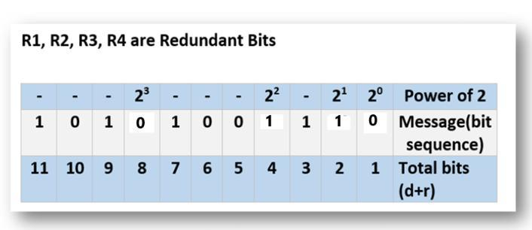

This message is transmitted at the receiver’s end. Suppose, bit 6 becomes corrupted and changes to 0. Then, the message becomes ‘10101101110.’ So, at the receiver’s end, the number of 1’s in the respective bit positions of R1, R2, R3, and R4 is rechecked to correct the corrupted bit. This is done in the following steps: For all the parity bits we will check the

For R1: bits 1, 3, 5, 7, 9, and 11 are checked. We can see that the number of 1’s in these bit positions is 4(even) so R1 = 0.

For R2: bits 2,3,6,7,10,11 are checked. You can observe that the number of 1’s in these bit positions is 5(odd) so we get a R2 = 1.

For R3: bits 4, 5, 6, and 7 are checked. We see that the number of 1’s in these bit positions is 3(odd). Hence, R3 = 1.

For R8: bits 8,9,10,11 are observed. Here, the number of 1’s in these bit positions is 2 and that’s even so we get R4 = 0.

If we observe the Redundant bits, they give the binary number 0110 whose decimal representation is 6. Thus, bit 6 contains an error. To correct the error the 6th bit is changed from 1 to 0 to correct the error.

**Flow Control**

If the receiver’s receiving speed is lower than the sender’s sending speed, then this can lead to an overflow in the receiver’s buffer and some frames may get lost. So, it’s the responsibility of DLL to synchronize the sender’s and receiver’s speeds and establish flow control between them.

Techniques of Flow Control in Data Link Layer : There are basically two types of techniques being developed to control the flow of data

**1-Stop-and-Wait Flow Control :**

This method is the easiest and simplest form of flow control. In this method, basically a message or data is broken down into various multiple frames, and then the receiver indicates its readiness to receive a frame of data. When acknowledgement is received, then only the sender will send or transfer the next frame. This process is continued until the sender transmits the EOT (End of Transmission) frame. In this method, only one of the frames can be in transmission at a time. It leads to inefficiency i.e. less productivity if propagation delay is very much longer than the transmission delay and Ultimately In this method sender sent a single frame and receiver took one frame at a time and sent acknowledgement(which is next frame number only) for new frame.

**2-Sliding Window Flow Control :**

This method is required where reliable in-order delivery of packets or frames is very much needed like in the data link layer. It is a point to point protocol that assumes that none of the other entities tries to communicate until current data or frame transfer gets completed. In this method, the sender transmits or sends various frames or packets before receiving any acknowledgement. In this method, both the sender and receiver agree upon the total number of data frames after which acknowledgement is needed to be transmitted. Data Link Layer requires and uses this method that simply allows sender to have more than one unacknowledged packet “in-flight” at a time. This increases and improves network throughput. and Ultimately In this method sender sends multiple frames but receivers take one by one and after completing one frame acknowledge(which is next frame number only) for new frames.

**Simplest Protocol**

**Noiseless Channel :**An idealistic channel in which no frames are lost, corrupted or duplicated. The protocol does not implement error control in this category. There are two protocols for the noiseless channel as follows.

**Simplest Protocol :**We consider here that the receiver can maintain any frame received with insignificant processing time. The receiver’s data link layer immediately removes the header from the frame and assigns the data packet to its network layer, which can also accept the packet immediately. That is to say, the receiver can never be overwhelmed with forthcoming frames.

**Design :** The data link layer at the sender site gets data from its network layer, makes a frame out of the data, and sends it. The data link layer(receiver site) receives a frame from its physical layer, extracts data from the frame, and conveys the data to its network layer. The data link layers of the sender and receiver provide communication/transmission services for their network layers. The data link layers utilize the services provided by their physical layers for the physical transmission of bits.



**Sender-site algorithm :**

| **while(true) //Repeat forever {   waitForEvent(); //sleep until an event occur  if (Event(RequestToSend)) //there is a packet to send  {  GetData();  MakeFrame();  SendFrame(); //send the frame  } }** |
| --- |

**Receivers algorithm :**

| while(true) //Repeat forever {   waitForEvent(); //sleep until an event occur  if (Event(ArrivalNotification)) //data frame arrived  {  ReceiveFrame();  ExtractData();  DeliverData(); //Deliver data to network layer  } } |
| --- |

**Flow Diagram :**



**Stop and Wait Protocol**

In the Stop and Wait protocol, the sender sends one frame at a time and waits for an acknowledgment (ACK) from the receiver before sending the next frame. This method ensures that the receiver successfully receives and processes each frame, making it reliable for data transmission but slower due to idle time while waiting for ACKs.



**Flow Diagram :**

This figure shows an example of communication using the Stop-and-wait protocol. It is still straightforward. The sender sends a frame and waits for a response from the receiver. When ACK(acknowledged) will arrive from the receiver side then send the next frame and so on. Keep it in mind when two frames will be there the sender will be involved in four events and the receivers will be involved in two events.



**Stop and Wait ARQ (Automatic Repeat Request)**

Stop-and-Wait Automatic Repeat Request(ARQ) is a common type of error control protocol widely used in computer networks to ensure reliable data transmission. This protocol works by transmitting a single data packet and waiting for an acknowledgement before sending the next packet. In this ARQ protocol, the sender sends a data packet to the receiver and waits for an acknowledgement from the receiver side. The receiver after receiving the packet, sends an acknowledgement back to the sender indicating that the packet has been successfully received. If the sender does not receive an acknowledgement from the receiver side within a specified time frame then the sender retransmits the packet. So, this protocol is called “stop-and-wait” because the sender must wait for the acknowledgement before sending the next packet. Roe that reason the protocol became relatively slow, as it does not allow for pipelining or sending multiple packets at once. This protocol is commonly used in such situations where data loss is not frequent or where the cost of retransmitting a lost packet is low.







**Go-Back-N Automatic Repeat Request**

Go-Back-N Automatic Repeat Request(ARQ) is also an error control protocol used in computer networks to ensure reliable data transmission. It this protocol the sender is allowed to transmit multiple packets before waiting for an acknowledgement which improves the efficiency of data transmission. In this protocol the sender sends multiple numbers of packets to the receiver without waiting for an acknowledgement for each packet. The receiver receives the data packets and sends an acknowledgement for the last correctly received packet only. If the sender does not receive an acknowledgement from the receiver end within a specified time frame then sender retransmits all packets starting from the last unacknowledged packet. So, this protocol is called “go-back-n” because the sender must go back and retransmit all the packets that were not acknowledged. This means that if a single packet is lost then all the subsequent packets must be retransmitted and this can lead to inefficient use of network resources. This protocol is commonly used in situations where data loss is moderate and network resources are not limited.





**Selective Repeat Automatic repeat Request –**

The selective repeat ARQ is like the Go-Back-N ARQ, which lets the user transmit multiple data packets before they receive any acknowledgment from the server side. But, there is a small difference in this mechanism, unlike the Go-Back-N ARQ, which informs the user to retransmit the entire window of packets sent to it, if any one packet is found erroneous. The Selective Repeat ARQ doesn’t inform the user to retransmit the entire window, as it checks each of the packets one by one and if found any error, then it only retransmits only those faulty packages, not the entire window. In this protocol, the client (packet sender) maintains a timer for each window of packets, now after the successful transmission of packets, if the sender doesn’t receive the ACK package in between a certain time, then the sender retransmits those packets only. Now on the receiver side, if the receiver receives the expected packet properly then it sends back an ACK packet to the sender for the next packet. But if there is any error, then the receiver sends a NAK (Negative Acknowledgement) packet to the sender and asks to retransmit that packet only.



**Access Control**

When multiple devices share the same communication channel there is a high probability of collision, so it’s the responsibility of DLL to check which device has control over the channel and CSMA/CD and CSMA/CA can be used to avoid collisions and loss of frames in the channel. Access Control is a method of limiting access to a system or resources. Access control refers to the process of determining who has access to what resources within a network and under what conditions. It is a fundamental concept in security that reduces risk to the business or organization. Access control systems perform identification, authentication, and authorization of users and entities by evaluating required login credentials that may include passwords, pins, biometric scans, or other authentication factors. Multi-factor authentication requires two or more authentication factors, which is often an important part of the layered defense to protect access control systems.

### 57. Explain ALOHA protocols

Aloha is a type of Random access protocol it was developed at the University of Hawaii in early 1970, it is a LAN-based protocol this type there are more chances of occurrence of collisions during the transmission of data from any source to the destination, Aloha has two types one Pure Aloha and another Slotted Aloha.

**Pure Aloha**

Pure Aloha can be termed as the main Aloha or the original Aloha. Whenever any frame is available, each station sends it, and due to the presence of only one channel for communication, it can lead to the chance of collision. In the case of the pure aloha, the user transmits the frame and waits till the receiver acknowledges it, if the receiver does not send the acknowledgment, the sender will assume that it has not been received and the sender resends the acknowledgment.



Pure ALOHA vulnerable time = 2 x Tfr

The throughput for pure ALOHA is S =G x e-2G.

The maximum throughput Smax =0.184 when G =(1/2).

**Slotted Aloha**

Slotted Aloha is simply an advanced version of pure Aloha that helps in improving the communication network. A station is required to wait for the beginning of the next slot to transmit. The vulnerable period is halved as opposed to Pure Aloha.Slotted Aloha helps in reducing the number of collisions by properly utilizing the channel and this basically results in the somehow delay of the users. In Slotted Aloha, the channel time is separated into particular time slots.

The throughput for slotted ALOHA is S =: G x e-G.

The maximum throughput Smax == 0.368 when G =1.

Slotted ALOHA vulnerable time = Tfr.

**Carrier Sense Multiple Access (CSMA)**

Carrier Sense Multiple Access (CSMA) is a method used in computer networks to manage how devices share a communication channel to transfer the data between two devices. In this protocol, each device first senses the channel before sending the data. If the channel is busy, the device waits until it is free. This helps reduce collisions, where two devices send data at the same time, ensuring smoother communication across the network. CSMA is commonly used in technologies like Ethernet and Wi-Fi.This method was developed to decrease the chances of collisions when two or more stations start sending their signals over the data link layer. Carrier Sense multiple access requires that each station first check the state of the medium before sending.

**Vulnerable time** is the short period when there’s a chance that two devices on a network might send data at the same time and cause a collision.In networks like Wi-Fi or Ethernet, devices first listen to see if the network is clear before sending their data. However, after a device checks and finds the network free, there’s a small delay before it starts sending data. During this time, another device might also try to send data, which can lead to both data packets crashing into each other (a collision). This period, where a collision might happen, is called the vulnerable time.

**Vulnerable time = Propagation time (Tp)**



Types of CSMA Protocol: **CSMA/CD** and **CSMA/CA**

**Carrier Sense Multiple Access with Collision Detection (CSMA/CD)**

In this method, a station monitors the medium after it sends a frame to see if the transmission was successful. If successful, the transmission is finished, if not, the frame is sent again.



In the diagram, starts sending the first bit of its frame at t1 and since C sees the channel idle at t2, starts sending its frame at t2. C detects A’s frame at t3 and aborts transmission. A detects C’s frame at t4 and aborts its transmission. Transmission time for C’s frame is, therefore, t3-t2 and for A’s frame is t4-t1

So, the frame transmission time (Tfr) should be at least twice the maximum propagation time (Tp). This can be deduced when the two stations involved in a collision are a maximum distance apart.

Process: The entire process of collision detection can be explained as follows:

Throughput and Efficiency: The throughput of CSMA/CD is much greater than pure or slotted ALOHA.

• For the 1-persistent method, throughput is 50% when G=1.

• For the non-persistent method, throughput can go up to 90%.



**Carrier Sense Multiple Access with Collision Avoidance (CSMA/CA)**

The basic idea behind CSMA/CA is that the station should be able to receive while transmitting to detect a collision from different stations. In wired networks, if a collision has occurred then the energy of the received signal almost doubles, and the station can sense the possibility of collision. In the case of wireless networks, most of the energy is used for transmission, and the energy of the received signal increases by only 5-10% if a collision occurs. It can’t be used by the station to sense collision. Therefore CSMA/CA has been specially designed for wireless networks.

These are three types of strategies:

* InterFrame Space (IFS): When a station finds the channel busy it senses the channel again, when the station finds a channel to be idle it waits for a period of time called IFS time. IFS can also be used to define the priority of a station or a frame. Higher the IFS lower is the priority.
* Contention Window: It is the amount of time divided into slots. A station that is ready to send frames chooses a random number of slots as wait time.
* Acknowledgments: The positive acknowledgments and time-out timer can help guarantee a successful transmission of the frame.

**Characteristics of CSMA/CA**

* **Carrier Sense:** The device listens to the channel before transmitting, to ensure that it is not currently in use by another device.
* **Multiple Access:** Multiple devices share the same channel and can transmit simultaneously.
* **Collision Avoidance:** If two or more devices attempt to transmit at the same time, a collision occurs. CSMA/CA uses random backoff time intervals to avoid collisions.
* **Acknowledgment (ACK):** After successful transmission, the receiving device sends an ACK to confirm receipt.
* **Fairness:** The protocol ensures that all devices have equal access to the channel and no single device monopolizes it.
* **Binary Exponential Backoff:** If a collision occurs, the device waits for a random period of time before attempting to retransmit. The backoff time increases exponentially with each retransmission attempt.
* **Interframe Spacing:** The protocol requires a minimum amount of time between transmissions to allow the channel to be clear and reduce the likelihood of collisions.
* **RTS/CTS Handshake:** In some implementations, a Request-To-Send (RTS) and Clear-To-Send (CTS) handshake is used to reserve the channel before transmission. This reduces the chance of collisions and increases efficiency.
* **Wireless Network Quality:** The performance of CSMA/CA is greatly influenced by the quality of the wireless network, such as the strength of the signal, interference, and network congestion.
* **Adaptive Behavior:** CSMA/CA can dynamically adjust its behavior in response to changes in network conditions, ensuring the efficient use of the channel and avoiding congestion.

Process: The entire process of collision avoidance can be explained as follows:



**Reservation Protocol**

In controlled access, the stations seek data from one another to find which station has the right to send. It allows only one node to send at a time, to avoid the collision of messages on a shared medium. Reservation is one of the method used in this

**Reservation**

Reservation In the reservation method, a station needs to make a reservation before sending data. Time is divided into intervals. In each interval, a reservation frame precedes the data frames sent in that interval .If there are N stations in the system, there are exactly N reservation minislots in the reservation frame. Each minislot belongs to a station. When a station needs to send a data frame, it makes a reservation in its own minislot. The stations that have made reservations can send their data frames after the reservation frame. The below Figure shows a situation with five stations and a five-minislot reservation frame. In the first interval, only stations 1, 3, and 4 have made reservations. In the second interval, only station 1 has made a reservation.



**Polling**

Polling process is similar to the roll-call performed in class. Just like the teacher, a controller sends a message to each node in turn.In this, one acts as a primary station(controller) and the others are secondary stations. All data exchanges must be made through the controller.The message sent by the controller contains the address of the node being selected for granting access.Although all nodes receive the message the addressed one responds to it and sends data if any. If there is no data, usually a “poll reject”(NAK) message is sent back.Problems include high overhead of the polling messages and high dependence on the reliability of the controller.



**Advantages of Polling**

* The maximum and minimum access time and data rates on the channel are fixed and predictable.
* It has maximum efficiency and maximum bandwidth and No slot is wasted in polling.

**Disadvantages of Polling**

* It consumes more time.
* Since every station has an equal chance of winning in every round, link sharing is biased.
* Only some stations might run out of data to send.

**Efficiency**

Let Tpoll be the time for polling and Tt be the time required for transmission of data. Then,

Efficiency = Tt/(Tt + Tpoll)

**Token Passing**

Token Passing In the token-passing method, the stations in a network are organized in a logical ring. In other words, for each station, there is a predecessor and a successor. The predecessor is the station which is logically before the station in the ring; the successor is the station which is after the station in the ring. The current station is the one that is accessing the channel now. The right to this access has been passed from the predecessor to the current station. The right will be passed to the successor when the current station has no more data to send. But how is the right to access the channel passed from one station to another? In this method, a special packet called a token circulates through the ring. The possession of the token gives the station the right to access the channel and send its data. When a station has some data to send, it waits until it receives the token from its predecessor.

It then holds the token and sends its data. When the station has no more data to send, it releases the token, passing it to the next logical station in the ring. The station cannot send data until it receives the token again in the next round. In this process, when a station receives the token and has no data to send, it just passes the data to the next station. Token management is needed for this access method. Stations must be limited in the time they can have possession of the token. The token must be monitored to ensure it has not been lost or destroyed. For example, if a station that is holding the token fails, the token will disappear from the network. Another function of token management is to assign priorities to the stations and to the types of data being transmitted. And finally, token management is needed to make low-priority stations release the token to high priority stations. performance of token ring can be concluded by 2 parameters:-

**Delay** is a measure of time between when a packet is ready and when it is delivered. So, the average time (delay) required to send a token to the next station = a/N.

**Throughput,** which is a measure of successful traffic.

# 

# MODULE 4

## 2 Mark Questions

### 1. What is the ipv4 address?

An IPv4 address is a 32-bit address that uniquely and universally defines the connection of a device (for example, a computer or a router) to the Internet. IPv4 addresses are unique. They are unique in the sense that each address defines one, and only one, connection to the Internet. Two devices on the Internet can never have the same address at the same time.

### 2. What do you mean by dotted decimal notation?

To make the IPv4 address more compact and easier to read, Internet addresses are usually written in decimal form with a decimal point (dot) separating the bytes. Dotted decimal notation is a way of expressing IP addresses in a human-readable format. It consists of four decimal numbers separated by dots, with each number representing an 8-bit byte of the address. For example, the IP address "192.168.1.1" has four parts: 192, 168, 1, and 1. Each part can range from 0 to 255, making it easy to read and understand compared to its binary equivalent. This format is commonly used in networking to identify devices on a local network or the internet.

**Eg:** 117.149.29.2

### 3. What is ipv4 address space?

A protocol such as IPv4 that defines addresses has an address space. An address space is the total number of addresses used by the protocol. If a protocol uses N bits to define an address, the address space is 2N because each bit can have two different values (0 or 1) and N bits can have 2N values. IPv4 uses 32-bit addresses, which means that the address space is 232 or 4,294,967,296 (more than 4 billion). This means that, theoretically, if there were no restrictions, more than 4 billion devices could be connected to the Internet. The address space of IPv4 is 232 or 4,294,967,296

### 

### 4. What is ipv4 binary notation?

In binary notation, the IPv4 address is displayed as 32 bits. Each octet is often referred to as a byte. An IPv4 address is referred to as a 32-bit address or a 4-byte address. The following is an example of an IPv4 address in binary notation: 01110101 10010101 00011101 00000010

### 5. What is classful addressing?

IPv4 addressing, at its inception, used the concept of classes. This architecture is called classful addressing. In classful addressing, the address space is divided into five classes: A, B, C, D, and E. Each class occupies some part of the address space. We can find the class of an address when given the address in binary notation or dotted-decimal notation. If the address is given in binary notation, the first few bits can immediately tell us the class of the address. If the address is given in decimal-dotted notation, the first byte defines the class

### 6. What do you mean net id?

In classful addressing, an IP address in class A, B, or C is divided into net id and host id. These parts are of varying lengths, depending on the class of the address. In class A, one byte defines the network id and three bytes define the host id. In class B, two bytes define the net id and two bytes define the host id. In class C, three bytes define the net id and one byte defines the host id.

### 7. What is host id?

In classful addressing, an IP address in class A, B, or C is divided into net id and host id. These parts are of varying lengths, depending on the class of the address. In class A, one byte defines the net id and three bytes define the host id. In class B, two bytes define the net id and two bytes define the host id. In class C, three bytes define the net id and one byte defines the hos tid

### 8. What is a mask?

It’s a 32 bit binary number where the length of net id bits will be set to 1 and the remaining bits will be set to 0. When it is applied on an incoming ip address at a router it will return the network id of the packet. Based on that the packet can be forwarded to the desired network.

### 9. What is subnetting?

During the era of classful addressing, subnetting was introduced. If an organization was granted a large block in class A or B, it could divide the addresses into several contiguous groups and assign each group to smaller networks (called subnets) or, in rare cases, share part of the addresses with neighbors. Subnetting increases the number of 1s in the mask.

### 10. What is supernetting?

The time came when most of the class A and class B addresses were depleted; however, there was still a huge demand for midsize blocks. The size of a class C block with a maximum number of 256 addresses did not satisfy the needs of most organizations. Even a midsize organization needed more addresses. One solution was supernetting. In supernetting, an organization can combine several class C blocks to create a larger range of addresses. In other words, several networks are combined to create a supernetwork or a super net.

An organization can apply for a set of class C blocks instead of just one. For example, an organization that needs 1000 addresses can be granted 4 contiguous class C blocks. The organization can then use these addresses to create one supernetwork. Supernetting decreases the number of Is in the mask. For example, if an organization is given four class C addresses, the mask changes from /24 to /22.The classless addressing eliminates the need for supernetting.

### 11. What is the problem of address depletion?

Address depletion refers to the exhaustion of available IP addresses within a given address space, particularly in the context of IPv4. Each IPv4 address is 32 bits long, allowing for about 4.3 billion unique addresses. However, with the rapid growth of the internet, the number of devices needing unique IP addresses has far outstripped this supply.

### 12. What is classless addressing?

To overcome address depletion and give more organizations access to the Internet, classless addressing was designed and implemented. In this scheme, there are no classes, but the addresses are still granted in blocks in powers of 2. Classless addressing, also known as Classless Inter-Domain Routing (CIDR), is a method used to allocate and manage IP addresses more efficiently than the traditional class-based system.

### 13. What is network address translation?

The number of home users and small businesses that want to use the Internet is ever increasing. In the beginning, a user was connected to the Internet with a dial-up line, which means that she was connected for a specific period of time. An ISP with a block of addresses could dynamically assign an address to this user. An address was given to a user when it was needed. Home users and small businesses can be connected by an ADSL line or cable modem. In addition, many are not happy with one address; many have created small networks with several hosts and need an IP address for each host.

### 14. What is the IPv6 address?

An IPv6 address consists of 16 bytes (octets); it is 128 bits long. An IPv6 address is a unique identifier for a device on an IPv6 network. IPv6, or Internet Protocol version 6, was developed to replace IPv4 due to the exhaustion of available IPv4 addresses. It uses a 128-bit address scheme, allowing for a vastly larger number of unique addresses—about 340 undecillion (3.4 x 10^38).

### 15. What is hexadecimal colon notation?

Hexadecimal colon notation. In this notation, 128 bits is divided into eight sections, each 2 bytes in length. Two bytes in hexadecimal notation requires four hexadecimal digits. Therefore, the address consists of 32 hexadecimal digits, with every four digits separated by a colon. Although the IP address, even in hexadecimal format, is very long, many of the digits are Zeros. In this case, we can abbreviate the address. The leading zeros of a section (four digits between two colons) can be omitted. Only the leading zeros can be dropped, not the trailing zeros.

### 16. What is a unicast address?

A unicast address defines a single computer. The packet sent to a unicast address must be delivered to that specific computer. IPv6 defines two types of unicast addresses:

* Geographically based (left for future definition)
* Provider-based.( used by a normal host)

### 17. What is a multicast address?

Multicast addresses are used to define a group of hosts A packet sent to a multicast address must be delivered to each member of the group. The second field is a flag that defines the group address as either permanent or transient.

### 18. What is anycast address?

IPv6 also defines anycast addresses. An anycast address, like a multicast address, defines a group of nodes. However, a packet destined for an anycast address is delivered to only one of the members of the anycast group, the nearest one (the one with the shortest route).The routers outside the ISP deliver a packet destined for the ISP to the nearest ISP router. No block is assigned for anycast addresses.

### 

### 19. What is a loopback address?

A loopback address is used by a host to test itself without going into the network.

### 20. What is an unspecified address?

An unspecified address is used when a host does not know its own address and sends an inquiry to find its address.

### 21. What is a compatible address?

A compatible address is used during the transition from IPv4 to IPv6 .It is used when a computer using IPv6 wants to send a message to another computer using IPv6, but the message needs to pass through a part of the network that still operates in IPv4.

### 22. What is a mapped address?

A mapped address is also used during transition. However, it is used when a computer that has migrated to IPv6 wants to send a packet to a computer still using IPv4.

### 23. What is the link-local address?

A link local address is used in an isolated subnet.

### 24. What is the site-local address?

A site local address is used in an isolated site with several subnets.

### 25. What is connectionless service?

In a connectionless service, the packets are sent from one party to another with no need for connection establishment or connection release. The packets are not numbered; they may be delayed or lost or may arrive out of sequence. There is no acknowledgement either.

**Eg:** UDP

### 26. What is a connection-oriented service?

In a connection-oriented service, a connection is first established between the sender and the receiver. Data is transferred. At the end, the connection is released.

**Eg:** TCP and SCTP.

### 27. What is the loose source route?

A loose source route option is similar to the strict source route, but it is less rigid. Each router in the list must be visited, but the datagram can visit other routers as well.

### 28. What is the strict source route?

A strict source route option is used by the source to predetermine a route for the datagram as it travels through the Internet.

### 29. What is a record route?

A record route option is used to record the Internet routers that handle the datagram. It can list up to nine router addresses. It can be used for debugging and management purposes.

### 30. What is a dual stack?

Dual Stack It is recommended that all hosts, before migrating completely to version 6, have a dual stack of protocols. In other words, a station must run IPv4 and IPv6 simultaneously until all the Internet uses IPv6.

### 31. What is Tunneling?

Tunneling is a strategy used when two computers using IPv6 want to communicate with each other and the packet must pass through a region that uses IPv4. To pass through this region, the packet must have an IPv4 address. So the IPv6 packet is encapsulated in an IPv4 packet when it enters the region, and it leaves its capsule when it exits the region. It seems as if the IPv6 packet goes through a tunnel at one end and emerges at the other end. To make it clear that the IPv4 packet is carrying an IPv6 packet as data, the protocol value is set to 41.

### 32. What is header translation?

Header translation is necessary when the majority of the Internet has moved to IPv6 but some systems still use IPv4. The sender wants to use IPv6, but the receiver does not understand IPv6. Tunneling does not work in this situation because the packet must be in the IPv4 format to be understood by the receiver. In this case, the header format must be totally changed through header translation. The header of the IPv6 packet is converted to an IPv4 header.

### 33. What is a physical address?

A physical address is a local address. Its jurisdiction is a local network. It must be unique locally, but is not necessarily unique universally. It is called a physical address because it is usually (but not always) implemented in hardware. An example of a physical address is the 48-bit MAC address in the Ethernet protocol, which is imprinted on the NIC installed in the host or router.

### 

### 34. What is static mapping?

Static mapping involves the creation of a table that associates a logical address with a physical address. This table is stored in each machine on the network. Each machine that knows, for example, the IP address of another machine but not its physical address can look it up in the table.

### 35. What is dynamic mapping?

In dynamic mapping, each time a machine knows one of the two addresses (logical or physical), it can use a protocol to find the other one.

### 36. What is the functionality of address resolution ARP?

Anytime a host or a router has an IP datagram to send to another host or router, it has the logical (IP) address of the receiver. The logical (IP) address is obtained from the DNS if the sender is the host or it is found in a routing table if the sender is a router. But the IP datagram must be encapsulated in a frame to be able to pass through the physical network. This means that the sender needs the physical address of the receiver. The host or the router sends an ARP query packet.

The packet includes the physical and IP addresses of the sender and the IP address of the receiver. Because the sender does not know the physical address of the receiver, the query is broadcast over the network. Every host or router on the network receives and processes the ARP query packet, but only the intended recipient recognizes its IP address and sends back an ARP response packet. The response packet contains the recipient's IP and physical addresses. The packet is unicast directly to the inquirer by using the physical address received in the query packet.

### 37. What is the functionality of the reverse address resolution protocol?

Reverse Address Resolution Protocol (RARP) finds the logical address for a machine that knows only its physical address. Each host or router is assigned one or more logical (IP) addresses, which are unique and independent of the physical (hardware) address of the machine. To create an IP datagram, a host or a router needs to know its own IP address or addresses. The IP address of a machine is usually read from its configuration file stored on a disk file.

### 

### 38. What is Bootstrap protocol functionality?

The Bootstrap Protocol (BOOTP) is a client/server protocol designed to provide physical address to logical address mapping. BOOTP is an application layer protocol. The administrator may put the client and the server on the same network or on different networks. BOOTP messages are encapsulated in a UDP packet, and the UDP packet itself is encapsulated in an IP packet.

### 39. What is DHCP?

BOOTP is not a dynamic configuration protocol. When a client requests its IP address, the BOOTP server consults a table that matches the physical address of the client with its IP address. This implies that the binding between the physical address and the IP address of the client already exists. The binding is predetermined. However, what if a host moves from one physical network to another? What if a host wants a temporary IP address? BOOTP cannot handle these situations because the binding between the physical and IP addresses is static and fixed in a table until changed by the administrator. BOOTP is a static configuration protocol. The Dynamic Host Configuration Protocol (DHCP) has been devised to provide static and dynamic address allocation that can be manual or automatic.

### 40. What is ICMP?

The IP protocol has no error-reporting or error-correcting mechanism. What happens if something goes wrong? What happens if a router must discard a datagram because it cannot find a router to the final destination, or because the time-to-live field has a zero value? What happens if the final destination host must discard all fragments of a datagram because it has not received all fragments within a predetermined time limit? These are examples of situations where an error has occurred and the IP protocol has no built-in mechanism to notify the original host. The IP protocol also lacks a mechanism for host and management queries. A host sometimes needs to determine if a router or another host is alive. And sometimes a network administrator needs information from another host or router. The Internet Control Message Protocol (ICMP) has been designed to compensate for the above two deficiencies. It is a companion to the IP protocol 1.

### 41. What is IGMP?

The IP protocol can be involved in two types of communication: unicasting and multicasting. Unicasting is the communication between one sender and one receiver. It is a one-to-one communication. However, some processes sometimes need to send the same message to a large number of receivers simultaneously. This is called multicasting, which is a one-to-many communication. Multicasting has many applications. For example, multiple stockbrokers can simultaneously be informed of changes in a stock price, or travel agents can be informed of a plane cancellation. Some other applications include distance learning and video-on-demand. The Internet Group Management Protocol (IGMP) is one of the necessary, but not sufficient (as we will see), protocols that is involved in multicasting. IGMP is a companion to the IP protocol.

### 42. What are routing protocols?

Routing protocols are algorithms used by routers to determine the best paths for data packets to travel across a network. They help ensure that data is efficiently transmitted from its source to its destination, adapting to changes in the network's topology.

### 43. What is direct delivery?

Direct delivery, in the context of computer networks, refers to the method by which data packets are sent directly from the source to the destination without passing through intermediate routers or devices. This typically occurs when both the source and destination are on the same local network segment or subnet.

### 44. What is indirect delivery?

Indirect delivery refers to the method of sending data packets from a source to a destination when they are not on the same local network. In this case, the packets must traverse one or more intermediate devices (usually routers) to reach their destination.

### 45. What is forwarding?

Forwarding means to place the packet in its route to its destination. Forwarding requires a host or a router to have a routing table. When a host has a packet to send or when a router has received a packet to be forwarded, it looks at this table to find the route to the final destination. However, this simple solution is impossible today in an internetwork such as the Internet because the number of entries needed in the routing table would make table lookups inefficient.

### 46. What is the next hop method?

One technique to reduce the contents of a routing table is called the next-hop method. In this technique, the routing table holds only the address of the next hop instead of information about the complete route (route method). The entries of a routing table must be consistent with one another.

### 47. What is a network specific method?

A second technique to reduce the routing table and simplify the searching process is called the network-specific method. Here, instead of having an entry for every destination host connected to the same physical network (host-specific method)

### 48. What is the longest mask matching?

Longest mask matching, also known as longest prefix matching, is a technique used in routing to determine the best route for forwarding packets based on IP addresses. It involves comparing the destination IP address of a packet with the entries in a routing table to find the most specific match.

### 49. What is interdomain routing?

Interdomain routing, also known as exterior routing, refers to the process of exchanging routing information between different autonomous systems (ASes) on the internet. An autonomous system is a collection of IP networks and routers under the control of a single organization that presents a common routing policy to the internet. The last column of Table 19.2 shows the mask in the form /n where n can be 8, 16, or 24 in classful addressing. This notation is also called slash notation or Classless Interdomain Routing (CIDR) notation. The notation is used in classless addressing.

### 50. What is intradomain routing?

Intradomain routing, also known as interior routing, refers to the process of routing data packets within a single autonomous system (AS). An autonomous system is typically a network or group of networks under the control of a single organization that has a unified routing policy.

### 51. What is two node instability?

A problem with distance vector routing is instability, which means that a network using this protocol can become unstable. To understand the problem, let us look at the scenario depicted in Figure 22.17

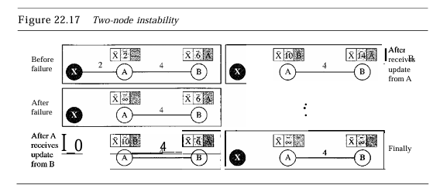

Figure 22.17 shows a system with three nodes. We have shown only the portions of the routing table needed for our discussion. At The beginning, both nodes A and B know how to reach node X. Butsuddenly, the linkbetweenA and X fails. NodeA changes its table. IfA can send its table to B immediately, everything is fine.

However, the system becomes unstable if B sends its routing table to A before receiving A's routing table. NodeA receives the update and, assuming that B has found a way to reach X, immediately updates its routing table. Based on the triggered update strategy, A sends its new 664 update to B. Now B thinks that something has been changed around A and updates its routing table. The cost of reaching X increases gradually until it reaches infinity. At this moment, both A and B know that X cannot be reached. However, during this time the system is not stable. Node A thinks that the route to X is via B; node B thinks that the route to X is via A. IfA receives a packet destined for X, it goes to B and then comes back to A. Similarly, ifB receives a packet destined for X, it goes to A and comes back toB. Packets bounce betweenA and B, creating a two-node loop problem. A few solutions have been proposed for instability of this kind. Defining Infinity The first obvious solution is to redefine infinity to a smaller number, such as 100. For our previous scenario, the system will be stable in less than 20 updates.

As a matter of fact, most implementations of the distance vector protocol define the distance between each node to be I and define 16 as infinity. However, this means that the distance vector routing cannot be used in large systems. The size of the network, in each direction, can not exceed 15 hops. Split Horizon Another solution is called split horizon. In this strategy, instead of flooding the table through each interface, each node sends only part of its table through each interface. If, according to its table, node B thinks that the optimum route to reach X is viaA, it does not need to advertise this piece of information to A. The information has come from A (A already knows). Taking information from node A, modifying it, and sending it back to node A creates the confusion. In our scenario, node B eliminates the last line of its routing table before it sends it to A. In this case, node A keeps the value of infinity as the distance to X. Later when node A sends its routing table to B, node B also corrects its routing table.

The system becomes stable after the first update: both node A and B know thatX is not reachable. Split Horizon and Poison Reverse Using the split horizon strategy has one drawback. Normally, the distance vector protocol uses a timer, and if there is no news about a route, the node deletes the route from its table. When node B in the previous scenario eliminates the route to X from its advertisement to A, node A cannot guess that this is due to the split horizon strategy (the source of information was A) or because B has not received any news about X recently. The split horizon strategy can be combined with the poison reverse strategy. Node B can still advertise the value for X, but if the source of information is A, it can replace the distance with infinity as a warning: "Do not use this value; what I know about this route comes from you.

### 52. What is three node instability?

The two-node instability can be avoided by using the split horizon strategy combined with poison reverse. However, if the instability is between three nodes, stability cannot be guaranteed. Figure 22.18 shows the scenario. Suppose, after finding that X is not reachable, node A sends a packet to Band C to inform them of the situation. Node B immediately updates its table, but the packet to C is lost in the network and never reaches C. Node C remains in the dark and still thinks that there is a route to X viaA with a distance of5. After a while, node C sends to its routing table, which includes the route to X. Node B is totally fooled here. It receives information on the route to X from C, and according to the algorithm, it updates its

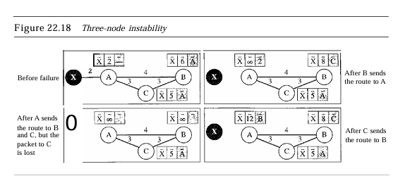

table, showing the route to X via C with a cost of8. This information has come from C, not from A, so after a while node B may advertise this route to A. NowA is fooled and updates its table to show that A can reach X via B with a cost of12. Ofcourse, the loop continues; now A advertises the route to X to C, with increased cost, but not to B. Node C then advertises the route to B with an increased cost. Node B does the same to A. And so on. The loop stops when the cost in each node reaches infinity.

**RIP**

The Routing Information Protocol (RIP) is an intradomain routing protocol used inside an autonomous system. It is a very simple protocol based on distance vector routing. RIP implements distance vector routing directly with some considerations:

**1.** In an autonomous system, we are dealing with routers and networks (links). The routers have routing tables; networks do not.

**2.** The destination in a routing table is a network, which means the first column defines a network address.

**3.** The metric used by RIP is very simple; the distance is defined as the number of links (networks) to reach the destination. For this reason, the metric in RIP is called a hop count.

**4.** Infinity is defined as 16, which means that any route in an autonomous system using RIP cannot have more than 15 hops.

**5.** The Next-node column defines the address of the router to which the packet is to be sent to reach its destination.

Figure 22.19 shows an autonomous system with seven networks and four routers. The table of each router is also shown. Let us look at the routing table for Rl. The table has seven entries to show how to reach each network in the autonomous system. Router Rl is directly connected to networks 130.10.0.0 and 130.11.0.0, which means that there are no next-hop entries for these two networks. To send a packet to one of the three networks at the far left, router Rl needs to deliver the packet to R2. The next-node entry for these three networks is the interface of router R2 with IP address 130.10.0.1. To send a packet to the two networks at the far right, router Rl needs to send the packet to the interface of router R4 with IP address 130.11.0.1. The other tables can be explained similarly

### 

### 53. What is the process to process delivery?

The data link layer is responsible for delivery of frames between two neighboring nodes over a link. This is called node-to-node delivery. The network layer is responsible for delivery of datagrams between two hosts. This is called host-to-host delivery. Communication on the Internet is not defined as the exchange of data between two nodes or between two hosts. Real communication takes place between two processes (application programs).

### 

### 54. What is an ephemeral port?

An ephemeral port is a short-lived transport protocol port typically used for client-side communications in computer networks. These ports are dynamically assigned by the operating system from a designated range, usually between 49152 and 65535 (though this range can vary based on the system).

### 55. What is a well-known port?

A well-known port is a specific range of port numbers in the Internet protocol suite that are designated for particular services or applications. These ports range from 0 to 1023 and are defined by the Internet Assigned Numbers Authority (IANA).

### 56. What is the socket address?

A socket address is a combination of an IP address and a port number that uniquely identifies a network service or application endpoint on a device. It allows for communication between devices over a network using the transport layer protocols, such as TCP or UDP.

### 57. What is a three- way handshake?

The three-way handshake is a method used in the Transmission Control Protocol (TCP) to establish a reliable connection between a client and a server. This process ensures that both parties are ready for data transmission and agree on initial sequence numbers.

* The client starts the process and sets the SYN flag to 1. The client sends the message to the server by setting the SYN flag to 1.
* The server replies with (SYN+ACK)
* The final acknowledgment from the client (ACK)

### 58. What is a four-way handshake?

The four-way handshake is a process used in the Transmission Control Protocol (TCP) to gracefully terminate a connection between a client and a server. This procedure ensures that both parties can safely close the connection without losing any data. Here’s how it works.

* The client sends an INIT signal to the server
* The server sends an INIT-ACK response to the client, which includes a state cookie
* The client sends a COOKIE-ECHO response, which echoes the state cookie
* The server verifies the state cookie's authenticity, allocates resources, and sends a COOKIE-ACK response

### 59. What is the average data rate?

The average data rate refers to the average amount of data transmitted over a network during a specific period of time. It is a key metric for assessing network performance and capacity.

### 60. What is the peak data rate?

peak data rate refers to the maximum rate at which data can be transmitted over a network or communication channel during a specific period of time. It represents the highest throughput achievable under ideal conditions and is typically measured in bits per second (bps), kilobits per second (kbps), megabits per second (Mbps), or gigabits per second (Gbps).

### 61. What is the maximum burst size?

Maximum burst size (MBS) refers to the maximum amount of data that can be transmitted over a network in a single burst or transmission event without violating the network's traffic management policies. It is typically measured in bytes or bits.

### 62. What is the variable bit rate?

Variable Bit Rate (VBR) refers to a method of data transmission where the bitrate can vary over time based on the complexity of the data being transmitted. This approach is commonly used in multimedia applications, such as audio and video streaming.

### 63. What is bursty data?

Bursty data refers to a pattern of data transmission where information is sent in sudden, high-volume bursts rather than at a steady, consistent rate. This behavior is common in various types of network traffic, where periods of high activity are followed by lulls or inactivity.

### 64. What is congestion?

An important issue in a packet-switched network is congestion. Congestion in a network may occur if the load on the network-the number of packets sent to the network-is greater than the capacity of the network-the number of packets a network can handle. Congestion control refers to the mechanisms and techniques to control the congestion and keep the load below the capacity.

### 65. What is open loop congestion control?

Open-Loop Congestion Control In open-loop congestion control, policies are applied to prevent congestion before it happens. In these mechanisms, congestion control is handled by either the source or the destination. We give a brief list of policies that can prevent congestion.

### 66. What is closed-loop congestion control?

Closed-loop congestion control mechanisms try to alleviate congestion after it happens. Several mechanisms have been used by different protocols

### 67. What is reliability?

The transport layer service can be reliable or unreliable. If the application layer program needs reliability, we use a reliable transport layer protocol by implementing flow and error control at the transport layer. This means a slower and more complex service. On the other hand, if the application program does not need reliability because it uses its own flow and error control mechanism or it needs fast service or the nature of the service does not demand flow and error control (real-time applications), then an unreliable protocol can be used.

### 

### 68. What is delay?

The latency or delay defines how long it takes for an entire message to completely arrive at the destination from the time the first bit is sent out from the source. We can say that latency is made of four components: propagation time, transmission time, queuing time and processing delay.

**Latency = propagation time +transmission time +queuing time + processing delay**

### 69. What is jitter?

Jitter refers to the variation in the packet arrival time. It is the uneven delay in the delivery of audio or video packets. For example, let us assume that video packets are sent every 3D ms. Ifsome of the packets arrive with 3D-ms delay and others with 4D-ms delay, an uneven quality in the video is the result

## 5 Mark Questions

### 

### 70. Explain ipv4 packet protocol?

The Internet Protocol version 4 (IPv4) is the delivery mechanism used by the TCP/IP protocols.

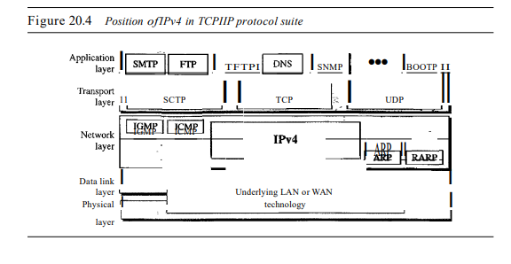

The term best-effort means that IPv4 provides no error control or flow control (except for error detection on the header). IPv4 assumes the unreliability of the underlying layers and does its best to get a transmission through to its destination, but with no guarantees. If Reliability is important, IPv4 must be paired with a reliable protocol such as TCP.

An example of a more commonly understood best-effort delivery service is the post office. The post office does its best to deliver the mail but does not always succeed. If an unregistered letter is lost, it is up to the sender or would-be recipient to discover the loss and rectify the problem. The post office itself does not keep track of every letter and cannot notify a sender of loss or damage.

IPv4 is also a connectionless protocol for a packet-switching network that uses the datagram approach (see Chapter 8). This means that each datagram is handled independently, and each datagram can follow a different route to the destination. This implies that datagrams sent by the same source to the same destination could arrive out of order. Also, some could be lost or corrupted during transmission. Again, IPv4 relies on a higher-level protocol to take care of all these problems.

**Datagram**

Packets in the IPv4 layer are called datagrams. A datagram is a variable-length packet consisting of two parts: header and data. The header is 20 to 60 bytes in length and contains information essential to routing and delivery. It is customary in TCP/IP to show the header in 4-byte sections. A brief description of each field is in order.

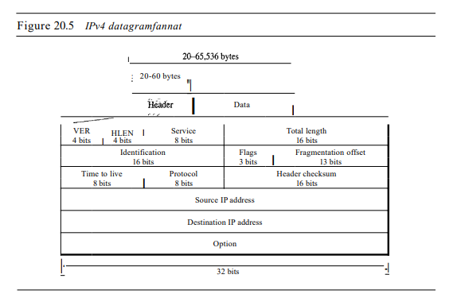

**Version (VER).** This 4-bit field defines the version of the IPv4 protocol. Currently the version is 4. However, version 6 (or IPng) may totally replace version 4 in the future. This field tells the IPv4 software running in the processing machine that the datagram has the format of version 4. All fields must be interpreted as specified in the fourth version of the protocol. If the machine is using some other version of IPv4, the datagram is discarded rather than interpreted incorrectly.

**Header length (HLEN)**. This 4-bit field defines the total length of the datagram header in 4-byte words. This field is needed because the length of the header is variable (between 20 and 60 bytes). When there are no options, the header length is 20 bytes, and the value of this field is 5 (5 x 4 = 20). When the option field is at its maximum size, the value of this field is 15 (15 x 4 = 60).

**Services.** IETF has changed the interpretation and name of this 8-bit field. This field, previously called service type, is now called differentiated services

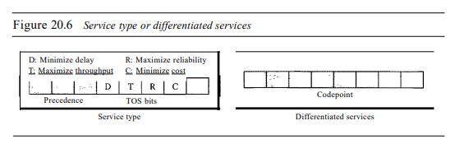

* **Service Type**

In this interpretation, the first 3 bits are called precedence bits. The next 4 bits are called type of service (TOS) bits, and the last bit is not used.

* + a. Precedence is a 3-bit subfield ranging from 0 (000 in binary) to 7 (111 in binary). The precedence defines the priority of the datagram in issues such as congestion. If a router is congested and needs to discard some datagrams, those datagrams with lowest precedence are discarded first. Some datagrams on the Internet are more important than others. For example, a datagram used for network management is much more urgent and important than a datagram containing optional information for a group. The precedence subfield was part of version 4, but never used.
  + b. TOS bits is a 4-bit subfield with each bit having a special meaning. Although a bit can be either 0 or 1, one and only one of the bits can have the value of 1 in each datagram. The bit patterns and their interpretations are given in Table 20.1. With only 1 bit set at a time, we can have five different types of services

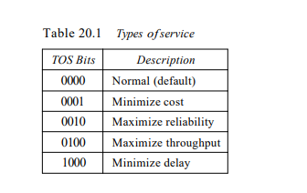

Application programs can request a specific type of service. The defaults for some applications are shown in Table 20.2

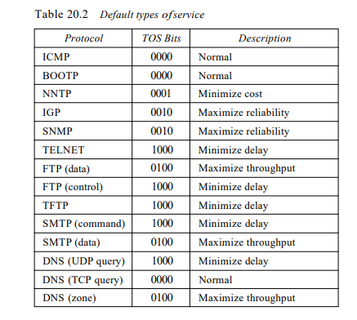

* **Differentiated Services**

In this interpretation, the first 6 bits make up the codepoint subfield, and the last 2 bits are not used. The codepoint subfield can be used in two different ways.

* + When the 3 rightmost bits are Os, the 3 leftmost bits are interpreted the same as the precedence bits in the service type interpretation. In other words, it is compatible with the old interpretation
  + When the 3 rightmost bits are not all Os, the 6 bits define 64 services based on the priority assignment by the Internet or local authorities according to Table 20.3. The first category contains 32 service types; the second and the third each contain 16. The first category (numbers 0, 2,4, ... ,62) is assigned by the Internet authorities (IETF). The second category (3, 7, 11, 15, , 63) can be used by local authorities (organizations). The third category (1, 5, 9, ,61) is temporary and can be used for experimental purposes. Note that the numbers are not contiguous. Ifthey were, the first category would range from 0 to 31, the second from 32 to 47, and the third from 48 to 63. This would be incompatible with the TOS interpretation because XXXOOO (which includes 0, 8, 16, 24, 32, 40, 48, and 56) would fall into all three categories. Instead, in this assignment method all these services belong to category 1. Note that these assignments have not yet been finalized

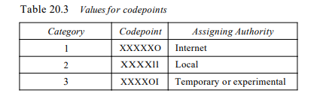

* + Total length. This is a In-bit field that defines the total length (header plus data) of the IPv4 datagram in bytes. To find the length of the data coming from the upper layer, subtract the header length from the total length. The header length can be found by multiplying the value in the HLEN field by 4. Length of data =total length - header length Since the field length is 16 bits, the total length of the IPv4 datagram is limited to 65,535 (216 - 1) bytes, of which 20 to 60 bytes are the header and the rest is data from the upper layer. The total length field defines the total length of the datagram including the header

**Example 20.1** An IPv4 packet has arrived with the first 8 bits as show: 01000010

**The receiver discards the packet. Why?**

**Solution**

There is an elTOr in this packet. The 4 leftmost bits (0100) show the version, which is correct. The next 4 bits (0010) show an invalid header length (2 x 4 =8). The minimum number of bytes in the header must be 20. The packet has been corrupted in transmission

**Fragmentation**

A datagram can travel through different networks. Each router decapsulates the IPv4 datagram from the frame it receives, processes it, and then encapsulates it in another frame. The format and size of the received frame depend on the protocol used by the physical network through which the frame has just traveled. The format and size of the sent frame depend on the protocol used by the physical network through which the frame is going to travel. For example, if a router connects a LAN to a WAN, it receives a frame in the LAN format and sends a frame in the WAN format.

**Maximum Transfer Unit (MTU)**

Each data link layer protocol has its own frame format in most protocols. One of the fields defined in the format is the maximum size of the data field. In other words, when a datagram is encapsulated in a frame, the total size of the datagram must be less than this maximum size, which is defined by the restrictions imposed by the hardware and software used in the network (see Figure 20.9). The value of the MTU depends on the physical network protocol. Table 20.5 shows the values for some protocols

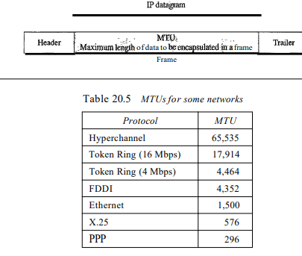

Fields Related to Fragmentation

The fields that are related to fragmentation and reassembly of an IPv4 datagram are the identification, flags, and fragmentation offset fields.

**Identification.** This 16-bit field identifies a datagram originating from the source host. The combination of the identification and source IPv4 address must uniquely define a datagram as it leaves the source host. To guarantee uniqueness, the IPv4 protocol uses a counter to label the datagrams. The counter is initialized to a positive number. When the IPv4 protocol sends a datagram, it copies the current value of the counter to the identification field and increments the counter by'~ 1. As long as the counter is kept in the main memory, uniqueness is guaranteed. When a datagram is fragmented, the value in the identification field is copied to all fragments. In other words, all fragments have the same identification number, the same as the original datagram. The identification number helps the destination in reassembling the datagram. It knows that all fragments having the same identification value must be assembled into one datagram.

**Flags.** This is a 3-bit field. The first bit is reserved. The second bit is called the do not fragment bit. If Its value is 1, the machine must not fragment the datagram. If it cannot pass the datagram through any available physical network, it discards the datagram and sends an ICMP error message to the source host (see Chapter 21). If its value is 0, the datagram can be fragmented if necessary. The third bit is called the more fragment bit. If its value is 1, it means the datagram is not the last fragment; there are more fragments after this one. If its value is 0, it means this is the last or only fragment

**Fragmentation offset.** This 13-bit field shows the relative position of this fragment with respect to the whole datagram. It is the offset of the data in the original datagram measured in units of 8 bytes. Figure 20.11 shows a datagram with a data size of 4000 bytes fragmented into three fragments. The bytes in the original datagram are numbered 0 to 3999. The first fragment carries bytes 0 to 1399. The offset for this datagram is 0/8 = O. The second fragment carries bytes 1400 to 2799; the offset value for this fragment is 1400/8 = 175. Finally, the third fragment carries bytes 2800 to 3999. The offset value for this fragment is 2800/8 =350. Remember that the value of the offset is measured in units of 8 bytes. This is done because the length of the offset field is only 13 bits and cannot represent

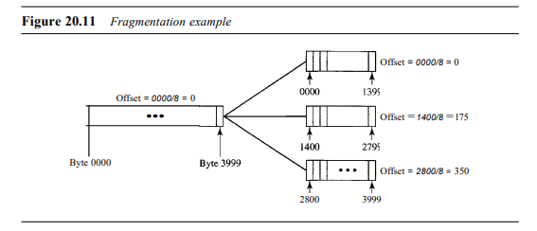

**Checksum**

We discussed the general idea behind the checksum and how it is calculated in Chapter 10. The implementation of the checksum in the IPv4 packet follows the same principles. First, the value of the checksum field is set to O. Then the entire header is divided into 16-bit sections and added together. The result (sum) is complemented and inserted into the checksum field.

The checksum in the IPv4 packet covers only the header, not the data. There are two good reasons for this. First, all higher-level protocols that encapsulate data in the IPv4 datagram have a checksum field that covers the whole packet. Therefore, the checksum for the IPv4 datagram does not have to check the encapsulated data. Second, the header of the IPv4 packet changes with each visited router, but the data do not. So the checksum includes only the part that has changed. If the data were included, each router must recalculate the checksum for the whole packet, which means an increase in processing time.

**Example 20.10**

shows an example of a checksum calculation for an IPv4 header without options. The header is divided into 16-bit sections. All the sections are added and the sum is complemented. The result is inserted in the checksum field.

**Options**

The header of the IPv4 datagram is made of two parts: a **fixed part** and a **variable part.**

The fixed part is 20 bytes long and was discussed in the previous section. The variable part comprises the options that can be a maximum of 40 bytes. Options, as the name implies, are not required for a datagram. They can be used for network testing and debugging. Although options are not a required part of the IPv4 header, option processing is required of the IPv4 software. This means that all implementations must be able to handle options if they are present in the header. The detailed discussion of each option is beyond the scope of this book. We give the taxonomy of options in Figure 20.14 and briefly explain the purpose of each. No Operation A no-operation option is a I-byte option used as a filler between options.

**End of Option**

An end-of-option option is an I-byte option used for padding at the end of the option field. It, however, can only be used as the last option.

**Record Route**

A record route option is used to record the Internet routers that handle the datagram. It can list up to nine router addresses. It can be used for debugging and management purposes.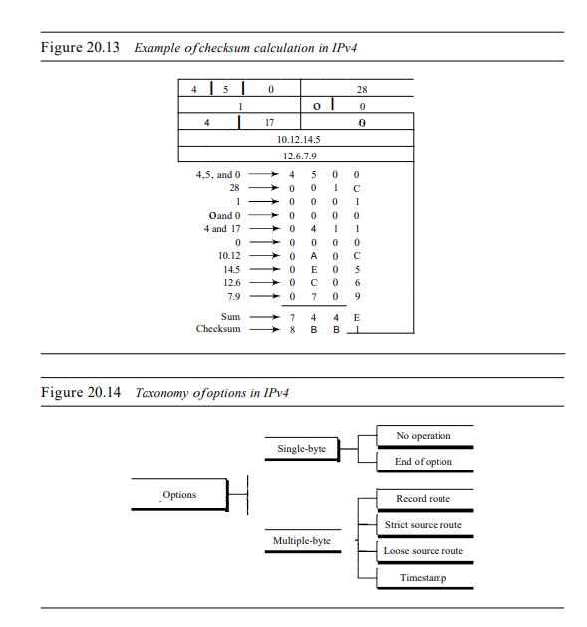

**Strict Source Route**

A strict source route option is used by the source to predetermine a route for the datagram as it travels through the Internet. Dictation of a route by the sour for several purposes. The sender can choose a route with a specific type of service, such as minimum delay or maximum throughput. Alternatively, it may choose a route that is safer or more reliable for the sender's purpose. For example, a sender can choose a route so that its datagram does not travel through a competitor's network. If a datagram specifies a strict source route, all the routers defined in the option must be visited by the datagram. A router must not be visited if its IPv4 address is not listed in the datagram. If the datagram visits a router that is not on the list, the datagram is discarded and an error message is issued. If the datagram arrives at the destination and some of the entries were not visited, it will also be discarded and an error message issued.

**Loose Source Route**

A loose source route option is similar to the strict source route, but it is less rigid. Each router in the list must be visited, but the datagram can visit other routers as well.

**Timestamp**

A timestamp option is used to record the time of datagram processing by a router. The time is expressed in milliseconds from midnight, Universal time or Greenwich mean time. Knowing the time a datagram is processed can help users and managers track the behavior of the routers in the Internet. We can estimate the time it takes for a datagram to go from one ~outer to another. We say estimate because, although all routers may use Universal time, their local clocks may not be synchronized.

### 71. Explain classful address?

IPv4 addressing, at its inception, used the concept of classes. This architecture is called classful addressing. Although this scheme is becoming obsolete, we briefly discuss it here to show the rationale behind classless addressing. In classful addressing, the address space is divided into five classes: A, B, C, D, and E. Each class occupies some part of the address space. In classful addressing, the address space is divided into five classes: A, B, C, D, and E.

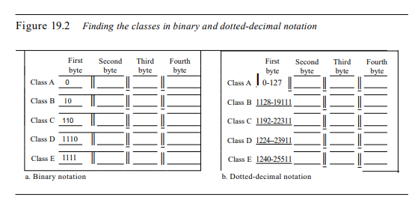

**Example 19.4**

Find the class of each address.

a. 00000001 00001011 00001011 11101111

b. 11000001 10000011 00011011 11111111

c. 14.23.120.8

d. 252.5.15.111

**Solution**

a. The first bit is O. This is a class A address.

b. The first 2 bits are 1; the third bit is O. This is a class C address.

c. The first byte is 14 (between 0 and 127); the class is A.

d. The first byte is 252 (between 240 and 255); the class is E.

### 72. Explain classless address?

To overcome address depletion and give more organizations access to the Internet, classless addressing was designed and implemented. In this scheme, there are no classes, but the addresses are still granted in blocks. In classless addressing, when an entity, small or large, needs to be connected to the Internet, it is granted a block (range) of addresses. The size of the block (the number of addresses) varies based on the nature and size of the entity. For example, a household may be given only two addresses; a large organization may be given thousands of addresses. An ISP, as the Internet service provider, may be given thousands or hundreds of thousands based on the number of customers it may serve.

Restriction To simplify the handling of addresses, the Internet authorities impose three restrictions on classless address blocks:

1. The addresses in a block must be contiguous, one after another.

2. The number of addresses in a block must be a power of 2 (I, 2, 4, 8, ... ).

3. The first address must be evenly divisible by the number of addresses

**Classes and Blocks**

One problem with classful addressing is that each class is divided into a fixed number of blocks with each block having a fixed size as shown in Table 19.1.

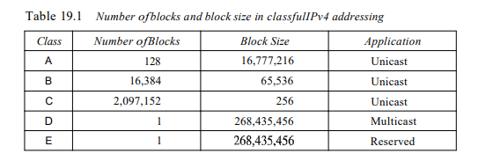

In classful addressing, a large part of the available addresses were wasted.

**Netid and Hostid**

In classful addressing, an IP address in class A, B, or C is divided into net id and host id. These parts are of varying lengths, depending on the class of the address. Figure 19.2 shows some net id and host id bytes. The net id is in color, the host id is in white. Note that the concept does not apply to classes D and E. In class A, one byte defines the net id and three bytes define the host id. In class B, two bytes define the net id and two bytes define the host id. In class C, three bytes define the net id and one byte defines the host id.

**Mask**

Although the length of the net id and host id (in bits) is predetermined in classful addressing, contiguous Is followed by contiguous as. The masks for classes A, B, and C are shown in Table 19.2. The concept does not apply to classes D and E

**Subnetting**

During the era of classful addressing, subnetting was introduced. If an organization was granted a large block in class A or B, it could divide the addresses into several contiguous groups and assign each group to smaller networks (called subnets) or, in rare cases, share part of the addresses with neighbors. Subnetting increases the number of Is in the mask, as we will see later when we discuss classless addressing. Supernetting

The time came when most of the class A and class B addresses were depleted; however, there was still a huge demand for midsize blocks. The size of a class C block with a maximum number of 256 addresses did not satisfy the needs of most organizations. Even a midsize organization needed more addresses. One solution was supernetting. In supernetting, an organization can combine several class C blocks to create a larger range of addresses. In other words, several networks are combined to create a supernetwork or a supernet.

An organization can apply for a set of class C blocks instead of just one. For example, an organization that needs 1000 addresses can be granted four contiguous class C blocks. The organization can then use these addresses to create one supernetwork. Supernetting decreases the number of Is in the mask. For example, if an organization is given four class C addresses, the mask changes from /24 to /22. We will see that classless addressing eliminates the need for supernetting.

**Address Depletion**

The flaws in the classful addressing scheme combined with the fast growth of the Internet led to the near depletion of the available addresses. Yet the number of devices on the Internet is much less than the 232 address space. We have run out of class A and B addresses, and a class C block is too small for most midsize organizations. One solution that has alleviated the problem is the idea of classless addressing. Classful addressing, which is almost obsolete, is replaced with classless addressing

### 73. Explain network address?

A very important concept in IP addressing is the network address. When an organization is given a block of addresses, the organization is free to allocate the addresses to the devices that need to be connected to the Internet. The first address in the class, however, is normally (not always) treated as a special address. The first address is called the network address and defines the organization network. It defines the organization itself to the rest of the world. In a later chapter we will see that the first address is the one that is used by routers to direct the message sent to the organization from the outside.

### 74. Explain network address translation?

The number of home users and small businesses that want to use the Internet is ever increasing. In the beginning, a user was connected to the Internet with a dial-up line, which means that she was connected for a specific period of time. An ISP with a block of addresses could dynamically assign an address to this user. An address was given to a user when it was needed. But the situation is different today. Home users and small businesses can be connected by an ADSL line or cable modem. In addition, many are not happy with one address; many have created small networks with several hosts and need an IP address for each host. With the shortage of addresses, this is a serious problem.

A quick solution to this problem is called network address translation (NAT). NAT enables a user to have a large set of addresses internally and one address, or a small set of addresses, externally. The traffic inside can use the large set; the traffic outside, the small set.

To separate the addresses used inside the home or business and the ones used for the Internet, the Internet authorities have reserved three sets of addresses as private addresses.

Any organization can use an address out of this set without permission from the Internet authorities. Everyone knows that these reserved addresses are for private networks. They are unique inside the organization, but they are not unique globally. No router will forward a packet that has one of these addresses as the destination address.

### 75. Explain ipv6 packet protocol?

The network layer protocol in the TCP IP protocol suite is currently IPv4 (Internetworking Protocol, version 4). IPv4 provides host-to-host communication between systems on the Internet. Although IPv4 is well designed, data communication has evolved since the inception of IPv4 in the 1970s. IPv4 has some deficiencies (listed below) that make it unsuitable for the fast-growing Internet.

* Despite all short-term solutions, such as subnetting, classless addressing, and NAT, address depletion is still a long-term problem on the Internet.
* The Internet must accommodate real-time audio and video transmission. This type of transmission requires minimum delay strategies and reservation of resources not provided in the IPv4 design.
* The Internet must accommodate encryption and authentication of data for some applications. No encryption or authentication is provided by IPv4.
* To overcome these deficiencies, IPv6 (Internetworking Protocol, version 6), also known as IPng (Internetworking Protocol, next generation), was proposed and is now a standard. In IPv6, the Internet protocol was extensively modified to accommodate the unforeseen growth of the Internet. The format and the length of the IP address were changed along with the packet format. Related protocols, such as ICMP, were also modified.

Other protocols in the network layer, such as ARP, RARP, and IGMP, were either deleted or included in the ICMPv6 protocol (see Chapter 21). Routing protocols, such as RIP and OSPF (see Chapter 22), were also slightly modified to accommodate these changes. Communications experts predict that IPv6 and its related protocols will soon replace the current IP version. In this section first we discuss IPv6. Then we explore the strategies used for the transition from version 4 to version 6. The adoption of IPv6 has been slow. The reason is that the original motivation for its development, depletion ofIPv4 addresses, has been remedied by short-term strategies such as classless addressing and NAT. However, the fast-spreading use of the Internet, and new services such as mobile IP, IP telephony, and IP-capable mobile telephony, may eventually require the total replacement of IPv4 with IPv6.

**Advantages**

The next-generation IP, or IPv6, has some advantages over IPv4 that can be summarized as follows:

* Larger address space. An IPv6 address is 128 bits long, as we discussed in Chapter 19. Compared with the 32-bit address of IPv4, this is a huge (296) increase in the address space.
* Better header format. IPv6 uses a new header format in which options are separated from the base header and inserted, when needed, between the base header and the upper-layer data. This simplifies and speeds up the routing process because most of the options do not need to be checked by routers.
* New options. IPv6 has new options to allow for additional functionalities.
* Allowance for extension. IPv6 is designed to allow the extension of the protocol if required by new technologies or applications.
* Support for resource allocation. In IPv6, the type-of-service field has been removed, but a mechanism (called blow label) has been added to enable the source to request special handling of the packet. This mechanism can be used to support traffic such as real-time audio and video.
* Support for more security. The encryption and authentication options in IPv6 provide confidentiality and integrity of the packet

**Packet Format**

The IPv6 packet is shown in Figure 20.15. Each packet is composed of a mandatory base header followed by the payload. The payload consists of two parts: optional extension headers and data from an upper layer. The base header occupies 40 bytes, whereas the extension headers and data from the upper layer contain up to 65,535 bytes of information

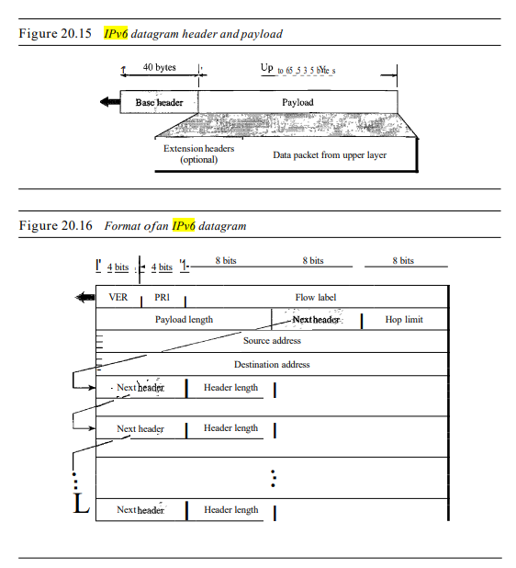

* **Flow label.** The flow label is a 3-byte (24-bit) field that is designed to provide special handling for a particular flow of data. We will discuss this field later.
* **Payload length.** The 2-byte payload length field defines the length of the IP datagram excluding the base header.
* **Next header.** The next header is an 8-bit field defining the header that follows the base header in the datagram. The next header is either one of the optional extension headers used by IP or the header of an encapsulated packet such as UDP or TCP. Each extension header also contains this field. Table 20.6 shows the values of next headers. Note that this field in version 4 is called the protocol. o Hop limit. This 8-bit hop limit field serves the same purpose as the TIL field in IPv4.
* **Source address.** The source address field is a 16-byte (128-bit) Internet address that identifies the original source of the datagram.

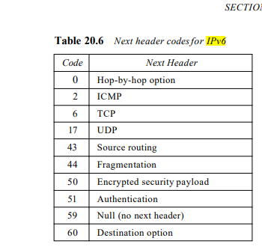

* **Destination address.** The destination address field is a 16-byte (128-bit) Internet address that usually identifies the final destination of the datagram. However, if source routing is used, this field contains the address of the next router.
* **Priority** The priority field of the IPv6 packet defines the priority of each packet with respect to other packets from the same source. For example, if one of two consecutive datagrams must be discarded due to congestion, the datagram with the lower packet priority will be discarded. IPv6 divides traffic into two broad categories: congestion-controlled and noncongestion-controlled.
* **Congestion-Controlled Traffic** If a source adapts itself to traffic slowdown when there is congestion, the traffic is referred to as congestion-controlled traffic. For example, TCP, which uses the sliding window protocol, can easily respond to traffic. In congestion-controlled traffic, it is understood that packets may arrive delayed, lost, or out of order. Congestion-controlled data are assigned priorities from 0 to 7, as listed in Table 20.7. A priority of 0 is the lowest; a priority of 7 is the highest.

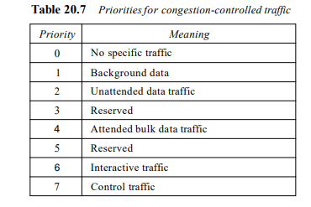

* **No specific traffic.** A priority of 0 is assigned to a packet when the process does not define a priority.
* **Background data.** This group (priority 1) defines data that are usually delivered in the background. Delivery of the news is a good example.
* **Unattended data traffic.** If the user is not waiting (attending) for the data to be received, the packet will be given a priority of 2. Email belongs to this group. The recipient of an email does not know when a message has arrived. In addition, an e-mail is usually stored before it is forwarded. A little bit of delay is of little consequence.
* **Attended bulk data traffic.** A protocol that transfers data while the user is waiting (attending) to receive the data (possibly with delay) is given a priority of 4. FTP and HTTP belong to this group.
* **Interactive traffic.** Protocols such as TELNET that need user interaction are assigned the second-highest priority (6) in this group.
* **Control traffic.** Control traffic is given the highest priority (7). Routing protocols such as OSPF and RIP and management protocols such as SNMP have this priority.
* **Non Congestion-Controlled Traffic** This refers to a type of traffic that expects minimum delay. Discarding packets is not desirable. Retransmission in most cases is impossible. In other words, the source does not adapt itself to congestion. Real-time audio and video are examples of this type of traffic. Priority numbers from 8 to 15 are assigned to noncongestion-controlled traffic. Although there are not yet any particular standard assignments for this type of data, the priorities are usually based on how much the quality of received data is affected by the discarding of packets. Data containing less redundancy (such as low-fidelity audio or video) can be given a higher priority (15). Data containing more redundancy

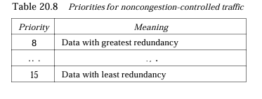

**Flow Label**

Sequence of packets, sent from a particular source to a particular destination, that needs special handling by routers is called a flow of packets. The combination of the source address and the value of the flow label uniquely defines a flow of packets. To a router, a flow is a sequence of packets that share the same characteristics, such as traveling the same path, using the same resources, having the same kind of security, and so on. A router that supports the handling of flow labels has a flow label table. The table has an entry for each active flow label; each entry defines the services required by the corresponding flow label. When the router receives a packet, it consults its flow label table to find the corresponding entry for the flow label value defined in the packet. It then provides the packet with the services mentioned in the entry. However, note that the flow label itself does not provide the information for the entries of the flow label table; the information is provided by other means such as the hop-by-hop options or other protocols.

In its simplest form, a flow label can be used to speed up the processing of a packet by a router. When a router receives a packet, instead of consulting the routing table and going through a routing algorithm to define the address of the next hop, it can easily look in a flow label table for the next hop. In its more sophisticated form, a flow label can be used to support the transmission of real-time audio and video. Real-time audio or video, particularly in digital form, requires resources such as high bandwidth, large buffers, long processing time, and so on. A process can make a reservation for these resources beforehand to guarantee that real-time data will not be delayed due to a lack of resources. The use of real-time data and the reservation of these resources require other protocols such as Real-Time Protocol (RTP) and Resource Reservation Protocol (RSVP) in addition to IPv6. To allow the effective use of flow labels, three rules have been defined: 1. The flow label is assigned to a packet by the source host. The label is a random number between 1 and 224- 1.

A source must not use a flow label for a new flow while the existing flow is still active. 2. Ifa host does not support the flow label, it sets this field to zero. Ifa router does not support the flow label, it simply ignores it. 3. All packets belonging to the same flow have the same source, same destination, same priority, and same options.

**Extension Headers**

The length of the base header is fixed at 40 bytes. However, to give greater functionality to the IP datagram, the base header can be followed by up to six extension headers. Many of these headers are options in IPv4. Six types of extension headers have been defined, as shown in Figure 20.17

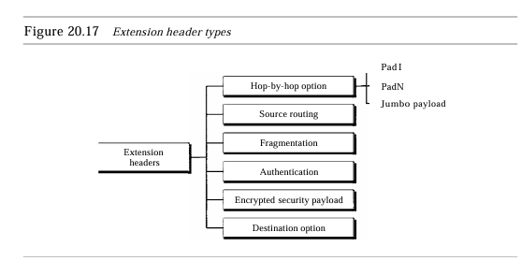

**Hop-by-Hop Option**

The hop-by-hop options used when the source needs to pass information to all routers visited by the datagram. So far, only three options have been defined: Padl,PadN, and jumbo payload. The Padl option is 1 byte long and is designed for alignment purposes. PadN is similar in concept to Padi. The difference is that PadN is used when 2 or more bytes are needed for alignment. The Jumbo payload option is used to define a payload longer than 65,535 bytes. Source Routing The source routing extension header combines the concepts of the strict source route and the loose source route options ofIPv4

**Fragmentation**

The concept of fragmentation is the same as that in IPv4. However, the place where fragmentation occurs differs. In IPv4, the source or a router is required to fragment if the size of the datagram is larger than the MTU of the network over which the datagram travels. In IPv6, only the original source can fragment. A source must use a path MTU discovery technique to find the smallest MTU supported by any network on the path. The source then fragments using this knowledge.

**Authentication**

The authentication extension header has a dual purpose: it validates the message sender and ensures the integrity of data. We discuss this extension header when we discuss network security.

**Encrypted Security Payload**

The encrypted security payload (ESP) is an extension that provides confidentiality and

guards against eavesdropping. We discuss this extension header in Chapter 31. Destination Option The destination option is used when the source needs to pass information to the destination only. Intermediate routers are not permitted access to this information

### 76. Explain different types of addresses?

**1:Unicast Addresses**

A unicast address defines a single computer. The packet sent to a unicast address must be delivered to that specific computer. IPv6 defines two types of unicast addresses: geographically based and provider-based. We discuss the second type here; the first type is left for future definition. The provider-based address is generally used by a normal host as a unicast address.

**2: Multicast Addresses**

Multicast addresses are used to define a group of hosts instead of just one. A packet sent to a multicast address must be delivered to each member of the group. The second field is a flag that defines the group address as either permanent or transient. A permanent group address is defined by the Internet authorities and can be accessed at all times. A transient group address, on the other hand, is used only temporarily. Systems engaged in a teleconference, for example, can use a transient group address. The third field defines the scope of the group address. Many different scopes have been defined.

**3:Anycast Addresses**

IPv6 also defines anycast addresses. An anycast address, like a multicast address, also defines a group of nodes. However, a packet destined for an anycast address is delivered to only one of the members of the anycast group, the nearest one (the one with the shortest route). Although the definition of an anycast address is still debatable, one possible use is to assign an anycast address to all routers of an ISP that covers a large logical area in the Internet. The routers outside the ISP deliver a packet destined for the ISP to the nearest ISP router. No block is assigned for anycast addresses.

**4: Reserved Addresses**

Another category in the address space is the reserved address. These addresses start with eight Os (type prefix is 00000000). A few subcategories are defined in this category

**5: Local Addresses**

These addresses are used when an organization wants to use IPv6 protocol without being connected to the global Internet. In other words, they provide addressing for private networks. Nobody outside the organization can send a message to the nodes using these addresses. Two types of addresses are defined for this purpose

### 77. Explain method for transition from ipv4 to ipv6?

Because of the huge number of systems on the Internet, the transition from IPv4 to IPv6 cannot happen suddenly. It takes a considerable amount of time before every system in the Internet can move from IPv4 to IPv6. The transition must be smooth to prevent any problems between IPv4 and IPv6 systems. Three strategies have been devised to help the transition .

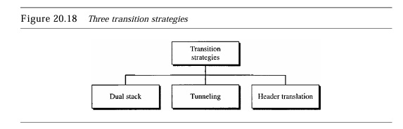

**Dual Stack**

It is recommended that all hosts, before migrating completely to version 6, have a dual stack of protocols. In other words, a station must run IPv4 and IPv6 simultaneously until all the Internet uses IPv6. See Figure 20.19 for the layout of a dual-stack configuration.

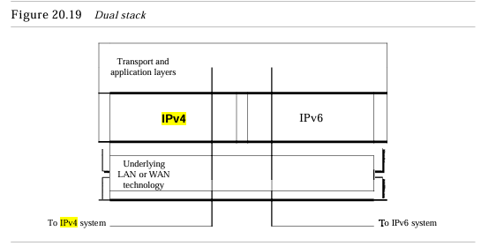

**Tunneling**

Tunneling is a strategy used when two computers using IPv6 want to communicate with each other and the packet must pass through a region that uses IPv4. To pass through this region, the packet must have an IPv4 address. So the IPv6 packet is encapsulated in an IPv4 packet when it enters the region, and it leaves its capsule when it exits the region. It seems as if the IPv6 packet goes through a tunnel at one end and emerges at the other end. To make it clear that the IPv4 packet is carrying an IPv6 packet as data, the protocol value is set to 41.

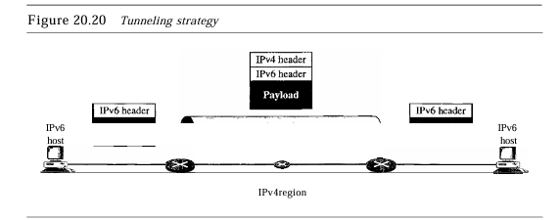

**Header Translation**

Header translation is necessary when the majority of the Internet has moved to IPv6 but some systems still use IPv4. The sender wants to use IPv6, but the receiver does not understand IPv6. Tunneling does not work in this situation because the packet must be in the IPv4 format to be understood by the receiver. In this case, the header format must be totally changed through header translation. The header of the IPv6 packet is converted to an IPv4 header.

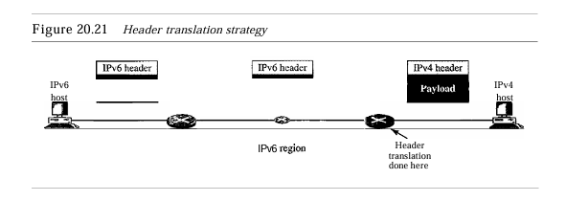

### 78. Explain ARP protocol?

Anytime a host or a router has an IP datagram to send to another host or router, it has the logical (IP) address of the receiver. The logical (IP) address is obtained from the DNS (see Chapter 25) if the sender is the host or it is found in a routing table (see Chapter 22) if the sender is a router. But the IP datagram must be encapsulated in a frame to be able to pass through the physical network. This means that the sender needs the physical address of the receiver. The host or the router sends an ARP query packet. The packet includes the physical and IP addresses of the sender and the IP address of the receiver. Because the sender does not know the physical address of the receiver, the query is broadcast over the network

Every host or router on the network receives and processes the ARP query packet, but only the intended recipient recognizes its IP address and sends back an ARP response packet. The response packet contains the recipient's IP and physical addresses. The packet is unicast directly to the inquirer by using the physical address received in the query packet.

This packet is received by every system on the physical network, but only system B will answer it. System B sends an ARP reply packet that includes its physical address. Now system A can send all the packets it has for this destination by using the physical address it received.

**Cache Memory**

Using ARP is inefficient if system A needs to broadcast an ARP request for each IP packet it needs to send to system B. It could have broadcast the IP packet itself. ARP can be useful if the ARP reply is cached (kept in cache memory for a while) because a system normally sends several packets to the same destination. A system that receives an ARP reply stores the mapping in the cache memory and keeps it for 20 to 30 minutes unless the space in the cache is exhausted. Before sending an ARP request, the system first checks its cache to see if it can find the mapping.

**Operation**

Let us see how ARP functions on a typical internet. First we describe the steps involved. Then we discuss the four cases in which a host or router needs to use ARP. These are the steps involved in an ARP process:

1. The sender knows the IP address of the target. We will see how the sender obtains this shortly.
2. IP asks ARP to create an ARP request message, filling in the sender physical address, the sender IP address, and the target IP address. The target physical address field is filled with Os.
3. The message is passed to the data link layer where it is encapsulated in a frame by using the physical address of the sender as the source address and the physical broadcast address as the destination address.
4. Every host or router receives the frame. Because the frame contains a broadcast destination address, all stations remove the message and pass it to ARP. All machines except the one targeted drop the packet. The target machine recognizes its IP address.
5. The target machine replies with an ARP reply message that contains its physical address. The message is unicast.
6. The sender receives the reply message. It now knows the physical address of the target machine.
7. The IP datagram, which carries data for the target machine, is now encapsulated in a frame and is unicast to the destination.

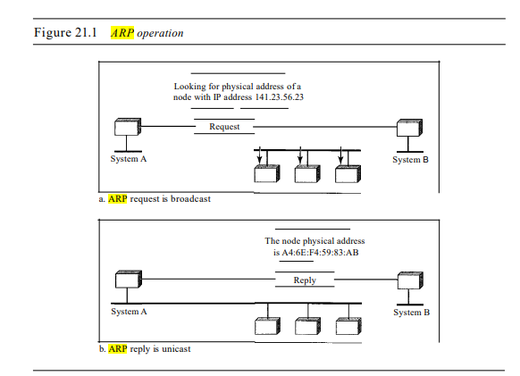

**Four Different Cases**

The following are four different cases in which the services of ARP can be used (see Figure 21.4).

**1.** The sender is a host and wants to send a packet to another host on the same network. In this case, the logical address that must be mapped to a physical address is the destination IP address in the datagram header.

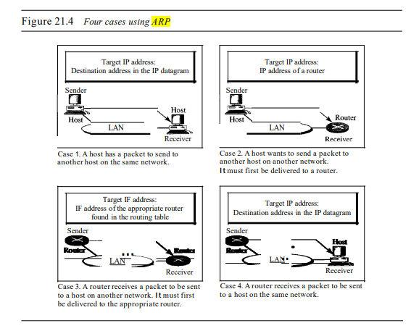

**2.** The sender is a host and wants to send a packet to another host on another network. In this case, the host looks at its routing table and finds the IP address of the next hop (router) for this destination. Ifit does not have a routing table, it looks for the IP address of the default router. The IP address of the router becomes the logical address that must be mapped to a physical address.

**3.** The sender is a router that has received a datagram destined for a host on another network. It checks its routing table and finds the IP address of the next router. The IP address of the next router becomes the logical address that must be mapped to a physical address.

**4.** The sender is a router that has received a datagram destined for a host on the same network. The destination IP address of the datagram becomes the logical address that must be mapped to a physical address. An ARP request is broadcast; an ARP reply is unicast

### 79. Explain RARP protocol?

Reverse Address Resolution Protocol (RARP) finds the logical address for a machine that knows only its physical address. Each host or router is assigned one or more logical (IP) addresses, which are unique and independent of the physical (hardware) address of the machine. To create an IP datagram, a host or a router needs to know its own IP address or addresses. The IP address of a machine is usually read from its configuration file stored on a disk file. However, a diskless machine is usually booted from ROM, which has minimum booting information.

The ROM is installed by the manufacturer. It cannot include the IP address because the IP addresses on a network are assigned by the network administrator. The machine can get its physical address (by reading its NIC, for example), which is unique locally. It can then use the physical address to get the logical address by using the RARP protocol. A RARP request is created and broadcast on the local network. Another machine on the local network that knows all the IP addresses will respond with a RARP reply. The requesting machine must be running a RARP client program; the responding machine must be running a RARP server program. There is a serious problem with RARP: Broadcasting is done at the data link layer. The physical broadcast address, allis in the case of Ethernet, does not pass the boundaries of a network. This means that if an administrator has several networks or several subnets, it needs to assign a RARP server for each network or subnet. This is the reason that RARP is almost obsolete. 1\vo protocols, BOOTP and DHCp, are replacing RARP.

BOOTP The Bootstrap Protocol (BOOTP) is a client/server protocol designed to provide physical address to logical address mapping. BOOTP is an application layer protocol. The administrator may put the client and the server on the same network or on BOOTP messages are encapsulated in a UDP packet, and the UDP packet itself is encapsulated in an IP packet.

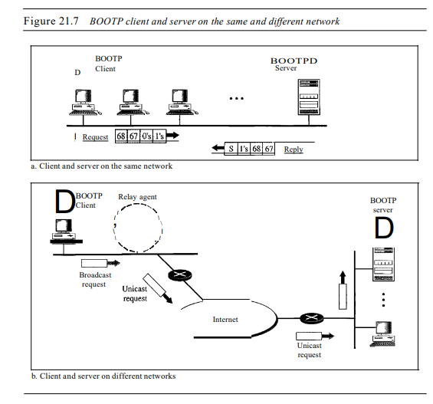

One of the advantages of BOOTP over RARP is that the client and server are application-layer processes. As in other application-layer processes, a client can be in one network and the server in another, separated by several other networks. However, there is one problem that must be solved. The BOOTP request is broadcast because the client does not know the IP address of the server. A broadcast IP datagram cannot pass through any router. To solve the problem, there is a need for an intermediary. One of the hosts (or a router that can be configured to operate at the application layer) can be used as a relay.

The host in this case is called a relay agent. The relay agent knows the unicast address of a BOOTP server. When it receives this type of packet, it encapsulates the message in a unicast datagram and sends the request to the BOOTP server. The packet carrying a unicast destination address, is routed by any router and reaches the BOOTP server. The BOOTP server knows the message comes from a relay agent because one of the fields in the request message defines the IP address of the relay agent. The relay agent, after receiving the reply, sends it to the BOOTP client

### 80. Explain DHCP protocol?

BOOTP is not a dynamic configuration protocol. When a client requests its IP address, the BOOTP server consults a table that matches the physical address of the client with its IP address. This implies that the binding between the physical address and the IP address of the client already exists. The binding is predetermined. However, what if a host moves from one physical network to another? What if a host wants a temporary IP address? BOOTP cannot handle these situations because the binding between the physical and IP addresses is static and fixed in a table until changed by the administrator. BOOTP is a static configuration protocol. The Dynamic Host Configuration Protocol (DHCP) has been devised to provide static and dynamic address allocation that can be manual or automatic.

DHCP provides static and dynamic address allocation that can be manual or automatic.

Static Address Allocation In this capacity DHCP acts as BOOTP does. It is backward compatible with BOOTP, which means a host running the BOOTP client can request a static address from a DHCP server. A DHCP server has a database that statically binds physical addresses to IP addresses. Dynamic Address Allocation DHCP has a second database with a pool of available IP addresses. This second database makes DHCP dynamic. When a DHCP client requests a temporary IP address, the DHCP server goes to the pool of available (unused) IP addresses and assigns an IP address for a negotiable period of time. When a DHCP client sends a request to a DHCP server, the server first checks its static database. If an entry with the requested physical address exists in the static database, the permanent IP address of the client is returned.

On the other hand, if the entry does not exist in the static database, the server selects an IP address from the available pool, assigns the address to the client, and adds the entry to the dynamic database. The dynamic aspect of DHCP is needed when a host moves from network to network or is connected and disconnected from a network (as is a subscriber to a service provider). DHCP provides temporary IP addresses for a limited time. The addresses assigned from the pool are temporary addresses. The DHCP server issues a lease for a specific time. When the lease expires, the client must either stop using the IP address or renew the lease.

The server has the option to agree or disagree with the renewal. If the server disagrees, the client stops using the address. Manual and Automatic Configuration One major problem with the BOOTP protocol is that the table mapping the IP addresses to physical addresses needs to be manually configured. This means that every time there is a change in a physical or IP address, the administrator needs to manually enter the changes. DHCP, on the other hand, allows both manual and automatic configurations. Static addresses are created manually~ dynamic addresses are created automatically.

### 81. Explain ICMP protocol?

It was designed this way to make efficient use of network resources. The IP protocol is a best-effort delivery service that delivers a datagram from its original source to its final destination. However, it has two deficiencies: lack of error control and lack of assistance mechanisms. The IP protocol has no error-reporting or error-correcting mechanism. What happens if something goes wrong? What happens if a router must discard a datagram because it cannot find a router to the final destination, or because the time-to-live field has a zero value? What happens if the final destination host must discard all fragments of a datagram because it has not received all fragments within a predetermined time limit?

These are examples of situations where an error has occurred and the IP protocol has no built-in mechanism to notify the original host. The IP protocol also lacks a mechanism for host and management queries. A host sometimes needs to determine if a router or another host is alive. And sometimes a network administrator needs information from another host or router. The Internet Control Message Protocol (ICMP) has been designed to compensate for the above two deficiencies. It is a companion to the IP protocol 1.

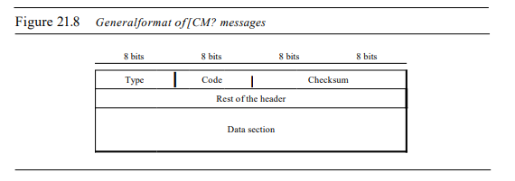

ICMP messages are divided into two broad categories: error-reporting messages and query messages. The error-reporting messages report problems that a router or a host (destination) may encounter when it processes an IP packet. The query messages, which occur in pairs, help a host or a network manager get specific information from a router or another host. For example, nodes can discover their neighbors. Also, hosts can discover and learn about routers on their network, and routers can help a node redirect its messages.

**Error Reporting**

One of the main responsibilities of ICMP is to report errors. Although technology has produced increasingly reliable transmission media, errors still exist and must be handled. IP, as discussed in Chapter 20, is an unreliable protocol. This means that error checking and error control are not a concern of IP. ICMP was designed, in part, to compensate for this shortcoming. However, ICMP does not correct errors-it simply reports them. Error correction is left to the higher-level protocols. Error messages are always sent to the original source because the only information available in the datagram about the route is the source and destination IP addresses. ICMP uses the source IP address to send the error message to the source (originator) of the datagram. ICMP always reports error messages to the original source.

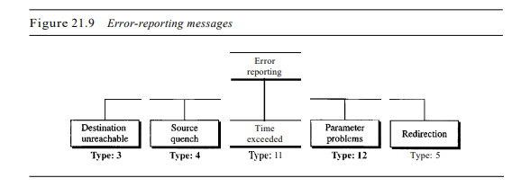

Five types of errors are handled: destination unreachable, source quench, time exceeded, parameter problems, and redirection.

* No ICMP error message will be generated in response to a datagram carrying an ICMP error message. D N
* ICMP error message will be generated for a fragmented datagram that is not the first fragment. D N
* IeMP error message will be generated for a datagram having a multicast address. D N
* ICMP error message will be generated for a datagram having a special address such as 127.0.0.0 or 0.0.0.0

**Destination Unreachable**

When a router cannot route a datagram or a host cannot deliver a datagram, the datagram is discarded and the router or the host sends a destination-unreachable message back to the source host that initiated the datagram. Note that destination-unreachable messages can be created by either a router or the destination host.

**Source Quench**

The IP protocol is a connectionless protocol. There is no communication between the source host, which produces the datagram, the routers, which forward it, and the destination host, which processes it. One of the ramifications of this absence of communication is the lack of flow control. IP does not have a flow control mechanism embedded in the protocol. The lack of flow control can create a major problem in the operation of IP: congestion.

The source host never knows if the routers or the destination host has been overwhelmed with datagrams. The source host never knows if it is producing datagrams faster than can be forwarded by routers or processed by the destination host. The lack of flow control can create congestion in routers or the destination host. A router or a host has a limited-size queue (buffer) for incoming datagrams waiting to be forwarded (in the case of a router) or to be processed (in the case of a host). If the datagrams are received much faster than they can be forwarded or processed, the queue may overflow. In this case, the router or the host has no choice but to discard some of the datagrams. The source-quench message in ICMP was designed to add a kind of flow control to the IP. When a router or host discards a datagram due to congestion, it sends a source-quench message to the sender of the datagram. This message has two purposes. First, it informs the source that the datagram has been discarded. Second, it warns the source that there is congestion somewhere in the path and that the source should slow down (quench) the sending process.

**Time Exceeded**

The time-exceeded message is generated in two cases: As we see in Chapter 22, routers use routing tables to find the next hop (next router) that must receive the packet. Ifthere are errors in one or more routing tables, a packet can travel in a loop or a cycle, going from one router to the next or visiting a series of routers endlessly. As we saw in Chapter 20, each datagram contains a field called time to live that controls this situation. When a datagram visits a router, the value of this field is decremented by 1. When the time-to-live value reaches 0, after decrementing, the router discards the datagram. However, when the datagram is discarded, a time-exceeded message must be sent by the router to the original source. Second, a time-exceeded message is also generated when not all fragments that make up a message arrive at the destination host within a certain time limit.

**Parameter Problem**

Any ambiguity in the header part of a datagram can Create serious problems as the datagram travels through the Internet. If a router or the destination host discovers an ambiguous or missing value in any field of the datagram, it discards the datagram and sends a parameter-problem message back to the source.

**Redirection**

When a router needs to send a packet destined for another network, it must know the IP address of the next appropriate router. The same is true if the sender is a host. Both routers and hosts, then, must have a routing table to find the address of the router or the next router. Routers take part in the routing update process, as we will see in Chapter 22, and are supposed to be updated constantly. Routing is dynamic. However, for efficiency, hosts do not take part in the routing update process because there are many more hosts on the internet than routerS. Updating the routing tables of hosts dynamically produces unacceptable traffic. The hosts usually use static routing. When a host comes up, its routing table has a limited number of entries. It usually knows the IP address of only one router, the default router. For this reason, the host may send a datagram, which is destined for another network, to the wrong router. In this case, the router that receives the datagram will forward the datagram to the correct router. However, to update the routing table of the host, it sends a redirection message to the host

**Query**

In addition to error reporting, ICMP can diagnose some network problems. This is accomplished through the query messages, a group of four different pairs of messages, as shown in Figure 21.12. In this type of ICMP message, a node sends a message that is answered in a specific format by the destination node. A query message is encapsulated in an IP packet, which in tum is encapsulated in a data link layer frame. However, in this case, no bytes of the original IP are included in the message, as shown in Figure 21.13

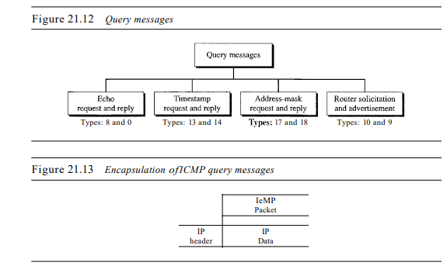

**Echo Request and Reply**

The echo-request and echo-reply messages are designed for diagnostic purposes. Network managers and users utilize this pair of messages to identify network problems. The combination of echo-request and echo-reply messages determines whether two systems (hosts or routers) can communicate with each other. The echo-request and echo-reply messages can be used to determine if there is communication at the IP level. Because ICMP messages are encapsulated in IP datagrams, the receipt of an echo-reply message by the machine that sent the echo request is proof that the IP protocols in the sender and receiver are communicating with each other using the IP datagram.

Also, it is proof that the intermediate routers are receiving, processing, and forwarding IP datagrams. Today, most systems provide a version of the ping command that can create a series (instead of just one) of echo-request and echo-reply messages, providing statistical information. We will see the use of this program at the end of the chapter

**Timestamp Request and Reply**

Two machines (hosts or routers) can use the timestamp request and timestamp reply messages to determine the round-trip time needed for an IP datagram to travel between them. It can also be used to synchronize the clocks in two machines.

**Address-Mask Request and Reply**

A host may know its IP address, but it may not know the corresponding mask. For example, a host may know its IP address as 159.31.17.24, but it may not know that the corresponding mask is /24. To obtain its mask, a host sends an address-mask-request message to a router on the LAN. If The host knows the address of the router, it sends the request directly to the router. If it does not know, it broadcasts the message. The router receiving the address-mask-request message responds with an address-mask-reply message, providing the necessary mask for the host. This can be applied to its full IP address to get its subnet address.

**Router Solicitation and Advertisement**

As we discussed in the redirection message section, a host that wants to send data to a host on another network needs to know the address of routers connected to its own network. Also, the host must know if the routers are alive and functioning. The router-solicitation and router-advertisement messages can help in this situation. A host can broadcast (or multicast) a router-solicitation message. The router or routers that receive the solicitation message broadcast their routing information using the router-advertisement message. A router can also periodically send router-advertisement messages even if no host has solicited. Note that when a router sends out an advertisement, it announces not only its own presence but also the presence of all routers on the network of which it is aware.

**Checksum**

We learned the concept and idea of the checksum. In ICMP the checksum is calculated over the entire message (header and data)

### 82. Explain IGMP protocol?

The IP protocol can be involved in two types of communication: unicasting and multicasting. Unicasting is the communication between one sender and one receiver. It is a one-to-one communication. However, some processes sometimes need to send the same message to a large number of receivers simultaneously. This is called multicasting, which is a one-to-many communication.

Multicasting has many applications. For example, multiple stockbrokers can simultaneously be informed of changes in a stock price, or travel agents can be informed of a plane cancellation. Some other applications include distance learning and video-on-demand. The Internet Group Management Protocol (IGMP) is one of the necessary, but not sufficient (as we will see), protocols that is involved in multicasting. IGMP is a companion to the IP protocol.

IGMP is not a multicasting routing protocol; it is a protocol that manages group membership. In any network, there are one or more multicast routers that distribute multicast packets to hosts or other routers. The IGMP protocol gives the multicast routers information about the membership status of hosts (routers) connected to the network.

A multicast router may receive thousands of multicast packets every day for different groups. If a router has no knowledge about the membership status of the hosts, it must broadcast all these packets. This creates a lot of traffic and consumes bandwidth. A better solution is to keep a list of groups in the network for which there is at least one loyal member. IGMP helps the multicast router create and update this list.

**IGMP Messages**

IOMP has gone through two versions. We discuss IOMPv2, the current version. IOMPv2 has three types of messages: the query, the membership report, and the leave report. There are two types of query messages: general and special.

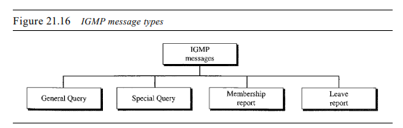

Message Format

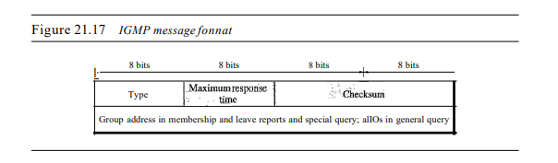

* Type. This 8-bit field defines the type of message, as shown in Table 21.1. The value of the type is shown in both hexadecimal and binary notation.
* Maximum Response Time. This 8-bit field defines the amount of time in which a query must be answered. The value is in tenths of a second

**IGMP Operation**

IGMP operates locally. A multicast router connected to a network has a list of multicast addresses of the groups with at least one loyal member in that network

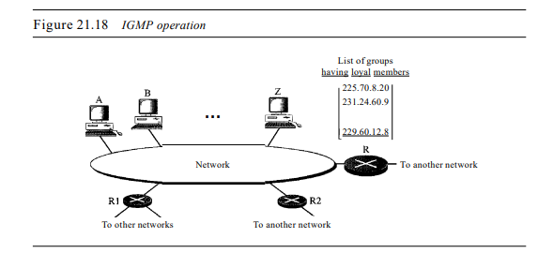

For each group, there is one router that has the duty of distributing the multicast packets destined for that group. This means that if there are three multicast routers connected to a network, their lists of groupids are mutually exclusive. For example, in Figure 21.18 only router R distributes packets with the multicast address of 225.70.8.20. A host or multicast router can have membership in a group.

When a host has membership, it means that one of its processes (an application program) receives multicast packets from some group. When a router has membership, it means that a network connected to one of its other interfaces receives these multicast packets. We say that the host or the router has an interest in the group. In both cases, the host and the router keep a list of groupids and relay their interest to the distributing router. For example, in Figure 21.18, router R is the distributing router. There are two other multicast routers (R1 and R2) that, depending on the group list maintained by router R, could be the recipients of router R in this network. Routers RI and R2 may be distributors for some of these groups in other networks, but not on this network.

**Joining a Group**

A host or a router can join a group. A host maintains a list of processes that have membership in a group. When a process wants to join a new group, it sThe host adds the name of the process and the name of the requested group to its list. If this is the first entry for this particular group, the host sends a membership report message. Ifthis is not the first entry, there is no need to send the membership report since the host is already a member of the group; it already receives multicast packets for this group. The protocol requires that the membership report be sent twice, one after the other within a few moments. In this way, if the first one is lost or damaged, the second one replaces it.

**Leaving a Group**

When a host sees that no process is interested in a specific group, it sends a leave report. Similarly, when a router sees that none of the networks connected to its interfaces is interested in a specific group, it sends a leave report about that group. However, when a multicast router receives a leave report, it cannot immediately purge that group from its list because the report comes from just one host or router; there may be other hosts or routers that are still interested in that group. To make sure, the router sends a special query message and inserts the group id, or multicast address, related to the group. The router allows a specified time for any host or router to respond. If, during this time, no interest (membership report) is received, the router assumes that there are no loyal members in the network and purges the group from its list.

**Monitoring Membership**

A host or router can join a group by sending a membership report message. It can leave a group by sending a leave report message. However, sending these two types of reports is not enough. Consider the situation in which there is only one host interested in a group, but the host is shut down or removed from the system. The multicast router will never receive a leave report. How is this handled? The multicast router is responsible for monitoring all the hosts or routers in a LAN to see if they want to continue their membership in a group. The router periodically (by default, every 125 s) sends a general query message. In this message, the group address field is set to 0.0.0.0. This means the query for membership continuation is for all groups in which a host is involved, not just one.

**Delayed Response**

To prevent unnecessary traffic, IGMP uses a delayed response strategy. When a host or router receives a query message, it does not respond immediately; it delays the response. Each host or router uses a random number to create a timer, which expires between I and lOs. The expiration time can be in steps of I s or less. A timer is set for each group in the list. For example, the timer for the first group may expire in 2 s, but the timer for the third group may expire in 5 s. Each host or router waits until its timer has expired before sending a membership report message. During this waiting time, if the timer of another host or router, for the same group, expires earlier, that host or router sends a membership report. Because, as we will see shortly, the report is broadcast, the waiting host or router receives the report and knows that there is no need to send a duplicate report for this group; thus, the waiting station cancels its corresponding timer

### 83. Explain distance vector routing?

In distance vector routing, the least-cost route between any two nodes is the route with minimum distance. In this protocol, as the name implies, each node maintains a vector (table) of minimum distances to every node. The table at each node also guides the packets to the desired node by showing the next stop in the route (next-hop routing). We can think of nodes as the cities in an area and the lines as the roads connecting them. A table can show a tourist the minimum distance between cities.

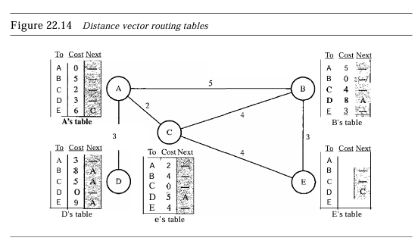

The table for node A shows how we can reach any node from this node. For example, our least cost to reach node E is 6. The route passes through C.

**Initialization**

The tables in Figure 22.14 are stable; each node knows how to reach any other node and the cost. At the beginning, however, this was not the case. Each node can know only SECTION 22.3 UNICAST ROUTING PROTOCOLS 661 the distance between itself and its immediate neighbors, those directly connected to it. So for the moment, we assume that each node can send a message to the immediate neighbors and find the distance between itself and these neighbors. Figure 22.15 shows the initial tables for each node. The distance for any entry that is not a neighbor is marked as infinite (unreachable).

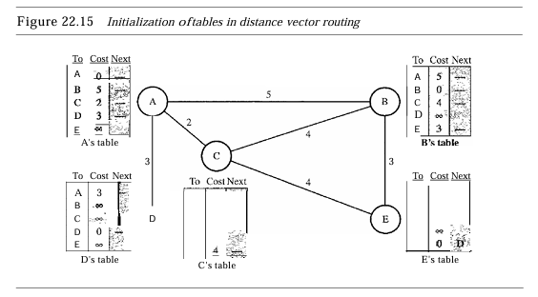

**Sharing**

The whole idea of distance vector routing is the sharing of information between neighbors. Although node A does not know about node E, node C does. So if node C shares its routing table with A, node A can also know how to reach node E. On the other hand, node C does not know how to reach node D, but node A does. If node A shares its routing table with node C, node C also knows how to reach node D. In other words, nodes A and C, as immediate neighbors, can improve their routing tables if they help each other. There is only one problem. How much of the table must be shared with each neighbor? A node is not aware of a neighbor's table.

The best solution for each node is to send its entire table to the neighbor and let the neighbor decide what part to use and what part to discard. However, the third column of a table (next stop) is not useful for the neighbor. When the neighbor receives a table, this column needs to be replaced with the sender's name. If any of the rows can be used, the next node is the sender of the table. A node therefore can send only the first two columns of its table to any neighbor. In other words, sharing here means sharing only the first two columns. In distance vector routing, each node shares its routing table with its immediate neighbors periodically and when there is a change.

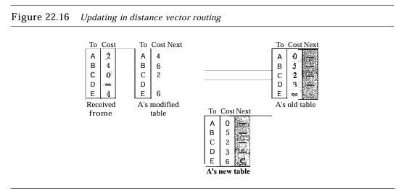

**Updating**

When a node receives a two-column table from a neighbor, it needs to update its routing table. Updating takes three steps: 1. The receiving node needs to add the cost between itself and the sending node to each value in the second column. The logic is clear. If node C claims that its distance to a destination is x mi, and the distance between A and C is y mi, then the distance between A and that destination, via C, is x + y mi. 2. The receiving node needs to add the name of the sending node to each row as the third column if the receiving node uses information from any row.

The sending node is the next node in the route. 3. The receiving node needs to compare each row of its old table with the corresponding row of the modified version of the received table. a. If the next-node entry is different, the receiving node chooses the row with the smaller cost. If there is a tie, the old one is kept. b. If the next-node entry is the same, the receiving node chooses the new row. For example, suppose node C has previously advertised a route to node X with distance 3. Suppose that now there is no path between C and X; node C now advertises this route with a distance of infinity. Node A must not ignore this value even though its old entry is smaller. The old route does not exist any more. The new route has a distance of infinity

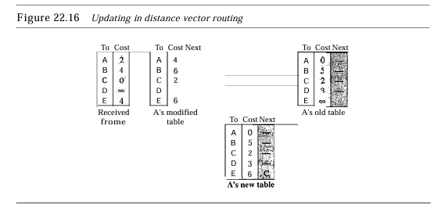

Each node can update its table by using the tables received from other nodes. In a short time, if there is no change in the network itself, such as a failure in a link, each node reaches a stable condition in which the contents of its table remain the same. When to

share the question now is, When does a node send its partial routing table (only two columns) to all its immediate neighbors?

The table is sent both periodically and when there is a change in the table. Periodic Update A node sends its routing table, normally every 30 s, in a periodic update. The period depends on the protocol that is using distance vector routing. Triggered Update A node sends its two-column routing table to its neighbors any time there is a change in its routing table. This is called a triggered update. The change can result from the following.

**1.** A node receives a table from a neighbor, resulting in changes in its own table after updating.

**2.** A node detects some failure in the neighboring links which results in a distance change to infinity.



Figure 22.17 shows a system with three nodes. We have shown only the portions of the routing table needed for our discussion. At The beginning, both nodes A and B know how to reach node X. Butsuddenly, the linkbetweenA and X fails. NodeA changes its table. IfA can send its table to B immediately, everything is fine. However, the system becomes unstable if B sends its routing table to A before receiving A's routing table. NodeA receives the update and, assuming that B has found a way to reach X, immediately updates its routing table. Based on the triggered update strategy, A sends its new 664 update to B. Now B thinks that something has been changed around A and updates its routing table. The cost of reaching X increases gradually until it reaches infinity. At this moment, both A and B know that X cannot be reached.

However, during this time the system is not stable. Node A thinks that the route to X is via B; node B thinks that the route to X is via A. IfA receives a packet destined for X, it goes to B and then comes back to A. Similarly, ifB receives a packet destined for X, it goes to A and comes back toB. Packets bounce betweenA and B, creating a two-node loop problem. A few solutions have been proposed for instability of this kind. Defining Infinity The first obvious solution is to redefine infinity to a smaller number, such as 100. For our previous scenario, the system will be stable in less than 20 updates. As a matter of fact, most implementations of the distance vector protocol define the distance between each node to be I and define 16 as infinity.

However, this means that the distance vector routing cannot be used in large systems. The size of the network, in each direction, can not exceed 15 hops. Split Horizon Another solution is called split horizon. In this strategy, instead of flooding the table through each interface, each node sends only part of its table through each interface. If, according to its table, node B thinks that the optimum route to reach X is viaA, it does not need to advertise this piece of information to A; the information has come from A (A already knows). Taking information from node A, modifying it, and sending it back to node A creates the confusion. In our scenario, node B eliminates the last line of its routing table before it sends it to A.

In this case, node A keeps the value of infinity as the distance to X. Later when node A sends its routing table to B, node B also corrects its routing table. The system becomes stable after the first update: both node A and B know thatX is not reachable. Split Horizon and Poison Reverse Using the split horizon strategy has one drawback. Normally, the distance vector protocol uses a timer, and if there is no news about a route, the node deletes the route from its table. When node B in the previous scenario eliminates the route to X from its advertisement to A, node A cannot guess that this is due to the split horizon strategy (the source of information was A) or because B has not received any news about X recently. The split horizon strategy can be combined with the poison reverse strategy. Node B can still advertise the value for X, but if the source of information is A, it can replace the distance with infinity as a warning: "Do not use this value; what I know about this route comes from you.

**RIP**

The Routing Information Protocol (RIP) is an intradomain routing protocol used inside an autonomous system. It is a very simple protocol based on distance vector routing. RIP implements distance vector routing directly with some considerations:

1. In an autonomous system, we are dealing with routers and networks (links). The routers have routing tables; networks do not.
2. The destination in a routing table is a network, which means the first column defines a network address.
3. The metric used by RIP is very simple; the distance is defined as the number of links (networks) to reach the destination. For this reason, the metric in RIP is called a hop count. Infinity is defined as 16, which means that any route in an autonomous system using RIP cannot have more than 15 hops.
4. The Next-node column defines the address of the router to which the packet is to be sent to reach its destination.

Figure 22.19 shows an autonomous system with seven networks and four routers. The table of each router is also shown. Let us look at the routing table for Rl. The table has seven entries to show how to reach each network in the autonomous system. Router Rl is directly connected to networks 130.10.0.0 and 130.11.0.0, which means that there are no next-hop entries for these two networks. To send a packet to one of the three networks at the far left, router Rl needs to deliver the packet to R2. The next-node entry for these three networks is the interface of router R2 with IP address 130.10.0.1. To send a packet to the two networks at the far right, router Rl needs to send the packet to the interface of router R4 with IP address 130.11.0.1. The other tables can be explained similarly.

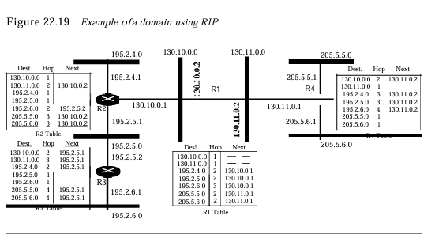

### 84. Explain link state routing?

Link state routing has a different philosophy from that of distance vector routing. In link state routing, if each node in the domain has the entire topology of the domain the list of nodes and links, how they are connected including the type, cost (metric), and condition of the links (up or down)-the node can use Dijkstra's algorithm to build a routing table.

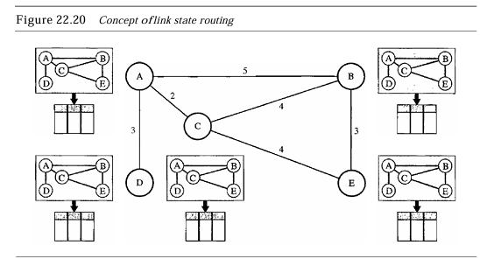

Each node uses the same topology to create a routing table, but the routing table for each node is unique because the calculations are based on different interpretations of the topology. This is analogous to a city map. While each person may have the same map, each needs to take a different route to reach her specific destination

The topology must be dynamic, representing the latest state of each node and each link. Ifthere are changes in any point in the network (a link is down, for example), the topology must be updated for each node. How can a common topology be dynamic and stored in each node? No node can know the topology at the beginning or after a change somewhere in the network. Link state routing is based on the assumption that, although the global knowledge about the topology is not clear, each node has partial knowledge: it knows the state (type, condition, and cost) of its links

In other words, the whole topology can be compiled from the partial knowledge of each node.

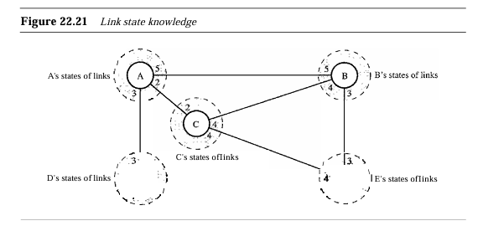

In link state routing, four sets of actions are required to ensure that each node has the routing table showing the least-cost node to every other node.

1. Creation of the states of the links by each node, called the link state packet (LSP).
2. Dissemination of LSPs to every other router, called flooding, in an efficient and reliable way
3. Formation of a shortest path tree for each node.
4. Calculation of a routing table based on the shortest path tree.
5. Flooding of LSPs After a node has prepared an LSP, it must be disseminated to all other nodes, not only to its neighbors. The process is called flooding and based on the following:
   * The creating node sends a copy of the LSP out of each interface.
   * A node that receives an LSP compares it with the copy it may already have. Ifthe newly arrived LSP is older than the one it has (found by checking the sequence number), it discards the LSP. Ifit is newer, the node does the following: a. It discards the old LSP and keeps the new one. b. It sends a copy of it out of each interface except the one from which the packet arrived. This guarantees that flooding stops somewhere in the domain (where a node has only one interface). Formation ofShortestPath Tree: DijkstraAlgorithm After receiving all LSPs, each node will have a copy of the whole topology. However, the topology is not sufficient to find the shortest path to every other node; a shortest path tree is needed.

A tree is a graph of nodes and links; one node is called the root. All other nodes can be reached from the root through only one single route. A shortest path tree is a tree in which the path between the root and every other node is the shortest. What we need for each node is a shortest path tree with that node as the root. The Dijkstra algorithm creates a shortest path tree from a graph. The algorithm divides the nodes into two sets: tentative and permanent. It finds the neighbors of a current node, makes them tentative, examines them, and if they pass the criteria, makes them permanent. We can informally define the algorithm by using the flowchart in Figure 22.22. Let us apply the algorithm to node A of our sample graph in Figure 22.23. To find the shortest path in each step, we need the cumulative cost from the root to each node, which is shown next to the node. The following shows the steps. At the end of each step, we show the permanent (filled circles) and the tentative (open circles) nodes and lists with the cumulative costs.

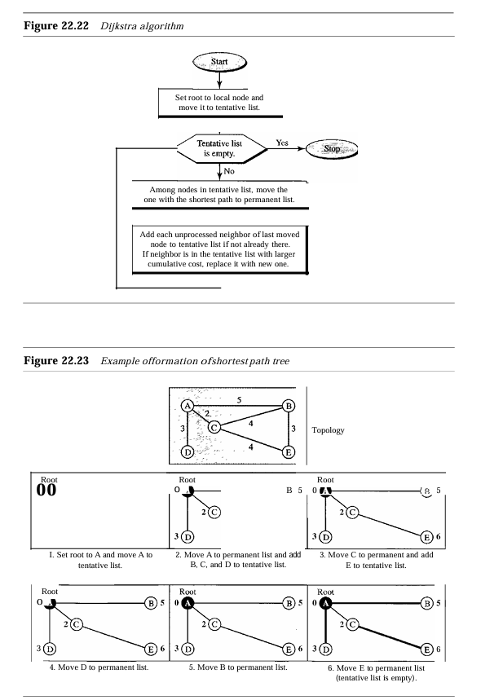

* + We made a node at the root of the tree and moved to the tentative list. Our two lists are Permanent list: empty Tentative list: A(O)
  + NodeA has the shortest cumulative cost from all nodes in the tentative list. We moveA to the pennant list and add all neighbors ofA to the tentative list. Our New lists are Permanentlist: A(O) Tentative list: B(5), C(2), D(3)
  + NodeC has the shortest cumulative cost from all nodes in the tentative list. We move C to the permanent list. Node C has three neighbors, but node A is already processed, which makes the unprocessed neighborsjustB and E. However, B is already in the tentative list with a cumulative cost of 5. Node A could also reach node B through C with a cumulative costof6. Since 5 is less than 6, we keep node B with a cumulative costof5 in the tentative list and do not replace it. Our new lists are Permanent list: A(O), e(2) Tentative list: B(5), 0(3), E(6)
  + Node D has the shortest cumulative cost of all the nodes in the tentative list. We moveD to the permanent list. Node D has no unprocessed neighbor to be added to the tentative list. Our new lists are Permanentlist: A(O), C(2), 0(3) Tentative list: B(5), E(6)
  + Node B has the shortest cumulative cost of all the nodes in the tentative list. We moveB to the permanent list. We need to add all unprocessed neighbors ofB to the tentative list (this is just node E). However, E(6) is already in the list with a smaller cumulative cost. The cumulative cost to node E, as the neighbor ofB, is 8. We keep node E(6) in the tentative list. Our new lists are Permanent list: A(O), B(5), C(2), 0(3) Tentative list: E(6)
  + Node E has the shortest cumulative cost from all nodes in the tentative list. We move E to the permanent list. Node E has no neighbor. Now the tentative list is empty. We stop; our shortest path tree is ready. The final lists are Permanentlist: A(O), B(5), C(2), D(3), E(6) Tentative list: empty Calculation ofRouting Table from Shortest Path Tree Each node uses the shortest path tree protocol to construct its routing table. The routing table shows the cost of reaching each node from the root. Table 22.2 shows the routing table for nodeA.

**OSPF**

The Open Shortest Path First or OSPF protocol is an intradomain routing protocol based on link state routing. Its domain is also an autonomous system. Areas To handle routing efficiently and in a timely manner, OSPF divides an autonomous system into areas. An area is a collection of networks, hosts, and routers all contained within an autonomous system. An autonomous system can be divided into many different areas. All networks inside an area must be connected. Routers inside an area flood the area with routing information. At the border of an area, special routers called area border routers summarize the information about the area and send it to other areas. Among the areas inside an autonomous system is a special area called the backbone; all the areas inside an autonomous system must be connected to the backbone.

In other words, the backbone serves as a primary area and the other areas as secondary areas. This does not mean that the routers within areas cannot be connected to each other, however. The routers inside the backbone are called the backbone routers. Note that a backbone router can also be an area border router. If, because of some problem, the connectivity between a backbone and an area is broken, a virtual link between routers must be created by an administrator to allow continuity of the functions of the backbone as the primary area. Each area has an area identification. The area identification of the backbone is zero. Figure 22.24 shows an autonomous system and its areas.

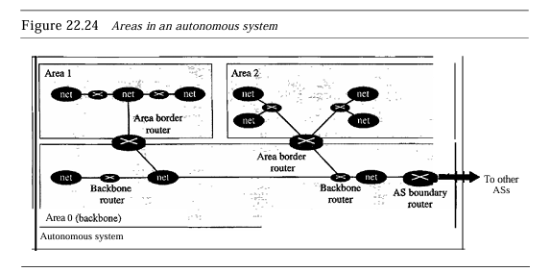

Metric TheOSPFprotocol allows the administrator to assign a cost, called the metric, to each route. The metric can be based on a type of service (minimum delay, maximum throughput, and so on). As a matter of fact, a router can have multiple routing tables, each based on a different type of service. Types ofLinks In OSPF terminology, a connection is called a link. Four types of links have been defined: point-to-point, transient, stub, and virtual (see Figure 22.25)

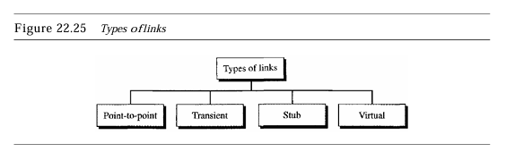

A point-to-point link connects two routers without any other host or router in between. In other words, the purpose of the link (network) is just to connect the two routers. An example of this type of link is two routers connected by a telephone line or a T line. There is no need to assign a network address to this type of link. Graphically, the routers are represented by nodes, and the link is represented by a bidirectional edge connecting the nodes. The metrics, which are usually the same, are shown at the two ends, one for each direction. In other words, each router has only one neighbor at the other side of the link (see Figure 22.26).

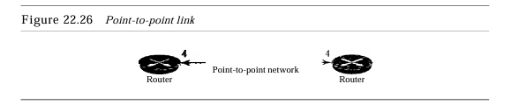

A transient link is a network with several routers attached to it. The data can enter through any of the routers and leave through any router. All LANs and someWANs with two or more routers are of this type. In this case, each router has many neighbors. For example, consider the Ethernet in Figure 22.27a. Router A has routers B, C, D, and E as neighbors. Router B has routers A, C, D, and E as neighbors. Ifwe want to show the neighborhood relationship in this situation, we have the graph shown in Figure 22.27b.

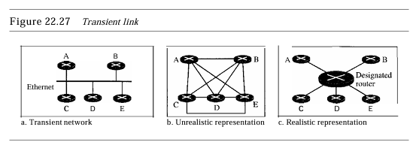

Graphical Representation Let us now examine how an AS can be represented graphically. Figure 22.29 shows a small AS with seven networks and six routers. Two of the networks are point-to-point networks. We use symbols such as Nl and N2 for transient and stub networks. There is no need to assign an identity to a point-to-point network. The figure also shows the graphical representation of the AS as seen by OSPF. We have used square nodes for the routers and ovals for the networks (represented by designated routers). However, OSPF sees both as nodes. Note that we have three stub networks.

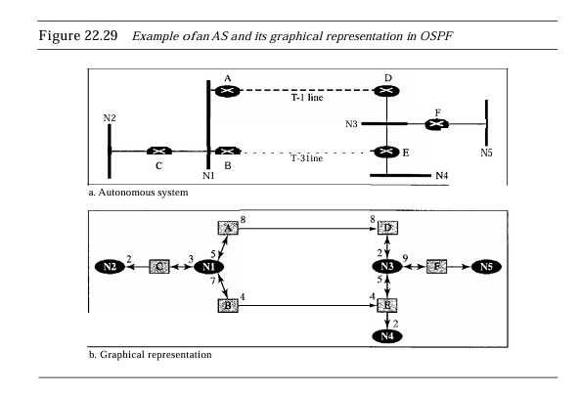

### 85. Explain path vector routing?

Distance vector and link state routing are both intradomain routing protocols. They can be used inside an autonomous system, but not between autonomous systems. These two protocols are not suitable for interdomain routing mostly because of scalability. Both of these routing protocols become intractable when the domain of operation becomes large. Distance vector routing is subject to instability if there are more than a few hops in the domain of operation. Link state routing needs a huge amount of resources to calculate routing tables. It also creates heavy traffic because of flooding. There is a need for a third routing protocol which we call path vector routing. Path vector routing proved to be useful for interdomain routing.

The principle of path vector routing is similar to that of distance vector routing. In path vector routing, we assume that there is one node (there can be more, but one is enough for our conceptual discussion) in each autonomous system that acts on behalf of the entire autonomous system. Let us call it the speaker node. The speaker node in an AS creates a routing table and advertises it to speaker nodes in the neighboring ASs. The idea is the same as for distance vector routing except that only speaker nodes in each AS can communicate with each other. However, what is advertised is different. A speaker node advertises the path, not the metric of the nodes, in its autonomous system or other autonomous systems.

**Initialization**

At the beginning, each speaker node can know only the reachability of nodes inside its autonomous system. Figure 22.30 shows the initial tables for each speaker node in a system made of four As.

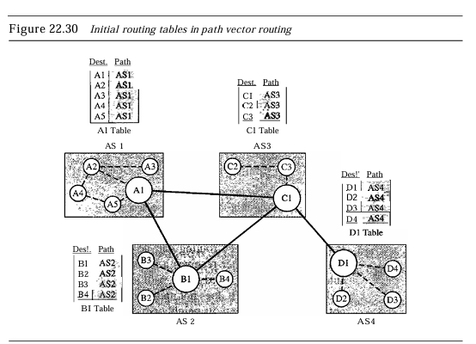

Node Al is the speaker node for ASl, Bl for AS2, Cl for AS3, and Dl for AS4. Node Al creates an initial table that shows All to A5 are located in ASI and can be reached through it. Node Bl advertises that Bl to B4 are located in AS2 and can be reached through Bl.And so on. Sharing Just as in distance vector routing, in path vector routing, a speaker in an autonomous system shares its table with immediate neighbors. In Figure 22.30, node Al shares its table with nodes Bl and Cl. Node Cl shares its table with nodes Dl, Bl, andAl. Node Bl shares its table with Cl andAl.

Node Dl shares its table with Cl. Updating When a speaker node receives a two-column table from a neighbor, it updates its own table by adding the nodes that are not in its routing table and adding its own autonomous system and the autonomous system that sent the table. After a while each speaker has a table and knows how to reach each node in otherASs. Figure 22.31 shows the tables for each speaker node after the system is stabilized. According to the figure, if route Al receives a packet for nodes A3, it knows that the path is in ASI (the packet is at home); but if it receives a packet for Dl, it knows that the packet should go from ASl, to AS2, and then to AS3. The routing table shows the path completely. On the other hand, if node Dl in AS4 receives a packet for node A2, it knows it should go through AS4, AS3, andAS1. o Loop prevention. The instability of distance vector routing and the creation of loops can be avoided in path vector routing. When a router receives a message, it checks to see if its autonomous system is in the path list to the destination. Ifit is, looping is involved and the message is ignored.

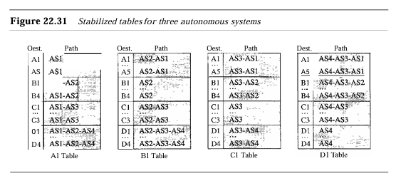

**Policy routing.** Policy routing can be easily implemented through path vector routing. When a router receives a message, it can check the path. Ifone of the autonomous systems listed in the path is against its policy, it can ignore that path and that destination. It does not update its routing table with this path, and it does not send this message to its neighbors.

**Optimum Path.** What Is the optimum path in path vector routing? We are looking for a path to a destination that is the best for the organization that runs the autonomous system. We definitely cannot include metrics in this route because each autonomous system that is included in the path may use a different criterion for the metric. One system may use, internally, RIP, which defines hop count as the metric; another may use OSPF with minimum delay defined as the metric.

The optimum path is the path that fits the organization. In our previous figure, each autonomous system may have more than one path to a destination. For example, a path from AS4 to ASI can beAS4-AS3-AS2-AS1, oritcanbeAS4-AS3-ASI. For The tables, we chose the one that had the smaller number of autonomous systems, but this is not always the case. Other criteria, such as security, safety, and reliability, can also be applied.

**BGP**

Border Gateway Protocol (BGP) is an interdomain routing protocol using path vector routing. It first appeared in 1989 and has gone through four versions. Types ofAutonomous Systems As we said before, the Internet is divided into hierarchical domains called autonomous systems. For example, a large corporation that manages its own network and has full control over it is an autonomous system. A local ISP that provides services to local customers is an autonomous system. We can divide autonomous systems into three categories: stub, multihomed, and transit.

* **StubAS.** A stub AS has only one connection to another AS. The interdomain data traffic in a stubAS can be either created or terminated in the US. The hosts in the AS can send data traffic to otherASs. The hosts in the AS can receive data coming from hosts in otherASs. Datatraffic, however, cannot pass through a stub AS. A stub AS is either a source or a sink. A good example of a stub AS is a small corporation or a small local ISP.
* **Multihomed AS.** A multihomed AS has more than one connection to other ASs, but it is still only a source or sink for data traffic. It can receive data traffic from more than oneAS. Itcan send data traffic to more than one AS, but there is no transient traffic. It does not allow data coming from one AS and going to another AS to pass through. A good example of a multihomed is a large corporation that is connected to more than one regional or national AS that does not allow transient traffic.
* **TransitAS.** A transitAS is a multihomed AS that also allows transient traffic. Good examples of transit ASs are national and international ISPs (Internet backbones). Path Attributes In our previous example, we discussed a path for a destination network. The path was presented as a list of autonomous systems, but is, in fact, a list of attributes. Each attribute gives some information about the path.

The list of attributes helps the receiving router make a more-informed decision when applying its policy. Attributes are divided into two broad categories: **well known** and **optional.**

* **A well known** attribute is one that every BGP router must recognize. An optional attribute is one that needs not be recognized by every router. Well-known attributes are themselves divided into two categories: **mandatory** and **discretionary**.
  + **A well-known mandatory attribute** is one that must appear in the description of a route.
  + **A well-known discretionary attribute** is one that must be recognized by each router, but is not required to be included in every update message.

One well known mandatory attribute is ORIGIN. This defines the source of the routing information (RIP, OSPF, and so on). Another well-known mandatory attribute is AS_PATH. This defines the list of autonomous systems through which the destination can be reached. Still another well-known mandatory attribute is NEXT-HOP, which defines the next router to which the data packet should be sent.

* **The optional attributes** can also be subdivided into two categories: **transitive** and **non transitive.**
  + **An optional transitive attribute** is one that must be passed to the next router by the router that has not implemented this attribute.
  + **An optional non transitive attribute** is one that must be discarded if the receiving router has not implemented it.

BGPSessions The exchange of routing information between two routers using BGP takes place in a session. A session is a connection that is established between two BGP routers only for the sake of exchanging routing information. To create a reliable environment, BGP uses the services ofTCP. In other words, a session at the BGP level, as an application program, is a connection at the TCP level.

However, there is a subtle difference between a connection in TCP made for BGP and other application programs. When aTCPconnectionis created for BGP, it can last for a long time, until something unusual happens. For this reason, BGP sessions are sometimes referred to as semi permanent connections. External and Internal BGP If We want to be precise, BGP can have two types of sessions: external BGP (E-BGP) and internal BGP (I-BGP) sessions. The E-BGP session is used to exchange information between two speaker nodes belonging to two different autonomous systems. The I-BGP session, on the other hand, is used to exchange routing information between two routers inside an autonomous system. Figure 22.32 shows the idea.

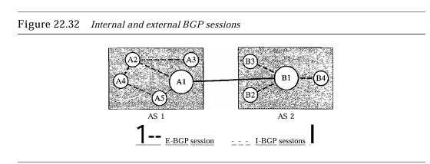

The session established betweenAS1andAS2 is an E-BOP session. The two speaker routers exchange information they know about networks on the Internet. However, these two routers need to collect information from other routers in the autonomous systems. This is done using I-BOP sessions.

### 86. Explain UDP protocol?

The User Datagram Protocol (UDP) is called a connectionless, unreliable transport protocol. It does not add anything to the services of IP except to provide process-to process communication instead of host-to-host communication. Also, it performs very limited error checking. If UDP is so powerless, why would a process want to use it? With the disadvantages come some advantages.

**User Datagram**

UDP packets, called user datagrams, have a fixed-size header of 8 bytes. Figure 23.9 shows the format of a user datagram. The fields are as follows: o Source port number. This is the port number used by the process running on the source host. It is 16 bits long, which means that the port number can range from 0 to 65,535. If The source host is the client (a client sending a request), the port number, in most cases, is an ephemeral port number requested by the process and chosen by the UDP software running on the source host. If the source host is the server (a server sending a response), the port number, in most cases, is a well-known port number.

**Destination port number.** This is the port number used by the process running on the destination host. It is also 16 bits long. If the destination host is the server (a client sending a request), the port number, in most cases, is a well-known port number. If the destination host is the client (a server sending a response), the port number, in most cases, is an ephemeral port number. In this case, the server copies the ephemeral port number it has received in the request packet.

**Length.** This is a 16-bit field that defines the total length of the user datagram, header plus data. The 16 bits can define a total length of 0 to 65,535 bytes. However, the total length needs to be much less because a UDP user datagram is stored in an IP datagram with a total length of 65,535 bytes.

The length field in a UDP user datagram is actually not necessary. A user datagram is encapsulated in an IP datagram. There is a field in the IP datagram that defines the total length. There is another field in the IP datagram that defines the length of the header. So if we subtract the value of the second field from the first, we can deduce the length of a UDP datagram that is encapsulated in an IP datagram

**UDP length = IP length - IP header's length.**

**Checksum**. This field is used to detect errors over the entire user datagram (header plus data). The checksum is discussed next.

**UDP Operation**

UDP uses concepts common to the transport layer. These concepts will be discussed here briefly, and then expanded in the next section on the TCP protocol.

**Connectionless Services**

As mentioned previously, UDP provides a connectionless service. This means that each user datagram sent by UDP is an independent datagram. There is no relationship between the different user datagrams even if they are coming from the same source process and going to the same destination program. The user datagrams are not numbered.

Also, there is no connection establishment and no connection termination, as is the case for TCP. This means that each user datagram can travel on a different path. One of the ramifications of being connectionless is that the process that uses UDP cannot send a stream of data to UDP and expect UDP to chop them into different related user datagrams. Instead each request must be small enough to fit into one user datagram. Only those processes sending short messages should use UDP.

**Flow and Error Control**

UDP is a very simple, unreliable transport protocol. There is no flow control and hence no window mechanism. The receiver may overflow with incoming messages. There is no error control mechanism in UDP except for the checksum. This means that the sender does not know if a message has been lost or duplicated. When the receiver detects an error through the checksum, the user datagram is silently discarded. The lack of flow control and error control means that the process using UDP should provide these mechanisms. Encapsulation and Decapsulation To send a message from one process to another, the UDP protocol.

**Encapsulation and Decapsulation**

To send a message from one process to another, the UDP protocol encapsulates and decapsulates messages in an IP datagram

**Queuing**

We have talked about ports without discussing the actual implementation of them. In UDP, queues are associated with ports.

**Use of UDP**

The following lists some uses of the UDP protocol:

* UDP is suitable for a process that requires simple request-response communication with little concern for flow and error control. It is not usually used for a process such as FrP that needs to send bulk data (see Chapter 26).
* UDP is suitable for a process with internal flow and error control mechanisms. For example, the Trivial File Transfer Protocol (TFTP) process includes flow and error control. It can easily use UDP.
* UDP is a suitable transport protocol for multicasting. Multicasting capability is embedded in the UDP software but not in the TCP software. o UDP is used for management processes such as SNMP (see Chapter 28).
* UDP is used for some route updating protocols such as Routing Information Protocol (RIP)

### 87. Explain TCP protocol?

The second transport layer protocol we discuss in this chapter is called Transmission Control Protocol (TCP). TCP, like UDP, is a process-to-process (program-to-program) protocol. TCP, therefore, like UDP, uses port numbers. Unlike UDP, TCP is a connection oriented protocol; it creates a virtual connection between two TCPs to send data. In addition, TCP uses flow and error control mechanisms at the transport level. In brief, TCP is called a connection-oriented, reliable transport protocol. It adds connection-oriented and reliability features to the services of IP.

**TCP Services**

Before we discuss TCP in detail, let us explain the services offered by TCP to the processes at the application layer.

**Process-to-Process Communication**

Like UDP, TCP provides process-to-process communication using port numbers. Table 23.2 lists some well-known port numbers used by TCP.

**Stream Delivery Service**

TCP, unlike UDP, is a stream-oriented protocol. In UDP, a process (an application program) sends messages, with predefined boundaries, to UDP for delivery. UDP adds its own header to each of these messages and delivers them to IP for transmission. Each message from the process is calIed a user datagram and becomes, eventually, one IP datagram. Neither IP nor UDP recognizes any relationship between the datagrams. TCP, on the other hand, allows the sending process to deliver data as a stream of bytes and allows the receiving process to obtain data as a stream of bytes.

TCP creates an environment in which the two processes seem to be connected by an imaginary "tube" that carries their data across the Internet. This imaginary environment is depicted in Figure 23.13. The sending process produces (writes to) the stream of bytes, and the receiving process consumes (reads from) them.

**Full-Duplex Communication**

TCP offers full-duplex service, in which data can flow in both directions at the same time. Each TCP then has a sending and receiving buffer, and segments move in both directions.

**Connection-Oriented Service**

TCP, unlike UDP, is a connection-oriented protocol. When a process at site A wants to send and receive data from another process at site B, the following occurs:

1. The two TCPs establish a connection between them.
2. Data is exchanged in both directions.
3. The connection is terminated.

**Reliable Service**

TCP is a reliable transport protocol. It uses an acknowledgment mechanism to check the safe and sound arrival of data. We will discuss this feature further in the section on error control.

**TCP Features**

**Numbering System**

Although the TCP software keeps track of the segments being transmitted or received, there is no field for a segment number value in the segment header. Instead, there are two fields called the sequence number and the acknowledgment number. These two fields refer to the byte number and not the segment number. Byte Number TCP numbers all data bytes that are transmitted in a connection. Numbering is independent in each direction. When TCP receives bytes of data from a process, it stores them in the sending buffer and numbers them.

The numbering does not necessarily start from O. Instead, TCP generates a random number between 0 and 232 - 1 for the number of the first byte. For example, if the random number happens to be 1057 and the total data to be sent are 6000 bytes, the bytes are numbered from 1057 to 7056. We will see that byte numbering is used for flow and error control. The bytes of data being transferred in each connection are numbered by TCP. The numbering starts with a randomly generated number.

Sequence Number After the bytes have been numbered, TCP assigns a sequence number to each segment that is being sent. The sequence number for each segment is the number of the first byte carried in that segment

**Flow Control**

TCP, unlike UDP, provides flow control. The receiver of the data controls the amount of data that is to be sent by the sender. This is done to prevent the receiver from being overwhelmed with data. The numbering system allows TCP to use a byte-oriented flow control.

**Error Control**

To provide reliable service, TCP implements an error control mechanism. Although error control considers a segment as the unit of data for error detection (loss or corrupted segments), error control is byte-oriented, as we will see later.

**Congestion Control**

TCP, unlike UDP, takes into account congestion in the network. The amount of data sent by a sender is not only controlled by the receiver (flow control), but is also determined by the level of congestion in the network.

**Segment**

Before we discuss TCP in greater detail, let us discuss the TCP packets themselves. A packet in TCP is called a segment

**A TCP Connection**

TCP is connection-oriented. A connection-oriented transport protocol establishes a virtual path between the source and destination. All the segments belonging to a message are then sent over this virtual path. Using a single virtual pathway for the entire message facilitates the acknowledgment process as well as retransmission of damaged or lost frames. You may wonder how TCP, which uses the services of IP, a connectionless protocol, can be connection-oriented.

The point is that a TCP connection is virtual, not physical. TCP operates at a higher level. TCP uses the services of IP to deliver individual segments to the receiver, but it controls the connection itself. If a segment is lost or corrupted, it is retransmitted. Unlike TCP, IP is unaware of this retransmission. If a segment arrives out of order, TCP holds it until the missing segments arrive; IP is unaware of this reordering. In TCP, connection-oriented transmission requires three phases: connection establishment, data transfer, and connection termination.

### 

### 88. Explain open loop congestion control method?

**Open-Loop Congestion Control** In open-loop congestion control, policies are applied to prevent congestion before it happens. In these mechanisms, congestion control is handled by either the source or the destination. We give a brief list of policies that can prevent congestion.

**Retransmission Policy**

Retransmission is sometimes unavoidable. If the sender feels that a sent packet is lost or corrupted, the packet needs to be retransmitted. Retransmission in general may increase congestion in the network. However, a good retransmission policy can prevent congestion. The retransmission policy and the retransmission timers must be designed to optimize efficiency and at the same time prevent congestion. For example, the retransmission policy used by TCP (explained later) is designed to prevent or alleviate congestion.

**Window Policy**

The type of window at the sender may also affect congestion. The Selective Repeat window is better than the Go-Back-N window for congestion control. In the Go-Back-N window, when the timer for a packet times out, several packets may be resent, although some may have arrived safe and sound at the receiver. This duplication may make the congestion worse. The Selective Repeat window, on the other hand, tries to send the specific packets that have been lost or corrupted.

**Acknowledgment Policy**

The acknowledgment policy imposed by the receiver may also affect congestion. If The receiver does not acknowledge every packet it receives, it may slow down the sender and help prevent congestion. Several approaches are used in this case. A receiver may send an acknowledgment only if it has a packet to be sent or a special timer expires. A receiver may decide to acknowledge only N packets at a time. We need to know that the acknowledgments are also part of the load in a network. Sending fewer acknowledgments means imposing less load on the network.

**Discarding Policy**

A good discarding policy by the routers may prevent congestion and at the same time may not harm the integrity of the transmission. For example, in audio transmission, if the policy is to discard less sensitive packets when congestion is likely to happen, the quality of sound is still preserved and congestion is prevented or alleviated.

**Admission Policy**

An admission policy, which is a quality-of-service mechanism, can also prevent congestion in virtual-circuit networks. Switches in a flow first check the resource requirement of a flow before admitting it to the network. A router can deny establishing a virtual circuit connection if there is congestion in the network or if there is a possibility of future congestion.

### 89. Explain closed loop congestion control method?

**Closed-loop congestion control** mechanisms try to alleviate congestion after it happens. Several mechanisms have been used by different protocols. We describe a few of them here.

**Backpressure**

The technique of backpressure refers to a congestion control mechanism in which a congested node stops receiving data from the immediate upstream node or nodes. This may cause the upstream node or nodes to become congested, and they, in turn, reject data from their upstream nodes or nodes. And so on.

Backpressure is a node-to-node congestion control that starts with a node and propagates, in the opposite direction of data flow, to the source. The backpressure technique can be applied only to virtual circuit networks, in which each node knows the upstream node from which a flow of data is corning.

**Choke Packet**

A choke packet is a packet sent by a node to the source to inform it of congestion. Note the difference between the backpressure and choke packet methods. In backpressure, the warning is from one node to its upstream node, although the warning may eventually reach the source station. In the choke packet method, the warning is from the router, which has encountered congestion, to the source station directly.

The intermediate nodes through which the packet has traveled are not warned. We have seen an example of this type of control in ICMP. When a router in the Internet is over with IP datagrams, it may discard some of them; but it informs the source host, using a source quench ICMP message. The warning message goes directly to the source station; the intermediate routers, and does not take any action. Figure 24.7 shows the idea of a choke packet.

**Implicit Signaling**

In implicit signaling, there is no communication between the congested node or nodes and the source. The source guesses that there is congestion somewhere in the network from other symptoms. For example, when a source sends several packets and there is no acknowledgement for a while, one assumption is that the network is congested. The delay in receiving an acknowledgment is interpreted as congestion in the network; the source should slow down. We will see this type of signaling when we discuss TCP congestion control later in the chapter.

**Explicit Signaling**

The node that experiences congestion can explicitly send a signal to the source or destination. The explicit signaling method, however, is different from the choke packet method. In the choke packet method, a separate packet is used for this purpose; in the explicit signaling method, the signal is included in the packets that carry data. Explicit signaling, as we will see in Frame Relay congestion control, can occur in either the forward or the backward direction.

**Backward Signaling**

A bit can be set in a packet moving in the direction opposite to the congestion. This bit can warn the source that there is congestion and that it needs to slow down to avoid the discarding of packets.

**Forward Signaling**

A bit can be set in a packet moving in the direction of the congestion. This bit can warn the destination that there is congestion. The receiver in this case can use policies, such as slowing down the acknowledgments, to alleviate the congestion.

### 

### 90. Explain congestion control in TCP?

**Congestion Window**

We talked about flow control and tried to discuss solutions when the receiver is overwhelmed with data. We said that the sender window size is determined by the available buffer space in the receiver (rwnd). In other words, we assume that it is only the receiver that can dictate to the sender the size of the sender's window. We totally ignored another entity here-the network. If the network cannot deliver the data as fast as they are created by the sender, it must tell the sender to slow down. In other words, in addition to the receiver, the network is a second entity that determines the size of the sender's window.

Today, the sender's window size is determined not only by the receiver but also by congestion in the network. The sender has two pieces of information: the receiver-advertised window size and the congestion window size. The actual size of the window is the minimum of these two. Actual window size;minimum (rwnd, cwnd) We show shortly how the size of the congestion window (cwnd) is determined.

**Congestion Policy**

TCP's general policy for handling congestion is based on three phases: slow start, congestion avoidance, and congestion detection. In the slow-start phase, the sender starts with a very slow rate of transmission, but increases the rate rapidly to reach a threshold. When the threshold is reached, the data rate is reduced to avoid congestion. Finally if congestion is detected, the sender goes back to the slow-start or congestion avoidance phase based on how the congestion is detected. Slow Start: Exponential Increase One of the algorithms used in TCP congestion control is called slow start. This algorithm is based on the idea that the size of the congestion window (cwnd) starts with one maximum segment size (MSS).

The MSS is determined during connection establishment by using an option of the same name. The size of the window increases one MSS each time an acknowledgment is received. As the name implies, the window starts slowly, but grows exponentially. To show the idea, let us look at Figure 24.8. Note that we have used three simplifications to make the discussion more understandable. We have used segment numbers instead of byte numbers (as though each segment contains only 1 byte). We have assumed that rwnd is much higher than cwnd, so that the sender window size always equals cwnd. We have assumed that each segment is acknowledged individually.

The sender starts with cwnd =1 MSS. This means that the sender can send only one segment. After receipt of the acknowledgment for segment 1, the size of the congestion window is increased by 1, which means that cwnd is now 2. Now two more segments can be sent. When each acknowledgment is received, the size of the window is increased by 1 MSS. When all seven segments are acknowledged, cwnd = 8.

**Congestion Avoidance:** Additive Increase If we start with the slow-start algorithm, the size of the congestion window increases exponentially. To avoid congestion before it happens, one must slow down this exponential growth. TCP defines another algorithm called congestion avoidance, which undergoes an additive increase instead of an exponential one. When the size of the congestion window reaches the slow-start threshold, the slow-start phase stops and the additive phase begins. In this algorithm, each time the whole window of segments is acknowledged (one round), the size of the congestion window is increased by 1. To show the idea, we apply this algorithm to the same scenario as slow start, although we will see that the congestion avoidance algorithm usually starts when the size of the window is much greater than 1.

**Congestion Detection:** Multiplicative Decrease If congestion occurs, the congestion window size must be decreased. The only way the sender can guess that congestion has occurred is by the need to retransmit a segment. However, retransmission can occur in one of two cases: when a timer times out or when three ACKs are received. In both cases, the size of the threshold is dropped to one-half, a multiplicative decrease. Most TCP implementations have two reactions:

* If a time-out occurs, there is a stronger possibility of congestion.
* A segment has probably been dropped in the network, and there is no news about the sent segments. In this case TCP reacts strongly:
* It sets the value of the threshold to one-half of the current window size.
* It sets cwnd to the size of one segment. c. It starts the slow-start phase again.
* If three ACKs are received, there is a weaker possibility of congestion;
* A segment may have been dropped, but some segments after that may have arrived safely since three ACKs are received. This is called fast transmission and fast recovery. In this case, TCP has a weaker reaction:
* It sets the value of the threshold to one-half of the current window size.
* It sets cwnd to the value of the threshold (some implementations add three segment sizes to the threshold).
* It starts the congestion avoidance phase.

### 91. Explain techniques to improve quantity of service?

**Scheduling**

Packets from different flows arrive at a switch or router for processing. A good scheduling technique treats the different flows in a fair and appropriate manner. Several scheduling techniques are designed to improve the quality of service. We discuss three of them here: FIFO queuing, priority queuing, and weighted fair queuing.

**FIFO Queuing**

In first-in, first-out (FIFO) queuing, packets wait in a buffer (queue) until the node (router or switch) is ready to process them. If The average arrival rate is higher than the average processing rate, the queue will fill up and new packets will be discarded. A FIFO queue is familiar to those who have had to wait for a bus at a bus stop. Figure 24.16 shows a conceptual view of a FIFO queue.

**In priority queuing,**

packets are first assigned to a priority class. Each priority class has its own queue. The packets in the highest-priority queue are processed first. Packets in the lowest-priority queue are processed last. Note that the system does not stop serving 777 a queue until it is empty. Figure 24.17 shows priority queuing with two priority levels (for simplicity)

**Weighted Fair Queuing**

A better scheduling method is weighted fair queuing. In this technique, the packets are still assigned to different classes and admitted to different queues. The queues, however, are weighted based on the priority of the queues; higher priority means a higher weight. The system processes packets in each queue in a round-robin fashion with the number of packets selected from each queue based on the corresponding weight. For example, if the weights are 3, 2, and 1, three packets are processed from the first queue, two from the second queue, and one from the third queue. If the system does not impose priority on the classes, all weights can be equaL In this way, we have fair queuing with priority. Figure 24.18 shows the technique with three classes.

**Traffic Shaping**

Traffic shaping is a mechanism to control the amount and the rate of the traffic sent to the network. Two techniques can shape traffic: **Leaky bucket and token bucket.**

* **Leaky Bucket**

If a bucket has a small hole at the bottom, the water leaks from the bucket at a constant rate as long as there is water in the bucket. The rate at which the water leaks does not depend on the rate at which the water is input to the bucket unless the bucket is empty. The input rate can vary, but the output rate remains constant. Similarly, in networking, a technique called leaky bucket can smooth out bursty traffic. Bursty chunks are stored in the bucket and sent out at an average rate. Figure 24.19 shows a leaky bucket and its effects

* **Token Bucket**

The leaky bucket is very restrictive. It does not credit an idle host. For example, if a host is not sending for a while, its bucket becomes empty. Now if the host has bursty data, the leaky bucket allows only an average rate. The time when the host was idle is not taken into account. On the other hand, the token bucket algorithm allows idle hosts to accumulate credit for the future in the form of tokens. For each tick of the clock, the system sends n tokens to the bucket. The system removes one token for every cell (or byte) of data sent.

For example, if n is 100 and the host is idle for 100 ticks, the bucket collects 10,000 tokens. Now the host can consume all these tokens in one tick with 10,000 cells, or the host takes 1000 ticks with 10 cells per tick. In other words, the host can send bursty data as long as the bucket is not empty. Figure 24.21 shows the idea. The token bucket can easily be implemented with a counter. The token is initialized to zero. Each time a token is added, the counter is incremented by 1. Each time a unit of data is sent, the counter is decremented by 1. When the counter is zero, the host cannot send data. The token bucket allows bursty traffic at a regulated maximum rate

**Resource Reservation**

A flow of data needs resources such as a buffer, bandwidth, CPU time, and so on. The quality of service is improved if these resources are reserved beforehand. We discuss in this section one QoS model called Integrated Services, which depends heavily on resource reservation to improve the quality of service.

**Admission Control**

Admission control refers to the mechanism used by a router, or a switch, to accept or reject a flow based on predefined parameters called flow specifications. Before a router accepts a flow for processing, it checks the flow specifications to see if its capacity (in terms of bandwidth, buffer size, CPU speed, etc.) and its previous commitments to other flows can handle the new flow.

## 15 Mark Questions

### 92. Explain different routing protocols?

**1-Distance Vector Routing**

In distance vector routing, the least-cost route between any two nodes is the route with minimum distance. In this protocol, as the name implies, each node maintains a vector (table) of minimum distances to every node. The table at each node also guides the packets to the desired node by showing the next stop in the route (next-hop routing). We can think of nodes as the cities in an area and the lines as the roads connecting them. A table can show a tourist the minimum distance between cities.

**2-Link State Routing**

Link state routing has a different philosophy from that of distance vector routing. In link state routing, if each node in the domain has the entire topology of the domain the list of nodes and links, how they are connected including the type, cost (metric), and condition of the links (up or down)-the node can use Dijkstra's algorithm to build a routing table The topology must be dynamic, representing the latest state of each node and each link. If there are changes in any point in the network (a link is down, for example), the topology must be updated for each node. How can a common topology be dynamic and stored in each node? No node can know the topology at the beginning or after a change somewhere in the network. Link state routing is based on the assumption that, although the global knowledge about the topology is not clear, each node has partial knowledge: it knows the state (type, condition, and cost) of its links. In other words, the whole topology can be compiled from the partial knowledge of each node.

**3-Path Vector Routing**

Distance vector and link state routing are both intradomain routing protocols. They can be used inside an autonomous system, but not between autonomous systems. These two protocols are not suitable for interdomain routing mostly because of scalability. Both of these routing protocols become intractable when the domain of operation becomes large. Distance vector routing is subject to instability if there are more than a few hops in the domain of operation. Link state routing needs a huge amount of resources to calculate routing tables.

It also creates heavy traffic because of flooding. There is a need for a third routing protocol which we call path vector routing. Path vector routing proved to be useful for interdomain routing. The principle of path vector routing is similar to that of distance vector routing. In path vector routing, we assume that there is one node (there can be more, but one is enough for our conceptual discussion) in each autonomous system that acts on behalf of the entire autonomous system. Let us call it the speaker node. The speaker node in an AS creates a routing table and advertises it to speaker nodes in the neighboring ASs.

The idea is the same as for distance vector routing except that only speaker nodes in each AS can communicate with each other. However, what is advertised is different. A speaker node advertises the path, not the metric of the nodes, in its autonomous system or other autonomous systems.

**(refer paragraph questions)**

### 93. Explain classful addressing?

IPv4 addressing, at its inception, used the concept of classes. This architecture is called classful addressing. Although this scheme is becoming obsolete, we briefly discuss it here to show the rationale behind classless addressing. In classful addressing, the address space is divided into five classes: A, B, C, D, and E. Each class occupies some part of the address space. In classful addressing, the address space is divided into five classes: A, B, C, D, and E.

### 94. Explain functionalities of the network layer?

The network layer is responsible for the source-to-destination delivery of a packet, possibly across multiple networks (links). Whereas the data link layer oversees the delivery of the packet between two systems on the same network (links), the network layer ensures that each packet gets from its point of origin to its final destination. If two systems are connected to the same link, there is usually no need for a network layer. However, if the two systems are attached to different networks (links) with connecting devices between the networks (links), there is often a need for the network layer to accomplish source-to-destination delivery.

The network layer is responsible for the delivery of individual packets from the source host to the destination host.

Other responsibilities of the network layer include the following:

**Logical addressing.** The physical addressing implemented by the data link layer handles the addressing problem locally. If a packet passes the network boundary, we need another addressing system to help distinguish the source and destination systems. The network layer adds a header to the packet coming from the upper layer that, among other things, includes the logical addresses of the sender and receiver. (Explain IPV4 and V6 addressing)

**Routing.** When independent networks or links are connected to create networks (network of networks) or a large network, the connecting devices (called routers route or switch the packets to their final destination. One of the functions of the network layer is to provide this mechanism.

**(Explain routing in detail)**

### 95. Explain TCP & UDP?

**USER DATAGRAM PROTOCOL**

The User Datagram Protocol (UDP) is called a connectionless, unreliable transport protocol. It does not add anything to the services of IP except to provide process-to process communication instead of host-to-host communication. Also, it performs very limited error checking. If UDP is so powerless, why would a process want to use it? With the disadvantages come some advantages.

**User Datagram**

UDP packets, called user datagrams, have a fixed-size header of 8 bytes. Figure 23.9 shows the format of a user datagram. The fields are as follows: o Source port number. This is the port number used by the process running on the source host. It is 16 bits long, which means that the port number can range from 0 to 65,535. If The source host is the client (a client sending a request), the port number, in most cases, is an ephemeral port number requested by the process and chosen by the UDP software running on the source host. If the source host is the server (a server sending a response), the port number, in most cases, is a well-known port number.

* **Destination port number.** This is the port number used by the process running on the destination host. It is also 16 bits long. If the destination host is the server (a client sending a request), the port number, in most cases, is a well-known port number. If the destination host is the client (a server sending a response), the port number, in most cases, is an ephemeral port number. In this case, the server copies the ephemeral port number it has received in the request packet.
* **Length.** This is a 16-bit field that defines the total length of the user datagram, header plus data. The 16 bits can define a total length of 0 to 65,535 bytes. However, the total length needs to be much less because a UDP user datagram is stored in an IP datagram with a total length of 65,535 bytes.

The length field in a UDP user datagram is actually not necessary. A user datagram is encapsulated in an IP datagram. There is a field in the IP datagram that defines the total length. There is another field in the IP datagram that defines the length of the header. So if we subtract the value of the second field from the first, we can deduce the length of a UDP datagram that is encapsulated in an IP datagram

**UDP length = IP length - IP header's length.**

* **Checksum.** This field is used to detect errors over the entire user datagram (header plus data). The checksum is discussed next.

**UDP Operation**

UDP uses concepts common to the transport layer. These concepts will be discussed here briefly, and then expanded in the next section on the TCP protocol.

* **Connectionless Services**

As mentioned previously, UDP provides a connectionless service. This means that each user datagram sent by UDP is an independent datagram. There is no relationship between the different user datagrams even if they are coming from the same source process and going to the same destination program. The user datagrams are not numbered. Also, there is no connection establishment and no connection termination, as is the case for TCP. This means that each user datagram can travel on a different path. One of the ramifications of being connectionless is that the process that uses UDP cannot send a stream of data to UDP and expect UDP to chop them into different related user datagrams. Instead each request must be small enough to fit into one user datagram. Only those processes sending short messages should use UDP.

* **Flow and Error Control**

UDP is a very simple, unreliable transport protocol. There is no flow control and hence no window mechanism. The receiver may overflow with incoming messages. There is no error control mechanism in UDP except for the checksum. This means that the sender does not know if a message has been lost or duplicated. When the receiver detects an error through the checksum, the user datagram is silently discarded. The lack of flow control and error control means that the process using UDP should provide these mechanisms. Encapsulation and Decapsulation To send a message from one process to another, the UDP protocol.

* **Encapsulation and Decapsulation**

To send a message from one process to another, the UDP protocol encapsulates and decapsulates messages in an IP datagram

* **Queuing**

We have talked about ports without discussing the actual implementation of them. In UDP, queues are associated with ports.

**Use of UDP**

The following lists some uses of the UDP protocol:

* UDP is suitable for a process that requires simple request-response communication with little concern for flow and error control. It is not usually used for a process such as FrP that needs to send bulk data (see Chapter 26).
* UDP is suitable for a process with internal flow and error control mechanisms. For example, the Trivial File Transfer Protocol (TFTP) process includes flow and error control. It can easily use UDP.
* UDP is a suitable transport protocol for multicasting. Multicasting capability is embedded in the UDP software but not in the TCP software. o UDP is used for management processes such as SNMP (see Chapter 28).
* UDP is used for some route updating protocols such as Routing Information Protocol (RIP)

**TRANSPORT CONTROL PROTOCOL**

The second transport layer protocol we discuss in this chapter is called Transmission Control Protocol (TCP). TCP, like UDP, is a process-to-process (program-to-program) protocol. TCP, therefore, like UDP, uses port numbers. Unlike UDP, TCP is a connection oriented protocol; it creates a virtual connection between two TCPs to send data. In addition, TCP uses flow and error control mechanisms at the transport level. In brief, TCP is called a connection-oriented, reliable transport protocol. It adds connection-oriented and reliability features to the services of IP.

**TCP Services**

Before we discuss TCP in detail, let us explain the services offered by TCP to the processes at the application layer.

* **Process-to-Process Communication**

Like UDP, TCP provides process-to-process communication using port numbers. Table 23.2 lists some well-known port numbers used by TCP.

* **Stream Delivery Service**

TCP, unlike UDP, is a stream-oriented protocol. In UDP, a process (an application program) sends messages, with predefined boundaries, to UDP for delivery. UDP adds its own header to each of these messages and delivers them to IP for transmission. Each message from the process is calIed a user datagram and becomes, eventually, one IP datagram. Neither IP nor UDP recognizes any relationship between the datagrams.

TCP, on the other hand, allows the sending process to deliver data as a stream of bytes and allows the receiving process to obtain data as a stream of bytes. TCP creates an environment in which the two processes seem to be connected by an imaginary "tube" that carries their data across the Internet. This imaginary environment is depicted in Figure 23.13. The sending process produces (writes to) the stream of bytes, and the receiving process consumes (reads from) them.

* **Full-Duplex Communication**

TCP offers full-duplex service, in which data can flow in both directions at the same time. Each TCP then has a sending and receiving buffer, and segments move in both directions.

* **Connection-Oriented Service**

TCP, unlike UDP, is a connection-oriented protocol. When a process at site A wants to send and receive data from another process at site B, the following occurs:

1. The two TCPs establish a connection between them.
2. Data is exchanged in both directions.
3. The connection is terminated.

* **Reliable Service**

TCP is a reliable transport protocol. It uses an acknowledgment mechanism to check the safe and sound arrival of data. We will discuss this feature further in the section on error control.

**TCP Features**

* **Numbering System**

Although the TCP software keeps track of the segments being transmitted or received, there is no field for a segment number value in the segment header. Instead, there are two fields called the sequence number and the acknowledgment number. These two fields refer to the byte number and not the segment number. Byte Number TCP numbers all data bytes that are transmitted in a connection. Numbering is independent in each direction. When TCP receives bytes of data from a process, it stores them in the sending buffer and numbers them. The numbering does not necessarily start from O. Instead, TCP generates a random number between 0 and 232 - 1 for the number of the first byte. For example, if the random number happens to be 1057 and the total data to be sent are 6000 bytes, the bytes are numbered from 1057 to 7056.

We will see that byte numbering is used for flow and error control. The bytes of data being transferred in each connection are numbered by TCP. The numbering starts with a randomly generated number.

Sequence Number After the bytes have been numbered, TCP assigns a sequence number to each segment that is being sent. The sequence number for each segment is the number of the first byte carried in that segment

* **Flow Control**

TCP, unlike UDP, provides flow control. The receiver of the data controls the amount of data that is to be sent by the sender. This is done to prevent the receiver from being overwhelmed with data. The numbering system allows TCP to use a byte-oriented flow control.

* **Error Control**

To provide reliable service, TCP implements an error control mechanism. Although error control considers a segment as the unit of data for error detection (loss or corrupted segments), error control is byte-oriented, as we will see later.

* **Congestion Control**

TCP, unlike UDP, takes into account congestion in the network. The amount of data sent by a sender is not only controlled by the receiver (flow control), but is also determined by the level of congestion in the network.

* **Segment**

Before we discuss TCP in greater detail, let us discuss the TCP packets themselves. A packet in TCP is called a segment

**A TCP Connection**

TCP is connection-oriented. A connection-oriented transport protocol establishes a virtual path between the source and destination. All the segments belonging to a message are then sent over this virtual path. Using a single virtual pathway for the entire message facilitates the acknowledgment process as well as retransmission of damaged or lost frames. You may wonder how TCP, which uses the services of IP, a connectionless protocol, can be connection-oriented.

The point is that a TCP connection is virtual, not physical. TCP operates at a higher level. TCP uses the services of IP to deliver individual segments to the receiver, but it controls the connection itself. If a segment is lost or corrupted, it is retransmitted. Unlike TCP, IP is unaware of this retransmission. If a segment arrives out of order, TCP holds it until the missing segments arrive; IP is unaware of this reordering. In TCP, connection-oriented transmission requires three phases: connection establishment, data transfer, and connection termination.

### 96. Explain multicast routing protocol?

In this section, we discuss multicasting and multicast routing protocols. We first define the term multicasting and compare it to unicasting and broadcasting. We also briefly discuss the applications of multicasting. Finally, we move on to multicast routing and the general ideas and goals related to it. We also discuss some common multicast routing protocols used on the Internet today. Unicast, Multicast, and Broadcast A message can be unicast, multicast, or broadcast. Let us clarify these terms as they relate to the Internet. Unicasting In unicast communication, there is one source and one destination. The relationship between the source and the destination is one-to-one. In this type of communication, both the source and destination addresses, in the IP datagram, are the unicast addresses assigned to the hosts (or host interfaces, to be more exact). In Figure 22.33, a unicast.

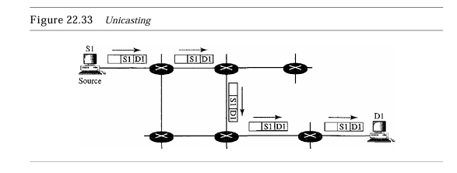

from the source S1and passes through routers to reach the destination D1. We have shown the networks as a link between the routers to simplify the figure. Note that in unicasting, when a router receives a packet, it forwards the packet through only one of its interfaces (the one belonging to the optimum path) as defined in the routing table. The router may discard the packet if it cannot find the destination address in its routing table. In unicasting, the router forwards the received packet through only one of its interfaces.

**Multicasting**

In multicast communication, there is one source and a group of destinations. The relationship is one-to-many. In this type of communication, the source address is a unicast address, but the destination address is a group address, which defines one or more destinations. The group address identifies the members of the group. Figure 22.34 shows the idea behind multicasting.

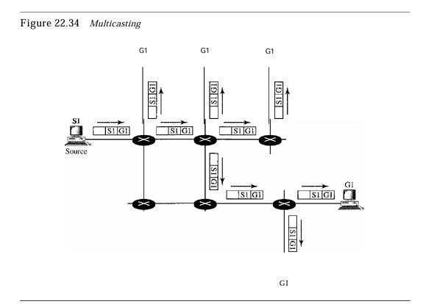

A multicast packet starts from the source S1 and goes to all destinations that belong to group G1. In multicasting, when a router receives a packet, it may forward it through several of its interfaces. In Multicasting, the router may forward the received packet through several of its interfaces.

**Broadcasting**

In broadcast communication, the relationship between the source and the destination is one-to-all. There is only one source, but all the other hosts are the destinations. The Internet does not explicitly support broadcasting because of the huge amount of traffic it would create and because of the bandwidth it would need. Imagine the traffic generated on the Internet if one person wanted to send a message to everyone else connected to the Internet. Multicasting Versus Multiple Unicasting Before we finish this section, we need to distinguish between multicasting and multiple unicasting. Figure 22.35 illustrates both concepts

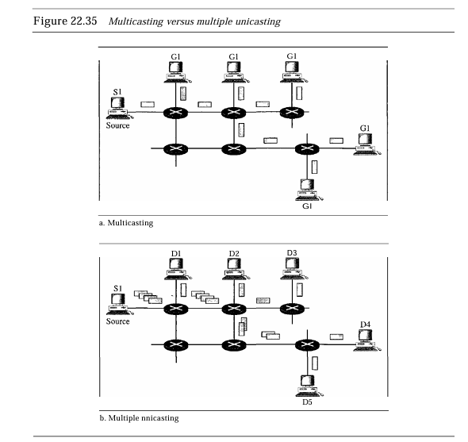

Multicasting starts with one single packet from the source that is duplicated by the routers. The destination address in each packet is the same for all duplicates. Note that only one single copy of the packet travels between any two routers. In multiple unicasting, several packets start from the source. If there are five destinations, for example, the source sends five packets, each with a different unicast destination address. Note that there may be multiple copies traveling between two routers. For example, when a person sends an e-mail message to a group of people, this is multiple unicasting. The e-mail software creates replicas of the message, each with a different destination address and sends them one by one. This is not multicasting; it is multiple unicasting. Emulation ofMulticasting with Unicasting You might wonder why we have a separate mechanism for multicasting, when it can be emulated with unicasting. There are two obvious reasons for this.

1. Multicasting is more efficient than multiple unicasting. In Figure 22.35, we can see how multicasting requires less bandwidth than does multiple unicasting. In multiple unicasting, some of the links must handle several copies.
2. In multiple unicasting, the packets are created by the source with a relative delay between packets. Ifthere are 1000 destinations, the delay between the first and the last packet may be unacceptable. In multicasting, there is no delay because only one packet is created by the source. Emulation of multicasting through multiple unicasting is not efficient and maycreate long delays, particularly with a large group.

**Applications**

Multicasting has many applications today such as access to distributed databases, information dissemination, teleconferencing, and distance learning. Access to DistributedDatabases Most of the large databases today are distributed. That is, the information is stored in more than one location, usually at the time of production. The user who needs to access the database does not know the location of the information. A user's request is multicast to all the database locations, and the location that has the information responds. Information Dissemination Businesses often need to send information to their customers.

If The nature of the information is the same for each customer, it can be multicast. In this way a business can send one message that can reach many customers. For example, a software update can be sent to all purchasers of a particular software package. Dissemination ofNews In a similar manner news can be easily disseminated through multicasting. One single message can be sent to those interested in a particular topic. For example, the statistics of the championship high school basketball tournament can be sent to the sports editors of many newspapers.

**Teleconferencing** involves multicasting. The individuals attending a teleconference all need to receive the same information at the same time. Temporary or permanent groups can be formed for this purpose. For example, an engineering group that holds meetings every Monday morning could have a permanent group while the group that plans the holiday party could form a temporary group. Distance Learning One growing area in the use of multicasting is distance learning. Lessons taught by one single professor can be received by a specific group of students.

This is especially convenient for those students who find it difficult to attend classes on campus. Multicast Routing In this section, we first discuss the idea of optimal routing, common in all multicast protocols. We then give an overview of multicast routing protocols.

**Optimal Routing:** ShortestPath Trees The process of optimal interdomain routing eventually results in the finding of the shortest path tree. The root of the tree is the source, and the leaves are the potential destinations. The path from the root to each destination is the shortest path. However, the number of trees and the formation of the trees in unicast and multicast routing are different. Let us discuss each separately.

**Unicast Routing** In unicast routing, when a router receives a packet to forward, it needs to find the shortest path to the destination of the packet. The router consults its routing table for that particular destination. The next-hop entry corresponding to the destination is the start of the shortest path. The router knows the shortest path for each destination, which means that the router has a shortest path tree to optimally reach all destinations. In other words, each line of the routing table is a shortest path; the whole routing table is a shortest path tree. In unicast routing, each router needs only one shortest path tree to forward a packet; however, each router has its own shortest path tree.

Figure 22.36 shows the situation. The figure shows the details of the routing table and the shortest path tree for router Rl. Each line in the routing table corresponds to one path from the root to the corresponding network. The whole table represents the shortest path tree. Inunicast routing, each router in the domain has a table that defines a shortest path tree to possible destinations. Multicast Routing When a router receives a multicast packet, the situation is different from when it receives a unicast packet. A multicast packet may have destinations in more than one network. Forwarding of a single packet to members of a group requires a shortest path tree. If We have n groups, we may need n shortest path trees. We can imagine the complexity of multicast routing. Two approaches have been used to solve the problem: source-based trees and group-shared trees.

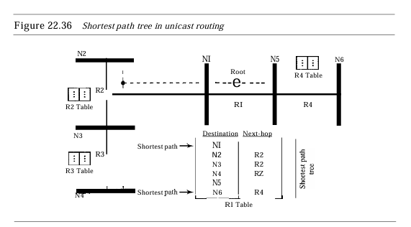

**Source-BasedTree.** In the source-based tree approach, each router needs to have one shortest path tree for each group. The shortest path tree for a group defines the next hop for each network that has loyal member(s) for that group. In Figure 22.37, we assume that we have only five groups in the domain: GI, G2, G3, G4, and G5. At the moment GI has loyal members in four networks, G2 in three, G3 in two, G4 in two, and G5 in two. We have shown the names of the groups with loyal members on each network. Figure 22.37 also shows the multicast routing table for router RI. There is one shortest path tree for each group; therefore there are five shortest path trees for five groups. If Router Rl receives a packet with destination.

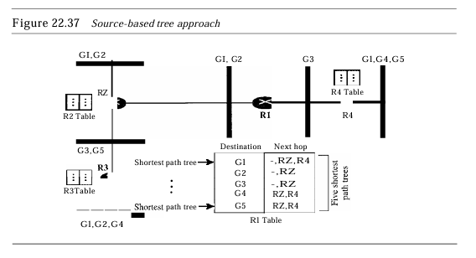

**Group-Shared Tree.** In the group-shared tree approach, instead of each router having m shortest path trees, only one designated router, called the center core, or rendezvous router, takes the responsibility of distributing multicast traffic. The core has m shortest path trees in its routing table. The Rest of the routers in the domain have none. If a router receives a multicast packet, it encapsulates the packet in a unicast packet and sends it to the core router. The core router removes the multicast packet from its capsule, and consults its routing table to route the packet. Figure 22.38 shows the idea.

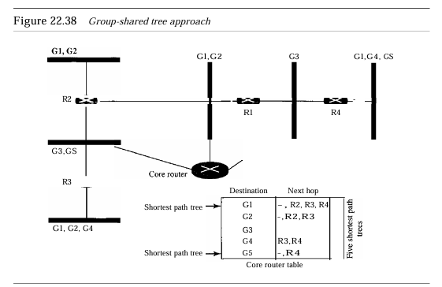

**CRT The Core-Based Tree (CBT)** protocol is a group-shared protocol that uses a core as the root of the tree. The autonomous system is divided into regions, and a core (center router or rendezvous router) is chosen for each region. Formation of the Tree After The rendezvous point is selected, every routeris infonned of the unicast address of the selected router. Eachrouter then sends a unicast join message (similar to a grafting message) to show that it wants to join the group.

This message passes through all routers that are located between the sender and the rendezvous router. Each intermediate router extracts the necessary information from the message, such as the unicast address of the sender and the interface through which the packet has arrived, and forwards the message to the next router in the path. When the rendezvous router has received all join messages from every member of the group, the tree is formed. Now every router knows its upstream router (the router that leads to the root) and the downstream router (the router that leads to the leaf). Ifa router wants to leave the group, it sends a leave message to its upstream router. The upstream router removes the link to that router from the tree and forwards the message to its upstream router, and so on. Figure 22.44 shows a group-shared tree with its rendezvous router.

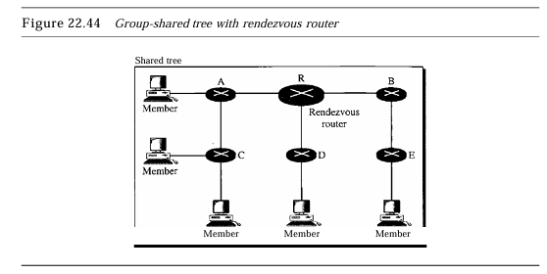

The reader may have noticed two differences between DVMRP and MOSPF, on one hand, and CBT, on the other. First, the tree for the first two is made from the root up~ the tree for CBT is formed from the leaves down. Second, in DVMRP, the tree is SECTION 22.4

**MULTICAST ROUTING PROTOCOLS** 691 first made (broadcasting) and then pruned; in CBT, there is no tree at the beginning; the joining (grafting) gradually makes the tree. Sending Multicast Packets After Formation of the tree, any source (belonging to the group or not) can send a multicast packet to all members of the group. It simply sends the packet to the rendezvous router, using the unicast address of the rendezvous router; the rendezvous router distributes the packet to all members of the group. Figure 22.45 shows how a host can send a multicast packet to all members of the group. Note that the source host can be any of the hosts inside the shared tree or any host outside the shared tree. In Figure 22.45 we show one located outside the shared tree.

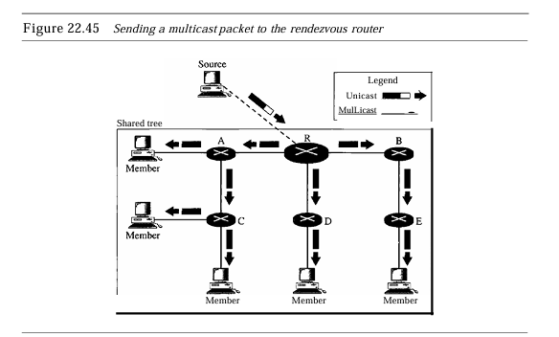

Selecting the Rendezvous Router This approach is simple except for one point. How do we select a rendezvous router to optimize the process and multicasting as well? Several methods have been implemented. However, this topic is beyond the scope of this book, and we leave it to more advanced books.

In summary, the Core-Based Tree (CBT) is a group-shared tree, center-based protocol using one tree per group. One of the routers in the tree is called the core. A packet is sent from the source to members of the group following this procedure:

1. The source, which may not be part of the tree, encapsulates the multicast packet inside a unicast packet with the unicast destination address of the core and sends it to the core. This part of delivery is done using a unicast address; the only recipient is the core router.
2. The core decapsulates the unicast packet and forwards it to all interested interfaces.
3. Each router that receives the multicast packet, in tum, forwards it to all interested interfaces.

**PIM Protocol Independent Multicast (PIM)** is the name given to two independent multicast routing protocols: Protocol Independent Multicast, Dense Mode (PIM-DM) and Protocol Independent Multicast, Sparse Mode (PIM-SM). Both protocols are unicast protocol-dependent, but the similarity ends here. We discuss each separately. PIM-DM PIM-DMis used when there is a possibility that each router is involved in multicasting (dense mode). In this environment, the use of a protocol that broadcasts the packet is justified because almost all routers are involved in the process. PIM-DMis used in a dense multicast environment, such as a LAN. PIM-DM is a source-based tree routing protocol that uses RPF and pruning and grafting strategies for multicasting. Its operation is like that of DVMRP; however, unlike DVMRP, it does not depend on a specific unicasting protocol. It assumes that the autonomous system is using a unicast protocol and each router has a table that can find the outgoing interface that has an optimal path to a destination.

This unicast protocol can be a distance vector protocol (RIP) or link state protocol (OSPF). PIM-DMuses RPFn pruning and grafting strategies to handle multicasting. However, it is independent of the underlying unicast protocol. PIM-SM PIM-SMis used when there is a slight possibility that each router is involved in multicasting (sparse mode). In this environment, the use of a protocol that broadcasts the packet is not justified; a protocol such as CBT that uses a group-shared tree is more appropriate. PIM-SMis used ina sparsemulticastenvironmentsuchas a WAN. PIM-SM is a group-shared tree routing protocol that has a rendezvous point (RP) as the source of the tree. Its operation is like CBT; however, it is simpler because it does not require acknowledgement from a join message.

In addition, it creates a backup set of RPs for each region to coverRP failures. One Of The characteristics ofPIM-SM is that it can switch from a group-shared tree strategy to a source-based tree strategy when necessary. This can happen if there is a dense area of activity far from the RP. That area can be more efficiently handled with a source-based tree strategy instead of a group-shared tree strategy. PIM-SMissimilarto CRT but uses a simpler procedure. MBONE Multimedia and real-time communication have increased the need for multicasting in the Internet. However, only a small fraction ofInternet routers are multicast routers. In other words, a multicast router may not find another multicast router in the neighborhood to forward the multicast packet. Although this problem may be solved in the next few years by adding more and more multicast routers, there is another solution to this problem.

The solution is tunneling. The multicast routers are seen as a group of routers on top of unicast routers. The multicast routers may not be connected directly, but they are connected logically. Figure 22.46 shows the idea. In Figure 22.46, only the routers enclosed in the shaded circles are capable of multicasting. Without tunneling, these routers are isolated islands. To enable multicasting, we make a multicast backbone (MBONE) out of these isolated routers by using the concept of tunneling.

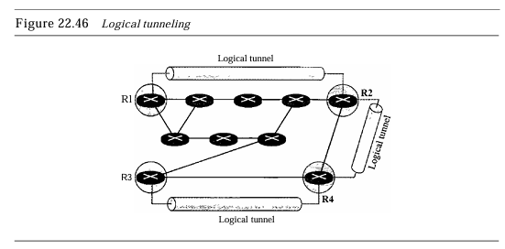

Alogical tunnel is established by encapsulating the multicast packet inside a unicast packet. The multicast packet becomes the payload (data) of the unicast packet. The intermediate (non multicast) routers forward the packet are unicast routers and deliver the packet from one island to another. It's as if the unicast routers do not exist and the two multicast routers are neighbors. Figure 22.47 shows the concept. So far the only protocol that supports MBONE and tunneling is DVMRP.

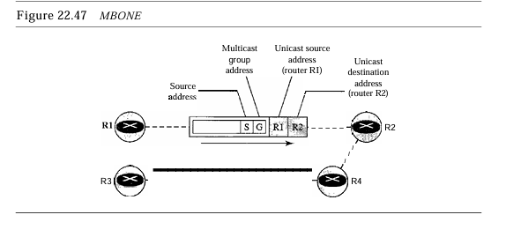

# 

# MODULE 5

## 2 Mark Questions

### 1. What is Flat Namespace?

In a flat name space, a name is assigned to an address. A name in this space is a sequence of characters without structure. The names may or may not have a common section; if they do, it has no meaning. The main disadvantage of a fiat namespace is that it cannot be used in a large system such as the Internet because it must be centrally controlled to avoid ambiguity and duplication.

### 2. What is Hierarchical Name Space?

In a hierarchical name space, the central authority assigns and controls the initial part of the name (such as the nature and name of the organization). The organization itself manages the rest, allowing them to add unique identifiers like host names, ensuring the entire name is globally unique. **For example,** "challenger.jhda.edu" and "challenger.berkeley.edu" are distinct despite using the same host name because the higher-level domain names differ.

### 3. What is Domain Name Space?

A Domain Name Space in DNS is hierarchical and organized in a tree structure, where each node or domain is identified by a label. The domain names start from the

root, represented by a dot (.), and can have multiple levels. Each level of the hierarchy defines specific segments, such as top-level domains (e.g., .com, .edu), second-level domains (e.g., example.com), and subdomains, making the names globally unique.

### 4. What is a Fully Qualified Domain Name?

A Fully Qualified Domain Name (FQDN) is the complete domain name that specifies the exact location of a node in the DNS hierarchy. It includes all parts of the domain, starting from the host name up to the top-level domain (TLD), ending with a period to represent the root. For example, in www.example.com., "www" is the host, "example" is the second-level domain, "com" is the TLD, and the trailing dot represents the root.

### 5. What is a Partially Qualified Domain Name?

A Partially Qualified Domain Name (PQDN) is an incomplete domain name that does not specify the full path to the root in the DNS hierarchy. It lacks some parts, typically the higher-level domains. For example, "www" or "sales.example" could be PQDNs, as they do not include the full domain ending with a top-level domain (TLD) like .com and the root (.). PQDNs rely on the local context to be fully interpreted.

### 6. What is Root Server?

A root server is a server whose zone consists of the whole tree. A root server usually does not store any information about domains but delegates its authority to other servers, keeping references to those servers. There are several root servers, each covering the whole domain name space. The servers are distributed all around the world.

### 7. What is Generic Domain?

A Generic Domain refers to the top-level domains (TLDs) in the Domain Name System (DNS) that are meant for specific categories of organizations or purposes. Examples of generic domains include .com for commercial organizations, .edu for educational institutions, .org for non-profit organizations, and .gov for government entities. These are widely recognized and used across the internet.

### 8. What are Country Domains?

Country Domains are top-level domains (TLDs) that are assigned to specific countries or territories, typically consisting of two levels based on the ISO 3166 standard. Examples include .us for the United States, .uk for the United Kingdom, and .in for India. Each country manages its own country code top-level domain (ccTLD) and sets policies for its usage.

### 9. What is the Inverse Domain?

The Inverse Domain is used in the Domain Name System (DNS) to map an IP address back to a domain name. It is primarily used for reverse DNS lookups, where the goal is to find the domain name associated with a given IP address.

### 10. What is the URL?

A Uniform Resource Locator (URL) is a specific type of Uniform Resource Identifier (URI) that provides the address used to access resources on the internet. A URL typically consists of several components: the protocol (e.g., http or https), the domain name (e.g., www.example.com), and optionally, a path to a specific resource (e.g., /index.html). It tells the browser where and how to retrieve the resource.

### 11. What is Cryptography?

Cryptography is the practice and study of techniques for securing communication and information by transforming it into a format that is unreadable to unauthorized users. This involves the use of algorithms to encrypt (convert plaintext into ciphertext) and decrypt (convert ciphertext back to plaintext) data, ensuring confidentiality, integrity, and authenticity. Cryptography plays a crucial role in securing data transmission over networks.

### 12. What is Plaintext and Ciphertext?

The original message, before being transformed, is called plaintext. After the message is transformed, it is called ciphertext. An encryption algorithm transforms the plaintext into ciphertext; a decryption algorithm transforms the ciphertext back into plaintext. The sender uses an encryption algorithm, and the receiver uses a decryption algorithm.

### 13. What is Key?

A key is a number (or a set of numbers) that the cipher, as an algorithm, operates on. To encrypt a message, we need an encryption algorithm, an encryption key, and the plaintext. These create the ciphertext. To decrypt a message, we need a decryption algorithm, a decryption key, and the ciphertext. These reveal the original plaintext.

### 14. What is a Symmetric-key?

Symmetric-key cryptography is a type of encryption where the same key is used for both encryption and decryption of data. In this method, both the sender and receiver must share the secret key, which must be kept confidential to ensure security. The main advantage of symmetric-key cryptography is its speed and efficiency, making it suitable for encrypting large amounts of data. However, the challenge lies in securely distributing and managing the shared key.

### 15. What is an Asymmetric-key?

Asymmetric-key cryptography, also known as public key cryptography, uses a pair of keys for encryption and decryption: a public key and a private key. The public key is shared openly and can be used by anyone to encrypt messages, while the private key is kept secret by the owner and is used to decrypt messages encrypted with the corresponding public key.

### 16. What is Message Confidentiality?

Message confidentiality or privacy means that the sender and the receiver expect confidentiality. The transmitted message must make sense to only the intended receiver. To all others, the message must be garbage. When a customer communicates with her bank, she expects that the communication is totally confidential.

### 17. What is Message Integrity?

Message integrity means that the data must arrive at the receiver exactly as they were sent. There must be no changes during the transmission, neither accidentally nor maliciously. As more and more monetary exchanges occur over the Internet, integrity is crucial. For example, it would be disastrous if a request for transferring $100 changed to a request for $10,000 or $100,000. The integrity of the message must be preserved in a secure communication.

### 18. What is Message Authentication?

Message authentication is a service beyond message integrity. In message authentication the receiver needs to be sure of the sender's identity and that an imposter has not sent the message.

### 19. What is Entity Authentication?

In entity authentication (or user identification) the entity or user is verified prior to access to the system resources (files, for example). For example, a student who needs to access her university resources needs to be authenticated during the logging process. This is to protect the interests of the university and the student.

### 20. What are Firewalls?

Firewalls are security systems that monitor and control incoming and outgoing network traffic based on predetermined security rules. They act as a barrier between a trusted internal network and untrusted external networks (like the internet), helping to prevent unauthorized access, data breaches, and various types of cyber attacks.

## Essay Questions

### 21. What is HTTP?

HTTP (Hypertext Transfer Protocol) is a protocol used for transmiƫng hypertext via the World Wide Web. It facilitates communication between web clients (like browsers) and web servers, allowing users to access and interact with web content. Here are the key aspects of HTTP:

**Client-Server Model:** HTTP operates on a client server model, where the client (web browser) sends requests to a server hosting a website. The server processes these requests and responds with the requested resources, such as HTML documents, images, or data.

**Stateless Protocol:** HTTP is stateless, meaning each request from a client to a server is treated as an independent transaction. The server does not retain any information about previous requests, which simplifies the protocol but requires additional mechanisms (like cookies or sessions) for maintaining user state.

**Request and Response Structure:** HTTP requests consist of a method (such as GET, POST, PUT, DELETE), a URL, and optional headers and body content. The server responds with a status code indicating the result of the request (e.g., 200 for success, 404 for not found) along with the requested content.

**Secure Version (HTTPS):** HTTP can be secured using SSL/TLS to form HTTPS (Hypertext Transfer Protocol Secure), which encrypts the data exchanged between the client and server, ensuring confidentiality and integrity during transmission.

**Support for Various Media Types:** HTTP supports the transfer of various types of data formats, including text, images, audio, and video, making it versatile for delivering diverse web content.

### 22. What is DNS?

DNS (Domain Name System) is a critical component of the internet that translates human-friendly domain names into IP addresses, allowing users to access websites without needing to remember numerical addresses. Here are the key aspects of DNS:

**Hierarchical Structure:** DNS operates in a hierarchical name space, where domain names are organized into levels, starting from the root domain (.) down to top level domains (TLDs) like .com, .edu, and .org, and further down to second level domains (e.g., example.com) and subdomains (e.g., www.example.com). This structure enables

organized management of domain names.

**Name Resolution:** The primary function of DNS is to resolve domain names into IP addresses through a process called name resolution. When a user enters a domain name in a browser, the DNS system queries a series of servers to find the

corresponding IP address, allowing the browser to connect to the appropriate web server.

**DNS Records:** DNS uses various types of records to store information about domain names. Common record types include:

* A (Address) Record: Maps a domain name to an IPv4 address.
* AAAA Record: Maps a domain name to an IPv6 address.
* CNAME (Canonical Name) Record: Aliases one domain name to another.
* MX (Mail Exchange) Record: Specifies the mail server responsible for receiving email messages on behalf of a domain.
* NS (Name Server) Record: Indicates the authoritative name servers for a domain.

**Distributed System:** DNS is a distributed system composed of multiple servers that work together to ensure redundancy and reliability. When a DNS query is made, it may be resolved by various DNS servers, including local caches, authoritative servers, and root servers, contributing to a more efficient query process.

**Caching and Performance:** To improve performance, DNS responses are often cached at

different levels, including user devices, local DNS servers, and ISPs. This caching reduces the number of queries that must be sent over the internet, speeding up the resolution process and reducing the load on DNS servers.

### 23. What is FTP?

File Transfer Protocol (FTP) is a standard network protocol used for transferring files between a client and a server over a TCP/IP network, such as the Internet. Here are the key features of FTP:

**Client-Server Model:** FTP operates on a client-server architecture where the client initiates the request to upload or download files from the FTP server. The server responds by providing access to its files and directories, allowing clients to interact with them.

**Modes of Operation:** FTP can operate in two modes:

1. **Active Mode:** The client opens a random port for the data connection, and the server connects to the client on that port. This can pose issues with firewalls since the server initiates a connection back to the client.
2. **Passive Mode:** The client requests the server to open a random port for the data connection, and the client connects to that port. This is more firewall-friendly and is often preferred.

**Commands and Responses:** FTP uses a set of standardized commands for file operations, such as GET (to download files), PUT (to upload files), DELETE (to remove files), and LIST (to display directory contents). The server responds with status codes indicating the success or failure of the commands.

**Authentication and Security:** FTP typically requires user authentication via a username and password. However, standard FTP does not encrypt its traffic, making it vulnerable to eavesdropping. To address this, secure variants like FTPS (FTP Secure) and SFTP (SSH File Transfer Protocol) are used to encrypt data transfers.

**File Management Capabilities:** FTP not only supports file transfers but also allows for file

management operations. Users can create directories, rename files, and change permissions on files stored on the server, making it a versatile tool for managing files remotely. Overall, FTP is a widely used protocol for transferring files efficiently across networks, providing essential capabilities for both file upload and download operations.

### 24. What is SMTP?

Simple Mail Transfer Protocol (SMTP) is a protocol used for sending and receiving email messages across networks. Here are the key features of SMTP:

**Client-Server Architecture:** SMTP operates using a client-server model, where the email client (sender) communicates with the email server (SMTP server) to send messages. The client establishes a connection to the server, sends the email, and the server then processes the request and forwards the email to the recipient's server.

**Message Sending:** SMTP is primarily used for sending outgoing email messages. It defines how the sender's email client communicates with the mail server to transmit messages. It handles the encapsulation of the email content, which includes the recipient's address, sender's address, subject, and body of the message.

**Protocol Commands:** SMTP uses a set of text based commands to facilitate communication between the client and server. Common commands include HELO or EHLO (to identify the sender to the server), MAIL FROM (to specify the sender's email address), RCPT TO (to specify the recipient's email address), and DATA (to indicate the beginning of the email content).

**Queue Management:** If the recipient's server is not available, SMTP allows the sending server to queue the email for later delivery. The server will periodically attempt to resend the email until it is successfully delivered or until it reaches a predefined time limit, at which point it may noƟfy the sender of a failure.

**Limitations and Extensions:** While SMTP is effective for sending emails, it does not inherently support secure communication or message retrieval. To address these limitations, it is often used in conjunction with other protocols, such as IMAP (Internet Message Access Protocol) or POP3 (Post Office Protocol) for retrieving messages. Additionally, secure variants like SMTPS (SMTP Secure) and STARTTLS are used to encrypt email transmissions, enhancing security. Overall, SMTP is a fundamental protocol for email communication, ensuring the reliable transfer of messages from senders to recipients across the internet.

### 25. What is Symmetric Cryptography?

Symmetric cryptography, also known as symmetric key cryptography, is a type of encryption that uses the same key for both the encryption and decryption processes. This method contrasts with asymmetric cryptography, where a pair of keys—a public key and a private key—are used. Symmetric cryptography is widely utilized in various applications for securing sensitive data due to its efficiency and speed.

**Key Features of Symmetric Cryptography**

**Single Key Usage:** In symmetric cryptography, both the sender and the receiver share a single secret key. This key must remain confidential to ensure the security of the encrypted data. Anyone possessing the key can encrypt or decrypt messages, which makes key management crucial.

**Efficiency and Speed:** One of the primary advantages of symmetric cryptography is its efficiency. Symmetric algorithms are generally faster and require less computational power compared to asymmetric algorithms. This speed makes symmetric cryptography ideal for encrypting large volumes of data, such as in file encryption or securing network traffic.

**Common Algorithms:** There are several widely used symmetric encryption algorithms, including:

* **Advanced Encryption Standard (AES):** A widely accepted standard for encrypting data, AES supports key sizes of 128, 192, and 256 bits, providing a high level of security.
* **Data Encryption Standard (DES):** Once a standard for symmetric encryption, DES uses a 56-bit key. It is now considered insecure due to advances in computing power and the ability to perform brute force attacks.
* **Triple DES (3DES):** An enhancement of DES, it applies the DES algorithm three times to increase security but is slower than AES.
* **Blowfish and Twofish:** These are alternative symmetric key algorithms known for their speed and effectiveness in various applications.

**Applications of Symmetric Cryptography**

Symmetric cryptography is used in various applications and scenarios, including:

* **Data Encryption:** It is commonly used to encrypt files, databases, and data at rest to prevent unauthorized access. For example, disk encryption software uses symmetric algorithms to secure the contents of hard drives.
* **Secure Communication:** Protocols like TLS/SSL utilize symmetric encryption to secure data transmission over the internet. After establishing a secure connection with asymmetric encryption (for key exchange), symmetric encryption is used for the actual data transmission due to its speed.
* **Virtual Private Networks (VPNs):** Symmetric cryptography is integral to VPNs, where it encrypts data traffic between remote users and corporate networks to ensure privacy and security.
* **Authentication:** In some authentication protocols, symmetric keys are used to verify the identity of users and systems. For instance, Message Authentication Codes (MACs) utilize symmetric keys to ensure message integrity and authenticity.

**Challenges of Symmetric Cryptography**

Despite its advantages, symmetric cryptography also faces several challenges:

* **Key Distribution:** The primary issue with symmetric cryptography is the secure distribution of the key. Both parties must exchange the key without interception. If a third party obtains the key, they can decrypt any messages encrypted with that key, compromising security.
* **Scalability:** In scenarios with many users, the number of keys required can become unwieldy. For instance, in a network of N users, N*(N-1)/2 unique keys are needed if every user needs a unique key for communication with every other user.
* **Key Management:** Proper management of keys is critical. This includes key generation, storage, rotation, and revocation. If a key is compromised, it needs to be replaced and securely distributed again.

Symmetric cryptography is a vital component of modern security frameworks, providing an efficient and robust method for securing sensitive information. While it has some challenges, particularly concerning key management and distribution, its speed and effectiveness make it a preferred choice for many applications. As cybersecurity threats continue to evolve, symmetric cryptography will remain essential in protecting data and ensuring secure communications in various sectors.

### 

### 26. What is Asymmetric Cryptography?

Asymmetric cryptography, also known as public key cryptography, is a revolutionary approach to secure communications and data protection that uses a pair of keys: a public key and a private key. Unlike symmetric cryptography, which relies on a single shared key, asymmetric cryptography enables secure data transmission, authentication, and digital signatures without the need to exchange secret keys beforehand. This innovation has transformed how information is protected in digital communications, contributing significantly to the security of the internet.

**Key Features of Asymmetric Cryptography**

* **Key Pair Mechanism:** Asymmetric cryptography employs two distinct keys: a public key that can be shared openly and a private key that is kept secret by the owner. The public key is used to encrypt messages or verify signatures, while the private key is used to decrypt messages or create signatures. This separation enhances security because the private key does not need to be shared or transmitted over potentially insecure channels.
* **Encryption and Decryption:** In this cryptographic system, when a sender wants to send a secure message, they encrypt it using the recipient's public key. Only the recipient can decrypt the message using their private key. This mechanism ensures confidentiality, as only the intended recipient can read the message.
* **Digital Signatures:** Asymmetric cryptography also facilitates the creation of digital signatures, which are used to verify the authenticity and integrity of a message. The sender signs a message with their private key, and anyone can verify this signature using the sender's public key. This process ensures that the message has not been altered and confirms the identity of the sender.

* **Widely Used Algorithms:** Several algorithms implement asymmetric cryptography, including:
  + **RSA (Rivest-Shamir-Adleman):** One of the first public-key cryptosystems, RSA relies on the difficulty of factoring large integers. It is widely used for secure data transmission and digital signatures.
  + **DSA (Digital Signature Algorithm):** Primarily used for digital signatures, DSA ensures the authenticity and integrity of messages.
  + **ECC (Elliptic Curve Cryptography):** ECC provides a higher level of security with smaller key sizes compared to RSA, making it efficient and suitable for mobile and embedded systems.

**Applications of Asymmetric Cryptography**

Asymmetric cryptography is used in a variety of applications, providing robust security solutions:

* **Secure Communication:** It underpins protocols like HTTPS (Hypertext Transfer Protocol Secure), where it secures the communication between web browsers and servers. When establishing a secure connection, asymmetric cryptography is used to exchange symmetric keys, which are then used for fast data encryption.
* **Email Security:** Asymmetric cryptography enables secure email communication through encryption methods like PGP (Pretty Good Privacy) and S/MIME (Secure/Multipurpose Internet Mail Extensions). Users can encrypt emails with the recipient's public key, ensuring that only the intended recipient can decrypt them.
* **Digital Certificates:** Asymmetric cryptography is a foundational component of digital certificates, which are used to authenticate the identity of users, devices, and organizations online. Certificates are issued by trusted Certificate Authorities (CAs) and verify that a public key belongs to a specific entity.
* **Blockchain and Cryptocurrencies:** Asymmetric cryptography plays a crucial role in securing transactions in blockchain technologies and cryptocurrencies like Bitcoin. Each user has a public key and a private key, enabling secure transaction verification and ownership of digital assets.

**Challenges of Asymmetric Cryptography**

While asymmetric cryptography offers significant advantages, it also faces challenges:

* **Performance:** Asymmetric algorithms are generally slower than symmetric algorithms due to their complex mathematical operations. This can be a limitation when encrypting large amounts of data or in high-performance applications.
* **Key Management:** Managing public and private keys is crucial for maintaining security. If a private key is compromised, an attacker can impersonate the owner. Therefore, secure storage and regular key rotation practices are necessary.
* **Dependence on Trusted Authorities:** In many implementations, the security of asymmetric cryptography relies on trusted Certificate Authorities (CAs) for issuing and managing digital certificates. If a CA is compromised, the integrity of the entire system can be jeopardized.

Asymmetric cryptography represents a significant advancement in the field of cryptography, enabling secure communication, authentication, and data integrity in various applications. Its use of public and private key pairs provides a robust framework for securing information without the challenges associated with key distribution in symmetric cryptography.

Despite its challenges, asymmetric cryptography remains a cornerstone of modern digital security, playing a vital role in protecting sensitive data and enabling secure online transactions in an increasingly interconnected world. As technology evolves, so too will the techniques and algorithms that underpin asymmetric cryptography, ensuring its continued relevance and effectiveness in securing our digital communications.

### 27. Explain Network Security Services?

Network Security Services In today’s digital landscape, securing data and communications over networks is of paramount importance. Network security services are a set of protective measures that ensure the integrity, confidentiality, and availability of data transmitted across a network. Among the key components of network security services are message confidentiality, message integrity, message authentication, message non-repudiation, and entity authentication. Each of these services plays a critical role in safeguarding sensitive information from unauthorized access and manipulation.

**Message Confidentiality**

Message confidentiality is a fundamental aspect of network security that ensures that sensitive information remains accessible only to authorized parties. This is primarily achieved through encryption, a process that transforms readable data (plaintext) into an unreadable format (ciphertext) using cryptographic algorithms. When a sender encrypts a message using a key before transmitting it, only the intended recipient, who possesses the correct decryption key, can access the original message.

This method protects data in transit over potentially insecure networks, such as the internet, where eavesdroppers could intercept communications. For example, protocols like HTTPS and Secure Socket Layer (SSL) use encryption to maintain the confidentiality of data exchanged between web servers and browsers, ensuring that sensitive information, such as credit card numbers and personal details, remains secure from unauthorized access.

**Message Integrity**

Message integrity ensures that the data sent over a network has not been altered or tampered with during transmission. This service is critical for maintaining trust in communication channels. Integrity is typically achieved using hash functions and digital signatures.

A **hash function** generates a fixed-size output (hash) from variable-sized input data. If even a single bit of the data changes, the hash will also change, signaling that the integrity of the message has been compromised. To further secure this process, digital signatures are employed. A sender can create a digital signature by encrypting the hash of the message with their private key. The recipient can then verify the signature using the sender’s public key, ensuring that the message has not been altered and confirming the sender's identity.

**Message Authentication**

Message authentication is a crucial service that verifies the identity of the sender of a message, ensuring that it comes from a legitimate source and has not been altered in transit. Authentication can be achieved through various methods, including passwords, cryptographic keys, and digital signatures. In practice, when a sender transmits a message, they include a cryptographic checksum or a digital signature. The recipient can then validate this information against a known value or public key to confirm the authenticity of the sender. This service is essential in preventing impersonation attacks and ensuring that only authorized entities can send messages within a network.

**Message Non-Repudiation**

Message non-repudiation is a security service that prevents the sender of a message from denying their involvement in the communication. This service is essential for accountability in digital transactions and communications. Non-repudiation can be achieved through the use of digital signatures and secure logging mechanisms.

When a sender signs a message with their private key, they create a digital signature that binds them to the message. This signature serves as proof that the sender authorized the message, preventing them from later denying that they sent it. In legal and financial contexts, non-repudiation is crucial for maintaining trust and accountability between parties.

**Entity Authentication**

Entity authentication is the process of verifying the identity of users or devices attempting to access network resources. This service is vital for preventing unauthorized access to sensitive information and systems. Authentication methods can include passwords, biometrics (such as fingerprints or facial recognition), and cryptographic tokens.

In many cases, entity authentication is implemented alongside authorization processes, which determine what resources authenticated users can access. For example, a user may enter a username and password to log into a corporate network, but additional verification steps, such as two-factor authentication (2FA), may be required to enhance security further. This layered approach helps ensure that only authorized individuals can access sensitive data and systems.

Network security services are essential in protecting data and communications from unauthorized access, manipulation, and disruption. By ensuring message confidentiality, integrity, authentication, nonrepudiation, and entity authentication, organizations can create secure communication channels that foster trust and accountability. As cyber threats continue to evolve, implementing robust network security measures will remain a critical priority for individuals and organizations alike. These services not only safeguard sensitive information but also contribute to the overall integrity and reliability of networked systems, enabling secure and efficient operations in an increasingly interconnected world.

### 28. Explain Firewalls in detail?

In the contemporary digital landscape, where cyber threats are rampant and evolving, firewalls serve as a crucial line of defense for computer networks. A firewall is a security device or software that monitors and controls incoming and outgoing network traffic based on predefined security rules. Its primary purpose is to establish a barrier between a trusted internal network and untrusted external networks, such as the internet. This essay delves into the types of firewalls, specifically focusing on packet-filter firewalls and proxy firewalls, as well as their functionalities, benefits, limitations, and best practices for implementation.

**Types of Firewalls**

Firewalls can be broadly categorized into two main types: packet-filter firewalls and proxy firewalls. Each type has its own mechanisms for monitoring and controlling network traffic.

**1-Packet-Filter Firewall**

A packet-filter firewall operates at the network layer of the OSI model and examines packets of data as they pass through the network. Its primary function is to make decisions based on predefined rules that assess the packet headers, including information such as source and destination IP addresses, port numbers, and protocols

(e.g., TCP, UDP). Here are key features of packet-filter firewalls:

* **Rule-Based Filtering:** Packet-filter firewalls use a set of rules to determine whether to allow or block specific traffic. Administrators can define rules based on criteria such as allowed IP addresses, ports, and protocols. For instance, a rule might permit incoming traffic on port 80 (HTTP) but block traffic on port 25 (SMTP).
* **Efficiency:** Because packet-filter firewalls operate at a lower level, they are generally faster and more efficient than higher-level firewalls. They can handle a large volume of traffic without significant delays, making them suitable for environments with high throughput.
* **Limitations:** While packet-filter firewalls are effective for basic traffic control, they have limitations in security. They do not inspect the contents of the packets, which makes them vulnerable to certain types of attacks, such as those that exploit application layer vulnerabilities. Additionally, they may struggle to manage complex threats that require a deeper analysis of traffic patterns.

**2-Proxy Firewall**

A proxy firewall, also known as an application-layer firewall, operates at the application layer of the OSI model. Unlike packet-filter firewalls, proxy firewalls act as intermediaries between clients and servers, intercepting and analyzing traffic before it reaches its destination. Key features of proxy firewalls include:

* **Content Filtering:** Proxy firewalls can inspect the payload of the packets, allowing them to filter traffic based on the content being transmitted. This capability enables organizations to block malicious content, enforce acceptable use policies, and prevent data leakage.
* **Enhanced Security:** By acting as an intermediary, proxy firewalls can provide an additional layer of security. They can mask the internal network's IP addresses, making it more difficult for attackers to target specific devices. Additionally, proxy firewalls can enforce authentication protocols, requiring users to authenticate before accessing external resources.
* **Performance Trade-offs:** While proxy firewalls offer enhanced security features, they may introduce latency due to the additional processing required to inspect and analyze traffic. This can affect the performance of applications, particularly in environments with heavy traffic.

**Functionality of Firewalls**

The core functionalities of firewalls, regardless of type, include:

* **Traffic Monitoring and Control:** Firewalls continuously monitor network traffic to detect and block unauthorized access attempts and harmful traffic. They enforce security policies by allowing or denying traffic based on established rules.
* **Threat Detection and Prevention:** Modern firewalls often include intrusion detection and prevention systems (IDPS) that analyze traffic patterns to identify potential threats. These systems can generate alerts or take automated actions to block malicious traffic.
* **Virtual Private Network (VPN) Support:** Firewalls can facilitate secure remote access to internal networks through VPNs, encrypting traffic between remote users and the organization’s network.
* **Logging and Reporting:** Firewalls maintain logs of network activity, providing valuable insights into security incidents and traffic patterns. Administrators can review these logs for auditing, compliance, and troubleshooting purposes.

**Benefits of Firewalls**

* **Enhanced Security:** Firewalls provide a critical layer of defense against external threats, including unauthorized access, malware, and denial-of service attacks.
* **Control Over Network Traffic:** Organizations can enforce security policies by controlling which applications and services are allowed to communicate over the network, reducing the risk of data breaches.
* **Protection of Sensitive Data:** By blocking unauthorized access and monitoring traffic, firewalls help protect sensitive information from exposure to malicious actors.
* **Regulatory Compliance:** Many industries are subject to regulatory requirements concerning data protection. Implementing firewalls can help organizations meet compliance standards and avoid legal repercussions.

**Limitations of Firewalls**

* **Not a Complete Security Solution:** While firewalls are a crucial component of network security, they should not be relied upon as the sole measure. They must be part of a comprehensive security strategy that includes antivirus software, intrusion detection systems, and user education.
* **Configuration Complexity:** Properly configuring a firewall can be challenging, especially for larger networks with complex requirements. Misconfigurations can lead to vulnerabilities or blocking legitimate traffic.
* **Limited Protection Against Internal Threats:** Firewalls primarily focus on external threats. Insider threats or compromised devices within the network may bypass firewall protections, necessitating additional security measures.

**Best Practices for Firewall Implementation**

* **Regular Updates and Maintenance:** Keep firewall software and firmware updated to ensure that the latest security patches and features are applied.
* **Create a Comprehensive Policy:** Develop and document a clear firewall policy that outlines the rules for traffic filtering and access control, ensuring it aligns with organizational security objectives.
* **Conduct Regular Audits and Testing:** Regularly review firewall logs and configurations, conduct penetration testing, and perform vulnerability assessments to identify and mitigate potential weaknesses.
* **Utilize Multiple Layers of Security:** Implement a multi layered security approach, combining firewalls with other security solutions such as intrusion detection systems, endpoint protection, and network segmentation to enhance overall security.

Firewalls are indispensable components of modern network security architecture, providing a crucial defense against a variety of cyber threats. By monitoring and controlling network traffic, they establish a secure boundary between trusted internal networks and potentially harmful external environments. With various types of firewalls, including packet-filter firewalls and proxy firewalls, organizations can tailor their security measures to meet specific needs. However, to maximize their effectiveness, firewalls should be part of a comprehensive security strategy that includes other protective measures and regular audits. As cyber threats continue to evolve, maintaining robust firewall protection remains essential for safeguarding sensitive data and ensuring the integrity of networked systems.

### 29. What are primary server and secondary server?

DNS defines two types of servers: primary and secondary. A primary server is a server that stores a file about the zone for which it is an authority. It is responsible for creating, maintaining, and updating the zone file. It stores the zone file on a local disk. A secondary server is a server that transfers the complete information about a zone from another server (primary or secondary) and stores the file on its local disk. The secondary server neither creates nor updates the zone files.

If updating is required, it must be done by the primary server, which sends the updated version to the secondary. The primary and secondary servers are both authoritative for the zones they serve. The idea is not to put the secondary server at a lower level of authority but to create redundancy for the data so that if one server fails, the other can continue serving clients. Note also that a server can be a primary server for a specific zone and a secondary server for another zone. Therefore, when we refer to a server as a primary or secondary server, we should be careful which zone we refer to.

### 30. Explain hierarchy of name of name servers?

The solution to these problems is to distribute the information among many computers called DNS servers. One way to do this is to divide the whole space into many domains based on the first level. In other words, we let the root stand alone and create as many domains (subtrees) as there are first-level nodes. Because a domain created in this way could be very large, DNS allows domains to be divided further into smaller domains (subdomains). Each server can be responsible (authoritative) for either a large or a small domain. In other words, we have a hierarchy of servers in the same way that we have a hierarchy of names

### 31. Explain name address resolution?

Mapping a name to an address or an address to a name is called name-address resolution.

**Resolver**

DNS is designed as a client/server application. A host that needs to map an address to a name or a name to an address calls a DNS client called a resolver. The resolver accesses the closest DNS server with a mapping request. If the server has the information, it satisfies the resolver; otherwise, it either refers the resolver to other servers or asks other servers to provide the infonnation. After the resolver receives the mapping, it interprets the response to see if it is a real resolution or an error, and finally delivers the result to the process that requested it.

**Mapping Names to Addresses**

Most of the time, the resolver gives a domain name to the server and asks for the corresponding address. In this case, the server checks the generic domains or the country domains to find the mapping. If the domain name is from the generic domains section, the resolver receives a domain name such as "chal.atc.jhda.edu.". The query is sent by the resolver to the local DNS server for resolution. If the local server cannot resolve the query, it either refers the resolver to other servers or asks other servers directly. If the domain name is from the country domains section, the resolver receives a domain name such as "ch.jhda.cu.ca.us.". The procedure is the same.

**Mapping Addresses to Names**

A client can send an IP address to a server to be mapped to a domain name. As mentioned before, this is called a PTR query. To answer queries of this kind, DNS uses the inverse domain. However, in the request, the IP address is reversed and the two labels in-addr and arpa are appended to create a domain acceptable by the inverse domain section. For example, if the resolver receives the IF address 132.34.45.121, the resolver first inverts the address and then adds the two labels before sending. The domain name sent is "121.45.34.132.in-addr.arpa." which is received by the local DNS and resolved.

**Recursive Resolution**

The client (resolver) can ask for a recursive answer from a name server. This means that the resolver expects the server to supply the final answer. If the server is the authority for the domain name, it checks its database and responds. If the server is not the authority, it sends the request to another server (the parent usually) and waits for the response. If the parent is the authority, it responds; otherwise, it sends the query to yet another server. When the query is finally resolved, the response travels back until it finally reaches the requesting client. This is called recursive resolution and is shown in

**Iterative Resolution**

If the client does not ask for a recursive answer, the mapping can be done iteratively. If the server is an authority for the name, it sends the answer. If it is not, it returns (to the client) the IP address of the server that it thinks can resolve the query. The client is responsible for repeating the query to this second server. If the newly addressed server can resolve the problem, it answers the query with the IP address; otherwise, it returns the IP address of a new server to the client. Now the client must repeat the query to the third server. This process is called iterative resolution because the client repeats the same query to multiple servers. In Figure 25.13 the client queries four servers before it gets an answer from the mcgraw.com server.

**Caching**

Each time a server receives a query for a name that is not in its domain, it needs to search its database for a server IP address. Reduction of this search time would increase efficiency. DNS handles this with a mechanism called caching. When a server asks for a mapping from another server and receives the response, it stores this information in its cache memory before sending it to the client. If the same or another client asks for the same mapping, it can check its cache memory and solve the problem.

### 32. Explain DNS Message types?

DNS has two types of messages: query and response. Both types have the same format. The query message consists of a header and question records; the response message consists of a header, question records, answer records, authoritative records, and additional records

**Header**

Both query and response messages have the same header format with some fields set to zero for the query messages. The header is 12 bytes, and its format is shown in Figure 25.15. The identification subfield is used by the client to match the response with the query. The client uses a different identification number each time it sends a query. The server duplicates this number in the corresponding response. The flags subfield is a collection of subfields that define the type of the message, the type of answer requested, the type of desired resolution (recursive or iterative), and so on. The number of question records subfield contains the number of queries in the question section of the message. The number of answer records subfield contains the number of answer records in the answer section of the response message.

Its value is zero in the query message. The number of authoritative records subfield contains the number of authoritative records in the authoritative section of a response message. Its value is zero in the query message. Finally, the number of additional records subfield contains the number of additional records in the additional section of a response message. Its value is zero in the query message.

**Question Section**

This is a section consisting of one or more question records. It is present on both query and response messages. We will discuss the question records in the following section.

**Answer Section**

This is a section consisting of one or more resource records. It is present only on response messages. This section includes the answer from the server to the client (resolver). We will discuss resource records in the following section.

**Authoritative Section**

This is a section consisting of one or more resource records. It is present only on response messages. This section gives infonnation (domain name) about one or more authoritative servers for the query.

**Additional Information Section**

This is a section consisting of one or more resource records. It is present only on response messages. This section provides additional information that may help the resolver. For example, a server may give the domain name of an authoritative server to the resolver in the authoritative section, and include the IP address of the same authoritative server in the additional information section.

### 33. Dynamic DNS?

**DYNAMIC DOMAIN NAME SYSTEM (DDNS)**

When the DNS was designed, no one predicted that there would be so many address changes. In DNS, when there is a change, such as adding a new host, removing a host, or changing an IP address, the change must be made to the DNS master file. These types of changes involve a lot of manual updating. The size of today's Internet does not allow for this kind of manual operation. The DNS master file must be updated dynamically. The Dynamic Domain Name System (DDNS) therefore was devised to respond to this need. In DDNS, when a binding between a name and an address is determined, the information is sent, usually by DHCP (see Chapter 21) to a primary DNS server. The primary server updates the zone.

The secondary servers are notified either actively or passively. In active notification, the primary server sends a message to the secondary servers about the change in the zone, whereas in passive notification, the secondary servers periodically check for any changes. In either case, after being notified about the change, the secondary requests information about the entire zone (zone transfer). To provide security and prevent unauthorized changes in the DNS records, DDNS can use an authentication mechanism.

### 34. Explain remote logging?

On the Internet, users may want to run application programs at a remote site and create results that can be transferred to their local site. For example, students may want to connect to their university computer lab from their home to access application programs for doing homework assignments or projects. One way to satisfy that demand and others is to create a client/server application program for each desired service. Programs such as file transfer programs (FTPs), e-mail (SMTP), and so on are currently available. However, it would be impossible to write a specific client/server program for each demand. The better solution is a general-purp.

**TELNET**

In this section, we discuss such a client/server application program: TELNET. TELNET is an abbreviation for TErminaL NETwork. It is the standard TCP/IP protocol for virtual terminal service as proposed by the International Organization for Standards (ISO). TELNET enables the establishment of a connection to a remote system in such a way that the local terminal appears to be a terminal at the remote system.

**Time Sharing Environment**

TELNET was designed at a time when most operating systems, such as UNIX, were operating in a time sharing environment. In such an environment, a large computer supports multiple users. The interaction between a user and the computer occurs through a terminal, which is usually a combination of keyboard, monitor, and mouse. Even a microcomputer can simulate a terminal with a terminal emulator.

**Logging**

In a time sharing environment, users are part of the system with some right to access resources. Each authorized user has an identification and probablY,a password. The user identification defines the user as part of the system. To access the system, the user logs into the system with a user id or log-in name. The system also includes password checking to prevent an unauthorized user from accessing the resources.

**Network Virtual Terminal**

The mechanism to access a remote computer is complex. This is so because every computer and its operating system accept a special combination of characters as tokens. For example, the end-of-file token in a computer running the DOS operating system is Ctrl+z, while the UNIX operating system recognizes Ctrl+d. We are dealing with heterogeneous systems. If we want to access any remote computer in the world, we must first know what type of computer we will be connected to, and we must also install the specific terminal emulator used by that computer.

TELNET solves this problem by defining a universal interface called the network virtual terminal (NVT) character set. Via this interface, the client TELNET translates characters (data or commands) that come from the local terminal into NVT form and delivers them to the network. The server TELNET, on the other hand, translates data and commands from NVT form into the form acceptable by the remote computer. For an illustration of this concept,

**Embedding**

TELNET uses only one TCP connection. The server uses the well-known port 23, and the client uses an ephemeral port. The same connection is used for sending both data and control characters. TELNET accomplishes this by embedding the control characters in the data stream. However, to distinguish data from control characters, each sequence of control characters is preceded by a special control character called interpret as control (lAC). For example, imagine a user wants a server to display a file (file) on a remote server. She can type catfilel However, suppose the name of the file has been mistyped (filea instead offilel). The user uses the backspace key to correct this situation. catjlleal However, in the default implementation of TELNET, the user cannot edit locally; the editing is done at the remote server. The backspace character is translated into two remote characters (lAC EC), which are embedded in the data and sent to the remote server.

**Mode of Operation**

Most TELNET implementations operate in one of three modes: default mode, character mode, or line mode.

* **Default Mode**

The default mode is used if no other modes are invoked through option negotiation. In this mode, the echoing is done by the client. The user types a character, and the client echoes the character on the screen (or printer) but does not send it until a whole line is completed.

* **Character Mode**

In the character mode, each character typed is sent by the client to the server. The server normally echoes the character back to be displayed on the client screen. In this mode the echoing of the character can be delayed if the transmission time is long (such as in a satellite connection). It also creates overhead (traffic) for the network because three TCP segments must be sent for each character of data.

* **Line Mode**

A new mode has been proposed to compensate for the deficiencies of the default mode and the character mode. In this mode, called the line mode, line editing (echoing, character erasing, line erasing, and so on) is done by the client. The client then sends the whole line to the server.

### 35. Explain electronic mail?

One of the most popular Internet services is electronic mail (e-mail). The designers of the Internet probably never imagined the popularity of this application program. Its architecture consists of several components that we discuss in this chapter. At the beginning of the Internet era, the messages sent by electronic mail were short and consisted of text only; they let people exchange quick memos. Today, electronic mail is much more complex. It allows a message to include text, audio, and video. It also allows one message to be sent to one or more recipients. In this chapter, we first study the general architecture of an e-mail system including the three main components: user agent, message transfer agent, and message access agent. We then describe the protocols that implement these components.

**Architecture**

To explain the architecture of e-mail, we give four scenarios. We begin with the simplest situation and add complexity as we proceed. The fourth scenario is the most common in the exchange of email.

**First Scenario**

In the first scenario, the sender and the receiver of the email are users (or application programs) on the same system; they are directly connected to a shared system. The administrator has created one mailbox for each user where the received messages are stored. A mailbox is part of a local hard drive, a special file with permission restrictions. Only the owner of the mailbox has access to it. When Alice, a user, needs to send a message to Bob, another user, Alice runs a user agent (VA) program to prepare the message and store it in Bob's mailbox.

The message has the sender and recipient mailbox addresses (names of files). Bob can retrieve and read the contents of his mailbox at his convenience, using a user agent. This is similar to the traditional memo exchange between employees in an office. There is a mailroom where each employee has a mailbox with his or her name on it.

When Alice needs to send a memo to Bob, she writes the memo and inserts it into Bob's mailbox. When Bob checks his mailbox, he finds Alice's memo and reads it.

**Second Scenario**

In the second scenario, the sender and the receiver of the email are users (or application programs) on two different systems.The message needs to be sent over the Internet. Here we need user agents (VAs) and message transfer agents (MTAs), Alice needs to use a user agent program to send her message to the system at her own site. The system (sometimes called the mail server) at her site uses a queue to store messages waiting to be sent. Bob also needs a user agent program to retrieve messages stored in the mailbox of the system at his site.

The message, however, needs to be sent through the Internet from Alice's site to Bob's site. Here two message transfer agents are needed: one 'client and one server. Like most client/server programs on the Internet, the server needs to run all the time because it does not know when a client will ask for a connection. The client, on the other hand, can be alerted by the system when there is a message in the queue to be sent.

**Third Scenario**

In the third scenario, Bob, as in the second scenario, is directly connected to his system. Alice, however, is separated from her system. Either Alice is connected to the system via a point-to-point WAN, such as a dial-up modem, a DSL, or a cable modem; or she is connected to a LAN in an organization that uses one mail server for handling emails-all users need to send their messages to this mail server. Figure 26.8 shows the situation.

Alice still needs a user agent to prepare her message. She then needs to send the message through the LAN or WAN. This can be done through a pair of message transfer agents (client and server).

Whenever Alice has a message to send, she calls the user agent which, in tum, calls the MTA client. The MTA client establishes a connection with the MTA server on the system, which is running all the time. The system at Alice's site queues all messages received. It then uses an MTA client to send the messages to the system at Bob's site; the system receives the message and stores it in Bob's mailbox. At his convenience, Bob uses his user agent to retrieve the message and reads it. Note that we need two pairs of MTA client/server programs.

**Fourth Scenario**

In the fourth and most common scenario, Bob is also connected to his mail server by a WAN or a LAN. After the message has arrived at Bob's mail server, Bob needs to retrieve it. Here, we need another set of client/server agents, which we call message access agents (MAAs). Bob uses an MAA client to retrieve his messages. The client sends a request to the MAA server, which is running all the time, and requests the transfer of the messages.

There are two important points here. First, Bob cannot bypass the mail server and use the MTA server directly.

To use the MTA server directly, Bob would need to run the MTA server all the time because he does not know when a message will arrive. This implies that Bob must keep his computer on all the time if he is connected to his system through a LAN. If he is connected through a-WAN, he must keep the connection up all the time. Neither of these situations is feasible today.

Second, note that Bob needs another pair of client/server programs: message access programs. This is so because an MTA client/server program is a push program: the client pushes the message to the server. Bob needs a pull program. The client needs to pull the message from the server.

### 36. Explain different types of web documents?

The documents in the WWW can be grouped into three broad categories: static, dynamic, and active. The category is based on the time at which the contents of the document are determined

**Static Documents**

Static documents are fixed-content documents that are created and stored in a server. The client can get only a copy of the document. In other words, the contents of the file are determined when the file is created, not when it is used. Of course, the contents in the server can be changed, but the user cannot change them. When a client accesses the document, a copy of the document is sent. The user can then use a browsing program to display the document

**HTML**

Hypertext Markup Language (HTML) is a language for creating Web pages. The term markup language comes from the book publishing industry. Before a book is typeset and printed, a copy editor reads the manuscript and puts marks on it. These marks tell the compositor how to format the text. For example, if the copy editor wants part of a line to be printed in boldface, he or she draws a wavy line under that part. In the same way, data for a Web page is formatted for interpretation by a browser.

**Dynamic Documents**

A dynamic document is created by a Web server whenever a browser requests the document. When a request arrives, the Web server runs an application program or a script that creates the dynamic document. The server returns the output of the program or script as a response to the browser that requested the document. Because a fresh document is created for each request, the contents of a dynamic document can vary from one request to another.

A very simple example of a dynamic document is the retrieval of the time and date from a server. Time and date are kinds of information that are dynamic in that they change from moment to moment. The client can ask the server to run a program such as the date program in UNIX and send the result of the program to the client.

**Common Gateway Interface**

(CGI) The Common Gateway Interface (CGI) is a technology that creates and handles dynamic documents. CGI is a set of standards that defines how a dynamic document is written, how data is input to the program, and how the output result is used. COl is not a new language; instead, it allows programmers to use any of several languages such as C, C++, Bourne Shell, Kom Shell, C Shell, Tcl, or Perl. The only thing that CGI defines is a set of rules and terms that the programmer must follow. The tenn common in COl indicates that the standard defines a set of rules that is common to any language or platform. The tenn gateway here means that a COl program can be used to access other resources such as databases, graphical packages, and so on.

The tenn interface here means that there is a set of predefined terms, variables, calls, and so on that can be used in any COl program. A COl program in its simplest form is code written in one of the languages supporting COL Any programmer who can encode a sequence of thoughts in a program and knows the syntax of one of the abovementioned languages can write a simple CGI program.

**Active Documents**

For many applications, we need a program or a script to be run at the client site. These are called active documents. For example, suppose we want to run a program that creates animated graphics on the screen or a program that interacts with the user. The program definitely needs to be run at the client site where the animation or interaction takes place. When a browser requests an active document, the server sends a copy of the document or a script. The document is then run at the client (browser) site.

**Java Applets**

One way to create an active document is to use Java applets. Java is a combination of a high-level programming language, a run-time environment, and a class library that allows a programmer to write an active document (an applet) and a browser to run it. It can also be a stand-alone program that doesn't use a browser. An applet is a program written in Java on the server. It is compiled and ready to be run. The document is in byte-code (binary) format.

The client process (browser) creates an instance of this applet and runs it. A Java applet can be run by the browser in two ways. In the first method, the browser can directly request the Java applet program in the URL and receive the applet in binary form. In the second method, the browser can retrieve and run an HTML file that has embedded the address of the applet as a tag.

# 2018-QP

## 2 Mark Questions

### 1. Define the term hamming distance ?

The Hamming distance between two words (of the same size) is the number of differences between the corresponding bits. We show the Hamming distance between two words x and y as d(x,y).

### 2. Expand the term ISO OSI.

* International Standards Organization (ISO) .
* Open Systems Interconnection model.(OSI)
* ISO is the organization. OSI is the model
* The OSI model is a layered framework for the design of network systems that allow communication between all types of computer systems.

### 3. What do you mean by computer networks ?

A computer network is an interconnected system of two or more computing devices to transmit and share data, applications, and other resources. These devices can be everything from laptops to desktops to mobile phones to servers.

### 

### 4. What is a burst error ?

The term burst error means that 2 or more bits in the data unit have changed from 1 to 0 or from 0 to 1.

### 

### 5. What is a Packet ?

In networking, a packet is a small segment of a larger message. Data sent over computer networks, such as the internet, is divided into packets. These packets are then recombined by the computer or device that receives them.

### 6. What do you mean byPiconet ?

A Bluetooth network is called a piconet, or a small net. A piconet can have up to eight stations, one of which is called the primary and the rest are called secondaries. A piconet can have only one primary station.

### 7. What is a hub ?

A hub is a basically multi-port repeater. A hub connects multiple wires coming from different branches, for example, the connector in star topology which connects different stations.

### 8. What do you mean by remote logging?

Remote logging refers to the process of collecting and analyzing log data from distant devices or systems. In other words, it allows you to gather log information from remote sources and centralize it for better management and analysis.

### 9. Define the term bit rate.

The bit rate is the number of bits sent in Is, expressed in bits per second (bps). Bit rate is used to describe digital signals.

### 10. Define the term roaming.

Roaming means, in principle, that a user can have access to communication or can be reached where there is coverage. A service provider usually has limited coverage. Neighboring service providers can provide extended coverage through a roaming contract.

### 11. What are various types of networks ?

**Local Area Network(LAN)**

* A Local area network(LAN) is usually privately owned and links the devices in a single office, building, or campus
* A LAN can be as simple as two PCs and a printer in someone's home office or it can extend throughout a company and include audio and video peripherals
* LAN size is limited to a few kilometers.

**Wide Area Network(WAN)**

* A wide area network(WAN) provides long-distance transmission of data, image, audio, and video information over large geographic areas that may comprise a country, a continent, or even the whole world.

**MetropolitanAreaNetworks(MAN)**

* A Metropolitan Area Network(MAN) isanetworkwithasizebetweenaLANanda WAN.
* Itnormallycovers theareainsideatownoracity.

### 12. Define periodic analog signal ?

A periodic signal completes a pattern within a measurable time frame, called a period, and repeats that pattern over subsequent identical periods. The completion of one full pattern is called a cycle.

Periodic analog signals can be classified as simple or composite. A simple periodic analog signal, a sine wave, cannot be decomposed into simpler signals. A composite periodic analog signal is composed of multiple sine waves.

### 13. What is the use of Parity Bit ?

The most familiar error-detecting code is the simple parity-check code. In this code, a k-bit dataword is changed to an n-bit codeword where n = k + 1. The extra bit, called the parity bit, is selected to make the total number of Is in the codeword even.

### 14. What is the purpose of multiplexing ?

* Multiplexing is the set of techniques that allows the simultaneous transmission of multiple signals across a single data link.
* Efficiency can be achieved by multiplexing

### 15. Explain the use of Leo satellites ?

* Low-Earth-orbit (LEO) satellites
* As communication devices: some communication systems like Iridium phone systems utilize the services of LEO.
* Earth monitoring satellites use LEO because they can view the surface of the Earth with more clarity. They are also a better choice to transverse the surface of the Earth.

### 

### 16. What do you mean by the logical address of a network?

* A logical address in the Internet is currently a 32-bit address that can uniquely define a host connected to the Internet.
* No two publicly addressed and visible hosts on the Internet can have the same IP address.

### 17. Write frame format of UDP protocol.

The UDP (User Datagram Protocol) frame format consists of several fields that are essential for providing connectionless data transfer over a network. Below is the breakdown of each field in the UDP frame format:

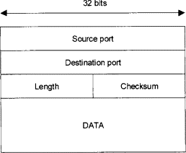

**UDP Frame Format**

**1. Source Port (16 bits):** Identifies the sender’s port.

**2. Destination Port (16 bits):** Identifies the receiver’s port.

**3. Length (16 bits):** Specifies the length of the UDP header and data.

**4. Checksum (16 bits):** Used for error-checking of the header and data.

**5. Data:** The actual data being transmitted.

### 18. Explain the term attenuation

Attenuation means a loss of energy. When a signal, simple or composite, travels through a medium, it loses some of its energy in overcoming the resistance of the medium.

### 19. Write functions of the session layer.

The session layer is the network dialog controller. It establishes, maintains, and synchronizes the interaction among communicating systems

Specific responsibilities of the session layer include the following:

* **Dialog control:** The session layer allows two systems to enter into a dialog. It allows the communication between two processes to take place in either half duplex (one way at a time) or full-duplex (two ways at a time) mode.
* **Synchronization:** The session layer allows a process to add checkpoints, or synchronization points, to a stream of data.

### 20. What is flow control ?

* Flow control refers to a set of procedures used to restrict the amount of data that the sender can send before waiting for acknowledgment.
* Flow control coordinates the amount of data that can be sent before receiving an acknowledgment and is one of the most important duties of the data link layer.

### 21. Explain flow control methods in noiseless channels.

There are two types of protocols for this type of channel. The first is a protocol that does not use flow control and the second is the one that does.

**Simplest Protocol :**There is no need for flow control in this scheme. As such it is a unidirectional protocol in which data frames are traveling in only one direction-from the sender to receiver. We assume that the receiver can immediately handle any frame it receives with a processing time that is small enough to be negligible. The data link layer of the receiver immediately removes the header from the frame and hands the data packet to its network layer, which can also accept the packet immediately. the receiver can never be overwhelmed with incoming frames in this scheme

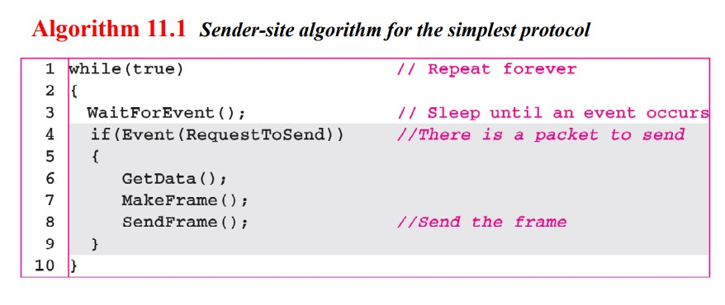

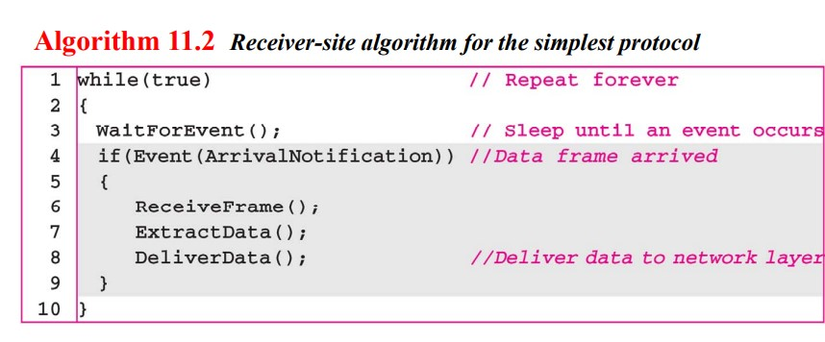

**Stop-and-Wait Protocol:** because the sender sends one frame, stops until it receives confirmation from the receiver (okay to go ahead), and then sends the next frame. We still have unidirectional communication for data frames, but auxiliary ACK frames (simple tokens of acknowledgment) travel from the other direction. We add flow control to our previous protocol.

## 

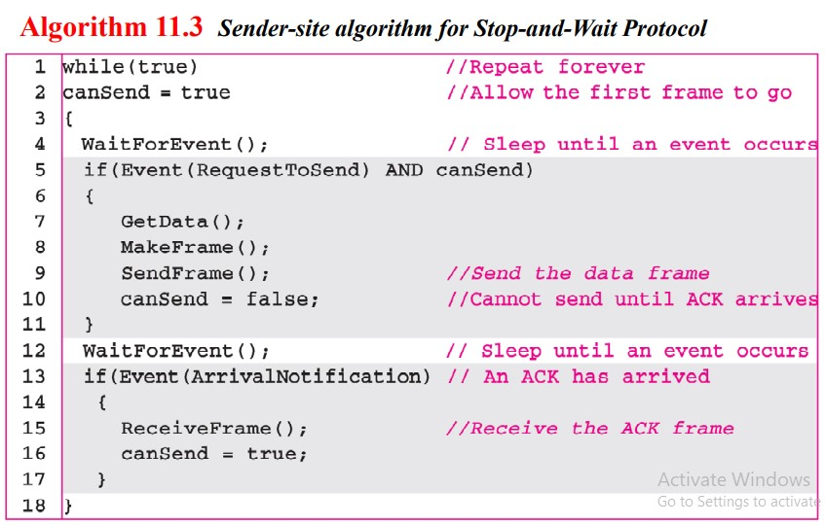

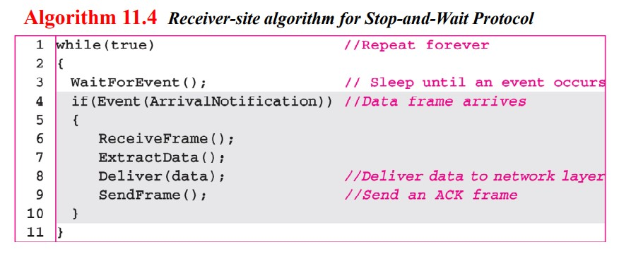

### 22. What do you mean by Bluetooth technology ?

* Bluetooth is a wireless LAN technology designed to connect devices of different functions such as telephones, notebooks, computers (desktop and laptop), cameras, printers, coffee makers, and so on.
* Bluetooth LAN is an ad hoc network, which means that the network is formed spontaneously; the devices, sometimes called gadgets, find each other and make a network called a piconet.
* A Bluetooth LAN can even be connected to the Internet if one of the gadgets has this capability.
* A Bluetooth LAN, by nature, can not be large.

## 5 Mark Questions

### 23. Discuss various transmission impairments

Signals travel through transmission media, which are not perfect.

The imperfection causes signal impairment.

This means that the signal at the beginning of the medium is not the same as the signal at the end of the medium . What is sent is not what is received.

**Causes of impairment:**

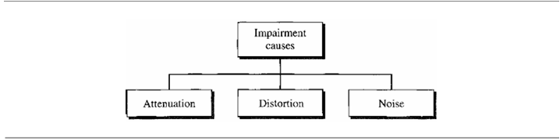

**Attenuation**

Attenuation means a loss of energy. When a signal, simple or composite, travels through a medium, it loses some of its energy in overcoming the resistance of the medium.

That is why a wire carrying electric signals gets warm, if not hot, after a while. Some of the electrical energy in the signal is converted to heat. To compensate for this loss, amplifiers are used to amplify the signal. Figure 3.26 shows the effect of attenuation and amplification.

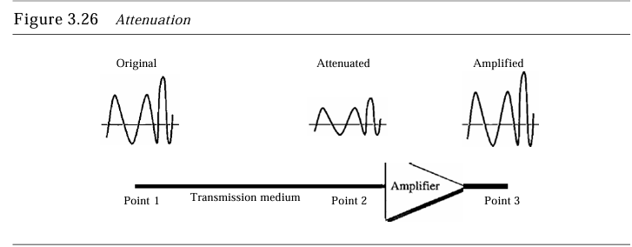

**Distortion**

Distortion means that the signal changes its form or shape. Distortion can occur in a composite signal made of different frequencies.Each signal component has its own propagation speed (see the next section) through a medium and, therefore, its own delay in arriving at the final destination. Differences in delay may create a difference in phase if the delay is not exactly the same as the period duration.

In other words, signal components at the receiver have phases different from what they had at the sender. The shape of the composite signal is therefore not the same. Figure 3.28 shows the effect of distortion on a composite signal.

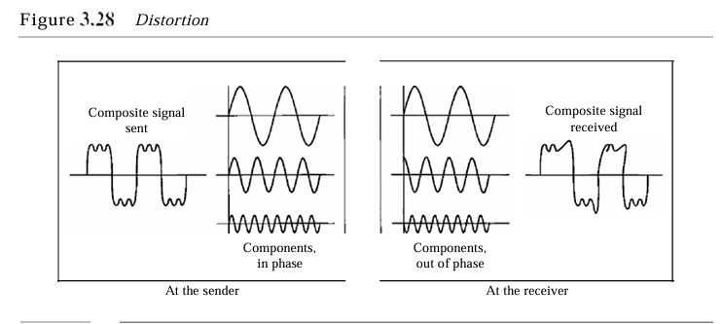

**Noise**

Noise is another cause of impairment. Several types of noise, such as thermal noise, induced noise, crosstalk, and impulse noise, may corrupt the signal. Thermal noise is the random motion of electrons in a wire which creates an extra signal not originally sent by the transmitter.

Induced noise comes from sources such as motors and appliances. These devices act as a sending antenna, and the transmission medium acts as the receiving antenna.

Crosstalk is the effect of one wire on the other. One wire acts as a sending antenna and the other as the receiving antenna. Impulse noise is a spike (a signal with high energy in a very short time) that comes from power lines, lightning, and so on. Figure 3.29 shows the effect of noise on a signal.

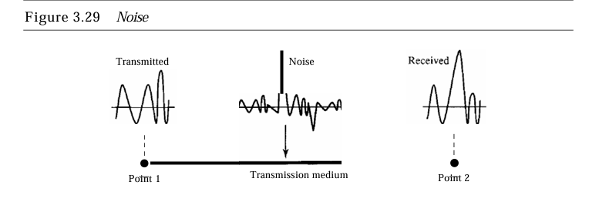

### 

### 24. Explain remote logging in detail.

On the Internet, users may want to run application programs at a remote site and create results that can be transferred to their local site.

For example, students may want to connect to their university computer lab from their home to access application programs for doing homework assignments or projects.

One way to satisfy that demand and others is to create a client/server application program for each desired service.

Programs such as file transfer programs (FTPs), e-mail (SMTP), and so on are currently available.

However, it would be impossible to write a specific client/server program for each demand. – The Better solution is a general purpose client/server program that lets a user access any application program on a remote computer,in other words, allow the user to log on to a remote computer.

**Logging**

After logging on, a user can use the services available on the remote computer and transfer the results back to the local computer,

In a time sharing environment, users are part of the system with some right to access resources. Each authorized user has an identification and probably a password. The user identification defines the user as part of the system. To access the system, the user logs into the system with a user id or login name.The system also includes password checking topreventanunauthorizeduserfromaccessingthe resources.

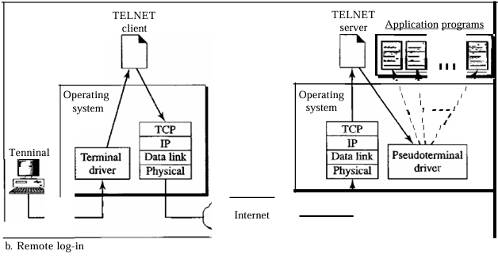

When a user wants to access an application program or utility located on a remote machine, she performs remote log-in.

Here the TELNET client and server programs come into use. The user sends the keystrokes to the terminal driver, where the local operating system accepts the characters but does not interpret them.

The characters are sent to the TELNETclient, which transforms the characters to a universal character set called network virtual terminal (NVT) characters and delivers them to the local TCP/IP protocol stack. The commands or text, in NVT form, travel through the Internet and arrive at the TCP/IP stack at the remote machine.

Here the characters are delivered to the operating system and passed to the TELNET server, which changes the characters to the corresponding characters understandable by the remote computer. However, the characters cannot be passed directly to the operating system because the remote operating system is not designed to receive characters from a TELNET server: It is designed to receive characters from a terminal driver.

The solution is to add a piece of software called a pseudo terminal driver which pretends that the characters are coming from a terminal. The operating system then passes the characters to the appropriate application program.

### 25. Explain briefly the CRC algorithm.

**Cyclic Redundancy Check**

We can create cyclic codes to correct errors. However, the theoretical background required is beyond the scope of this book. In this section, we simply discuss a category of cyclic codes called the cyclic redundancy check (CRC) that is used in networks such as LANs andWANs

In the encoder, the data word has k bits (4here); the code word has n bits(7here). The size of the data word is augmented by adding n-k(3here) Os to the right-hand side of the word. The n-bit result is fed into the generator . The generator uses an advisor of size n- k + I (4here), predefined and agreed upon . The generator divides the augmented data word by the divisor(modulo-2 division).The quotient of the division is discarded; the remainder(r2rlro) is appended to the data word to create the codeword.

The decoder receives the possibly corrupted code word.A copy of all n bits is fed to the checker which is a replica of the generator. The remainder produced by the checker 286 CHAPTER 10 ERROR DETECTION AND CORRECTION is a syndrome of n- k(3 here) bits, which is fed to the decision logic analyzer. The analyzer has a simple function. If the syndrome bits are all as, the 4 leftmost bits of the codeword are accepted as the data word (interpreted as no error); otherwise, the 4 bits are discarded (error).

**Encoder**

Let us take a closer look at the encoder. The encoder takes the dataword and augments it with a n- k number of as. It then divides the augmented dataword by the divisor, as shown in Figure 10.15.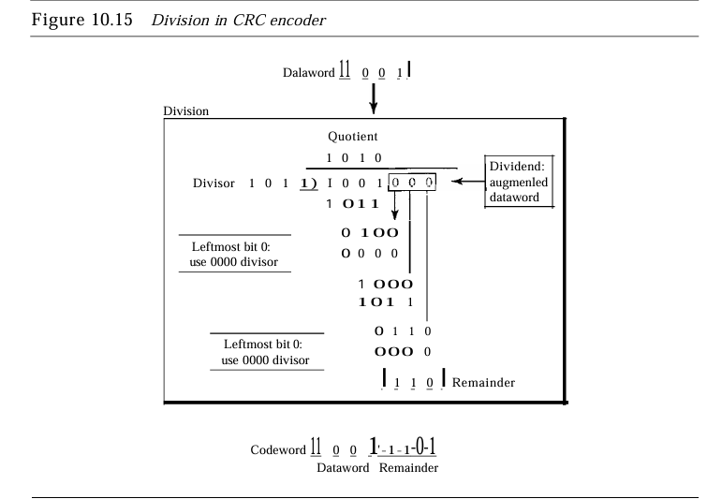

The process of modulo-2 binary division is the same as the familiar division process we use for decimal numbers. However, as mentioned at the beginning of the chapter, in this case addition and subtraction are the same. We use the XOR operation to do both. As in decimal division, the process is done step by step. In each step, a copy of the divisor is XORed with the 4 bits of the dividend. The result of the XOR operation (remainder) is 3 bits (in this case), which is used for the next step after 1 extra bit is pulled down to make it 4 bits long. There is one important point we need to remember in this type of division. If the leftmost bit of the dividend (or the part used in each step) is 0, the step cannot use the regular divisor; we need to use an all-Os divisor. When there are no bits left to pull down, we have a result. The 3-bit remainder forms the check bits (r2' rl' and ro). They are appended to the data word to create the codeword.

**Decoder**

The codeword can change during transmission. The decoder does the same division process as the encoder. The remainder of the division is the syndrome. If the syndrome is all Os, there is no error; the data word is separated from the received codeword and accepted. Otherwise, everything is discarded. Figure 10.16 shows two cases: The left hand figure shows the value of syndrome when no error has occurred; the syndrome is 000. The right-hand part of the figure shows the case in which there is one single error. The syndrome is not all Os (it is OIl).

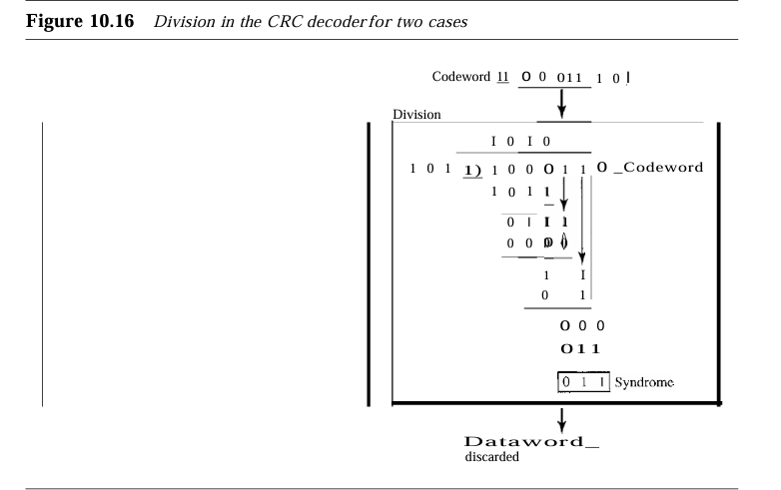

### 26. Explain TCP protocol in detail ?

**Transmission Control Protocol**

The Transmission Control Protocol (TCP) provides full transport-layer services to applications. TCP is a reliable stream transport protocol. The term stream, in this context, means connection-oriented: A connection must be established between both ends of a transmission before either can transmit data. At the sending end of each transmission, TCP divides a stream of data into smaller units called segments.

Each segment includes a sequence number for reordering after receipt, together with an acknowledgment number for the segments received. Segments are carried across the internet inside of IP datagrams.At the receiving end, TCP collects each datagram as it comes in and reorders the transmission based on sequence numbers.

### 27. Write a short note on any one guided media ?

Guided media, which are those that provide a channel from one device to another, include **twisted-pair cable, coaxial cable,** and **fiber-optic cable.**

**Coaxial Cable**

Coaxial cable (or coax) carries signals of higher frequency ranges than those in twisted pair cable, in part because the two media are constructed quite differently. Instead of having two wires, coax has a central core conductor of solid or stranded wire (usually copper) enclosed in an insulating sheath, which is, in turn, encased in an outer conductor of metal foil, braid, or a combination of the two.

The outer metallic wrapping serves both as a shield against noise and as the second conductor, which completes the circuit. This outer conductor is also enclosed in an insulating sheath, and the whole cable is protected by a plastic cover (see Figure 7.7)

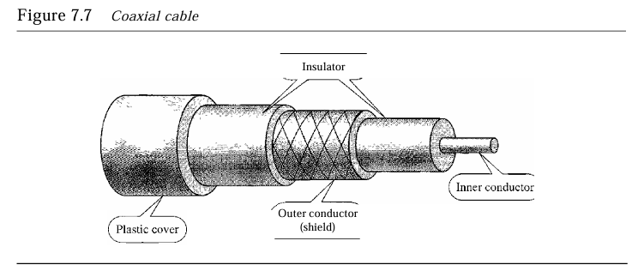

Coaxial cables are categorized by their radio government (RG) ratings. Each RG number denotes a unique set of physical specifications, including the wire gauge of the inner conductor, the thickness and type of the inner insulator, the construction of the shield, and the size and type of the outer casing.

**Connectors**

To connect coaxial cable to devices, we need coaxial connectors. The most common type of connector used today is the Bayonet-Neill-Concelman (BNe)connector, BNCT connector, and the BNC terminator.

**Applications**

* Coaxial cable was widely used in analog telephone networks signals.
* Used in digital telephone networks where a single coaxial cable could carry digital data up to 600 Mbps. Cable TV networks also use coaxial cables.
* Because of its high bandwidth, and consequently high data rate, coaxial cable was chosen for digital transmission in early Ethernet LANs.

### 28. Explain various switching techniques.

A switched network consists of a series of interlinked nodes, called switches. Switches are devices capable of creating temporary connections between two or more devices linked to the switch.

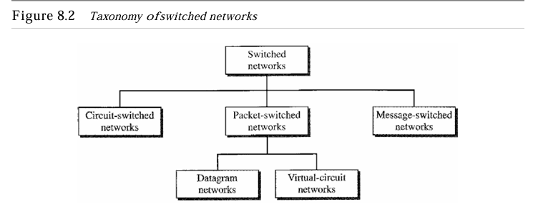

**Circuit switching**

Circuit switching takes place at the physical layer.In circuit switching, the resources need to be reserved during the setup phase; the resources remain dedicated for the entire duration of data transfer until the teardown phase.

**Packet switching**

In packet switching, there is no resource allocation for a packet. This means that there is no reserved bandwidth on the links, and there is no scheduled processing time for each packet. Resources are allocated on demand.

The allocation is done on a first come, first-served basis. When a switch receives a packet, no matter what is the source or destination, the packet must wait if there are other packets being processed. As with other systems in our daily life, this lack of reservation may create delay. For example, if we do not have a reservation at a restaurant, we might have to wait.

* **Datagram Networks in the Internet**

The Internet has chosen the datagram approach to switching at the network layer. It uses the universal addresses defined in the network layer to route packets from the source to the destination.

* **Virtual-circuit Network**

A virtual-circuit network is a cross between a circuit-switched network and a datagram network. It has some characteristics of both.

### 29. Write a short note on the token bus standard.

In the bus ring topology, also called a token bus, the stations are connected to a single cable called a bus. They, however, make a logical ring, because each station knows the address of its successor (and also predecessor for token management purposes). When a station has finished sending its data, it releases the token and inserts the address of its successor in the token. Only the station with the address matching the destination address of the token gets the token to access the shared media. The Token Bus LAN, standardized by IEEE, uses this topology.

### 30. Write a note on stop and wait ARQ.

The Stop-and-Wait Automatic Repeat Request (Stop-and Wait ARQ), adds a simple error control mechanism to the Stop-and-Wait Protocol.

To detect and correct corrupted frames, we need to add redundancy bits to our data frame. When the frame arrives at the receiver site, it is checked and if it is corrupted, it is silently discarded. The detection of errors in this protocol is manifested by the silence of the receiver. Lost frames are more difficult to handle than corrupted ones. In our previous protocols, there was no way to identify a frame. The received frame could be the correct one, or a duplicate, or a frame out of order.

The solution is to number the frames. When the receiver receives a data frame that is out of order, this means that frames were either lost or duplicated. The completed and lost frames need to be present in this protocol. If the receiver does not respond when there is an error, how can the sender know which frame to resend? To remedy this problem, the sender keeps a copy of the sent frame. At the same time, it starts a timer. If the timer expires and there is no ACK for the sent frame, the frame is resent, the copy is held, and the timer is restarted. Since the protocol uses the stop-and-wait mechanism, there is only one specific frame that needs an ACK even though several copies of the same frame can be in the network. Error correction in Stop-and-Wait ARQis done by keeping a copy of the sent frame and retransmitting of the frame when the timer expires. Since an ACK frame can also be corrupted and lost, it too needs redundancy bits and a sequence number. The ACKframe for this protocol has a sequence number field. In this protocol, the sender simply discards a corrupted ACK frame or ignores an out-of-order one.

### 31. Compare IPv4 and IPv6 addresses.

**IPV4 ADDRESS**

* An IPv4 address is a 32-bit address that uniquely and universally defines the connection of a device (for example, a computer or a router) to the Internet. IPv4 addresses are unique. They are unique in the sense that each address defines one, and only one, connection to the Internet. Two devices on the Internet can never have the same address at the same time
* The IPv4 addresses are universal in the sense that the addressing system must be accepted by any host that wants to be connected to the Internet.
* The address space of IPv4 is 232 or4,294,967,296.
* There are two prevalent notations to show an IPv4 address: binary notation and dotted decimal notation.
* Binary Notation : 01110101 10010101 00011101 00000010
* Dotted-Decimal Notation : 117.149.29.2

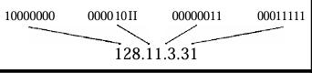

**IPV6 ADDRESS**

* An IPv6 address consists of 16 bytes (octets); it is 128 bits long. An IPv6 address is 128 bits long.
* Hexadecimal Colon Notation To make addresses more readable, IPv6 specifies hexadecimal colon notation. In this notation, 128 bits is divided into eight sections, each 2 bytes in length. Two bytes in hexadecimal notation requires four hexadecimal digits. Therefore, the address consists of 32 hexadecimal digits, with every four digits separated by a colon.
* IPv6 has a much larger address space; 2128 addresses are available.

## 15 Mark Questions

### 32. Explain functionality of various layers of iSO OSI reference model.

The OSI model is a layered framework for the design of network systems that allows communication between all types of computer systems. It consists of seven separate but related layers, each of which defines a part of the process of moving information across a network.

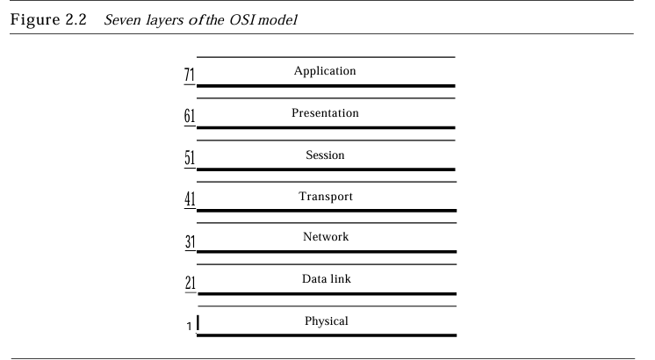

**Physical layer**

The physical layer is responsible for movements of individual bits from one hop (node) to the next.

Other responsibilities of the physical layer include the following:

* **Physical characteristics of interfaces and medium:** The physical layer defines the characteristics of the interface between the devices and the transmission medium. Italso defines the type of transmission medium.
* **Representation of bits:** The physical layer data consists of a stream of bits (sequence of Os or 1s) with no interpretation. To be transmitted, bits must be encoded into signals--electrical or optical. The physical layer defines the type of encoding (how Os and Is are changed to signals).
* **Data rate:** The transmission rate-the number of bits sent each second is also defined by the physical layer. In other words, the physical layer defines the duration of a bit, which is how long it lasts.
* **Synchronization of bits:** The sender and receiver not only must use the same bit rate but also must be synchronized at the bit level.
* **Line configuration:** The physical layer is concerned with the connection of devices to the media. In a point-to-point configuration, two devices are connected through a dedicated link. In a multipoint configuration, a link is shared among several devices.
* **Physical topology:** The physical topology defines how devices are connected to make a network. Devices can be connected by using a mesh topology (every device is connected to every other device), a star topology (devices are connected through a central device), a ring topology (each device is connected to the next, forming a ring), a bus topology (every device is on a commonlink), or a hybrid topology (this is a combination of two or more topologies).
* **Transmission Mode:** The physical layer also defines the direction of transmission between two devices: simplex, half-duplex, or full-duplex. In simplex mode, only one device can send; the other can only receive. The simplex mode is a one-way communication. In the half-duplex mode, two devices can send and receive, but not at the same time. In a full-duplex (or simply duplex) mode, two devices can send and receive at the same time.

**Data link layer**

The data link layer is responsible for moving frames from one hop(node) to the next.

Other responsibilities of the data link layer include the following:

* **Framing:** The data link layer divides the stream of bits received from the network layer into manageable data units called frames.
* **Physical addressing:** If frames are to be distributed to different systems on the network, the data link layer adds a header to the frame to define the sender and/or receiver of the frame. If the frame is intended for a system outside the sender's network, the receiver address is the address of the device that connects the network to the next one.
* **Flow control:** If the rate at which the data are absorbed by the receiver is less than the rate at which data are produced in the sender, the data link layer imposes a flow control mechanism to avoid overwhelming the receiver.
* **Error control:** The data link layer addressability to the physical layer by adding mechanisms to detect and retransmit damaged or lost frames. It also uses a mechanism to recognize duplicate frames. Error Control is normally achieved through trailers added to the end of the frame.
* **Accesscontrol :**When two or more devices are connected to the same link, data link layer protocols are necessary to determine which device has control over the link at any given time.

**Network Layer**

The network layer is responsible for the delivery of individual packets from the source host to the destination host.

Other responsibilities of the network layer include the following:

* **Logical addressing:** The physical addressing implemented by the data link layer handles the addressing problem locally. If a packet passes the network boundary, we need another addressing system to help distinguish the source and destination systems. The network layer adds a header to the packet coming from the upper layer that, among other things, includes the logical addresses of the sender and receiver. We discuss logical addresses later in this chapter.
* **Routing:** When independent networks or links are connected to create inter networks (network of networks) or a large network, the connecting devices (called routers or switches) route or switch the packets to their final destination. One of the functions of the network layer is to provide this mechanism.

**Transport Layer**

The transport layer is responsible for the delivery of messages from one process to another.

Other responsibilities of the transport layer include the following:

* **Service-point addressing:** Computers often run several programs at the same time. For this reason, source-to-destination delivery means delivery not only from one computer to the next but also from a specific process (running program) on one computer to a specific process (running program) on the other. The transport layer header must therefore include a type of address called a service-point address (or port address). The network layer gets each packet to the correct computer; the transport layer gets the entire message to the correct process on that computer.
* **Segmentation and reassembly:** A message is divided into transmittable segments, with each segment containing a sequence number. These numbers enable the transport layer to reassemble the message correctly upon arriving at the destination and to identify and replace packets that were lost in transmission.
* **Connection control:**The transport layer can be either connectionless or connection oriented. A connectionless transport layer treats each segment as an independent packet and delivers it to the transport layer at the destination machine. A connection oriented transport layer makes a connection with the transport layer at the destination machine first before delivering the packets. After all the data is transferred, the connection is terminated.
* **Flowcontrol:** Like the data link layer, the transport layer is responsible for flow control. However, flow control at this layer is performed end to end rather than across a single link.
* **Error control:** Like the data link layer, the transport layer is responsible for error control. However, error control at this layer is performed process-to-process rather than across a single link. The sending transport layer makes sure that the entire message arrives at the receiving transport layer without error (damage, loss, or duplication). Error correction is usually achieved through retransmission.

**Session Layer**

The session layer is responsible for dialog control and synchronization.

Specific responsibilities of the session layer include the following:

* **Dialog control:** The session layer allows two systems to enter into a dialog. It allows the communication between two processes to take place in either half- duplex (one way at a time) or full-duplex (two ways at a time) mode.
* **Synchronization:** The session layer allows a process to add checkpoints, or synchronization points, to a stream of data.

**Presentation Layer**

The presentation layer is responsible for translation, compression, and encryption.

Specific responsibilities of the presentation layer includes the following:

* **Translation:** The processes (running programs) in two systems are usually exchanging information in the form of character strings , numbers, and so on. The information must be changed to bit streams before being transmitted. Because different computers use different encoding systems, the presentation layer is responsible for interoperability between these different encoding methods. The presentation layer at the sender changes the information from its sender-dependent format into a common format. The Presentation layer at the receiving machine changes the common format into its receiver-dependent format.
* **Encryption:** To carry sensitive information, a system must be able to ensure privacy. Encryption Means that the sender transforms the original information to another form and sends the resulting message out over the network. Decryption reverses the original process to transform the message back to its original form.
* **Compression**: Data compression reduces the number of bits contained in the information. Data compression becomes particularly important in the transmission of multimedia such as text, audio, and video.

**Application Layer**

The application layer is responsible for providing services to the user.

Specific services provided by the application layer include the following:

* **Network virtual terminal:** A network virtual terminal is a software version of a physical terminal, and it allows a user to log on to a remote host. To do so, the application creates a software emulation of a terminal at the remote host. The user's computer talks to the software terminal which, in turn, talks to the host, and vice versa. The remote host believes it is communicating with one of its own terminals and allows the user to log on.
* **Filetransfer, access, and management:** This application allows a user to access files in a remote host (to make changes or read data), to retrieve files from a remote computer for use in the local computer, and to manage or control files in a remote computer locally.
  + **Mail services:** This application provides the basis for e-mail forwarding and storage.
  + **Directory services:** This application provides distributed database sources and access for global information about various objects and services.

### 33. Explain various error detection and correction methods.

**1-Simple Parity-Check Code**

The simple parity-check code is error-detecting code . In this code, a k-bit dataword is changed to an n-bit codeword where n = k + 1. The extra bit, called the parity bit, is selected to make the total number of Is in the codeword even. Although some implementations specify an odd number of Is, we discuss the even case. The minimum Hamming distance for this category is dmin =2, which means that the code is a single-bit error-detecting code, it cannot correct any error.

A Simple parity-check code can detect an odd number of errors.

**2-Two-dimensional parity check**

In this method, the data word is organized in a table (rows and columns). In the data to be sent, five 7-bit bytes are put in separate rows. For each row and each column, 1 parity-check bit is calculated. The whole table is then sent to the receiver, which finds the syndrome for each row and each column. The two-dimensional parity check can detect up to three errors that occur anywhere in the table (arrows point to the locations of the created nonzero syndromes). However, errors affecting 4 bits may not be detected.

**3-Hamming Codes**

Hamming codes are error-correcting codes . These codes were originally designed with dmin = 3, which means that they can detect up to two errors or correct one single error. There are some Hamming codes that can correct more than one error. First let us find the relationship between n and k in a Hamming code. We need to choose an integer m >= 3. The values of and k are then calculated from mas n = 2m- 1 and k ::: n- m. The number of check bits r =m.

For example, Ifm =3, then n ::: 7 and k::: 4. This is a Hamming code C(7, 4) with dmin =3.

**4-Cyclic Redundancy Check**

* **Encoder**

The encoder takes the dataword and augments it with a n- k number . It then divides the augmented dataword by the divisor, The process of modulo-2 binary division is the same as the familiar division process we use for decimal numbers. However, as mentioned at the beginning of the chapter, in this case addition and subtraction are the same. We use the XOR operation to do both. As in decimal division, the process is done step by step. In each step, a copy of the divisor is XORed with the 4 bits of the dividend.

The result of the XOR operation (remainder) is 3 bits (in this case), which is used for the next step after 1 extra bit is pulled down to make it 4 bits long. There is one important point we need to remember in this type of division. If The leftmost bit of the dividend (or the part used in each step) is 0, the step cannot use the regular divisor; we need to use an all-Os divisor. When there are no bits left to pull down, we have a result. The 3-bit remainder forms the check bits (r2' rl' and ro). They are appended to the dataword to create the codeword.

* **Decoder**

The codeword can change during transmission. The decoder does the same division process as the encoder. The remainder of the division is the syndrome. If the syndrome is all Os, there is no error; the dataword is separated from the received codeword and accepted. Otherwise, everything is discarded. Figure 10.16 shows two cases: The left hand figure shows the value of syndrome when no error has occurred; the syndrome is 000. The right-hand part of the figure shows the case in which there is one single error. The syndrome is not all Os (it is OIl).

**5-CHECKSUM**

**Example**

Suppose our data is a list of five 4-bit numbers that we want to send to a destination. In addition to sending these numbers, we send the sum of the numbers. For example, if the set of numbers is (7, 11, 12, 0, 6), we send (7, 11, 12,0,6,36), where 36 is the sum of the original numbers. The receiver adds the five numbers and compares the result with the sum. If the two are the same, the receiver assumes no error, accepts the five numbers, and discards the sum. Otherwise, there is an error somewhere and the data are not accepted.

The last error detection method we discuss here is called the checksum. The checksum is used in the Internet by several protocols although not at the data link layer. However, we briefly discuss it here to complete our discussion on error checking. Like linear and cyclic codes, the checksum is based on the concept of redundancy. Several protocols still use the checksum for error detection although the tendency is to replace it with a CRe. This means that the CRC is also used in layers other than the data link layer.

### 34. Explain briefly various ALOHA protocols.

**1-ALOHA Random Access Protocol**

It is designed for wireless LAN (Local Area Network) but can also be used in a shared medium to transmit data. Using this method, any station can transmit data across a network simultaneously when a data frameset is available for transmission.

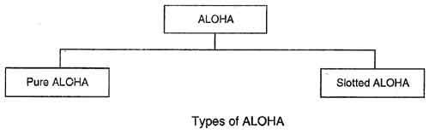

**2-Pure Aloha**

Whenever data is available for sending over a channel at stations, we use Pure Aloha. In pure Aloha, when each station transmits data to a channel without checking whether the channel is idle or not, the chances of collision may occur, and the data frame can be lost. When any station transmits the data frame to a channel, the pure Aloha waits for the receiver's acknowledgment. If it does not acknowledge the receiver ends within the specified time, the station waits for a random amount of time, called the backoff time (Tb). And the station may assume the frame has been lost or destroyed. Therefore, it retransmits the frame until all the data is successfully transmitted to the receiver.

**3-Slotted Aloha**

The slotted Aloha is designed to overcome the pure Aloha's efficiency because pure Aloha has a very high possibility of frame hitting. In slotted Aloha, the shared channel is divided into a fixed time interval called slots. So that, if a station wants to send a frame to a shared channel, the frame can only be sent at the beginning of the slot, and only one frame is allowed to be sent to each slot. And if the stations are unable to send data to the beginning of the slot, the station will have to wait until the beginning of the slot for the next time. However, the possibility of a collision remains when trying to send a frame at the beginning of two or more station time slots.

### 35. Write a short note on : (a) E-mail. (b) FTP

**a) E – mail**

* **UserAgent**

The first component of an electronic mail system is the user agent (VA). It provides service to the user to make the process of sending and receiving a message easier.

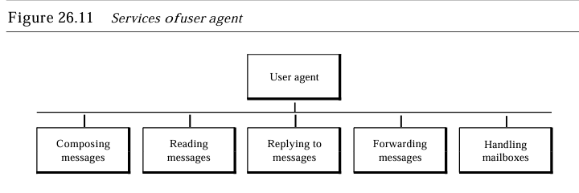

* **Composing Messages:** A user agent helps the user compose the e-mail message to be sent out.
* **Reading Messages:** The second duty of the user agent is to read the incoming messages. When a user invokes a user agent, it first checks the mail in the incoming mailbox
* **Replying to Messages:**After reading a message, a user can use the useragent to reply to a message. A user agent usually allows the user to reply to the original sender or to reply to all recipients of the message
* **Forwarding Messages:**Replying is defined as sending a message to the sender or recipients of the copy. Forwarding is defined as sending the message to a third party. A user agent allows the receiver to forward the message, with or without extra comments, to a third party.

A user agent normally creates two mailboxes: an inbox and an outbox. Each box is a file with a special format that can be handled by the user agent. The inbox keeps all the received emails until they are deleted by the user. The outbox keeps all the sent emails until the user deletes them. Most user agents today are capable of creating customized

* **Mailboxes.**

There are two types of user agents: **command-driven** and **GUI-based.**

* + **Command-Driven:**A command-driven user agent normally accepts a one-character command from the keyboard to perform its task. Some examples of command-driven user agents are mail, pine, and elm.
  + **GUI-Based Modem user agents:**GUI-Based Modem user agents are GUI-based. They contain graphical-user interface (GUI) components that allow the user to interact with the software by using both the keyboard and the mouse. They have graphical components such as icons, menu bars, and windows that make the services easy to access. Some examples ofGUI-based user agents are Eudora, Microsoft's Outlook, and
  + **Netscape**
    - **Sending Mail:**To send mail, the user, through the UA, creates mail that looks very similar to postal mail.
    - **Receive mail:** The user agent is triggered by the user (or a timer). Ifa user has mail, the VA informs the user with a notice. If The user is ready to read themail.Alist is displayed in which each line contains a summary of the information about a particular message in the mailbox.
    - **Envelope:** Theenvelope usually contains the sender and the receiver addresses. Message The message contains the header and the body. The header of the message defines the sender, the receiver, the subject of the message, and some other information (such as encoding type, as we see shortly). The body of the message contains the actual information to be read by the recipient.
    - **Addresses:**To deliver mail, a mail handling system must use an addressing system with unique addresses. In the Internet, the address consists of two parts: a local part and a domain name, separated by an @ sign
    - **Message TransferAgent:** SMTP The actual mail transfer is done through message transfer agents. To send mail, a system must have the client MTA, and to receive mail, a system must have a server MTA. The formal protocol that defines the MTA client and server on the Internet is called the Simple Mail Transfer Protocol (SMTP).

**b) File Transfer Protocol**

File Transfer Protocol (FTP) is the standard mechanism provided by TCP/IP for copying a file from one host to another. Although transferring files from one system to another seems simple and straightforward, some problems must be dealt with first.

For example, two systems may use different file name conventions. Two systems may have different ways to represent text and data. Two systems may have different directory structures. All these problems have been solved by FTP in a very simple and elegant approach. FTP differs from other client/server applications in that it establishes two connections between the hosts.

One connection is used for data transfer, the other for control information (commands and responses). Separation of commands and data transfer makes FTP more efficient.

The control connection uses very simple rules of communication. We need to transfer only a line of command or a line of response at a time. The data connection, on the other hand, needs more complex rules due to the variety of data types transferred.

However, the difference in complexity is at the FTP level, not TCP. For TCP, both connections are treated the same. FTP uses two well-known TCP ports: Port 21 is used for the control connection, and port 20 is used for the data connection.

# 

# 2019-QP

## 2 Mark Questions

### 1. Write a note on bit length and bit rate

The bit length is the distance one bit occupies on the transmission medium. Bit length=propagation speed x bit duration.

The bit rate is the number of bits sent in I s, expressed in bits per second (bps).

### 2. Define PCM

The most common technique to change an analog signal to digital data (digitization) is called pulse code modulation (PCM). A PCM encoder has three processes

1. The analog signal is sampled.
2. The sampled signal is quantized.
3. The quantized values are encoded as streams of bits

### 3. What is meant by interleaving in multiplexing?

TDM can be visualized as two fast-rotating switches, one on the multiplexing side and the other on the demultiplexing side. The switches are synchronized and rotate at the same speed, but in opposite directions. On the multiplexing side, as the switch opens in front of a connection, that connection has the opportunity to send a unit onto the path. This process is called interleaving.

### 4. Which are the principles used in the spread spectrum?

Spread spectrum achieves its goals through two principles:

* The bandwidth allocated to each station needs to be, by far, larger than what is needed. This allows redundancy.
* The expanding of the original bandwidth B to the bandwidth Bss must be done by a process that is independent of the original signal. In other words, the spreading process occurs after the signal is created by the source

### 5. Which are the different connectors used for twisted pair and coaxial cables?

The most common type of connector used today is the Bayonet-Neill-Concelman (BNe)connector. Three popular types of these connectors are the BNC connector, the BNCT connector, and the BNC terminator.

The BNC connector is used to connect the end of the cable to a device, such as a TV set. The BNC T connector is used in Ethernet networks to branch out to a connection to a computer or other device. The BNC terminator is used at the end of the cable to prevent the reflection of the signal.

### 6. Distinguish between forward error correction versus error correction by retransmission.

Forward error correction is the process in which the receiver tries to guess the message by using redundant bits. This is possible if the number of errors is small.

Correction by retransmission is a technique in which the receiver detects the occurrence of an error and asks the sender to resend the message. Resending is repeated until a message arrives that the receiver believes is error-free (usually, not all errors can be detected).

### 

### 7. What is the difference in the format of unicast address,multicast address and broadcast address

In unicast communication, there is one source and one destination. The relationship between the source and the destination is one-to-one. In this type of communication, both the source and destination addresses, in the IP datagram, are the unicast addresses assigned to the hosts. In unicasting, when a router receives a packet, it forwards the packet through only one of its interfaces as defined in the routing table. The router may discard the packet if it cannot find the destination address in its routing table.

In multicast communication, there is one source and a group of destinations. The relationship is one-to-many.

In this type of communication, the source address is a unicast address, but the destination address is a group address, which defines one or more destinations. In multicasting, the router may forward the received packet through several of its interfaces.

In broadcast communication, the relationship between the source and the destination is one-to-all. There is only one source, but all the other hosts are the destinations. The Internet does not explicitly support broadcasting because of the huge amount of traffic it would create and because of the bandwidth it would need

### 8. What is GSM?

The Global System for Mobile Communication (GSM) is a European standard that was developed to provide a common second-generation technology for all Europe. The aim was to replace a number of incompatible first-generation technologies. Bands GSM uses two bands for duplex communication. Each band is 25 MHz in width, shifted toward 900 MHz, Each band is divided into 124 channels of 200 kHz separated by guard bands.

### 9. Differentiate router and bridge?

A bridge operates in both the physical and the data link layer. As a physical layer device, it regenerates the signal it receives. As a data link layer device, the bridge can check the physical (MAC) addresses (source and destination) contained in the frame. A bridge does not change the physical (MAC) addresses in a frame.

A router is a three-layer device that routes packets based on their logical addresses (host-to-host addressing). A router normally connects LANs and WANs on the Internet and has a routing table that is used for making decisions about the route. The routing tables are normally dynamic and are updated using routing protocols.

### 10. Define TTL.

Time to Live (TTL) is a computer networking term that refers to the amount of time a data packet can exist in a network before it is discarded by a router .TTl is also known as hop limit.

TTL is implemented as a timestamp or counter that is embedded in or attached to the data .When the specified event count or timespan has passed ,the data is either discarded or revalidated . TTL is important for optimizing network performance and reliability.it prevents data packets from circulating indefinitely.

### 11. Briefly explain stream delivery service in TCP.

TCP, on the other hand, allows the sending process to deliver data as a stream of bytes and allows the receiving process to obtain data as a stream of bytes. TCP creates an environment in which the two processes seem to be connected by an imaginary "tube" that carries their data across the Internet. The sending process produces (writes to) the stream of bytes, and the receiving process consumes (reads from) them.

### 12. Hierarchical name space in DNS

In a hierarchical name space, each name is made of several parts. The first part can define the nature of the organization, the second part can define the name of an organization, the third part can define departments in the organization, and so on. In this case, the authority to assign and control the name spaces can be decentralized. A central authority can assign the part of the name that defines the nature of the organization and the name of the organization.

The responsibility of the rest of the name can be given to the organization itself. The organization can add suffixes (or prefixes) to the name to define its host or resources. The management of the organization need not worry that the prefix chosen for a host is taken by another organization because, even if part of an address is the same, the whole address is different.

## 5 Mark Questions

### 

### 13. Which are the data representation methods used in data communication?

Information today comes in different forms such as text, numbers, images, audio, and video.

**Text**

In data communications, text is represented as a bit pattern, a sequence of bits (Os or Is). Different sets of bit patterns have been designed to represent text symbols. Each set is called a code, and the process of representing symbols is called coding. Today, the prevalent coding system is called Unicode, which uses 32 bits to represent a symbol or character used in any language in the world.

**Numbers**

Numbers are also represented by bit patterns. However, a code such as ASCII is not used to represent numbers; the number is directly converted to a binary number to simplify mathematical operations.

**Images**

Images are also represented by bit patterns. In its simplest form, an image is composed of a matrix of pixels (picture elements), where each pixel is a small dot. The size of the pixel depends on the resolution. For example, an image can be divided into 1000 pixels or 10,000 pixels. In the second case, there is a better representation of the image , but more memory is needed to store the image.

**Audio**

Audio refers to the recording or broadcasting of sound or music. Audio is by nature different from text, numbers, or images. It is continuous, not discrete. Even when we use a microphone to change voice or music to an electric signal, we create a continuous signal.

**Video**

Video refers to the recording or broadcasting of a picture or movie. Video can either be produced as a continuous entity (e.g., by a TV camera), or it can be a combination of images, each a discrete entity, arranged to convey the idea of motion. Again we can change video to a digital or an analog signal

### 14. What is the function of layered Architecture?

Layered architecture in computer networks refers to dividing a network’s functioning into different layers, each responsible for a certain communication component. The major goal of this layered architecture is to separate the complex network communication process into manageable, smaller activities that can be better developed. In this article, we will discuss Layered Architecture in Computer Networks.

In computer networks, layered architecture is majorly used for communication. The two network models that makes use of layered architecture are:

1. OSI Model
2. TCP/IP Model

**1-OSI Model**

OSI stands for Open Systems Interconnection. OSI is a seven layered architecture. All these seven layers work collaboratively to transmit data from one layer to another. Below are the layers of OSI Model.

**Physical Layer:** Physical layer is the lowest layer of OSI model and is responsible for the physical connection between all the required devices. The information present in the physical layer is in the form of bits. Physical layer performs various functions such as bit rate control, bit synchronization, transmission mode etc.

**Data Link Layer:** Data Link layer provides successful delivery of messages from one node to the another. It checks whether this delivery of the message is error free. Other functions performed by the data link layer are error control, framing, flow control etc.

**Network Layer:** Network layer is responsible for the transmission of data from one host to another host that is connected in a different network. It performs other tasks such as routing and logical addressing.

**Transport Layer:** Transport Layer is defined as a layer that takes services from the network layer and provides services to the application layer. Other tasks performed by the transport layer are service point addressing, segmentation and reassembling.

**Session Layer:** Session layer is defined as a layer that is responsible for establishing a connection, maintenance of session and to provide security. Other functions of session Layer are to establish session termination and synchronization.

**Presentation Layer:** The data from the application layer is extracted at the presentation layer. This layer is also known as the translation layer. The functions of the presentation layer are encryption, decryption, compression and translation.

**Application Layer:** Application layer is the topmost layer of OSI Model. Application layer is also known as the desktop layer. It provides other functions such as directory services, mail services, network virtual terminal etc.

### 

### 15. Which are the different propagation modes in optical fiber?

Current technology supports two modes: **multimode** and **single mode** for propagating light along optical channels, each requiring fiber with different physical characteristics.

Multimode can be implemented in two forms: **step-index** or **graded-index.**Multimode is so named because multiple beams from a light source move through the core in different paths. How these beams move within the cable depends on the structure of the core

* In **multimode step-index fiber**, the density of the core remains constant from the center to the edges. A beam of light moves through this constant density in a straight line until it reaches the interface of the core and the cladding. At the interface, there is an abrupt change due to a lower density; this alters the angle of the beam's motion. The term step index refers to the suddenness of this change, which contributes to the distortion of the signal as it passes through the fiber.
* A second type of fiber, called **multimode graded-index fiber,** decreases this distortion of the signal through the cable. The word index here refers to the index of refraction. A graded-index fiber, therefore, is one with varying densities. Density is highest at the center of the core and decreases gradually to its lowest at the edge.

**Single-Mode**  uses step-index fiber and a highly focused source of light that limits beams to a small range of angles, all close to the horizontal. The single mode fiber itself is manufactured with a much smaller diameter than that of multimode fiber, and with substantially lower density (index of refraction).

The decrease in density results in a critical angle that is close enough to 90° to make the propagation of beams almost horizontal. In this case, propagation of different beams is almost identical, and delays are negligible. All the beams arrive at the destination "together" and can be recombined with little distortion to the signal.

### 16. Explain Stop and wait Automatic Repeat Request protocol in noisy channels.

**Stop-and-Wait Automatic Repeat Request**

Stop-and-Wait Automatic Repeat Request (Stop-and Wait ARQ), adds a simple error control mechanism to the Stop-and-Wait Protocol. To detect and correct corrupted frames, we need to add redundancy bits to our data frame . When the frame arrives at the receiver site, it is checked and if it is corrupted, it is silently discarded. The detection of errors in this protocol is manifested by the silence of the receiver .

Lost frames are more difficult to handle than corrupted ones. In other protocols, there was no way to identify a frame. The received frame could be the correct one, or a duplicate, or a frame out of order. The solution is to number the frames. When the receiver receives a data frame that is out of order, this means that frames were either lost or duplicated. The corrupted and lost frames need to be present in this protocol.

For the sender to identify which frame to resend, the sender keeps a copy of the sent frame. At the same time, it starts a timer. If the timer expires and there is no ACK for the sent frame, the frame is resent, the copy is held, and the timer is restarted. Since the protocol uses the stop-and-wait mechanism, there is only one specific frame that needs an ACK even though several copies of the same frame can be in the network.

**Sender-site algorithm for Stop-and-Wait ARQ**

| Sn= 0;  canSend = true; w hile (true) { WaitForEvent(); if (Event (RequestToSend) AND canSend) {  GetData () ;  MakeFrame (Sn) ;  StoreFrame(Sn);  SendFrame(Sn) ;  StartTimerO;  Sn = Sn + 1;  canSend = false; } WaitForEvent();  if(Event (ArrivaINotification) {  ReceiveFrame(ackNo);   if(not corrupted AND ackNo==Sn)  {  Stoptimer{};   PurgeFrame(Sn_l);  canSend = true;  } } if(Event (TimeOUt) {  StartTimer();  ResendFrame(Sn_l); } } |
| --- |

**Receiver-site algorithm for Stop-and-Wait ARQ Protocol**

| Rn= 0;   while (true) {  WaitForEvent(); if(Event(Arriva1Notificatio)) {  ReceiveFrame();  if(corrupted(frame));  sleep () ;  if(seqNo== Rn)  {  ExtractData();  DeliverData();  Rn= Rn + 1;  }  SendFrame (Rn) ; } } |
| --- |

### 17. Minimum frame size is important in CSMA/CD .Explain

Carrier sense multiple access with collision detection (CSMA/CD) augments the algorithm to handle the collision. In this method, a station monitors the medium after it sends a frame to see if the transmission was successful. If so, the station is finished. If, however, there is a collision, the frame is sent again.

For CSMA/CD to work, we need a restriction on the frame size. Before sending the last bit of the frame, the sending station must detect a collision, if any, and abort the transmission. This is so because the station, once the entire frame is sent, does not keep a copy of the frame and does not monitor the line for collision detection. Therefore, the frame transmission time Tfr must be at least two times the maximum propagation time Tp.

### 18. Briefly describe the Hexadecimal colon notation of an IPv6 address

**IPv6 ADDRESSES**

Despite all short-term solutions, such as classless addressing, Dynamic Host Configuration Protocol (DHCP) and NAT, address depletion is still a long-term problem for the Internet. This and other problems in the IP protocol itself, such as lack of accommodation for real-time audio and video transmission, and encryption and authentication of data for some applications, have been the motivation for IPv6.

**Structure**

An IPv6 address consists of 16 bytes (octets); it is 128 bits long. In hexadecimal colon notation, 128 bits is divided into eight sections, each 2 bytes in length. Two bytes in hexadecimal notation requires four hexadecimal digits. Therefore, the address consists of 32 hexadecimal digits, with every four digits separated by a colon.

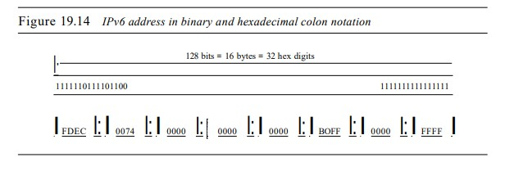

**Abbreviation**

Although the IP address, even in hexadecimal format, is very long, many of the digits are zer9s. In this case, we can abbreviate the address. The leading zeros of a section (four digits between two colons) can be omitted. Only the leading zeros can be dropped, not the trailing zeros

### 19. Distinguish between window policy and acknowledgement policy

An important issue in a packet-switched network is congestion. Congestion in a network may occur if the load on the network-the number of packets sent to the network-is greater than the capacity of the network-the number of packets a network can handle. Congestion control refers to the mechanisms and techniques to control the congestion and keep the load below the capacity.Window policy and acknowledgement policy are two types of congestion control methods.

**Window Policy**

The type of window at the sender may also affect congestion. The Selective Repeat window is better than the Go-Back-N window for congestion control. In the Go-Back-N window, when the timer for a packet times out, several packets may be resent, although some may have arrived safe and sound at the receiver. This duplication may make the congestion worse. The Selective Repeat window, on the other hand, tries to send the specific packets that have been lost or corrupted.

**Acknowledgment Policy**

The acknowledgment policy imposed by the receiver may also affect congestion. If the receiver does not acknowledge every packet it receives, it may slow down the sender and help prevent congestion. Several approaches are used in this case. A receiver may send an acknowledgment only if it has a packet to be sent or a special timer expires. A receiver may decide to acknowledge only N packets at a time. We need to know that the acknowledgments are also part of the load in a network. Sending fewer acknowledgments means imposing less load on the network.

### 20. Explain the different section of Domain Name Space

The sources explain that the Domain Name System (DNS) employs a hierarchical name space structured as an inverted tree, similar to the file system on a computer. This structure is divided into three main sections: generic domains, country domains, and the inverse domain. This hierarchical organization facilitates the decentralized management of the vast amount of information within the DNS.

**Generic Domains**

Generic domains categorize registered hosts based on their general characteristics, such as commercial organizations, educational institutions, or government entities. The first level of the generic domains section includes 14 labels, each representing a distinct organization type, such as:

• .com for commercial organizations

• .edu for educational institutions

• .gov for government institutions

• .org for non-profit organizations

This section employs a hierarchical structure, with each node in the tree serving as an index to the domain name space database.

**Country Domains**

Country domains utilize two-character country abbreviations to categorize hosts based on their geographical location. For instance, us represents the United States, uk represents the United Kingdom, and fr represents France. The second-level labels within a country domain may denote organizational categories or more specific national designations, such as state abbreviations in the United States (e.g., ca.us for California). This section provides a geographically organized index to the domain name space database.

**Inverse Domain**

The inverse domain serves the purpose of mapping an IP address to a domain name. This functionality is often required when a server needs to verify the identity of a client based on its IP address. To facilitate this reverse mapping, the inverse domain employs a structure that appears inverted compared to generic or country domains. The IP address components are arranged in reverse order, with the hostid portion preceding the netid portion. This arrangement allows a server serving an entire site to reside at a higher level than servers serving individual subnets, maintaining consistency with the hierarchical reading convention of domain labels.

For example, the IP address 132.34.45.121, a class B address with netid132.34, is represented in the inverse domain as 121.45.34.132.in-addr.arpa. This section provides a mechanism for reverse lookups, enabling the identification of domain names associated with specific IP addresses.

### 21. Explain ASymmetric cryptography

**Asymmetric-Key Cryptography**

In asymmetric or public-key cryptography, there are two keys: a private key and a public key. The private key is kept by the receiver. The public key is announced to the public.There are two types of algorithm in asymmetric

**Cryptography**

**1-RSA**

The most common public key algorithm is RSA. It uses two numbers, e and d, as the public and private keys.

The two keys, e and d, have a special relationship to each other.

**Selecting Keys**

* Bob use the following steps to select the private and public keys:
* Bob chooses two very large prime numbers p and q. Remember that a prime number is one that can be divided evenly only by 1 and itself.
* Bob multiplies the above two primes to find n, the modulus for encryption and decryption. In other words, n ::: p X q.
* Bob calculates another number ::: (p -1) X (q - 1).
* Bob chooses a random integer e. He then calculates d so that d x e::: 1 mod .
* Bob announces e and n to the public; he keeps and d secret.

**Encryption**

Anyone who needs to send a message to Bob can use nand e. For example, if Alice needs to send a message to Bob, she can change the message, usually a short one, to an integer. This is the plaintext. She then calculates the ciphertext, using e and n.

C=pe(mod n)

Alice sends C, the ciphertext, to Bob.

**Decryption**

Bob keeps Ø and d private. When he receives the ciphertext, he uses his private key d to decrypt the message:

P= Cd(modn)

**Restriction**

For RSA to work, the value of P must be less than the value of n. IfP is a large number, the plaintext needs to be divided into blocks to make P less than n.

**2-Diffie-Hellman**

RSA is a public-key cryptosystem that is often used to encrypt and decrypt symmetric keys. Diffie- Hellman, on the other hand, was originally designed for key exchange. In the Diffie-Hellman cryptosystem, two parties create a symmetric session key to exchange data without having to remember or store the key for future use. They do not have to meet to agree on the key; it can be done through the Internet. Before establishing a symmetric key, the two parties need to choose two numbers p and g. The first number, p, is a large prime number on the order of 300 decimal digits (1024 bits). The second number is a random number. These two numbers need not be confidential. They can be sent through the Internet; they can be public.

**Step 1:** Alice chooses a large random number x and calculates R1=gx mod p.

**Step 2:** Bob chooses another large random number y and calculates R2 = gY mod p.

**Step 3:** Alice sends R1 to Bob. Note that Alice does not send the value of x; she sends only R1-

**Step 4:** Bob sends R2 to Alice. Again, note that Bob does not send the value of y, he sends only R2.

**Step 5:** Alice calculates K = (R2)x mod p.

**Step 6:** Bob also calculates K = (R1)y mod p.

The symmetric key for the session is K.

(gx mod p)Y mod p =(gY mod p)X mod p =gxy mod p

Bob has calculated K = (R1)y mod p = (gx mod p)Y mod p= gxy mod p. Alice has calculated K =(R2)X mod p =(gY mod p)X mod =lfY mod p. Both have reached the same value without Bob knowing the value of x and without Alice knowing the value of y

## 15 Mark Questions

### 22. Which are the transmission modes used in computer network data Communications with example

Communication between two devices can be **simplex, half-duplex, or full-duplex**

**Simplex Mode**

In simplex mode, the communication is unidirectional, as on a one-way street. Only one of the two devices on a link can transmit; the other can only receive . Keyboards and traditional monitors are examples of simplex devices. The keyboard can only introduce input; the monitor can only accept output. The simplex mode can use the entire capacity of the channel to send data in one direction.

**Half-Duplex**

In half-duplex mode, each station can both transmit and receive, but not at the same time. : When one device is sending, the other can only receive, and vice versa. The half-duplex mode is like a one-lane road with traffic allowed in both directions. When cars are traveling in one direction, cars going the other way must wait. In a half-duplex transmission, the entire capacity of a channel is taken over by whichever of the two devices is transmitting at the time.

Walkie-talkies and CB (citizens band) radios are both half-duplex systems. The half-duplex mode is used in cases where there is no need for communication in both directions at the same time; the entire capacity of the channel can be utilized for each direction.

**Full-Duplex**

In Full –duplex mode (also called duplex),both stations can transmit and receive simultaneously .the full duplex mode is like a two –way street with traffic flowing in both directions at the same time.In full duplex mode,signals going in one direction share the capacity of the link with the signals going in the other direction.This sharing can occur in two ways,Either the link must contain two physically separate transmission paths,one for sending and the other for receiving ;or the capacity of the channel is divided between signals traveling in both directions.

One common example of full-duplex communication is the telephone network. When two people are communicating by a telephone line, both can talk and listen at the same time. The full-duplex mode is used when communication in both directions is required all the time. The capacity of the channel, however, must be divided between the two directions.

### 

### 23. Explain about packet switching.

In data communications, we need to send messages from one end system to another. If the message is going to pass through a packet-switched network, it needs to be divided into packets of fixed or variable size. The size of the packet is determined by the network and the governing protocol. In packet switching, there is no resource allocation for a packet.

This means that there is no reserved bandwidth on the links, and there is no scheduled processing time for each packet. Resources are allocated on demand. The allocation is done on a first come, first-served basis. When a switch receives a packet, no matter what is the source or destination, the packet must wait if there are other packets being processed.There are two types of packet switching

**1-Datagram Network**

In a datagram network, each packet is treated independently of all others. Even if a packet is part of a multi packet transmission, the network treats it as though it existed alone. Packets in this approach are referred to as datagrams. Datagram switching is normally done at the network layer.

The datagram networks are sometimes referred to as connectionless networks. The term connectionless here means that the switch (packet switch) does not keep information about the connection state. There are no setup or teardown phases. Each packet is treated the same by a switch regardless of its source or destination. In this type of network, each switch (or packet switch) has a routing table which is based on the destination address. The routing tables are dynamic and are updated periodically. The destination addresses and the corresponding forwarding output ports are recorded in the tables.

This is different from the table of a circuit switched network in which each entry is created when the setup phase is completed and deleted when the teardown phase is over. Every packet in a datagram network carries a header that contains, among other information, the destination address of the packet. When the switch receives the packet, this destination address is examined; the routing table is consulted to find the corresponding port through which the packet should be forwarded. The destination address in the header of a packet in a datagram network remains the same during the entire journey of the packet

**2-VIRTUAL-CIRCUIT NETWORKS**

* A virtual-circuit network is a cross between a circuit-switched network and a datagram network. It has some characteristics of both.
* As in a circuit-switched network, there are setup and teardown phases in addition to the data transfer phase.
* Resources can be allocated during the setup phase, as in a circuit-switched network, or on demand, as in a datagram network.
* As in a datagram network, data is packetized and each packet carries an address in the header. However, the address in the header has local jurisdiction (it defines what should be the next switch and the channel on which the packet is being caned), not end-to-end jurisdiction. The reader may ask how the intermediate switches know where to send the packet if there is no final destination address carried by a packet. The answer will be clear when we discuss virtual-circuit identifiers in the next section.
* As in a circuit-switched network, all packets follow the same path established during the connection.
* A virtual-circuit network is normally implemented in the data link layer, while a circuit-switched network is implemented in the physical layer and a datagram network in the network layer. But this may change in the future.

### 24. Explain byte stuffing and bit stuffing with suitable examples.

In a character-oriented protocol, data to be carried are 8-bit characters from a coding system such as ASCII. The header, which normally carries the source and destination addresses and other control information, and the trailer, which carries error detection or error correction redundant bits, are also multiples of 8 bits. To separate one frame from the next, an 8-bit (I-byte) flag is added at the beginning and the end of a frame.

The flag, composed of protocol-dependent special characters, signals the start or end of a frame. The flag could be selected to be any character not used for text communication. Now, however, we send other types of information such as graphs, audio, and video. Any pattern used for the flag could also be part of the information. If this happens, the receiver, when it encounters this pattern in the middle of the data, thinks it has reached the end of the frame.

To fix this problem, a byte-stuffing strategy was added to character-oriented framing. In byte stuffing (or character stuffing), a special byte is added to the data section of the frame when there is a character with the same pattern as the flag. The data section is stuffed with an extra byte. This byte is usually called the escape character (ESC), which has a predefined bit pattern. Whenever the receiver encounters the ESC character, it removes it from the data section and treats the next character as data, not a delimiting flag.

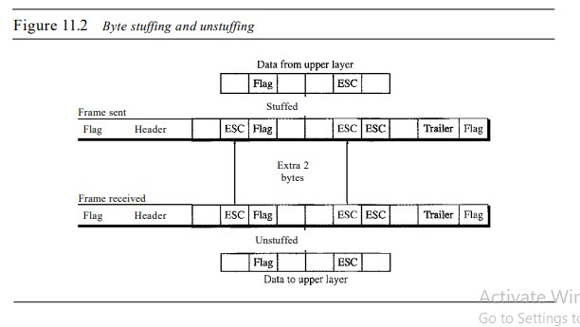

In a bit-oriented protocol, the data section of a frame is a sequence of bits to be interpreted by the upper layer as text, graphic, audio, video, and so on. However, in addition to headers (and possible trailers), we still need a delimiter to separate one frame from the other. Most protocols use a special 8-bit pattern flag 01111110 as the delimiter to define the beginning and the end of the frame.

This flag can create the same type of problem we saw in the byte-oriented protocols. That is, if the flag pattern appears in the data, we need to somehow inform the receiver that this is not the end of the frame. We do this by stuffing 1 single bit (instead of I byte) to prevent the pattern from looking like a flag. The strategy is called bit stuffing. In bit stuffing, if a 0 and five consecutive I bits are encountered, an extra 0 is added. This extra stuffed bit is eventually removed from the data by the receiver. Note that the extra bit is added after one 0 followed by five 1s regardless of the value of the next bit. This guarantees that the flag field sequence does not inadvertently appear in the frame.

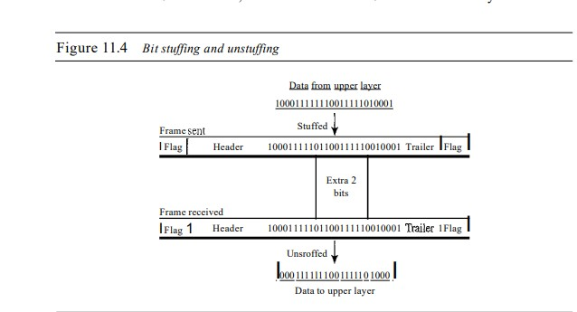

### 25. Explain classless addressing in IPv4. What are the advantages of classless addressing?

**Classless Addressing**

classless addressing was designed and implemented To overcome address depletion and give more organizations access to the Internet. In this scheme, there are no classes, but the addresses are still granted in blocks.

In classless addressing, when an entity, small or large, needs to be connected to the Internet, it is granted a block (range) of addresses. The size of the block (the number of addresses) varies based on the nature and size of the entity.

For example, a household may be given only two addresses; a large organization may be given thousands of addresses. An ISP, as the Internet service provider, may be given thousands or hundreds of thousands based on the number of customers it may serve. Restriction To simplify the handling of addresses, the Internet authorities impose three restrictions on classless address blocks:

**1.** The addresses in a block must be contiguous, one after another.

**2.** The number of addresses in a block must be a power of 2 (I, 2, 4, 8, ... ).

**3.** The first address must be evenly divisible by the number of addresses.

A better way to define a block of addresses is to select any address in the block and the mask. A mask is a 32-bit number in which the n leftmost bits are Is and the 32 - n rightmost bits are Os. However, in classless addressing the mask for a block can take any value from 0 to 32.

**Classless addressing has several advantages over classful addressing,**

* **More efficient use of IP addresses**

Classless addressing allows networks to use only the number of IP addresses they need, rather than being assigned larger pools of addresses than they need. This reduces the amount of wasted IP addresses.

* **More balanced use of IP address ranges**

Classless addressing allows for balanced use across the IP address ranges, rather than being limited to the Class A, B, and C ranges.

* **More efficient routing**

Classless addressing allows for more efficient routing by enabling route aggregation and classless routing protocols. This can reduce resource consumption on routers and save bandwidth.

* **Efficient address space allocation**

Classless addressing allows for addresses to be allocated in sizes of any binary multiple, rather than being allocated in fixed-size blocks.

# 2020-QP

## 2 Mark Questions

### 1. Write a note about TCP/IP protocol suite

**TCP/IP Protocol Suite: A Detailed Overview**

The TCP/IP protocol suite is a hierarchical protocol composed of interactive modules, each providing a particular function. These modules are not necessarily interdependent, meaning they can be mixed and matched as needed. This structure contrasts with the OSI model, where each layer has strictly defined functions.

The TCP/IP suite is often described as having four layers:

• Host-to-network

• Internet

• Transport

• Application

However, it can also be compared to the OSI model's five layers:

• Physical

• Data Link

• Network

• Transport

• Application

### 2. Explain time and frequency domain

**Time Domain and Frequency Domain**

The sources explain that a time-domain plot of a signal depicts how a signal's amplitude varies over time. This is essentially an amplitude-versus-time graph. The time domain is a straightforward representation of a signal but may not be the most informative when analyzing complex signals.

On the other hand, a frequency-domain plot illustrates the relationship between a signal's amplitude and frequency. This plot focuses on the peak value and the frequencies present in the signal, disregarding the changes in amplitude over a single period. The frequency domain provides a more compact and convenient representation, particularly for analyzing composite signals with multiple frequencies.

### 3. Define multiplexing

Multiplexing is a set of techniques that enables the simultaneous transmission of multiple signals across a single data link. This is achieved by combining multiple low-bandwidth channels into one channel with a larger bandwidth. In essence, multiplexing allows multiple users or devices to share the available bandwidth of a transmission medium. This sharing can be based on frequency, wavelength, or time, depending on the specific multiplexing technique employed.

The sources describe the concept of multiplexing using a multiplexer (MUX) at the sending end and a demultiplexer (DEMUX) at the receiving end. The MUX combines multiple transmission streams from different sources into a single stream, while the DEMUX separates the combined stream back into its individual components and directs them to their corresponding destinations.

**Types of Multiplexing Techniques:**

* **Frequency-Division Multiplexing (FDM):** An analog technique used when the bandwidth of a link is greater than the combined bandwidths of the signals to be transmitted. It involves modulating each signal onto different carrier frequencies, which are then combined into a single composite signal for transmission. FDM is commonly used in applications like telephone systems, radio, and television broadcasting.
* **Wavelength-Division Multiplexing (WDM):** Designed for use with fiber-optic cable, which has a high data-rate capability. WDM combines multiple light sources, each carrying a narrow band of frequencies, into a single light beam with a wider band of frequencies for transmission. At the receiver, the signals are separated using a demultiplexer.
* **Time-Division Multiplexing (TDM):** A digital technique that allows multiple connections to share the bandwidth of a link by dividing time into slots. Each connection is allocated a specific time slot for transmission. The sources further classify TDM into synchronous TDM and statistical TDM:
  + **Synchronous TDM:** Each input connection has a dedicated time slot, even if it has no data to send, leading to potential inefficiencies.
  + **Statistical TDM:** Time slots are dynamically allocated to improve bandwidth efficiency, only assigning a slot to a connection when it has data to transmit.
  + **Local Area Networks (LANs):** Both coaxial cable and fiber-optic cable, along with multiplexing techniques, are used in various types of Ethernet LANs.

In summary, multiplexing is a crucial technique in modern communication systems, enabling efficient use of bandwidth and facilitating the transmission of multiple signals over a shared medium. This capability is fundamental for various applications, ranging from traditional telephone systems to high-speed fiber-optic networks and wireless communication systems.

### 

### 4. Define transmission medium

A transmission medium refers to the physical path through which a message travels from a sender to a receiver. It is the tangible channel that facilitates the transfer of data between communicating devices.

**Examples of Transmission Media:**

The sources list various examples of transmission media, including:

• Twisted-pair wire

• Coaxial cable

• Fibre-optic cable

• Radio waves

Transmission media are fundamental components of any data communication system. They provide the conduit for the flow of information, enabling devices to exchange data.

### 5. Differentiate sky propagation and line of sight propagation.

**Sky Propagation:** This method utilizes the ionosphere, a layer of the atmosphere containing charged particles or ions, to reflect radio waves back to Earth. Sky propagation is typically employed for higher-frequency radio waves (2-30 MHz). This technique allows for long-distance communication with lower output power.

**Line-of-Sight Propagation:** As the name suggests, this method requires a direct, unobstructed path between the transmitting and receiving antennas. Very high-frequency signals (above 30 MHz) are used in line-of-sight propagation. The antennas must be directional, pointing directly at each other, and either sufficiently tall or close enough together to overcome the Earth's curvature. Line-of-sight propagation is used for applications like satellite communication and terrestrial microwave links.

**Key Differences**

* **Frequency Range:** Sky propagation uses lower frequencies than line-of-sight propagation.
* **Propagation Mechanism:** Sky propagation relies on reflection from the ionosphere, while line-of-sight requires a direct path.
* **Distance:** Sky propagation enables communication over longer distances compared to line-of-sight for a given power level.
* **Antenna Requirements:** Sky propagation can use omnidirectional antennas, while line-of-sight necessitates directional antennas.

### 6. Differentiate the terms dataword and codeword.

**Dataword:** This is the original block of data that needs to be transmitted. It consists of k bits and represents the smallest unit of information to be encoded for error control. You can think of it as the raw message before any processing for error control.

**Codeword:** This is the result of adding redundant bits to the dataword. These extra bits, r in number, are calculated based on a specific encoding scheme and are used to detect and possibly correct errors that may occur during transmission. The codeword is of length n bits, where n = k + r. It's essentially the protected version of the dataword, equipped with extra information to ensure reliable transmission.

### 7. Explain how throughput is calculated in pure ALOHA.

**Throughput Calculation in Pure ALOHA**

In the context of the pure ALOHA protocol, which is a random access method for shared medium networks, throughput is calculated using a specific formula that considers the average number of frames generated during one frame transmission time.

The formula for throughput (S) in pure ALOHA is:

**S = G × e−2G**

Where:

* G represents the average number of frames generated by all stations in the network during one frame transmission time.
* e is the mathematical constant approximately equal to 2.718.

The formula highlights the impact of collisions on the efficiency of pure ALOHA. The term e−2G represents the probability of a frame successfully transmitting without a collision. This probability decreases as the number of generated frames (G) increases, signifying the heightened risk of collisions as network traffic intensifies.

### 8. Explain the format of Ethernet addresses.

**Format of an Ethernet Address**

Each device on an Ethernet network, such as a computer, workstation, or printer, has its own Network Interface Card (NIC). The NIC provides the device with a unique 6-byte (48-bit) physical address, also known as the Ethernet address.

This address is typically represented using hexadecimal notation, making it more compact and readable. In this notation, each byte is represented by two hexadecimal digits, and a colon separates the bytes. For instance, a typical Ethernet address would look like this:

06:01:02:01:2C:4B

* 6 bytes: The address consists of six bytes, equivalent to 48 bits.
* 12 hexadecimal digits: Each byte is represented by two hexadecimal digits (0-9 and A-F), totalling 12 digits.
* Colons: Colons are used to separate the bytes, enhancing readability.

While the address is written in hexadecimal notation for human convenience, the actual transmission of the address on the network occurs differently. The address is sent left-to-right, byte by byte.

However, for each byte, the least significant bit is sent first, and the most significant bit is sent last. This transmission order ensures that the bit determining whether an address is unicast or multicast reaches the receiver first.

### 9. Find the class of the given IPv4 addresses a) 192.35.101.8 b)129.10.7.25

**Classifying IPv4 Addresses**

In classful addressing, the IPv4 address space is divided into five classes: A, B, C, D, and E. The first byte of the address, when represented in dotted-decimal notation, determines the class of the address.

**a) 192.35.101.8**

* The first byte is 192.
* Class C addresses fall within the range of 192-223 in the first byte.
* Therefore, 192.35.101.8 is a Class C address.

**b) 129.10.7.25**

* The first byte is 129.
* Class A addresses range from 1 to 127 in the first byte. Class B addresses range from 128 to 191.
* Therefore, 129.10.7.25 is a Class B address.

### 10. What is meant by abbreviation in IPv6 addressing?

**IPv6 Address Abbreviation**

The sources explain that IPv6 addresses, being 128 bits long, can be quite lengthy when represented in hexadecimal colon notation. To address this, IPv6 offers abbreviation methods to simplify the representation of these addresses.

**Leading Zero Compression:**

The most common abbreviation technique involves compressing leading zeros within each 16-bit section of the address. For instance, the section "0045" can be abbreviated to "45". However, it's important to note that only leading zeros can be omitted, not trailing zeros. So, "0320" cannot be shortened.

**Example:**

The address FDEC:0074:0000:0000:0000:BOFF:0000:FFFO can be abbreviated as:

FDEC:74:0:0:0:BOFF:0:FFFO

**Double Colon Compression:**

Further abbreviation is possible when there are consecutive sections consisting only of zeros. In such cases, these zero sections can be entirely replaced with a double colon (::). However, this type of compression can only be used once within a single address.

**Example:**

Building upon the previous example, the address FDEC:74:0:0:0:BOFF:0:FFFO can be further abbreviated as: FDEC:74::BOFF:0:FFFO

### 11. Distinguish between connection oriented and connectionless services?

**Connection-Oriented and Connectionless Services**

In networking, there are two primary types of services: connection-oriented and connectionless. These services describe how data is transmitted between communicating devices.

* Connection-oriented services establish a dedicated communication path, akin to a phone call, before data transfer begins. This involves a three-way handshake process to synchronize sequence numbers and other parameters. Once the connection is established, data flows sequentially and reliably, ensuring that packets arrive at the destination in the correct order. The connection is then formally terminated after the data transfer is complete. This ensures reliable data transmission, but it introduces overhead due to the setup and teardown phases.
* Connectionless services, in contrast, do not require a pre-established connection. Data packets are treated individually and sent independently, like sending multiple letters through the postal service. There is no guarantee of order or reliable delivery, as packets may arrive out of order, get lost, or become corrupted. This approach is efficient for applications where speed is prioritized over guaranteed delivery.
* **Examples:**
  + Connection-oriented protocols: TCP (Transmission Control Protocol) and SCTP (Stream Control Transmission Protocol) at the transport layer, and virtual circuit networks like Frame Relay and ATM (Asynchronous Transfer Mode) at the network layer.
  + Connectionless protocols: UDP (User Datagram Protocol) at the transport layer and IP (Internet Protocol), including both IPv4 and IPv6, at the network layer.

### 12. Define country Domain

**Country Domains in DNS**

Domain Name System (DNS) is responsible for mapping human-readable domain names to numerical IP addresses, which are used for communication on the internet. The DNS namespace is structured as an inverted tree, with the root at the top. To manage this vast namespace, it's divided into sections. One of these sections is the country domains.

* The country domains section of the DNS namespace is used to organize domain names based on their geographical location.
* It employs two-character country abbreviations, as defined by the ISO 3166 standard. For instance, "us" stands for the United States, "uk" for the United Kingdom, and "fr" for France.
* Following the country code, there can be additional labels that specify organizations or further subdivisions within the country.
* For example, the United States utilizes state abbreviations as a sub-level within "us." Hence, the domain name "example.ca.us" indicates an entity located in California, United States.

Country domains play a crucial role in organizing and localizing domain names based on geographical regions. They contribute to the hierarchical structure of the DNS namespace and facilitate the efficient routing and resolution of domain names based on their location.

## 5 Mark Questions

### 13. Write down the steps of analog to analog conversion

**Steps in Analog-to-Analog Conversion**

The sources explain that analog-to-analog conversion, also known as analog modulation, is the process of modifying an analog signal to make it suitable for transmission over a particular medium or channel. The primary reason for using analog modulation is to shift the frequency range of the original signal to match the available bandwidth of the transmission medium.

There are three primary techniques used for analog-to-analog conversion:

* **Amplitude Modulation (AM)**
  + Process: In AM, the amplitude of a high-frequency carrier signal is varied in proportion to the instantaneous amplitude of the modulating signal (the original analog signal). The frequency and phase of the carrier wave remain constant.
  + Bandwidth: The bandwidth of an AM signal is twice the bandwidth of the modulating signal.
  + Susceptibility to Noise: AM is highly susceptible to noise, as variations in amplitude due to noise can easily distort the received signal.
* **Frequency Modulation (FM)**
  + Process: In FM, the frequency of the carrier signal is varied in proportion to the instantaneous amplitude of the modulating signal. The amplitude and phase of the carrier signal remain constant.
  + Bandwidth: The bandwidth of an FM signal is significantly larger than the bandwidth of the modulating signal and is determined by the modulation index and the highest frequency component in the modulating signal.
  + Noise Immunity: FM offers better noise immunity compared to AM because noise primarily affects the amplitude of a signal, and in FM, the amplitude is kept constant.
* **Phase Modulation (PM)**
  + Process: In PM, the phase of the carrier signal is varied in proportion to the instantaneous amplitude of the modulating signal. The amplitude and frequency of the carrier wave remain constant.
  + Relationship with FM: PM is closely related to FM. In fact, PM can be considered as indirect FM, where the modulating signal is first differentiated and then used to modulate the phase of the carrier.
  + Bandwidth and Noise Immunity: PM shares similar bandwidth requirements and noise immunity characteristics with FM.

### 14. Define BPSK

**Defining Binary Phase Shift Keying (BPSK)**

Binary Phase Shift Keying (BPSK) is a digital-to-analog modulation technique used to represent digital data using changes in the phase of an analog carrier signal. It's a fundamental form of Phase Shift Keying (PSK) where only two phase shifts are used, making it the simplest PSK scheme.

**Key Characteristics:**

* Two Signal Elements: BPSK utilizes two signal elements, each distinguished by a specific phase shift relative to the carrier signal. Commonly, these phase shifts are 0° and 180°.
* Digital Data Representation: A binary '1' is represented by a specific phase, and a binary '0' is represented by the other phase. This allows for the transmission of one bit per signal element.
* Constant Amplitude and Frequency: In BPSK, both the amplitude and the frequency of the carrier signal remain constant throughout the transmission. Only the phase changes to encode the digital data.
* **Advantages:**
  + **Simplicity:** BPSK is relatively straightforward to implement, both in terms of modulation and demodulation.
  + **Noise Resilience:** Compared to Amplitude Shift Keying (ASK), BPSK exhibits greater resilience to noise. This is because noise tends to affect the amplitude of a signal more readily than its phase. In BPSK, the amplitude is kept constant, reducing the impact of noise on data recovery.

Overall, BPSK stands out as a simple yet robust digital modulation technique that effectively encodes digital data using phase changes in a carrier signal.

### 15. Explain FHSS in detail.

**Understanding Frequency Hopping Spread Spectrum (FHSS)**

Frequency Hopping Spread Spectrum (FHSS) is a spread spectrum technique used in wireless communication to achieve robustness against interference and enhance security. It involves rapidly switching the carrier frequency of a signal among multiple frequencies within a wider bandwidth, following a predetermined pattern known as a hopping sequence.

**How FHSS Works:**

* **Frequency Hopping:** The transmitter and receiver agree on a set of frequencies and a hopping pattern generated by a pseudorandom number generator. The transmitter changes the carrier frequency at fixed intervals called hopping periods, while the receiver synchronizes its frequency hopping with the transmitter to demodulate the signal.
* **Spreading Code:** The hopping pattern serves as a spreading code, which spreads the signal's energy over a broader bandwidth.
* **Bandwidth Expansion:** Spreading the signal's energy makes it less susceptible to narrowband interference, as an interfering signal would only affect a small portion of the transmitted data.
* **Advantages of FHSS:**
* **Interference Resistance:** FHSS is highly resistant to narrowband interference and jamming. Since the signal is spread over a wide bandwidth, an interfering signal would only affect a small portion of the transmitted data. The remaining data can still be recovered, ensuring reliable communication.
* **Security:** The pseudo random hopping sequence provides a level of security, as only a receiver synchronized with the transmitter's hopping pattern can decode the signal. Unauthorized receivers without knowledge of the hopping pattern would receive a seemingly random sequence of frequencies and struggle to extract meaningful information.
* **Multiple Access:** FHSS can facilitate multiple access scenarios where several users share the same bandwidth. By assigning different hopping patterns to different users, collisions can be minimized, allowing multiple transmissions to occur concurrently.

### 16. Explain various functions of Data Link Layer

**Functions of the Data Link Layer**

The data link layer builds upon the physical layer to establish a reliable link for data transmission. It works to make the physical transmission free from errors for the layers above it. Here are the key functions of the data link layer:

* **Framing:** The data link layer encapsulates the stream of bits from the network layer into manageable units called frames. This process involves adding headers and trailers to the data, creating distinct data packets for transmission.
* **Physical Addressing:** For frames to be delivered to the correct systems on a network, the data link layer incorporates physical addressing. This means the data link layer adds a header to the frame, specifying both the sender's and receiver's physical addresses. If the frame is destined for a system outside the sender's network, the receiver address will be the address of the device connecting that network to the next one. This is analogous to addressing a letter with the sender's and recipient's addresses before sending it through the postal system.
* **Flow Control:** To prevent the receiver from being overwhelmed with data, the data link layer manages the rate of data transmission between the sender and receiver. This is especially important when the sender's data transmission rate exceeds the receiver's processing capacity. Flow control mechanisms ensure data is sent at a pace the receiver can handle, preventing data loss.
* **Error Control:** The data link layer enhances the reliability of the physical layer by implementing mechanisms to detect and handle errors in transmission. These mechanisms can include error detection codes, such as checksums, and retransmission schemes for lost or corrupted frames. Additionally, the data link layer uses sequence numbers to identify and discard duplicate frames. This function is similar to a postal service using tracking numbers to ensure a package arrives at its destination and resending a package if it gets lost or damaged.
* **Access Control:** When multiple devices share the same communication link, the data link layer manages access to the link, determining which device can transmit data at any given time. This is particularly relevant in networks with a bus or ring topology, where a shared medium requires coordination to prevent data collisions. Different methods like token passing or CSMA/CD (Carrier Sense Multiple Access with Collision Detection) are used to regulate access to the shared link, ensuring organized data transmission.

These functions of the data link layer are essential for reliable communication between devices on a network. By creating frames, adding addresses, managing data flow, controlling errors, and coordinating link access, the data link layer transforms the raw transmission capability of the physical layer into a robust and efficient communication channel.

### 17. What is hands off? Differentiate hard handoff and soft handoff.

**Hard Handoffs and Soft Handoffs**

A handoff is a process in mobile telephony where an ongoing call is transferred from one base station to another as the mobile station moves from one cell coverage area to another. This ensures uninterrupted communication as the user moves around. The sources specifically describe this process in the context of cellular telephony.

There are two primary types of handoffs: hard handoffs and soft handoffs. The key difference between the two lies in how the call transfer is handled:

**Hard Handoff:** This is a more abrupt method of transferring a call. In a hard handoff, the communication with the current base station is completely terminated before a new connection is established with the next base station. This can lead to a noticeable break or interruption in the call. This method was more common in earlier cellular systems.

**Soft Handoff:** This is a smoother and more sophisticated technique for call transfer. In a soft handoff, the mobile station establishes communication with the new base station before disconnecting from the current one. This creates an overlap where the mobile station is simultaneously connected to two base stations. Once the connection with the new base station is stable and confirmed, the connection with the old base station is gracefully terminated. This process makes the handoff seamless for the user, without any noticeable interruption.

Soft handoffs became possible with advancements in cellular technology, allowing a mobile station to communicate with multiple base stations concurrently.

### 18. Write short notes on routers

* Routers are networking devices that operate at the network layer (layer 3) of the Internet model. They connect different networks together, such as LANs and WANs, and are crucial for the functioning of the internet.
* Routers use logical addresses, specifically IP addresses, to determine the best path for forwarding packets. This process, called routing, involves examining the destination IP address in a packet and consulting the router's routing table to find the appropriate next hop.
* Routing tables can be static or dynamic. Static routing tables are manually configured by administrators and are suitable for smaller networks with predictable traffic patterns. Dynamic routing tables, on the other hand, are automatically updated by routing protocols, which allow routers to exchange information about network topology and adapt to changes in real-time.
* Routers play a key role in internetworking, the process of connecting multiple independent networks to form a larger network like the internet. They enable communication between devices on different networks by forwarding packets based on their destination addresses.
* Different types of routers exist, such as those used in homes, businesses, and ISPs. Home routers typically connect a local network to the internet, while enterprise routers handle more complex networking needs within larger organizations. ISP routers are responsible for routing traffic between different parts of the internet.
* Routers offer various functionalities, including packet forwarding, routing, and security. Packet forwarding involves receiving packets on one interface and transmitting them out of another based on the routing table. Routing protocols enable routers to learn about network topology and determine optimal paths for packet delivery. Some routers also provide security features like firewalls to protect networks from unauthorized access. (Note: The specific security features offered by routers may vary depending on the model and configuration.)
* The sources differentiate routers from other connecting devices such as repeaters, bridges, and gateways. While all these devices connect network segments, they operate at different layers of the Internet model and offer different functionalities. For example, repeaters regenerate signals at the physical layer, bridges filter traffic at the data link layer, and gateways operate at all five layers, enabling communication between networks using different protocols.

Overall, routers are essential components of modern computer networks, enabling communication between diverse systems across vast distances. They provide the intelligence required to navigate the complex web of interconnected networks that make up the internet.

### 19. Distinguish between window policy and acknowledgement policy

**Window Policy Versus Acknowledgement Policy**

Both window policy and acknowledgement policy are mechanisms employed in data link control and transport layer protocols to ensure reliable data transmission over noisy channels. However, they address different aspects of this process.

**Window Policy**

A window policy dictates how much data the sender can transmit before receiving an acknowledgement from the receiver. It essentially governs the flow of data to prevent the receiver from being overwhelmed and to optimize network utilization. The sources explain the concept of sliding windows, which are abstract representations of a portion of the sender's and receiver's buffers used to manage data transmission.

* The size of the sender's window determines the number of frames or bytes that can be sent without waiting for an acknowledgement.
* The receiver's window indicates the number of frames or bytes it is prepared to accept.

Different windowing protocols exist, such as Go-Back-N ARQ and Selective Repeat ARQ, each with its own rules for window size and movement.

For instance, in Go-Back-N ARQ, the sender's window size is restricted to be less than 2m, where 'm' is the number of bits used for sequence numbers. This limitation prevents ambiguities in sequence numbers when frames are lost and retransmitted. In contrast, Selective Repeat ARQ uses a smaller sender window size, typically 2m-1, to reduce the number of duplicate frames transmitted.

**Acknowledgement Policy**

An acknowledgement policy defines the rules for acknowledging received data frames or segments. It ensures that the sender is informed about the successful reception of data and enables retransmission of lost or corrupted frames.

* **Positive Acknowledgement (ACK):** Sent by the receiver to indicate the successful reception of a frame or segment in the correct order.
* **Negative Acknowledgement (NAK):** Used in some protocols to explicitly signal the reception of a damaged or out-of-order frame, prompting the sender to retransmit.
* **Cumulative Acknowledgements:** An ACK that acknowledges all frames or segments up to a specific sequence number, even if some intermediate frames were lost. This can improve efficiency by reducing the number of ACKs transmitted.
* **Selective Acknowledgements (SACK):** Used in TCP to inform the sender about the reception of specific segments within a window, even if some segments are missing. This allows for the selective retransmission of only lost segments, further enhancing efficiency.
* **Piggybacking,** a technique where acknowledgements are carried within data frames traveling in the reverse direction, is also mentioned as a way to reduce overhead.

In summary, while both window and acknowledgement policies contribute to reliable data transmission, a window policy focuses on regulating the flow of data to avoid overwhelming the receiver, whereas an acknowledgement policy ensures the sender is informed about the status of transmitted data and enables retransmission when necessary.

### 20. Explain FTP

File Transfer Protocol (FTP) is the standard mechanism provided by TCP/IP for copying files between hosts on a network. It addresses the challenges of transferring files between systems with different file name conventions, data representation methods, and directory structures.

FTP differs from other client/server applications because it establishes two connections between the hosts:

* **Control Connection:** Used for transmitting control information, such as commands and responses. This connection utilizes the well-known TCP port 21.
* **Data Connection:** Used for the actual transfer of files. This connection employs the well-known TCP port 20.

This separation of control and data transfer enhances FTP's efficiency.

The control connection persists throughout the entire FTP session, while the data connection is opened and closed for each file transfer.

**Communication over the Control Connection**

Communication over the control connection relies on commands and responses encoded using the 7-bit ASCII character set. Each command or response is a single, short line terminated by a carriage return and line feed.

**Communication over the Data Connection**

The data connection facilitates the transfer of files based on commands issued over the control connection. FTP handles three primary file transfer scenarios

* **Retrieving a File:** Copying a file from the server to the client, initiated by the RETR command.
* **Storing a File:** Copying a file from the client to the server, initiated by the STOR command.
* **Listing Directory or File Names:** Sending a list of directory or file names from the server to the client, initiated by the LIST command.

Before the file transfer, the client specifies the following parameters through the control connection:

* **File Type:** ASCII, EBCDIC, or image (binary).
* **Data Structure:** File structure (continuous stream of bytes), record structure (divided into records), or page structure (divided into pages).
* **Transmission Mode:** Stream mode (continuous stream of bytes), block mode (data delivered in blocks), or compressed mode (data compressed using run-length encoding).

**Anonymous FTP**

Anonymous FTP allows public access to files on remote sites. Users typically log in with the username "anonymous" and provide their email address as the password. However, limitations on anonymous FTP are necessary to prevent potential misuse.

### 21. Explain the different section of Domain Name Space

The sources explain that the Domain Name System (DNS) employs a hierarchical name space structured as an inverted tree, similar to the file system on a computer. This structure is divided into three main sections: generic domains, country domains, and the inverse domain. This hierarchical organization facilitates the decentralized management of the vast amount of information within the DNS.

**Generic Domains**

Generic domains categorize registered hosts based on their general characteristics, such as commercial organizations, educational institutions, or government entities. The first level of the generic domains section includes 14 labels, each representing a distinct organization type, such as:

• .com for commercial organizations

• .edu for educational institutions

• .gov for government institutions

• .org for non-profit organizations

This section employs a hierarchical structure, with each node in the tree serving as an index to the domain name space database.

**Country Domains**

Country domains utilize two-character country abbreviations to categorize hosts based on their geographical location. For instance, us represents the United States, uk represents the United Kingdom, and fr represents France. The second-level labels within a country domain may denote organizational categories or more specific national designations, such as state abbreviations in the United States (e.g., ca.us for California). This section provides a geographically organized index to the domain name space database.

**Inverse Domain**

The inverse domain serves the purpose of mapping an IP address to a domain name. This functionality is often required when a server needs to verify the identity of a client based on its IP address. To facilitate this reverse mapping, the inverse domain employs a structure that appears inverted compared to generic or country domains. The IP address components are arranged in reverse order, with the hostid portion preceding the netid portion. This arrangement allows a server serving an entire site to reside at a higher level than servers serving individual subnets, maintaining consistency with the hierarchical reading convention of domain labels.

For example, the IP address 132.34.45.121, a class B address with netid132.34, is represented in the inverse domain as 121.45.34.132.in-addr.arpa. This section provides a mechanism for reverse lookups, enabling the identification of domain names associated with specific IP addresses.

## 15 Mark Questions

### 22. Categories the basic topologies in terms of line configuration

**Line Configurations and Basic Topologies**

The sources provide a clear explanation of how the four basic network topologies — mesh, star, bus, and ring — can be categorized in terms of their line configurations, which define how devices connect to the shared communication medium. There are two fundamental types of line configurations: point-to-point and multipoint.

**Point-to-Point Configuration**

A point-to-point configuration creates a dedicated link between two devices, reserving the entire link capacity for their exclusive communication. This type of connection is often established using physical wires or cables, although technologies like microwave or satellite links are also possible. Key characteristics of a point-to-point configuration include:

* **Dedicated Bandwidth:** The entire bandwidth of the link is available for communication between the two connected devices, eliminating the sharing issues seen in multipoint configurations.
* **Increased Security:** Since the link is dedicated, data transmission is inherently more secure, as there's no risk of other devices intercepting the communication.
* **Simplified Troubleshooting:** Isolating faults is easier in a point-to-point configuration, as any issue can be readily attributed to the specific link connecting the two devices.

**Multipoint Configuration**

In a multipoint configuration, also known as multidrop, a single link is shared by three or more devices. This shared access necessitates mechanisms to allocate channel capacity, either spatially or temporally:

* **Spatially Shared:** Multiple devices can use the link simultaneously, dividing the available bandwidth amongst them. This requires techniques like frequency division multiplexing or code division multiplexing to ensure each device has a dedicated portion of the bandwidth.
* **Time-Shared:** Devices take turns using the link, ensuring fair access but potentially leading to delays if multiple devices require frequent transmission. Common examples of time-sharing techniques include token passing and polling.

**Categorizing Topologies**

The sources categorize the four basic topologies based on their underlying line configuration:

**1-Mesh Topology:**

A mesh topology exclusively employs point-to-point connections to link every device to every other device in the network. This dedicated connectivity offers several advantages:

* **High Bandwidth and Low Contention:** Each connection carries traffic only between the two devices it connects, ensuring dedicated bandwidth and eliminating traffic congestion issues.
* **Robustness:** If one link fails, the network remains operational as alternative paths exist between devices.
* **Enhanced Security:** Since each message travels on a dedicated link, only the intended recipient can access it, ensuring privacy and security.
* **Simplified Fault Isolation:** Point-to-point links make it straightforward to identify and isolate faults, as any issue can be traced to a specific link.

However, mesh topologies are expensive and complex to implement, particularly in large networks. The number of links required increases quadratically with the number of devices, leading to high cabling costs and management overhead.

**2-Star Topology**

In a star topology, each device connects to a central hub through a dedicated point-to-point link. Communication between devices occurs indirectly through the hub, which acts as a central exchange. The star topology offers several benefits:

* **Cost-Effective:** Compared to a mesh topology, a star requires fewer cables and ports, making it more cost-effective to implement.
* **Easy Installation and Reconfiguration:** Adding, removing, or relocating devices is simple, as it involves only one connection – between the device and the hub.
* **Centralized Management:** The central hub facilitates monitoring and management of the network, simplifying tasks like fault isolation.

However, the star topology is heavily reliant on the central hub. If the hub fails, the entire network goes down. Moreover, the central hub can become a bottleneck, limiting the overall performance of the network.

**3-Bus Topology**

The bus topology employs a multipoint configuration, where all devices connect to a single shared cable, the backbone. Each device taps into the backbone using drop lines. This shared medium results in certain characteristics:

* Cost-Effective Installation: The bus topology minimizes cabling requirements, as only a single backbone cable spans the entire network.
* Simple Design: The design is inherently simple, making installation and configuration straightforward.

**However, a bus topology suffers from several drawbacks:**

* **Limited Scalability:** As the number of devices increases, contention for the shared medium becomes a significant issue, potentially leading to performance degradation.
* **Single Point of Failure:** A break in the backbone cable can cripple the entire network.
* **Difficult Fault Isolation:** Identifying the source of a problem can be challenging in a bus topology due to the shared medium.

**4-Ring Topology**

The ring topology uses point-to-point connections to form a closed loop, with each device connected to its two immediate neighbors. Signals travel in one direction around the ring, passing through each device until they reach their destination. The ring topology possesses some key advantages:

* **Fair Access:** The token-passing mechanism ensures equitable access to the shared medium, preventing any single device from monopolizing the network.
* **Simplified Fault Isolation:** A break in the ring can be easily detected, and the faulty device can be identified through diagnostic signals.
* **Deterministic Performance:** With token passing, each device has a guaranteed opportunity to transmit, leading to predictable network performance.

**However, a simple ring topology suffers from a major disadvantage:**

* Single Point of Failure: A break in the ring, such as a disabled station, can disable the entire network. This vulnerability is mitigated in advanced ring topologies that utilize dual rings or other redundancy mechanisms.

### 23. Explain about packet switching

Packet switching is a fundamental data transmission technique that underpins much of modern networking, including the internet. It stands in contrast to circuit switching, offering a more flexible and efficient way to handle data flow across networks.

At its core, packet switching involves the segmentation of data into smaller units called packets. Each packet is treated independently and includes addressing information, allowing it to traverse the network autonomously and be reassembled at the destination. This independence is a key differentiator from circuit switching, which relies on a dedicated path between sender and receiver for the entire communication duration.

The sources detail two main categories of packet-switched networks, each with distinct operational characteristics:

**1-Datagram Networks**

**A Connectionless Paradigm**

Datagram networks epitomize a connectionless approach to data transmission. This means that no dedicated path is pre-established between the sender and receiver. Each packet is treated as a discrete entity, carrying the complete destination address within its header. This characteristic offers significant flexibility and efficiency.

**Routing Tables: Guiding Packets to their Destination**

Datagram networks rely on routing tables housed within network switches or routers. These tables serve as dynamic maps, constantly updated to reflect the network's current state. They associate destination addresses with corresponding output ports, enabling the switch to direct incoming packets towards their intended recipients.

**Efficiency and Delay: A Balancing Act**

The connectionless nature of datagram networks brings advantages and potential drawbacks. The absence of dedicated paths fosters efficient resource utilization. Bandwidth is allocated on demand, only when packets are transmitted. This dynamic allocation prevents the wastage associated with idle circuits in circuit switching.

However, this efficiency can come at the cost of variable delays. Packets may experience queuing at switches as they contend for available resources. Additionally, packets can traverse different paths across the network, leading to variable arrival times at the destination and potential out-of-order delivery.

**2-Virtual-Circuit Networks:**

**A Hybrid Approach**

Virtual-circuit networks present a hybrid approach, merging elements of both circuit switching and datagram networks. They strike a balance between the dedicated path model of circuit switching and the flexibility of datagram networks.

**Setup and Teardown: Establishing a Virtual Path**

Similar to circuit switching, virtual-circuit networks incorporate setup and teardown phases. During setup, a virtual connection is established between the sender and receiver. This process involves creating entries in switching tables along the chosen path, defining the route for subsequent packets.

**Local Addressing: Guiding Packets along the Virtual Circuit**

Unlike datagram networks, packets in a virtual-circuit network do not carry the full destination address. Instead, they utilize a virtual-circuit identifier (VCI). The VCI acts as a local address, guiding the packet through switches along the pre-established path. This mechanism ensures that all packets belonging to a virtual circuit follow the same route and arrive in order.

**Resource Allocation: Flexibility and Control**

Virtual-circuit networks offer flexibility in resource allocation. Resources can be pre-allocated during the setup phase, ensuring consistent and minimal delays for packets. Alternatively, resources can be allocated on demand during data transfer, optimizing network utilization. This flexibility allows for a trade-off between delay performance and network efficiency.

**Efficiency and Delay: A Tailored Approach**

Virtual-circuit networks offer a more predictable delay profile compared to datagram networks. This predictability is particularly beneficial for applications sensitive to latency variations. Additionally, the ability to choose between pre-allocated and on-demand resource allocation provides control over the efficiency-delay trade-off.

**The Internet: A Datagram Network at its Core**

The internet, the largest and most pervasive network globally, has adopted the datagram approach for switching at the network layer. This choice reflects the internet's design principles, prioritizing:

* **Scalability:** The connectionless nature of datagram networks allows the internet to accommodate a vast and ever-growing number of interconnected devices.
* **Flexibility:** The ability to handle packets independently enables the internet to support a wide range of applications with diverse requirements.
* **Robustness:** The decentralized routing facilitated by datagram networks enhances the internet's resilience to failures.

This decision has been instrumental in the internet's success, enabling its growth and evolution into the global communication infrastructure it is today.

### 24. Explain (i) Stop-and-Wait Automatic Repeat Request(ii) Go-Back-N Automatic Repeat Request

**Stop-and-Wait ARQ and Go-Back-N ARQ**

The sources provide detailed information about two key ARQ protocols: Stop-and-Wait ARQ and Go-Back-N ARQ. Both protocols are designed for reliable data transmission over noisy channels, providing mechanisms to detect and recover from errors during transmission.

**(i) Stop-and-Wait Automatic Repeat Request:**

Stop-and-Wait ARQ, as explained in the sources, is a basic protocol where the sender transmits one frame at a time and patiently waits for an acknowledgment (ACK) from the receiver before proceeding to send the next frame. This ensures that each frame is received correctly before moving on.

**Key features of Stop-and-Wait ARQ:**

* **Sequence Numbers:** To differentiate between new frames and retransmissions, a modulo-2 sequence numbering system is employed. This means frames are numbered alternately with 0 and 1.
* **Acknowledgments (ACKs):** After successfully receiving a frame, the receiver transmits an ACK frame back to the sender. This ACK frame carries the sequence number of the next frame expected by the receiver.
* **Timeouts:** To handle potential frame loss or corruption, the sender starts a timer after sending a frame. If the ACK is not received within the designated timeout period, the sender presumes the frame was lost or damaged and retransmits it.
* **Error Detection:** When a frame is received, the receiver checks for errors. If any errors are found, the frame is discarded, and no ACK is sent. This lack of ACK triggers a timeout at the sender, leading to a retransmission of the frame.
* **Duplicate Frames:** Situations may arise where an ACK is lost or corrupted. In such cases, the sender will retransmit the same frame. The receiver, anticipating the next sequence number, identifies this as a duplicate and discards it while re-sending the previous ACK.

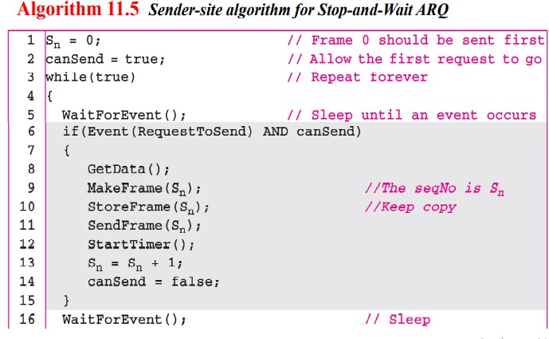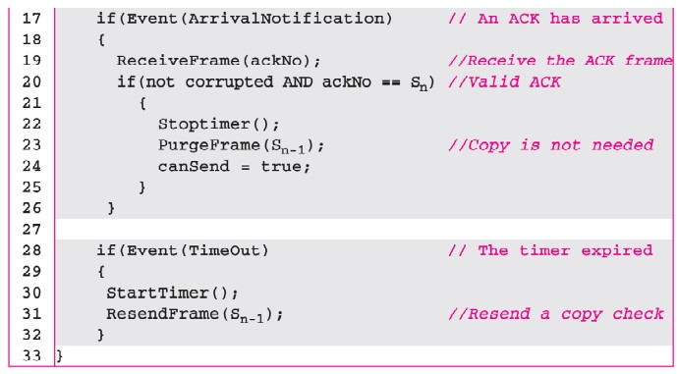

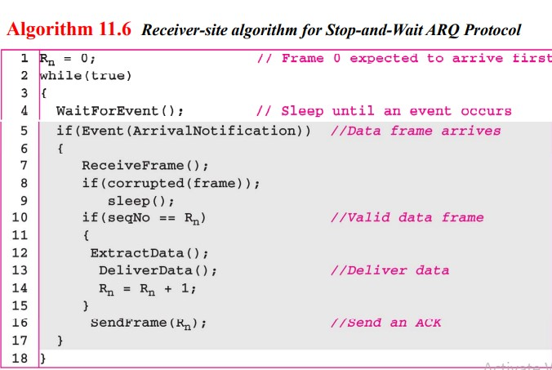

**(ii) Go-Back-N Automatic Repeat Request:**

Go-Back-N ARQ offers a solution to the efficiency limitations of Stop-and-Wait ARQ. It enables the sender to transmit multiple frames without waiting for individual acknowledgments, thereby increasing channel utilization. This pipelining technique is analogous to starting a new task before the previous one is finished. The sender maintains a window of frames that are sent but not yet acknowledged.

**Key Features of Go-Back-N ARQ:**

* **Sliding Window:** A defining feature of Go-Back-N ARQ is the sliding window maintained by the sender. This window, of size 2m-1, where m represents the number of bits used for sequence numbers, designates the range of sequence numbers the sender is permitted to transmit. This window is divided into four regions: frames already acknowledged, frames sent but not yet acknowledged, frames ready to be sent, and frames that cannot be sent yet.
* **Cumulative Acknowledgments:** For efficiency, the receiver only sends an ACK for the last consecutively received frame. This ACK implicitly acknowledges all frames with lower sequence numbers.
* **Error Handling:** Upon encountering a lost or corrupted frame, the receiver discards it and all subsequent frames until the expected frame arrives. The receiver persistently sends ACKs for the last correctly received frame.
* **Timeout and Retransmission:** A timer is initiated by the sender for the oldest unacknowledged frame. If a timeout occurs, the sender retransmits all frames within its send window, starting from the timed-out frame. This "go back and resend N frames" behavior lends the protocol its name.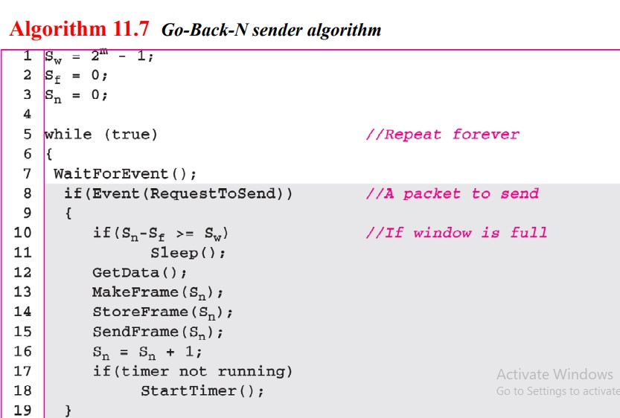

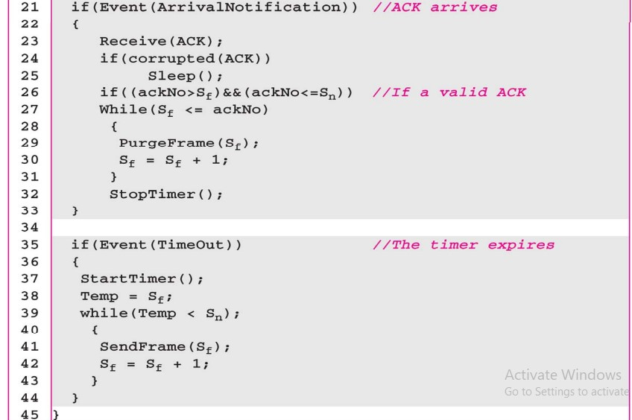

### 

### 25. Explain about IPV6 header format

The IPv6 header format is a crucial aspect of the next-generation Internet Protocol, designed to address the limitations of IPv4 and support the continued growth and evolution of the internet. The IPv6 header is streamlined compared to its IPv4 counterpart, offering improved efficiency and flexibility for handling data transmission across networks.

**Key Features of the IPv6 Header:**

* **Fixed Header Size:** Unlike the variable header size in IPv4, the IPv6 header maintains a fixed size of 40 bytes. This simplification enables faster processing by routers as they don't need to parse variable-length header options.
* **Extension Headers:** To provide additional functionality without cluttering the base header, IPv6 introduces the concept of extension headers. These optional headers are placed between the base header and the upper-layer data. This approach streamlines the routing process as routers primarily need to examine the base header for most forwarding decisions.
* **Enhanced Addressing:** IPv6 utilizes a 128-bit address space, significantly expanding the number of available addresses compared to IPv4's 32-bit address space. This vast address space accommodates the increasing number of devices connecting to the internet.
* **Simplified Header Fields:** IPv6 removes or renames several fields present in the IPv4 header to improve efficiency and clarity.

**Structure of the IPv6 Header:**

The IPv6 header comprises eight essential fields:

1. **Version (VER):** A 4-bit field indicating the IP version, which is set to 6 for IPv6.
2. **Traffic Class (TC):** An 8-bit field formerly known as Priority, it is divided into two parts:
   * Priority: A 4-bit field used to indicate the relative priority of a packet with respect to other packets from the same source. For example, in congestion situations, packets with lower priority might be discarded first.
   * Flow Label: A 20-bit field enabling the identification and special handling of specific data flows. This field allows routers to maintain per-flow state and provide differentiated services based on flow requirements.
3. **Payload Length:** A 16-bit field specifying the length of the payload, which includes any extension headers and the data from the upper layer. The maximum payload length is 65,535 bytes.
4. **Next Header:** An 8-bit field identifying the type of header following the base header. This could be an extension header or the header of an upper-layer protocol such as TCP or UDP.
5. **Hop Limit:** An 8-bit field serving a similar purpose to the Time-to-Live (TTL) field in IPv4. It decrements at each router, and the packet is discarded when the hop limit reaches zero, preventing packets from endlessly circulating in the network.
6. **Source Address:** A 128-bit field containing the IPv6 address of the packet's origin.
7. **Destination Address:** A 128-bit field containing the IPv6 address of the intended recipient.

**Extension Headers in IPv6:**

IPv6 supports six types of extension headers that provide optional functionalities:

1. **Hop-by-Hop Options Header:** Used to convey information to all routers along the packet's path. Examples of hop-by-hop options include padding for alignment and jumbo payload options for packets exceeding 65,535 bytes.
2. **Routing Header:** Specifies the route a packet should follow, similar to source routing in IPv4.
3. **Fragment Header:** Handles fragmentation when a packet needs to be divided into smaller units to traverse networks with lower Maximum Transmission Unit (MTU). In IPv6, only the source node can fragment packets.
4. **Authentication Header:** Provides mechanisms for authenticating the sender and ensuring data integrity.
5. **Encrypted Security Payload (ESP) Header:** Offers confidentiality by encrypting the packet's payload.
6. **Destination Options Header:** Contains information intended only for the destination node, similar to destination options in IPv4.

**No Header Checksum in IPv6:**

A notable difference between IPv4 and IPv6 is the absence of a header checksum in IPv6. This omission is based on the assumption that upper-layer protocols like TCP and UDP already implement their own checksum mechanisms, rendering a network-layer checksum redundant. This decision contributes to faster processing of IPv6 packets.

**Transition from IPv4 to IPv6:**

Due to the vast deployment of IPv4, the transition to IPv6 is a gradual process three primary strategies for managing this transition:

* **Dual Stack:** Devices run both IPv4 and IPv6 simultaneously, enabling communication with systems using either protocol version.
* **Tunneling:** Encapsulates IPv6 packets within IPv4 packets to traverse sections of the network that haven't yet transitioned to IPv6.
* **Header Translation:** Converts IPv6 headers into IPv4 headers, facilitating communication between IPv6 and IPv4 systems. This strategy involves mapping IPv6 addresses to IPv4 addresses and adjusting other header fields accordingly.

The IPv6 header format, with its fixed size, extension headers, and simplified fields, offers a more efficient and flexible framework for handling data transmission in the evolving internet landscape. The transition from IPv4 to IPv6 is underway, and understanding the IPv6 header structure is essential for comprehending the future of internet communication.

# 2021-QP

## 2 Mark Questions

### 1. Why is a composite signal always used in data communication?

A composite signal combines multiple signals into one, allowing for the transmission of various types of data over a single communication channel. This approach maximizes bandwidth usage and reduces the complexity and cost of wiring, making data communication more efficient.

### 2. What do you mean by coding?

Coding in data communication refers to the process of converting data into a specific format for transmission. This may involve encoding techniques like line coding, block coding, or channel coding to ensure accurate and efficient transmission of data, as well as to detect and correct errors.

### 3. What is meant by FDM? Which are the applications of FDM?

FDM (Frequency Division Multiplexing) is a technique that divides the available bandwidth into separate frequency bands, each carrying a different signal simultaneously. Applications of FDM include radio and television broadcasting, telephone systems, and cable modem connections, allowing multiple data streams to coexist without interference.

### 4. Differentiate ground propagation and line of sight propagation.

Ground propagation occurs when radio waves travel along the Earth's surface, often used for long-distance communication. In contrast, line of sight propagation requires a direct, unobstructed path between the transmitter and receiver, commonly used in microwave communication and satellite links.

### 5. What is the purpose of the routing table in a datagram network?

The routing table in a datagram network is a data structure that stores routes to various network destinations. It helps routers determine the most efficient path for forwarding packets, optimizing network performance and ensuring data reaches its intended destination.

### 6. Differentiate flow control and error control in the Data Link layer.

Flow control manages the rate of data transmission between sender and receiver to prevent data loss due to buffer overflow. Error control, on the other hand, involves techniques to detect and correct errors in transmitted data, ensuring data integrity during communication.

### 7. Data Link layer can be considered as two sublayers. Briefly explain the function of each sublayer.

The Data Link layer consists of the Logical Link Control (LLC) sublayer, which manages communication between the network layer and the Data Link layer, providing flow and error control. The Media Access Control (MAC) sublayer regulates how devices on the same network segment access the physical medium, coordinating data transmission to avoid collisions.

### 8. What is a scatternet?

A scatternet is a type of network formed by connecting multiple Bluetooth piconets, where devices can communicate with each other across different piconets, facilitating data exchange among various Bluetooth-enabled devices in proximity.

### 9. What is a jumbo payload?

Jumbo payload refers to the capability of a network frame or packet to carry a larger-than-standard size of data, typically exceeding the conventional maximum transmission unit (MTU) of 1500 bytes in Ethernet networks, allowing for more efficient data transmission.

### 

### 10. What are segments?

Segments are units of data created by the Transport layer of the OSI model, specifically in TCP (Transmission Control Protocol) communication. They encapsulate application data along with headers that include sequencing and control information, enabling reliable and ordered delivery of data across networks.

### 11. Define Jitter.

Jitter refers to the variation in packet arrival times in a network, which can cause fluctuations in the quality of service, particularly in real-time communications like voice over IP (VoIP) or video streaming. High jitter can lead to packet loss, delays, and degraded user experience.

### 12. Define request line and status line.

The request line is the first line of an HTTP request, specifying the method (e.g., GET, POST), the resource's URL (e.g., /index.html), and the HTTP version (e.g., HTTP/1.1). For example, a request line might look like: GET /index.html HTTP/1.1, indicating the action to be performed and the requested resource.

The status line is the first line of an HTTP response, indicating the HTTP version, the status code (e.g., 200 for success), and a reason phrase (e.g., OK). For example, a status line might look like: HTTP/1.1 200 OK, conveying the outcome of the server's attempt to process the request.

## 5 Mark Questions

### 13. Define Topologies

Network Topologies refer to the layout or arrangement of various elements (links, nodes, etc.) in a computer network. The choice of topology affects the performance, scalability, reliability, and cost of the network. Here are the main types of topologies:

**1-Bus Topology:**

In a bus topology, all devices share a single communication line (the bus). Each device is connected to this line, and data travels in both directions.

**Advantages:**

* Simple and cost-effective for small networks.
* Requires less cable than other topologies.

**Disadvantages:**

* If the central cable fails, the entire network goes down.
* Data collisions are common, leading to potential network slowdowns.

**Use Cases:** Small networks or temporary setups where ease of installation is prioritized.

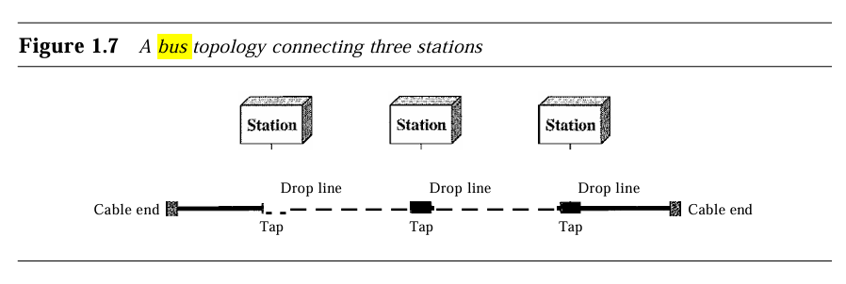

**2-Star Topology:**

All nodes are connected to a central hub or switch. The central device manages traffic and data flow.

**Advantages:**

* If one connection fails, it does not affect the rest of the network.
* Easier to troubleshoot and add new devices.

**Disadvantages:**

* The entire network depends on the central hub; if it fails, all communication is lost.
* Requires more cable than bus topology.

**Use Cases:** Common in home and office networks due to its reliability and ease of management.

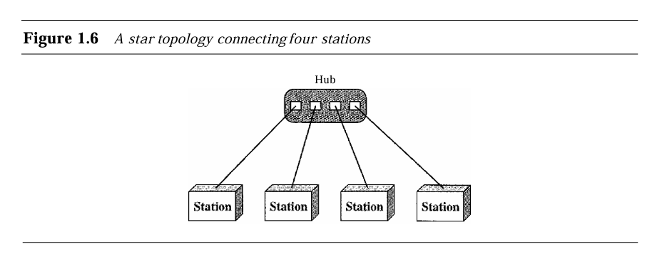

**3-Ring Topology:**

Each device is connected to two other devices, forming a circular pathway for data. Data travels in one direction, passing through each device until it reaches its destination.

**Advantages:**

* Data packets can be transmitted at high speeds due to the predictable path.
* Fewer collisions compared to bus topology.

**Disadvantages:**

* A failure in any cable or device can disrupt the entire network.
* Troubleshooting can be more complex than in star topology.

**Use Cases:** Used in some local area networks (LANs) and in certain WANs.

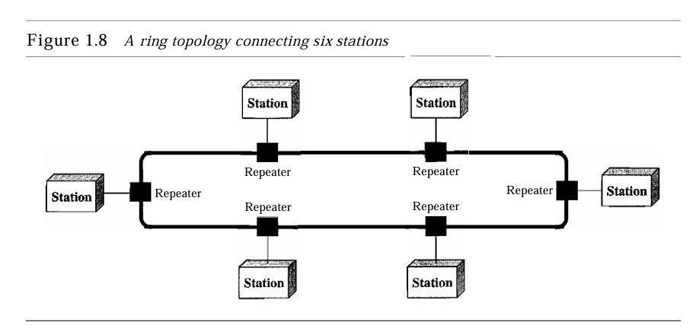

**4-Mesh Topology:**

In a mesh topology, every device is interconnected, allowing multiple paths for data transmission.

**Advantages:**

* Highly reliable; if one path fails, data can take another route.
* Excellent for networks that require high availability.

**Disadvantages:**

* Can be complex and expensive to set up due to the number of connections required.
* Requires significant cabling and management.

**Use Cases:** Often used in WANs and critical communication systems where reliability is paramount.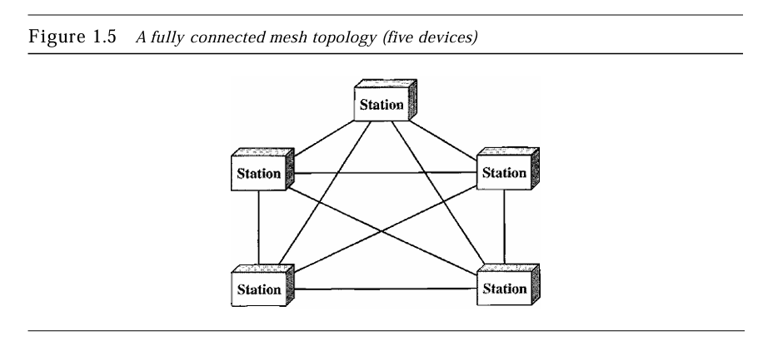

**5-Hybrid Topology:**

This is a hybrid topology that combines characteristics of star and bus topologies. It has a hierarchical structure with a root node and other nodes connected to it.

**Advantages:**

* Scalable; new devices can be added easily without affecting the rest of the network.
* Easy to manage and expand.

**Disadvantages:**

* If the root node fails, it can bring down the entire network.
* More cabling is required compared to bus topology.

**Use Cases:** Often used in larger networks where a hierarchical structure is beneficial.

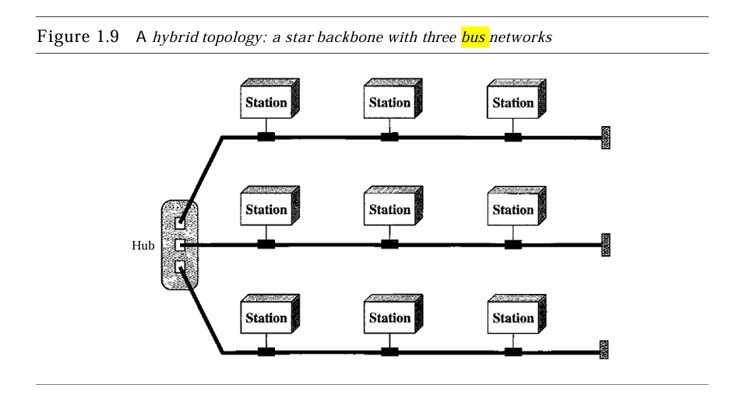

### 14. What Do You Mean by Amplitude Modulation?

Amplitude Modulation (AM) is a technique used in electronic communications, particularly in radio broadcasting. In AM, the amplitude of the carrier wave is varied in accordance with the amplitude of the input signal, which contains the information to be transmitted.

**Basic Principle:**

A carrier wave, typically a high-frequency sine wave, is modulated by the input signal (the audio or information signal). This modulation causes the amplitude of the carrier wave to change, while its frequency and phase remain constant.

The resulting signal is a combination of the carrier wave and the input signal, allowing it to carry the information over long distances.

**Advantages:**

* **Simplicity:** AM is straightforward to implement in both transmitting and receiving devices.
* **Coverage:** AM signals can cover vast distances, making it suitable for broadcasting, especially in rural areas.

**Disadvantages:**

* **Noise Susceptibility:** AM is more vulnerable to noise and interference, which can distort the received signal, leading to a lower quality of audio.
* **Lower Efficiency:** AM requires more power for transmission compared to frequency modulation (FM) and is less bandwidth-efficient.

**Applications:**

Primarily used in AM radio broadcasting, as well as in aviation communications and some two-way radio systems.

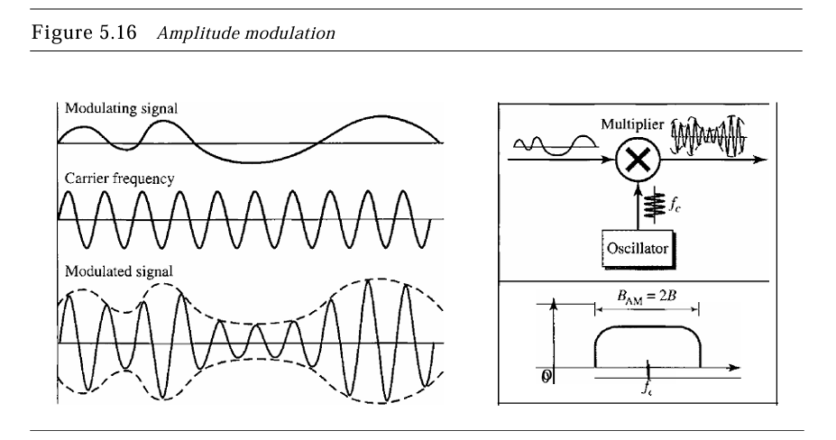

### 15. Explain the Data Communication Using Datagram Switching with a Neat Diagram

Data Communication Using Datagram Switching is a method of sending data packets through a network where each packet is treated independently. This technique contrasts with circuit-switching methods, where a dedicated communication path is established for the duration of the communication session.

**Concepts of Datagram Switching**

**1-Datagrams:**

* A datagram is a self-contained, independent packet of data that carries sufficient information to be routed from the source to the destination without needing prior arrangements. Each datagram can take a different path to reach the destination.
* The datagram includes headers with routing information and the data payload, which is the actual information being transmitted.

**2-Routing:**

* In a datagram switching network, routers examine the header of each incoming datagram to determine the next hop toward the destination.
* The decision is made based on the current network conditions, which means that the path can change dynamically. This flexibility enhances the resilience of the network.

**3-Connectionless Communication**

* Datagram switching is inherently connectionless, meaning that no prior connection is established before sending packets. This leads to several benefits, including reduced latency and overhead associated with connection establishment.
* Each datagram may take different routes to reach the destination, leading to variations in the order of arrival. Higher-level protocols, like Transmission Control Protocol (TCP), handle reordering if necessary.

**4-Reliability and Error Handling:**

* Since datagram switching does not guarantee delivery, reliability mechanisms must be implemented at higher layers of the protocol stack. Protocols like TCP provide error detection, retransmission of lost packets, and data ordering.
* In contrast, User Datagram Protocol (UDP) is often used with datagram switching for applications where speed is prioritized over reliability.

**5-Efficiency:**

* Datagram switching is efficient for bursty data traffic typical in Internet communications. It allows multiple communications to occur simultaneously over the same network paths, optimizing resource utilization.

**Advantages of Datagram Switching**

* **Scalability:** The connectionless nature allows the network to scale easily without the overhead of managing active connections.
* **Flexibility:** The ability to reroute datagrams in response to changing network conditions enhances robustness and fault tolerance.
* **Simplicity:** Simplified protocol design, as there is no need to establish or maintain a connection state.

**Disadvantages of Datagram Switching**

* **Variable Latency:** Since each datagram can take a different path, the arrival time can vary, leading to inconsistent latency.
* **Potential Packet Loss:** Without guaranteed delivery, packets can be lost in transit, requiring higher-layer protocols to manage such scenarios.

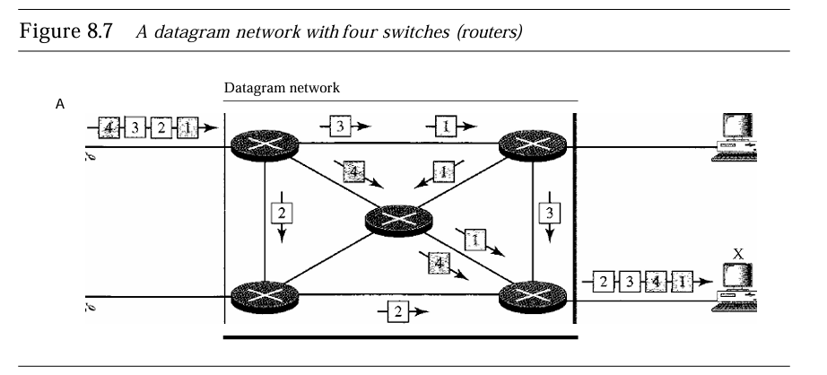

### 16. Explain Character-Oriented Protocols Used in Variable Size Framing

Character-oriented protocols, also known as byte-oriented protocols, are communication protocols that treat data as a stream of characters (bytes). This approach contrasts with bit-oriented protocols, which manage data as a sequence of bits. Character-oriented protocols are particularly useful in certain applications where data integrity and simplicity are crucial.

**Characteristics of Character-Oriented Protocols**

**1-Data Representation:**

In character-oriented protocols, data is represented as a sequence of characters or bytes. Each byte is typically 8 bits, and the protocols define specific characters for control and framing purposes.

**2-Framing:**

Framing is a critical function in data communication, enabling the sender and receiver to understand where the data begins and ends. In character-oriented protocols, frames are often defined by specific character sequences, known as delimiters.

**3-Variable Size Framing:**

* Unlike fixed-size framing, variable size framing allows frames to be of different lengths. This flexibility is particularly advantageous when transmitting data of varying sizes, such as text or binary files.
* Frames are often terminated by specific control characters, such as End of Text (ETX) or End of Transmission (EOT), which indicate the end of a data segment.

**Common Control Characters**

* **Start of Header (SOH):** Indicates the beginning of a frame.
* **End of Text (ETX):** Signals the end of the transmitted text.
* **End of Transmission (EOT):** Marks the conclusion of the transmission.

These control characters are essential for identifying the structure of the transmitted data, ensuring accurate framing and parsing.

**Examples of Character-Oriented Protocols**

**1-ASCII Protocol:**

The American Standard Code for Information Interchange (ASCII) is a widely used character encoding standard. It defines a set of control characters and printable characters, facilitating text-based communication. ASCII uses control characters to manage framing, such as Start of Text (STX) and End of Text (ETX).

**2-Bisynchronous Protocol:**

The Bisynchronous protocol, often used in mainframe and terminal communications, employs character-oriented framing. It utilizes control characters to define frame boundaries and control the flow of data, allowing for reliable transmission over serial lines.

**3-High-Level Data Link Control (HDLC):**

While primarily a bit-oriented protocol, HDLC can operate in a character-oriented mode for certain applications. It utilizes specific byte sequences for framing and control, enabling variable-size frames for transmitting data efficiently.

**Advantages of Character-Oriented Protocols**

* **Simplicity:** Character-oriented protocols are relatively simple to implement, making them suitable for applications with straightforward data structures.
* **Human-Readable:** The use of ASCII and similar encodings makes the data human-readable, facilitating debugging and troubleshooting.
* **Flexibility:** Variable size framing allows for efficient use of bandwidth, accommodating data of varying sizes without wasting resources.

**Disadvantages of Character-Oriented Protocols**

**Overhead:** The inclusion of control characters can increase the overhead, particularly for small data frames, which may affect efficiency.

**Limited Capacity:** Character-oriented protocols may not handle binary data effectively, as they are primarily designed for textual communication. This limitation can lead to issues when transmitting non-text data.

### 17. Explain simplex protocol in noiseless channels.

**Simplex Protocol in Noiseless Channels**

In the context of data communication, a simplex protocol is a unidirectional communication model where data is sent only in one direction—from the sender to the receiver. In this setup, the sender transmits the data without waiting for any feedback or acknowledgment from the receiver. This type of protocol can be employed in environments where communication is simple, and no error handling or flow control is required.

**Characteristics of a Noiseless Channel**

A noiseless channel is considered an ideal communication medium where no data is lost, corrupted, or duplicated during transmission. In such a perfect channel, protocols like the simplex protocol become more feasible because the absence of noise eliminates the need for error detection, retransmission, or acknowledgment mechanisms.

**Working of Simplex Protocol**

The simplex protocol does not require any flow or error control as it assumes that the receiver can handle incoming frames instantaneously and the transmission process is flawless. The sender continuously sends frames, and the receiver continuously processes them without any interruptions.

* **Sender’s Operation:** The sender collects data from its network layer, converts the data into a frame, and sends the frame through the physical layer to the receiver. The protocol operates in an infinite loop where frames are repeatedly transmitted as soon as data is available.
* **Receiver’s Operation:** The receiver, on the other hand, waits for the arrival of frames. Once a frame is received, the receiver extracts the data and delivers it to its network layer for further processing. Since there is no acknowledgment or feedback, the receiver does not notify the sender when data is received.

**Key Points of the Simplex Protocol:**

* **Unidirectional Data Flow:** Data flows in one direction, from the sender to the receiver.
* **No Flow Control:** The protocol does not implement any flow control, as it assumes that the receiver can handle all incoming frames immediately.
* **No Error Control:** Since the channel is noiseless, there is no need for mechanisms to detect or correct errors. Every frame is assumed to be transmitted and received perfectly.
* **Constant Operation:** Both the sender and the receiver are continuously running. The sender constantly checks for data to send, while the receiver constantly waits for incoming data

**Design and Algorithm**

The design of this protocol is straightforward. The sender and receiver use the physical layer for frame transmission, and the process is event-driven.

**1. Sender’s Algorithm:**

◦ Get data from the network layer.

◦ Create a frame from the data.

◦ Send the frame to the physical layer for transmission.

◦ Repeat the process as long as data is available.

**2. Receiver’s Algorithm:**

◦ Wait for a frame to arrive from the sender.

◦ Extract the data from the received frame.

◦ Deliver the data to the network layer.

◦ Continue waiting for more frames.

Both the sender and receiver processes are repeated in an infinite loop since they have no mechanism to stop the transmission and are not influenced by feedback

**Advantages and Limitations**

**Advantages:**

* Simple and efficient for noiseless environments.
* No overhead due to acknowledgment or error handling.

**Limitations:**

* No provision for error correction, making it unsuitable for noisy channels.
* The sender has no way of knowing if the receiver successfully received the data, making it unreliable in real-world noisy environments

### 18. Differentiate Classful Addressing vs. Classless Addressing

IP addressing is a fundamental concept in networking, enabling devices to communicate over the Internet. There are two primary methods of IP addressing: classful addressing and classless addressing. Each method has distinct characteristics, advantages, and limitations.

**Classful Addressing**

Classful addressing was the original method of assigning IP addresses, dividing the address space into fixed classes based on predefined boundaries. The classes are designated as A, B, C, D, and E, with Classes A, B, and C being the most commonly used for general networking purposes.

**1-Address Structure:**

Classful addressing uses a fixed number of bits to define the network and host portions of the address. The first few bits of the IP address determine the class:

* **Class A:** Starts with a 0 bit (0.0.0.0 to 127.255.255.255). Supports a large number of hosts, allowing for a single network to accommodate millions of devices.
* **Class B:** Starts with a 10 bit (128.0.0.0 to 191.255.255.255). Supports fewer hosts than Class A but more than Class C, making it suitable for medium-sized networks.
* **Class C:** Starts with a 110 bit (192.0.0.0 to 223.255.255.255). Designed for smaller networks, allowing for up to 254 hosts per network .
* **Class D:** Used for multicast addresses, not for standard host assignments.
* **Class E:** Reserved for experimental purposes.

**2-Subnetting:**

Classful addressing does not allow for variable-length subnet masks (VLSM). Subnetting within a class must follow the class boundaries, which can lead to inefficient address utilization. For instance, if a Class C network is assigned to a small organization with only a few hosts, the majority of IP addresses in that range may go unused.

**3- Limitations:**

The rigid structure of classful addressing can lead to address exhaustion, especially for Class A and B addresses, where large blocks may be allocated to organizations that do not fully utilize them. This inefficiency prompted the need for more flexible addressing methods.

**Classless Addressing**

Classless addressing, introduced with Classless Inter-Domain Routing (CIDR), allows for more flexible and efficient allocation of IP addresses by removing the fixed boundaries associated with classful addressing. CIDR was developed to improve address space utilization and to mitigate the issue of address exhaustion.

**1-Address Structure:**

* In classless addressing, IP addresses are represented in the format A.B.C.D/n, where n indicates the number of bits used for the network prefix. This format allows for the definition of subnets of various sizes without being constrained by class boundaries.
* For example, an address like 192.168.1.0/24 means the first 24 bits are used for the network portion, leaving 8 bits for host addresses, which can support 256 addresses.

**2-Subnetting**

* CIDR enables variable-length subnet masks (VLSM), allowing networks to be divided into subnets of different sizes. This flexibility enables organizations to allocate only as many addresses as needed, reducing waste.
* Organizations can aggregate multiple IP address ranges, leading to more efficient routing and a reduced number of entries in routing tables.

**3.-Advantages:**

Classless addressing provides a more efficient allocation of IP addresses, helping to mitigate the problem of address exhaustion. The flexibility of CIDR allows for better use of the available address space and improves routing efficiency.

### 19.Explain each subfield of an IPv6 unicast address.

A unicast address defines a single computer. The packet sent to a unicast address must be delivered to that specific computer. IPv6 defines two types of unicast addresses: geographically based and provider-based. We discuss the second type here; the first type is left for future definition.

The provider-based address is generally used by a normal host as a unicast address. Fields for the provider-based address are as follows: o Type identifier. This 3-bit field defines the address as a provider-based address. o Registry identifier. This 5-bit field indicates the agency that has registered the address. Currently three registry centers have been defined. INTERNIC (code 11000) is the center for North America; RIPNIC (code01000) is the center for European registration; and APNIC (code10100) is for Asian and Pacific countries. Provider identifier.

This variable-length field identifies the provider for Internet access (such as an ISP). A 16-bit length is recommended for this field. o Subscriber identifier. When an organization subscribes to the Internet through a provider, it is assigned a subscriber identification. A 24-bit length is recommended for this field. o Subnet identifier. Each subscriber can have many different subnetworks, and each subnetwork can have an identifier. The subnet identifier defines a specific subnetwork under the territory of the subscriber. A 32-bit length is recommended for this field. o Node identifier. The last field defines the identity of the node connected to a subnet.

A length of48 bits is recommended for this field to make it compatible with the 48-bit link (physical) address used by Ethernet. In the future, this link address will probably be the same as the node physical address.

### 20. Explain advantages and disadvantages of firewalls.

A firewall is a network security device that monitors and controls incoming and outgoing network traffic based on predetermined security rules. Firewalls act as barriers between trusted internal networks and untrusted external networks, such as the internet, providing critical protection against unauthorized access and malicious threats. Firewalls can be implemented in both hardware and software or a combination of both.

**Advantages of Firewalls**

1. **Enhanced Network Security:**

* The primary function of a firewall is to enforce security policies by regulating traffic between internal and external networks. Firewalls inspect each packet of data entering or leaving the network and block those that do not meet the established security rules.
* By filtering unwanted or malicious traffic, firewalls prevent external threats, such as viruses, worms, and hacking attempts, from entering the network.

1. **Access Control:**

* Firewalls enable organizations to control who can access their network and what data can be accessed. This is particularly important for ensuring that sensitive internal resources are only available to authorized users.
* Firewalls can be configured with specific rules to allow or deny access to certain users, IP addresses, domains, or applications, providing granular control over network access.

1. **Prevention of Unauthorized Remote Access:**

* Firewalls protect internal networks from unauthorized remote access by blocking or restricting external access to specific ports and services. This ensures that external attackers cannot exploit vulnerable services or access confidential data.
* In corporate environments, firewalls help secure remote access, such as VPN (Virtual Private Network) connections, by monitoring and verifying the authenticity of remote users.

1. **Protection Against Malware and Ransomware:**

* Firewalls act as the first line of defense against malware and ransomware. By blocking suspicious traffic from known malicious IP addresses or domains, firewalls reduce the chances of malware infections entering the network.
* They also prevent unauthorized outbound traffic that could indicate a compromised system attempting to communicate with a command-and-control server (used in botnets and ransomware attacks).

1. **Logging and Monitoring:**

* Firewalls often come with logging and monitoring capabilities, which allow administrators to track traffic patterns, detect anomalies, and respond to potential security incidents in real time.
* This feature helps in identifying and mitigating security threats before they can cause significant damage, while also providing valuable insights for auditing and forensic analysis.

1. **Traffic Management:**

* Firewalls can prioritize certain types of network traffic over others, enabling organizations to ensure that critical applications (such as VoIP, video conferencing, or cloud services) receive the necessary bandwidth to operate efficiently.
* This traffic management helps improve network performance and reduces congestion during peak times, ensuring smooth operation of essential services.

**Disadvantages of Firewalls**

1. **Performance Degradation:**

* Firewalls can introduce delays in data transmission, particularly when they are processing large volumes of traffic or implementing complex security policies. This can result in slower network performance and reduced throughput, especially in high-traffic environments.
* In some cases, the latency introduced by firewalls can affect the performance of time-sensitive applications, such as real-time video or voice communication.

1. **Limited Protection:**

* Firewalls are effective at blocking external threats, but they offer limited protection against internal threats, such as malicious insiders or compromised internal devices. Employees who have legitimate access to the network can still cause security breaches by accident or intentionally.
* Additionally, firewalls may not detect or block sophisticated attacks like Advanced Persistent Threats (APTs) or zero-day vulnerabilities, which require more advanced detection mechanisms.

1. **Complex Configuration and Management:**

* Setting up and configuring a firewall can be complex, particularly for large organizations with diverse network environments. Incorrect configurations can lead to vulnerabilities, such as open ports or weak access control rules, which attackers can exploit.
* Firewalls require ongoing maintenance and updates to keep up with evolving security threats. Managing firewall rules across multiple devices and network segments can be time-consuming and requires specialized expertise.

1. **Cost:**

* High-quality firewalls, particularly hardware-based firewalls for enterprise networks, can be expensive to purchase and maintain. Organizations may need to invest in additional resources for configuration, management, and monitoring.
* Small businesses with limited budgets may find it challenging to afford advanced firewalls, leading them to rely on less effective or outdated solutions, which could expose them to greater security risks.

1. **False Sense of Security**:

* Some organizations may develop a false sense of security after implementing a firewall, assuming that it provides complete protection against all threats. However, firewalls are only one layer of defense in a comprehensive security strategy.
* Without additional security measures, such as intrusion detection systems (IDS), anti-virus software, and user education, organizations may still be vulnerable to attacks. Firewalls alone cannot protect against phishing, social engineering, or insider threats.

1. **Incompatibility with Certain Applications:**

* Some firewalls, particularly those with stringent security settings, may block or interfere with legitimate applications and services. This can lead to disruptions in business operations and prevent employees from accessing essential tools.
* For example, firewalls may block peer-to-peer applications, video conferencing platforms, or cloud-based services, leading to communication delays or the need for network administrators to adjust firewall rules.

### 21. Explain substitution cipher with example.

A substitution cipher substitutes one symbol with another. If the symbols in the plain text are alphabetic characters, we replace one character with another. For example, we can replace character A with D, and character T with Z. If the symbols are digits (0 to 9), we can replace 3 with 7, and 2 with 6. Substitution ciphers can be categorized as either monoalphabetic or polyalphabetic ciphers. In a monoalphabetic cipher, a character (or a symbol) in the plaintext is always changed to the same character (or symbol) in the ciphertext regardless of its position in the text. For example, if the algorithm says that character A in the plaintext is changed to character D, every character A is changed to character D.

In other words, the relationship between characters in the plaintext and the ciphertext is a one-to-one relationship. In a polyalphabetic cipher, each occurrence of a character can have a different substitute. The relationship between a character in the plaintext to a character in the ciphertext is a one-to-many relationship. For example, character A could be changed to Din at the beginning of the text, but it could be changed to N at the middle. It is obvious that if the relationship between plaintext characters and ciphertext characters is one-to-many, the key must tell us which of the many possible characters can be chosen for encryption. To achieve this goal, we need to divide the text into groups of characters and use a set of keys.

For example, we can divide the text "THIS IS AN EASY TASK" into groups of 3 characters and then apply the encryption using a set of3 keys. We then repeat the procedure for the next 3 characters.

## 15 Mark Questions

### 22. Express TCP IP Protocol Suite architecture.

The TCP/IP protocol suite is a set of communication protocols used to connect network devices on the internet and other similar networks. The architecture of the TCP/IP model, also known as the Internet Protocol Suite, defines a layered framework that facilitates the process of sending and receiving data across diverse network infrastructures. It was designed to enable scalable and interoperable communications between systems that use different hardware and software configurations.

The TCP/IP model is built on a five-layer structure. Each layer has a specific role in the communication process, and each higher layer builds on the functionality provided by the lower layers. The five layers are:

**1-Physical Layer**

This is the lowest layer of the TCP/IP model. While TCP/IP doesn't define specific protocols for the physical layer, it supports different physical technologies and hardware that are responsible for the transmission of raw bit streams (0s and 1s) over the physical medium, such as electrical or optical cable, radio frequencies, or fiber optics.

* **Purpose:** This layer converts the data into signals that can be transmitted across a physical medium (such as copper wires, fiber optics, or radio waves). It also deals with the data rate, physical connectors, and electrical properties.
* **Example Technologies:** Ethernet cables, Wi-Fi, optical fiber, coaxial cable, and other hardware

Despite its crucial role in transmission, this layer is often vendor-specific, and its implementation may vary widely based on hardware.

**2-Data Link Layer**

The second layer in the TCP/IP protocol suite is responsible for framing the data into packets for transmission over the network, ensuring error detection and correction, and controlling access to the physical transmission medium. It provides node-to-node data transfer—a direct link between two physical devices on the same network (for example, between a computer and a switch).

* **Purpose:** The data link layer prepares data frames, detects and corrects errors, and manages access to the shared media.
* **Protocols & Technologies:**
  + **Ethernet:** One of the most widely used data link technologies, especially for local area networks (LANs).
  + **Point-to-Point Protocol (PPP):** Used in point-to-point connections, especially for WAN connections.
  + **MAC (Media Access Control):** Defines how devices on a network uniquely identify themselves.

This layer ensures that packets are transferred between two nodes that are directly connected and verifies the integrity of data through mechanisms such as Cyclic Redundancy Check (CRC) for error detection.

**3-Network Layer (Internet Layer)**

This is one of the most critical layers in the TCP/IP model, as it handles the end-to-end transmission of data across the network. The Network Layer is primarily responsible for routing data packets across different networks and ensuring that they are delivered to their destination. It provides logical addressing (IP addresses) and manages the movement of packets through routers and switches in an internetwork.

* **Purpose:** Ensures the correct routing of data packets across a network by establishing logical paths from the source to the destination. It also fragments and reassembles packets based on network constraints.
* **Key Protocols:**
* **IP (Internet Protocol):** The most fundamental protocol at this layer, responsible for addressing and routing packets. IP exists in two main versions:
* **IPv4:** The older but still widely used protocol, providing 32-bit addressing (about 4.3 billion addresses).
* **IPv6:** A newer version with 128-bit addressing, supporting an exponentially larger number of devices.
* **ARP (Address Resolution Protocol):** Resolves logical IP addresses to physical MAC addresses within the same network.
* **ICMP (Internet Control Message Protocol):** Used for diagnostic and error-reporting purposes (e.g., ping command).
* **IGMP (Internet Group Management Protocol):** Manages multicast group memberships, allowing efficient delivery of multicast messages.

The Network Layer is responsible for packet forwarding, which includes routing through different routers and handling congestion or fragmentation if needed.

**4-Transport Layer**

The transport layer is responsible for ensuring reliable communication between hosts over a network. It controls the flow of data between two end systems and ensures that the data arrives error-free, in sequence, and without losses or duplications.

* **Purpose:** This layer provides process-to-process communication and ensures that data is transferred reliably between hosts on a network.
* **Key Protocols:**
  + **TCP (Transmission Control Protocol):** Provides a connection-oriented, reliable communication channel between two devices. It ensures that data is delivered without errors and in the correct order, and it retransmits lost packets if necessary.

TCP also includes mechanisms like error-checking, data acknowledgment, and flow control to ensure reliability.

* + **UDP (User Datagram Protocol):** Provides a connectionless service that is faster but less reliable. It is often used for applications where speed is more critical than reliability, such as live video streaming or VoIP (Voice over IP).
  + **SCTP (Stream Control Transmission Protocol):** Combines features of both TCP and UDP, supporting multiple streams within a single connection for more efficient data transfer. It is used for specialized applications such as telephony over IP networks.

While TCP provides reliable transmission, ensuring data integrity and sequence, UDP is suitable for applications where speed and reduced latency are more critical than perfect reliability.

**5-Application Layer**

The Application Layer is the topmost layer of the TCP/IP protocol suite, where high-level protocols and user applications reside. It defines how applications interact with the network to send and receive data. This layer facilitates services like file transfer, email, and web browsing. Unlike the OSI model, which separates the application, presentation, and session layers, the TCP/IP model combines all these functionalities into a single Application Layer.

* **Purpose:** Provides services to the end user and enables applications to communicate over a network.
* **Key Protocols:**
* **HTTP/HTTPS (Hypertext Transfer Protocol/Secure):** The protocol used for accessing web pages.
* **FTP (File Transfer Protocol):** A protocol for transferring files over a network.
* **SMTP (Simple Mail Transfer Protocol):** Used to send emails.
* **DNS (Domain Name System):** Resolves domain names (e.g.www.example.com) into IP addresses.
* **Telnet/SSH (Secure Shell):** Used for remote login to network devices or servers.

The application layer is what users typically interact with, as it provides services that make it possible for applications to utilize the underlying network for communications.

### 23. What is the spread spectrum? Explain different spread spectrum techniques in detail

Spread spectrum is a wireless communication technique designed to increase the security, reliability, and performance of data transmission by spreading the signal over a broader bandwidth than required. This technique helps protect communications from interference, eavesdropping, and jamming—problems commonly encountered in wireless communications, such as LANs, WANs, and military communications.

In essence, spread spectrum works by distributing the data signal over a range of frequencies much wider than the original bandwidth. This spreading process offers several benefits, such as improved privacy, enhanced resistance to interference, and the ability to support multiple users without conflict.

**Key Principles of Spread Spectrum**

Spread spectrum achieves its goals through two fundamental principles:

* **Wider Bandwidth Allocation:** The bandwidth allocated for each station or user is much larger than necessary for the transmission, allowing redundancy.
* **Independent Spreading Process:** The spreading of the signal's bandwidth is independent of the original signal. A spreading code is applied to the signal after it is generated, effectively "hiding" it across a broader frequency range​.

Spread spectrum techniques utilize a spreading code, which consists of a series of numbers that appear random but follow a defined pattern. These techniques enhance signal security and reduce susceptibility to interference or jamming.

There are two primary methods used to implement spread spectrum:

1. **Frequency Hopping Spread Spectrum (FHSS)**
2. **Direct Sequence Spread Spectrum (DSSS)**

**1-Frequency Hopping Spread Spectrum (FHSS)**

In Frequency Hopping Spread Spectrum (FHSS), the signal "hops" or switches between multiple carrier frequencies in a predetermined, pseudorandom sequence. At any given moment, the signal modulates one carrier frequency, and at the next moment, it modulates another, creating a highly secure and interference-resistant transmission.

* **Carrier Frequencies:** FHSS uses a set of frequencies to transmit the data. The signal jumps between these frequencies at regular intervals, known as the "hopping period."
* **Pseudorandom Code Generator:** A pseudorandom noise (PN) generator creates the pattern of frequency changes. The generated k-bit pattern is mapped to different frequencies, creating a frequency table that helps the signal select a frequency during each hop.
* **Privacy and Anti Jamming:** The pseudo random hopping makes it difficult for eavesdroppers to intercept or jam the signal since the intruder would need to know the hopping sequence and its timing. Even if some portion of the signal is interfered with, only a small portion of data is lost before the signal moves to a new frequency.
* **FHSS Example:** Assume we have eight possible hopping frequencies, and a pseudorandom generator produces three-bit patterns, each corresponding to a different frequency. During a specific hopping period, the system might use frequencies like 200 kHz, 400 kHz, and 900 kHz in a particular sequence, effectively preventing external interference.
* **Bandwidth Utilization:** FHSS is particularly beneficial in environments with multiple users. If the number of hopping frequencies is large enough, multiple users can share the same bandwidth without interference, as each user operates on a unique pseudo random hopping pattern. This multiplexing capability adds to FHSS's efficiency, making it similar to frequency division multiplexing (FDM).

**2-Direct Sequence Spread Spectrum (DSSS)**

The Direct Sequence Spread Spectrum (DSSS) technique expands the bandwidth of the original signal by replacing each data bit with multiple bits, known as "chips." These chips spread the signal across a wider frequency range, offering improved security and resistance to noise.

* **Spreading Code:** Each data bit is multiplied by a pseudorandom code (spreading code), converting each bit into a sequence of chips. The length of the spreading code determines the spreading factor and, therefore, the expansion of bandwidth. A typical DSSS system might replace each data bit with a sequence of 11 chips.
* **Security and Interference:** DSSS systems provide enhanced security because an eavesdropper would need to know the spreading code to decipher the message. Additionally, DSSS improves resilience to interference because only a portion of the spread signal is affected by noise or jamming.
* **DSSS Example:** In a wireless LAN using DSSS, a spreading code such as the famous Barker sequence (10110111000) could be used. If the original signal has a data rate NNN, the DSSS system increases the rate by a factor of the spreading code length, resulting in a much broader signal. This spreading effectively makes the signal immune to interference.
* **Bandwidth Sharing:** Unlike FHSS, which can support multiple users in the same bandwidth, DSSS requires careful management of spreading codes to avoid signal overlap. Special codes are used in cellular networks to allow multiple users to share the same bandwidth without conflict.

**Applications and Benefits of Spread Spectrum**

Spread spectrum techniques, particularly FHSS and DSSS, are widely used in various wireless communication systems:

* **Military Communication:** Both techniques offer strong resistance to jamming, making them ideal for military applications where secure, interference-resistant communication is essential.
* **Wireless LANs and Bluetooth:** FHSS is employed in Bluetooth technology, while DSSS is used in Wi-Fi networks (e.g., IEEE 802.11). These technologies benefit from spread spectrum's ability to minimize interference from other devices operating in the same frequency band
* **Cellular Networks:** DSSS, particularly with code division multiple access (CDMA) techniques, is used in cellular communication to allow multiple users to share the same bandwidth without interference​.

### 24. Explain Cellular Telephony. Write notes on (i)base station (ii) mobile switching center (iii) frequency reuse principle (iv) Hand off.

Cellular telephony enables communication between two mobile stations (MSs) or between a mobile unit and a land unit (stationary unit). It relies on the division of a service area into small geographical regions known as cells, each served by a base station (BS). These base stations are controlled by a mobile switching center (MSC), which manages the communication between base stations and the central telephone office. This arrangement allows calls to be made and received from mobile stations even as they move between cells during a conversation.

**(i) Base Station**

The Base Station (BS) is a critical component in cellular telephony. It comprises an antenna, a tower, and equipment that facilitate wireless communication between the mobile devices in its designated cell and the core cellular network via the mobile switching center. Each base station is responsible for maintaining communication with the mobile stations in its range. It handles tasks like setting up calls, managing communication channels, and controlling the power levels of the transmission to avoid interference between neighboring cells.

**(ii) Mobile Switching Center (MSC)**

The Mobile Switching Center (MSC) is a computerized switching office responsible for coordinating communication between different base stations and connecting them to the wider public switched telephone network (PSTN). It also handles the management of calls, including routing, switching, and billing information. The MSC tracks the location of mobile stations within the network and manages processes like call setup, termination, and handoff when a mobile station moves from one cell to another.

**(iii) Frequency Reuse Principle**

The Frequency Reuse Principle is a key design element in cellular networks to maximize the use of available frequencies. Because the radio spectrum is limited, the same set of frequencies must be reused in different geographical areas. In frequency reuse, a pattern of cells is established where each cell uses a unique set of frequencies, and this pattern is repeated across the network. The distance between two cells using the same frequency is large enough to avoid interference. This enables the network to handle a large number of users without the need for additional spectrum.

For instance, in a system with a reuse factor of 7, the same set of frequencies is reused every seventh cell, ensuring efficient usage of the limited frequency spectrum.

**(iv) Handoff**

Handoff (also called handover) occurs when a mobile station moves from one cell to another during an active call. As the mobile station moves, the signal from its current base station may weaken, making it necessary to transfer the call to another base station that can provide a stronger signal. The MSC monitors the signal strength and manages this transfer process, ensuring the call is maintained without interruption.

There are two main types of handoff:

1. **Hard Handoff:** In older systems, the connection with the old base station is broken before the new connection is established. This can lead to a brief call interruption during the switch.
2. **Soft Handoff:** In newer systems, the mobile station can communicate with multiple base stations simultaneously, allowing a smoother transition as the connection is maintained with the new base station before breaking the old one.

Handoff is crucial for maintaining call quality and preventing dropped calls as users move across different cells in a cellular network.

By combining base stations, MSCs, frequency reuse, and handoff techniques, cellular telephony ensures continuous, reliable communication for mobile users across vast areas.

### 25. Explain any three connecting devices in detail.

**1-Hubs**

Hubs operate at the Physical Layer and are relatively simple devices compared to switches and routers. They are often used in Ethernet networks with a star topology to connect multiple devices within the same network segment.

1. **Active Hub:** This type of hub acts like a multiport repeater. It amplifies and regenerates signals before forwarding them to other devices on the network, ensuring that signal strength is maintained over longer distances.
2. **Passive Hub:** This type of hub does not amplify signals but simply connects multiple cables together. It is primarily a connector and does not engage in any data processing or signal regeneration.

**Functionality:** Hubs forward data packets to all devices in the network, regardless of the destination, which can result in data collisions in busy networks. Therefore, they are less efficient than switches.

**Limitation:** Hubs do not have the capability to filter traffic or limit data broadcast. Thus, they are rarely used in modern networks where switches are preferred

**2-Gateways**

A Gateway is the most advanced connecting device, operating at all five layers of the Internet model (or all seven layers of the OSI model). It is used to connect two different networks that may be using different protocols or architectures.

**Functionality:** Gateways can translate and process data between different communication systems or protocols, making them extremely versatile. For example, they can connect a network using the OSI model to one using the TCP/IP model. Gateways process data packets, interpret their content, and then forward them in the correct format to the destination network.

**Example:** A gateway might be used to connect a company’s internal network that uses IPv6 to the broader internet, which is primarily IPv4.

Security Features: Gateways can also function as firewalls or proxy servers, filtering and securing data as it passes between networks​

**3-Routers**

Routers operate in the Network Layer and are more sophisticated than bridges. A router directs data packets based on their logical addressing (e.g., IP addresses) and determines the best path for the data to travel between networks.

* **Function:** Routers analyze the network addresses within the data packets and make routing decisions based on pre-configured routing tables and algorithms. They connect multiple LANs and WANs, managing traffic across large-scale networks such as the Internet.
* **Routing Tables:** Routers use routing tables to store the best possible paths to reach different networks, which can be dynamically updated through routing protocols.
* **Advantages:** Routers provide connectivity between different types of networks, including networks using different protocols. They support packet switching and ensure efficient and reliable data transfer across wide-area networks (WANs).
* **Limitation:** Routers are more expensive and complex to configure compared to repeaters and bridges. Additionally, they introduce more latency due to the decision-making process involved in routing.

# 2022-QP

## 2 Mark Questions

### 1. What do you mean by periodic signal?

A periodic signal is a signal that repeats itself after a fixed time interval. For example, sine and cosine waves are periodic because they repeat at regular intervals.

### 2. Explain shift keying in analog transmission.

Shift keying is a modulation technique where a carrier signal is altered based on the input data signal. In analog transmission, this is often used in amplitude shift keying (ASK), frequency shift keying (FSK), and phase shift keying (PSK).

### 3. What are the merits and demerits of radio waves?

**Merits:**

* Radio waves can travel long distances and penetrate buildings and other obstacles.
* They are suitable for broadcasting and communication over large areas.

**Demerits:**

* Subject to interference and noise.
* Limited bandwidth.

### 4. What is meant by switched networks? What are the different types of switching techniques?

A switched network is a network that uses switches to route data between devices. There are three main types of switching techniques:

* Circuit switching: A dedicated communication path is established between two devices for the duration of a communication session.
* Packet switching: Data is broken into packets, and each packet can take a different path to the destination.
* Message switching: The entire message is sent to each node one at a time until it reaches the destination, with each node storing the message temporarily.

### 5. Which are the different types of addressing in virtual circuit networks?

Addressing in virtual circuit networks involves identifying the following:

* **Global addressing:** Unique addresses used to identify the endpoints (like IP addresses).
* **Local addressing:** Addresses used by switches to determine how to forward packets within a local area.
* **Virtual circuit identifier (VCI):** A temporary identifier assigned to each connection.

### 6. Explain the importance of redundant bits in forward error correction.

Redundant bits are additional bits added to data to help detect and correct errors. In forward error correction (FEC), redundant bits enable the receiver to identify and correct errors without needing the data to be present, ensuring more reliable communication.

### 7. What is a frame?

A frame is a data unit in the data link layer of the OSI model, which includes data to be transmitted and control information like error detection codes, source, and destination addresses.

### 8. What is Vulnerable time?

Vulnerable time refers to the time during which a signal is susceptible to interference or collisions. In networking, it can be used to describe the time window where two signals can collide in a multiple-access network, such as Ethernet.

### 9. What is a gateway?

A gateway is a network device that acts as a bridge between different networks using different protocols. It enables communication between devices on different networks, such as a local network and the internet.

### 10. Why is supernetting done in Class C addresses?

Supernetting involves combining several smaller network blocks into a larger one. It is done with Class C addresses to create more efficient routing and reduce the number of entries in a routing table by grouping multiple contiguous Class C networks.

### 11. What is queuing in UDP?

Queuing in UDP refers to the process of storing packets temporarily in a queue before they are transmitted. Since UDP is a connectionless protocol, it does not guarantee that packets will be delivered in order, and the queuing process helps manage transmission but without the reliability features of TCP.

### 12. What are the three functional modes in FTP?

The three functional modes in File Transfer Protocol (FTP) are:

* **Active mode:** The server opens a connection to the client.
* **Passive mode:** The client opens a connection to the server.
* **Extended passive mode:** Similar to passive mode but can handle connections using different protocols.

## 5 Mark Questions

### 13. Write a note about the organization of layers.

The OSI (Open Systems Interconnection) Model is a conceptual framework used to understand and standardize the functions of a telecommunication or networking system, independent of its underlying internal structure and technology. The OSI model divides these functions into seven distinct layers, each with specific responsibilities. These layers interact with the layers directly above and below them, passing data and ensuring that information is transmitted and received effectively.

The seven layers of the OSI model are:

**1-Physical Layer:**

* This is the first and lowest layer of the OSI model. The physical layer is responsible for the transmission of raw binary data over a communication channel. It manages the physical connection between network devices, including the hardware components (cables, switches, etc.) and the transmission media (electrical signals, light, radio waves).
* Important functions include defining cables, connectors, signaling, and hardware interfaces.
* Key standards include Ethernet, USB, and Bluetooth.

**2-Data Link Layer:**

* The data link layer is responsible for node-to-node data transfer and error detection/correction. It ensures that data sent from the physical layer is free of errors and manages how devices on a network share the physical medium.
* This layer is divided into two sublayers:
  + **Logical Link Control (LLC):** Manages communication between the network layer and the physical layer and provides flow and error control.
  + **Media Access Control (MAC):** Controls how devices in a network gain access to data and permission to transmit it.
* Protocols include Ethernet, PPP (Point-to-Point Protocol).

**3-Network Layer:**

* The network layer is responsible for determining the best path for data to travel from source to destination. It also handles logical addressing (such as IP addresses), routing, packet forwarding, and congestion control.
* This layer ensures that the data packets are delivered across various networks (internetworking) and handles the division of data into smaller packets for transmission.
* Key protocols include IP (Internet Protocol), ICMP (Internet Control Message Protocol), and IPsec.

**4-Transport Layer:**

* The transport layer provides reliable or unreliable delivery of data between devices, depending on the protocol used. It segments data from the application layer, ensures that it is transmitted correctly, and reassembles it at the destination.
* Key functions include flow control, error detection and correction, and retransmission of lost or damaged packets.
* Common protocols include:
  + **TCP (Transmission Control Protocol):** Ensures reliable data transfer with flow control and error recovery.
  + **UDP (User Datagram Protocol):** Provides a connectionless and unreliable service, suitable for time-sensitive applications such as live broadcasts or online gaming.

**5-Session Layer:**

* The session layer manages and controls the dialogues (sessions) between two computers or network devices. It establishes, maintains, and terminates communication sessions.
* It provides mechanisms for organizing and synchronizing data exchange between devices.
* Protocols in this layer include NetBIOS and RPC (Remote Procedure Call).

**6-Presentation Layer:**

* The presentation layer is responsible for the translation, encryption, and compression of data. It ensures that the data being sent is in a format that the receiving application can understand.
* **Key functions include:**
* **Translation:** Converts data between the format used by the application layer and the format used by the network (e.g., EBCDIC to ASCII).
* **Encryption:** Ensures secure transmission by encrypting data before transmission and decrypting upon receipt.
* **Compression:** Reduces the size of the data for faster transmission.

Examples include JPEG, MPEG, and SSL/TLS (for encryption).

**7-Application Layer:**

* The application layer is the closest to the end user and directly interacts with software applications. It provides services such as email, file transfer, and remote access.
* This layer is responsible for identifying communication partners, determining resource availability, and ensuring that both communication partners are ready for data transmission.
* Some common protocols include HTTP (Hypertext Transfer Protocol), FTP (File Transfer Protocol), SMTP (Simple Mail Transfer Protocol), and DNS (Domain Name System).

### 14. Which are the transmission models used in data communication?

There are three primary transmission models used in data communication, each serving different purposes based on the specific requirements of communication.

**1-Simplex Transmission:**

In simplex mode, communication is unidirectional, meaning that data flows in one direction only, from sender to receiver. The receiver does not send any data back to the sender. This method is suitable for applications where feedback is not necessary.

**Example:** A television broadcast is a typical example of simplex transmission. The TV station sends a signal to viewers, but viewers cannot send any information back to the station.

**Advantages:**

* Simple implementation and lower costs.
* Useful in scenarios where data is only needed to flow one way.

**Disadvantages:**

* Lack of two-way communication limits functionality.

**2-Half-Duplex Transmission:**

In half-duplex mode, both devices can send and receive data, but not at the same time. Each device must wait for the other to finish before it can transmit data. Half-duplex is useful for bidirectional communication that does not require simultaneous sending and receiving.

**Example:** Walkie-talkies operate in half-duplex mode. One person speaks while the other listens, and when the first person finishes speaking, the second person can respond.

**Advantages:**

* More efficient use of communication channels compared to simplex.
* Allows for bidirectional communication.

**Disadvantages:**

* Slower communication because only one party can send data at a time.

**3-Full-Duplex Transmission:**

In full-duplex mode, both devices can send and receive data simultaneously, allowing for continuous two-way communication. This is the most efficient method and is commonly used in modern network communication.

**Example:** A telephone conversation is a good example of full-duplex communication. Both parties can speak and listen at the same time without interrupting each other

**Advantages:**

* Fast and efficient data transfer.
* Maximizes the use of communication bandwidth.

**Disadvantages:**

* More complex and expensive to implement than simplex or half-duplex systems.

These transmission models are fundamental to data communication and are selected based on the specific needs of the communication task, considering factors like speed, simplicity, and the need for bidirectional communication.

### 15. Describe Fibre Optic Cable.

A Fibre Optic Cable is a high-speed data transmission medium that uses light to transmit data. It consists of thin strands of glass or plastic fibers, each about the diameter of a human hair, that transmit light signals over long distances. Fiber optic cables are widely used in telecommunications, internet connections, and cable television services due to their ability to transmit data much faster than traditional copper cables.

components of fiber optic cables include:

**Core:**

* The core is the central part of the fiber where light travels. It is made of glass or plastic and is responsible for carrying the light signals that transmit the data.
* Cores can vary in size, but generally, single-mode fibers have smaller cores (about 9 microns), while multi-mode fibers have larger cores (around 50 microns).

**Cladding:**

* Surrounding the core is the cladding, a layer of material that reflects light back into the core. This ensures that the light signals remain inside the core and do not escape, allowing them to travel long distances with minimal loss.
* The cladding and core together enable total internal reflection, which is crucial for guiding the light along the cable.

**Buffer Coating:**

A protective coating surrounds the cladding to protect the fiber from moisture, physical damage, and other environmental factors. It ensures that the delicate glass or plastic fiber is not broken or damaged during installation or operation.

**4- Strengthening Material:**

Fiber optic cables often have an additional layer of strengthening material (e.g., Kevlar or steel) to provide structural integrity, making the cables less prone to damage from external forces.

**Types of Fibre Optic Cables:**

* **Single-Mode Fibre (SMF):**
  + In single-mode fiber, light is transmitted in a single path or mode, allowing data to travel longer distances with less signal loss. Single-mode fibers are commonly used in long-distance communication systems such as telephone networks and internet backbones.
  + Wavelength: Typically uses a wavelength of 1310 nm or 1550 nm for transmission.
* **Multi-Mode Fiber (MMF):**
  + In multi-mode fiber, light can travel through multiple paths or modes, which limits its range compared to single-mode fiber but makes it ideal for short-distance communication.
  + Wavelength: Typically uses 850 nm or 1300 nm.
  + MMF is commonly used for local area networks (LANs), within buildings or campuses.

**Advantages of Fibre Optic Cables:**

* **High Bandwidth:** Fiber optics can support incredibly high data rates, much higher than copper cables.
* **Long-Distance Transmission:** Fiber optic cables can transmit data over long distances without significant signal degradation, thanks to the low attenuation of light signals.
* **Immunity to Electromagnetic Interference (EMI):** Unlike copper cables, fiber optic cables are not affected by electromagnetic interference, making them more reliable in environments with high levels of electrical noise.
* **Security**: Fiber optics are more secure because they do not emit signals that can be tapped, making it difficult for unauthorized individuals to intercept the transmitted data.

**Disadvantages:**

* **Cost:** Fiber optic cables and their installation can be more expensive than copper cables, especially in areas where existing infrastructure does not support fibre optics.
* **Fragility:** The glass core can be fragile and requires more careful handling compared to traditional copper cables.

Fiber optics have revolutionized communication systems by providing high-speed, reliable, and secure data transmission, particularly in telecommunications and data networking.

### 16. Explain sender side and receiver side algorithm for stop and wait protocol.

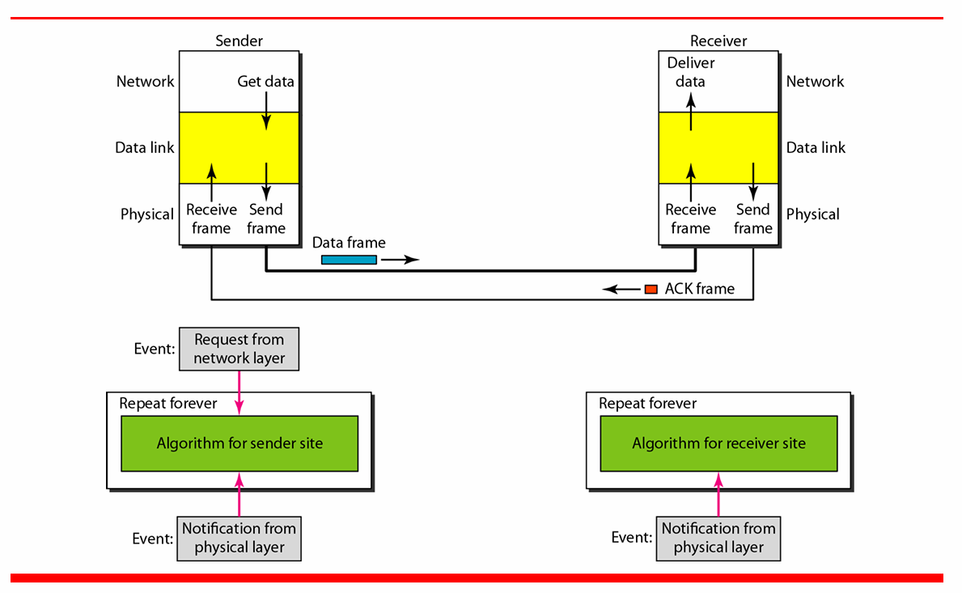

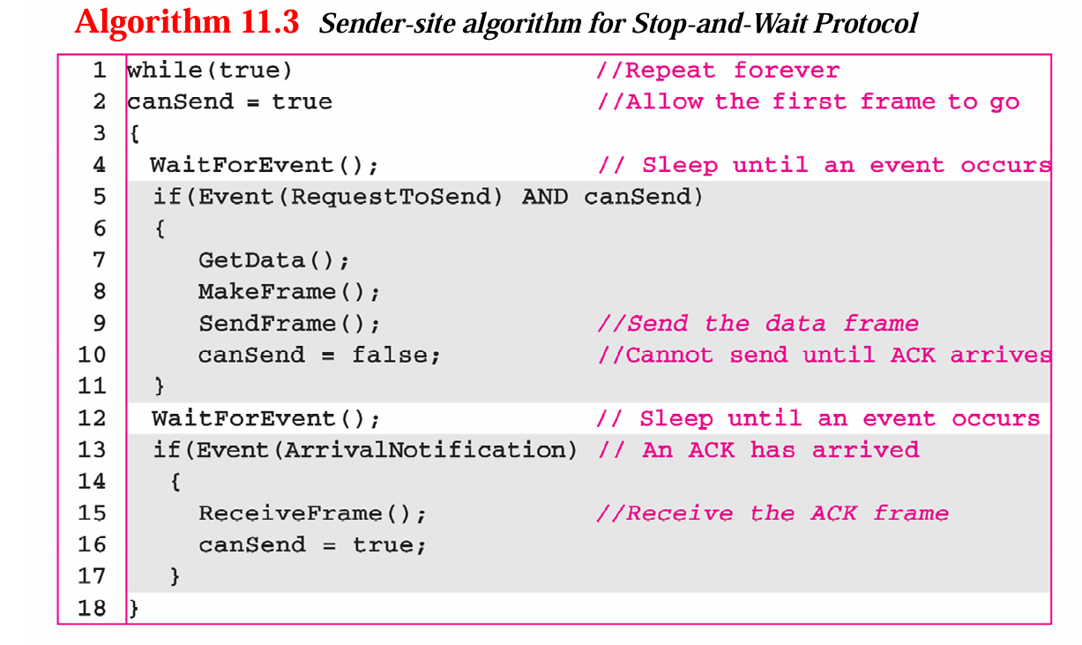

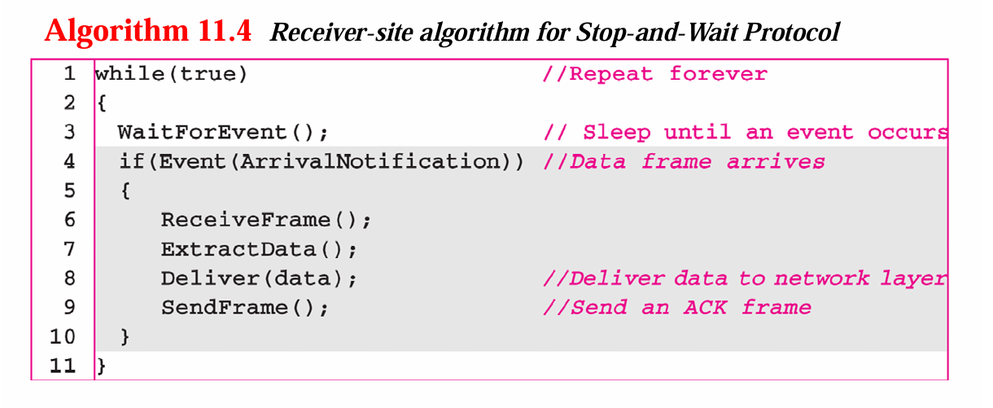

**The Stop-and-Wait Protocol** is a fundamental flow control protocol used in data communication. In this protocol, the sender transmits one frame (or packet) of data, and then waits for an acknowledgment (ACK) from the receiver before sending the next frame. If the sender does not receive an acknowledgment within a specified time, it retransmits the frame.

The Stop-and-Wait protocol is simple but inefficient for high-latency networks, as it only allows one frame to be in transit at any given time. Let's discuss how both the sender and receiver handle the process.

**Sender-Side Algorithm:**

1. **Send a Data Frame:**
   * The sender transmits a frame to the receiver and waits for an acknowledgment. Each frame is uniquely numbered (sequence number).
2. **Wait for Acknowledgment:**
   * After sending the frame, the sender starts a timer and waits for an acknowledgment from the receiver. The timer is used to handle situations where the acknowledgment is lost or the frame is not received.
3. **If Acknowledgment is Received:**
   * Upon receiving a valid acknowledgment (ACK), the sender stops the timer, assumes the frame was successfully received, and proceeds to send the next frame.
4. **If Acknowledgment is Not Received (Timeout):**
   * If the acknowledgment is not received within the timeout period, the sender assumes the frame was lost and retransmits the frame. This process repeats until an acknowledgment is received.

**Receiver-Side Algorithm:**

1. **Receive a Data Frame:**
   * The receiver listens for incoming frames. Upon receiving a frame, it checks the sequence number to determine whether it is the expected frame.
2. **Send an Acknowledgment:**
   * If the frame is received correctly and in the expected order, the receiver sends an acknowledgment (ACK) back to the sender, indicating that it successfully received the frame.
3. **Ignore Duplicate Frames:**
   * If the receiver receives a duplicate frame (i.e., a frame it has already acknowledged), it simply discards the duplicate and sends an acknowledgment again. This can happen if the sender times out and retransmits a frame unnecessarily.

### 17. Explain the frame format in the bluetooth.

Bluetooth technology uses a specific frame format to transmit data between devices. The Bluetooth frame structure is essential for communication as it organizes the data into a manageable and structured form, enabling devices to communicate efficiently in the short-range wireless standard.

Bluetooth utilizes different frame structures based on the Bluetooth version and the type of data being transmitted, but the most common frame format includes:

1. **Access Code:**
   * The Access Code is a 72-bit field used for device identification and synchronization. Every Bluetooth device has a unique access code that helps identify the sender and ensures that the receiver is synchronized with the correct device. The access code is also used in the paging process for device discovery and connection establishment.
   * It includes three subfields: Preamble, Sync Word, and Trailer.
2. **Header:**

The Header is a 54-bit field that provides essential control information for the transmission. It includes the following:

* + **Address (3 bits):** Identifies the Bluetooth device in the communication. It is used to route the frame to the appropriate device within a piconet (a network of Bluetooth devices).
  + **Type (4 bits):** Defines the type of payload and the type of frame, such as control, data, or voice frame.
  + **Flow Control (1 bit):** Manages the flow of data, preventing the receiver from being overwhelmed by too much data at once.
  + **Acknowledgment (1 bit):** Indicates whether the previous frame was received successfully.
  + **Sequence Number (1 bit):** Used to track the sequence of frames, ensuring that frames are received in order and no frames are lost.
  + **HEC (Header Error Check, 8 bits):** Used for error detection in the header.

1. **Payload:**
   * The Payload field carries the actual data being transmitted. The size of the payload varies depending on the type of data being sent, but it can range from 0 to 2745 bits. The payload can carry both voice and data in Bluetooth systems.
   * For Data Frames: The payload typically contains user data, like files or application data.
   * For Voice Frames: The payload contains audio data.
2. **Cyclic Redundancy Check (CRC):**
   * The CRC is an error-checking field that helps detect errors in the payload. Bluetooth uses CRC to ensure that the data received is the same as the data sent. If an error is detected, the frame is discarded, and the sender will retransmit it

### 18. Describe an option field in IPV4.

The IPv4 option field is a variable-length part of the IPv4 header that provides flexibility for special functionalities. The fixed part of the IPv4 header is 20 bytes long, but the inclusion of the option field can extend the header to up to 60 bytes (meaning the option field itself can be up to 40 bytes). These options are not required for every datagram but are used for network testing, debugging, routing control, and performance monitoring.

**Features of the IPv4 Option Field:**

The IPv4 option field has a variety of uses and includes several important options, each of which serves specific purposes:

* **No Operation (NOP):** This is a one-byte option used as a filler to align other options or pad the header to a specific size. It is mainly used for byte alignment in the header.
* **End of Option List:** This is another one-byte option that marks the end of the list of options. Any remaining space in the header is padded with this option to ensure alignment.
* **Record Route:** This option is used to record the IP addresses of routers the datagram passes through. It is primarily used for network debugging, allowing the sender to trace the route taken by the packet. However, due to space constraints, it can record only a limited number of routers.
* **Strict Source Routing:** With this option, the sender specifies the exact route the datagram must take to reach its destination. All routers along the path must match the addresses specified in the option. This provides strict control over the path the packet follows, often used in scenarios where security or specific routing decisions are critical.
* **Loose Source Routing:** Unlike strict source routing, loose source routing allows the datagram to visit other routers in addition to the ones listed in the option. The packet must pass through the specified routers but may take detours through other routers along the way. This offers more flexibility than strict source routing.
* **Timestamp:** This option records the time a datagram is processed by a router. Each router that handles the packet can append its timestamp to the option field, enabling network performance monitoring and route analysis.

**Option Field Structure:**

Each option in the option field is structured as follows:

* **Option Type:** A single byte that identifies the type of option.
* **Option Length:** Specifies the total length of the option, including the type and the data fields.
* **Option Data:** This is the variable-length data field associated with the option, carrying the information specific to the option type.

The options provide additional information or control functions for specific network requirements but are not typically included in every datagram. Processing these options can impose additional processing overhead on routers and reduce efficiency, which is why they are less commonly used in modern networks.

**Usage and Limitations:**

IPv4 options are useful in specific situations, such as debugging, route control, and time-stamping for performance evaluation. However, they have significant limitations:

* **Performance Overhead:** Adding options increases the header size and thus slows down packet processing, as routers must inspect and act upon the options.
* **Limited Space:** The option field has a maximum size of 40 bytes, restricting the number of routers that can record their addresses or the number of timestamps that can be logged.
* **Security Concerns:** Options such as source routing can be exploited for malicious purposes, leading many modern routers to drop or ignore packets with such options for security reasons.

### 19. Explain about Quality of Services

Quality of Service (QoS) in networking refers to the overall performance of a network, particularly the guarantee of reliable and timely delivery of data. QoS is essential in ensuring that the network meets the requirements of specific applications, such as video conferencing, online gaming, and voice over IP (VoIP), which have specific demands for bandwidth, delay, jitter, and reliability.

**Flow Characteristics of QoS:**

Four primary characteristics define the quality of service for a flow:

1. **Reliability:** Reliability in QoS refers to the network's ability to deliver packets without loss. In certain applications like file transfer, email, and Internet access, packet loss is critical because the loss leads to retransmissions, increasing delays. However, for real-time applications like telephony or video conferencing, some level of packet loss is tolerable, as retransmitting lost packets may not be feasible or necessary.
2. **Delay:** Delay is the time taken for a packet to travel from the source to the destination. Different applications have different tolerances for delay. For example, real-time applications like voice calls, video conferencing, and gaming require minimal delay for smooth operation, while file transfers or email can tolerate higher delays.
3. **Jitter:** Jitter refers to the variation in packet delay within a flow. In a perfect system, packets would all experience the same amount of delay. High jitter means that packets are experiencing varying delays, which can cause issues in real-time applications like audio or video streams where data needs to be delivered in a continuous stream. Low jitter is crucial for applications requiring consistent delivery times.
4. **Bandwidth:** Bandwidth refers to the amount of data that can be transmitted in a given amount of time. Different applications have different bandwidth requirements. For example, video streaming or conferencing demands much higher bandwidth than simple email or text-based communication.

**Techniques to Improve QoS:**

To address the flow characteristics and improve network performance, several techniques are used in managing QoS:

**1-Scheduling:** Scheduling is used to ensure that packets from different flows are processed fairly. Three common scheduling methods are:

* **FIFO Queuing:** Packets are processed in the order they arrive. However, this method may lead to delays for higher-priority packets.
* **Priority Queuing:** Packets are assigned to different priority classes. Higher-priority packets are processed first, which ensures that time-sensitive applications, like voice and video, receive better service.
* **Weighted Fair Queuing (WFQ):** Packets are assigned to different queues based on their weights (priority). This method ensures fair treatment for all flows by allocating more resources to higher-priority flows while still processing lower-priority flows.

**2-Traffic Shaping:** Traffic shaping controls the amount and rate of data sent into the network. Two common traffic shaping techniques are:

* **Leaky Bucket:** This technique smooths bursty traffic by storing excess packets in a buffer and sending them at a steady rate.
* **Token Bucket:** This allows bursty traffic by saving tokens during idle periods, which can then be used to send data at a higher rate when needed.

**3-Admission Control:** Admission control mechanisms ensure that the network does not accept more traffic than it can handle. When a new flow requests to join the network, the system checks whether it can meet the QoS requirements without affecting existing flows.

**4-Resource Reservation:** To guarantee certain levels of service, resources like bandwidth and buffer space can be reserved for specific flows. This is essential in applications where it is critical to maintain certain performance levels, like in video conferencing or VoIP calls.

**QoS Models:**

Two widely implemented models of QoS are Integrated Services (IntServ) and

**Differentiated Services (DiffServ):**

**1-Integrated Services (IntServ):** IntServ is a flow-based QoS model that sets up a virtual circuit from the source to the destination and reserves resources along the entire path. It uses the Resource Reservation Protocol (RSVP) for resource reservation. IntServ guarantees specific levels of service for each flow but is less scalable due to the need for routers to maintain state information for each flow.

**2-Differentiated Services (DiffServ):** DiffServ is a class-based QoS model designed for scalability. Instead of reserving resources for individual flows, DiffServ classifies traffic into different service levels at the edge of the network. These service levels are then used by routers to determine packet handling. DiffServ focuses on the per-hop behavior (PHB), where each packet is processed based on its service class.

By managing these factors, QoS ensures that the network meets the diverse performance requirements of different types of applications, especially in environments where both real-time and non-real-time traffic coexist

### 20. Explain about HTTP.

Hypertext Transfer Protocol (HTTP) is the fundamental protocol used for data communication on the World Wide Web (WWW). It is a stateless, application-layer protocol that facilitates the transfer of hypertext documents, such as web pages, between clients and servers. HTTP operates on top of the Transmission Control Protocol (TCP) and typically uses port 80.

**HTTP Transactions:**

The HTTP communication between a client and a server is based on a request-response model. The client (usually a web browser) initiates the interaction by sending an HTTP request to the server. The server processes the request and sends back an HTTP response, which includes the requested content or relevant status information.

* **Request:** The client sends a request message to the server, specifying the method, URL, and HTTP version.
* **Response:** The server responds with a status message, headers, and the body containing the requested resource if applicable.

**Structure of HTTP Messages:**

HTTP messages, whether request or response, share a common structure:

**Request Line / Status Line:**

**Request Line:** Contains the HTTP method (e.g., GET, POST), the requested resource's URL, and the HTTP version being used (e.g., HTTP/1.1).

**Status Line:** Appears in the response, containing the HTTP version, a status code (e.g., 200 OK for successful requests), and a status phrase describing the outcome (e.g., "Not Found" for 404 errors).

**Headers:** The header section is made up of various fields that convey metadata about the request or response. This includes the type of content, the format the client accepts, and cache control settings. Headers are divided into:

* General Headers: Information applicable to both request and response messages, such as the date and connection control.
* Request Headers: Specific to the client’s request, indicating accepted formats, host, or referrer details.
* Response Headers: Provide server information and response-specific details, such as server name, date, and caching details.
* Entity Headers: These provide information about the body content, such as the content type, content length, and language.

**3-Body:** The optional body section can contain the actual content in a response or additional data sent by the client, such as form data in POST requests.

**Methods in HTTP:**

HTTP defines several methods (also called verbs) that indicate the desired action for the server to perform. These include:

* **GET:** Requests a resource from the server without modifying it. This is the most common method used to retrieve data.
* **POST:** Sends data to the server, often used for submitting form data.
* **PUT:** Replaces all the current representations of the target resource with the request payload.
* **DELETE:** Removes the specified resource.
* **HEAD:** Similar to GET but requests only the headers, not the actual resource content.
* **OPTIONS:** Inquires about the communication options available for the target resource.
* **TRACE:** Echoes the received request, useful for debugging.

**Status Codes:**

HTTP response status codes consist of three-digit numbers that inform the client of the result of the request. These codes are categorized into different classes:

**1xx (Informational):** Indicates that the request has been received and is being processed.

**2xx (Success):** The request was successfully received and processed (e.g., 200 OK).

**3xx (Redirection)**: The client needs to take further action to complete the request (e.g., 301 Moved Permanently).

**4xx (Client Error):** There was an error with the client’s request (e.g., 404 Not Found).

**5xx (Server Error):** The server encountered an error while processing the request (e.g., 500 Internal Server Error).

**Persistent and Non-Persistent Connections:**

In HTTP version 1.0, each request/response pair uses a new TCP connection, which is closed after the transaction. This is known as non-persistent connection, which can introduce significant overhead when multiple resources (like images or scripts) need to be fetched.

With HTTP/1.1, persistent connections are the default. This allows the TCP connection to remain open for multiple requests and responses, reducing the overhead and improving performance. The server can close the connection when it is no longer needed or when a timeout is reached.

**Proxy Servers:**

HTTP also supports the use of proxy servers, which act as intermediaries between the client and the destination server. Proxy servers can cache responses to reduce the load on the origin server and improve the performance of frequently accessed resources

HTTP is crucial for the functioning of the World Wide Web, providing the framework that allows clients and servers to communicate efficiently. Its flexibility, combined with support for various methods and status codes, has made it the backbone of web interactions.

### 21. Explain Symmetric cryptography

In symmetric-key cryptography, the same key is used by both parties. The sender uses this key and an encryption algorithm to encrypt data; the receiver uses the same key and the corresponding decryption algorithm to decrypt the data.

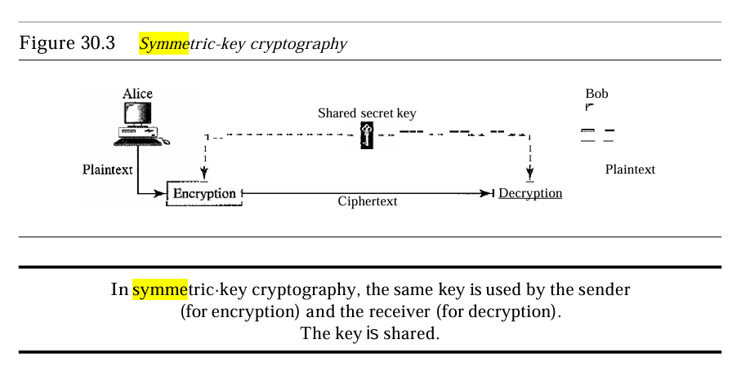  
Symmetric-key cryptography started thousands of years ago when people needed to exchange secrets (for example, in a war). Now still use symmetric-key cryptography in many networks’ security. However, today's ciphers are much more complex. In olden times, we used Traditional Ciphers which are character-oriented whereas now we use bit-oriented.

**Traditional Ciphers**

Traditional symmetric-key ciphers can be of two broad categories: substitution ciphers and transposition ciphers.

**Substitution Cipher:**

A substitution cipher substitutes one symbol with another. If the symbols in the plain text are alphabetic characters, we replace one character with another. For example, we can replace character A with D, and character T with Z. If the symbols are digits (0 to 9), we can replace 3 with 7, and 2 with 6. Substitution ciphers can be categorized as either monoalphabetic or polyalphabetic ciphers. A substitution cipher replaces one symbol with another. In a monoalphabetic cipher, a character (or a symbol) in the plaintext is always changed to the same character (or symbol) in the ciphertext regardless of its position in the text. For example, if the algorithm says that character A in the plaintext is changed to character D, every character.

A is changed to character D. In other words, the relationship between characters in the plaintext and the ciphertext is a one-to-one relationship. In a polyalphabetic cipher, each occurrence of a character can have a different substitute. The relationship between a character in the plaintext to a character in the ciphertext is a one-to-many relationship. For example, character A could be changed to Din at the beginning of the text, but it could be changed to N at the middle. It is obvious that if the relationship between plaintext characters and ciphertext characters is one-to-many, the key must tell us which of the many possible characters can be chosen for encryption. To achieve this goal, we need to divide the text into groups of characters and use a set of keys. For example, we can divide the text "THIS EASY TASK" into groups of3 characters and then apply the encryption using a set of3 keys. We then repeat the procedure for the next 3 characters.

**Transposition Ciphers:**

In a transposition cipher, there is no substitution of characters; instead, their locations change. A character in the first position of the plaintext may appear in the tenth position of the ciphertext. A character in the eighth position may appear in the first position. In other words, a transposition cipher reorders the symbols in a block of symbols. A transposition cipher reorders (permutes) symbols in a block of symbols. In a transposition cipher, the key is a mapping between the position of the symbols in the plaintext and cipher text. For example, the following shows the key using a block off our characters:

**Plaintext: Ciphertext:** 2 4 1 3 123 4 In encryption, we move the character at position 2 to position 1, the character at position 4 to position 2, and so on. In decryption, we do the reverse. Note that, to be more effective, the key should be long, which means encryption and decryption of long blocks of data. Figure 30.8 shows encryption and decryption for our four-character block using the above key. The figure shows that the encryption and decryption use the same key. The encryption applies it from downward while decryption applies it upward.

**Modern Ciphers:** Today’s symmetric-key algorithms are much more complex and often operate at the bit level rather than the character level. Modern ciphers typically combine various simple operations (like substitution and transposition) to achieve a secure encryption process. Popular modern symmetric-key algorithms include the Data Encryption Standard (DES) and the Advanced Encryption Standard (AES). DES encrypts data in 64-bit blocks using a 64-bit key, while AES, which is now a widely adopted standard, works with block sizes of 128 bits and key sizes of 128, 192, or 256 bits​.

**Different types of modern ciphers:**

**XOR Cipher** Modern ciphers today are normally made of a set of simple ciphers, which are simple predefined functions in mathematics or computer science. The first one discussed here is called the XORcipher because it uses the exclusive-or operation as defined in computer science. Figure 30.9 shows an XOR cipher. An XORoperation needs two data inputs plaintext, as the first and a key as the second. In other words, one of the inputs is the block to be encrypted, the other input is a key; the result is the encrypted block. Note that in an XOR cipher, the size of the key, the plaintext, and the ciphertext are all the same. XOR ciphers have a very interesting property: the encryption and decryption are the same.

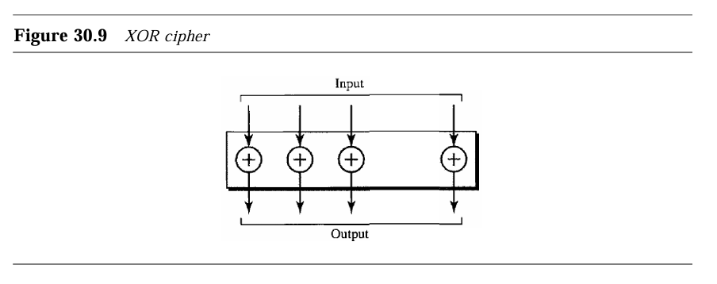  
  
Rotation Cipher Another common cipher is the rotation cipher, in which the input bits are rotated to the left or right. The rotation cipher can be keyed or keyless. In keyed rotation, the value of the key defines the number of rotations; in keyless rotation the number of rotations is fixed. Figure 30.10 shows an example of a rotation cipher. Note that the rotation cipher can be considered a special case of the transposition cipher using bits instead of characters. The rotation cipher has an interesting property. If the length of the original stream is N, after N rotations, we get the original input stream. This means that it is useless to apply more than N- 1 rotations. In other words, the number of rotations must be between 1 and N-1. The decryption algorithm for the rotation cipher uses the same key and the opposite rotation direction. If we use a right rotation in the encryption, we use a left rotation in decryption and vice versa.  
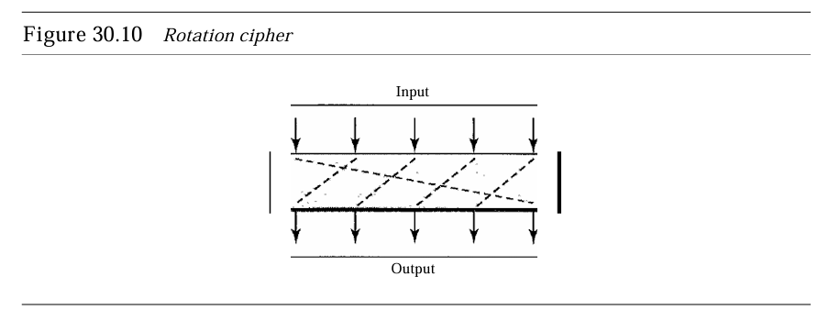  
Substitution Cipher: S-box an S-box (substitution box) parallels the traditional substitution cipher for characters. The input to an S-box is a stream of bits with length N; the result is another stream of bits with length M. And Nand M are not necessarily the same. Figure 30.11 shows an S-box. The S-box is normally keyless and is used as an intermediate stage of encryption or decryption. The function that matches the input to the output may be defined mathematically or by a table. Transposition Cipher: P-box A P-box (permutation box) for bits parallels the traditional transposition cipher for characters. It performs a transposition at the bit level; it transposes bits. It can be implemented in software or hardware, but hardware is faster. P-boxes, like S-boxes, are nominally keyless. We can have three types of permutations in P-boxes: the straight permutation, expansion permutation, and compression permutation as shown in Figure 30.12  
  
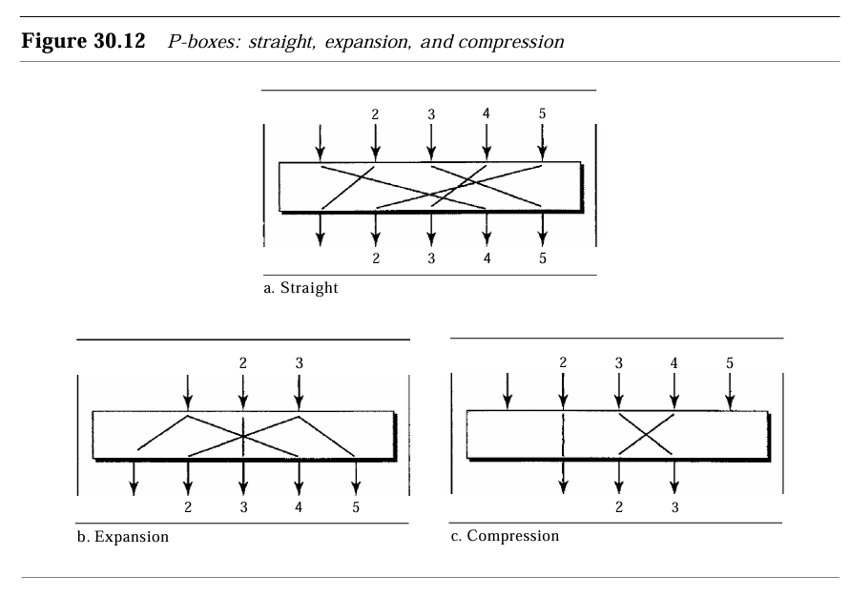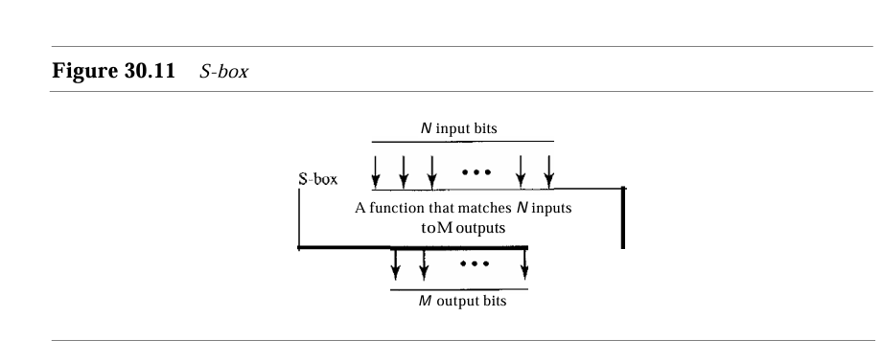

## 15 Mark Questions

### 22. Write in detail about data communication.

**Data Communication**

Data communication is the transfer of data between two or more devices through a transmission medium. This process is vital in our interconnected world, enabling devices to share information efficiently and effectively. Data communication forms the backbone of various applications, including business operations, personal communications, and multimedia broadcasting.

**Definition and Components of Data Communication**

Data communication refers to the exchange of data between devices, which can be local or remote. The term "data" denotes the information being communicated, which can exist in various forms, including text, numbers, images, audio, and video. The fundamental components that constitute a data communication system include:

* **Message:** This is the information (data) to be communicated, which can take various forms such as text, numbers, images, audio, and video.
* **Sender:** The sender is the device that initiates the data transmission. It could be a computer, workstation, video camera, or any other device capable of generating data.
* **Receiver:** The receiver is the device that receives the transmitted message. It can be a computer, workstation, telephone handset, television, etc.
* **Transmission Medium:** This is the physical path through which the data message travels from sender to receiver. Examples include twisted-pair wires, coaxial cables, fiber-optic cables, and wireless transmission methods like radio waves.
* **Protocol:** A protocol is a set of rules that govern the data communication process. It defines the syntax, semantics, and timing of communication, ensuring that both sender and receiver understand the transmitted information. Without protocols, devices could be connected but unable to communicate effectively.

**Characteristics of Effective Data Communication**

For data communication to be effective, several key characteristics must be considered:

* **Delivery:** The system must ensure that data is delivered to the correct destination. Only the intended device or user should receive the data.
* **Accuracy:** Data must be delivered accurately; any alteration during transmission can render the information useless. Protocols are often used to detect and correct errors in data transmission.
* **Timeliness:** Data must be delivered in a timely manner. For applications like video conferencing or online gaming, real-time delivery is crucial. Timely delivery means that data is transmitted and received as it is produced, without significant delays.
* **Jitter:** Jitter refers to the variation in packet arrival times. Inconsistent packet delivery can lead to uneven quality in audio or video streams, which can negatively impact user experience.

**Modes of Data Communication**

Data can flow between devices in several ways, primarily categorized into three types:

* **Simplex:** In simplex communication, the data flow is unidirectional; one device can send data while the other can only receive. For example, a keyboard sends input to a computer, but the computer cannot send data back to the keyboard.
* **Half-Duplex:** In half-duplex mode, each device can both send and receive data but not simultaneously. When one device is transmitting, the other must wait until the transmission is complete. An example of this is a walkie-talkie system.
* **Full-Duplex:** In full-duplex communication, both devices can transmit and receive data simultaneously, akin to a two-way street where traffic can flow in both directions at once. Telephones are a common example, as both parties can speak and listen simultaneously.

**Data Transmission Methods**

Data can be transmitted using two main methods:

**1. Serial Transmission:** This method sends data one bit at a time over a single channel, which can reduce costs. Serial transmission can occur in three forms:

* **Asynchronous:** Data is sent without a clock signal; each byte is sent independently with start and stop bits to signal the beginning and end of each byte.
* **Synchronous:** Data is sent in a continuous stream with a clock signal to synchronize the sender and receiver.
* **Isochronous:** This method is used for applications that require time constraints, such as audio and video streaming, ensuring data is delivered at regular intervals.

**2. Parallel Transmission:** In this method, multiple bits are sent simultaneously over multiple channels, increasing transfer speed. While this method is faster than serial transmission, it is typically limited to short distances due to cost and signal integrity issues.

**Transmission Media**

Data communication can occur over various transmission media:

* **Guided Media:** These are physical mediums that direct data signals along a specific path, such as twisted-pair cables, coaxial cables, and fiber-optic cables. Guided media provide a reliable and secure means of data transmission.
* **Unguided Media:** This includes wireless transmission methods such as radio waves, microwaves, and infrared. Unguided media are useful for transmitting data over long distances without the need for physical connections but can be more susceptible to interference​.

**Network Types**

Data communication often occurs within networks, which can be categorized into:

**1-Local Area Network (LAN)**

A Local Area Network (LAN) is a network that connects devices within a limited geographical area, such as a single building, office, or campus. LANs are typically owned and managed by a single organization and facilitate high-speed data transmission among connected devices. The size of a LAN can range from a few meters to several kilometers, but it generally covers an area less than 2 miles.

**Key Features of LANs:**

Resource Sharing: LANs allow multiple devices to share resources, such as printers, files, and applications, enhancing productivity and efficiency. For instance, in a business setting, a single server can store shared data accessible to all users on the network.

* **Topologies:** LANs can be configured in various physical topologies, including bus, star, and ring. The choice of topology affects the performance, installation complexity, and fault tolerance of the network.
* **Data Rates:** Early LANs operated at data rates of 4 to 16 Mbps. However, modern LANs commonly achieve speeds of 100 Mbps (Fast Ethernet) and up to 1 Gbps (Gigabit Ethernet), significantly improving data transmission capabilities.
* **Wireless LANs (WLANs):** With advancements in technology, wireless LANs have become prevalent, allowing devices to connect without physical cables, providing flexibility and mobility within a local area.

**2-Wide Area Network (WAN)**

A Wide Area Network (WAN) spans a much larger geographical area compared to LANs, connecting multiple LANs across cities, countries, or even continents. WANs enable long-distance data transmission, facilitating communication and data exchange over extensive distances.

**Key Features of WANs:**

* **Geographical Coverage:** WANs can cover vast distances, often using leased telecommunication lines or satellite links to connect different sites.
* **Complexity:** The design and management of WANs are typically more complex than that of LANs due to the need for interconnections between multiple networks and the integration of various transmission media.
* **Types of WANs:** WANs can be categorized as point-to-point or switched WANs. Point-to-point WANs involve direct connections between two locations, while switched WANs use routers and switches to connect multiple locations dynamically.
* **Applications:** WANs support various applications, such as Internet connectivity, data backups, and remote access to centralized resources.

**3-Metropolitan Area Network (MAN)**

A Metropolitan Area Network (MAN) is an intermediate network type that covers a larger area than a LAN but is smaller than a WAN. MANs typically span a city or a large campus, linking multiple LANs within that geographical region.

**Key Features of MANs:**

* **Coverage:** MANs connect users within a specific metropolitan area, providing high-speed connectivity among LANs in schools, universities, or corporate offices within a city.
* **Speed:** MANs generally support high data rates and low latency, making them suitable for bandwidth-intensive applications.
* **Ownership:** MANs can be privately owned or operated by telecommunication companies, providing connectivity for businesses and institutions.

**4-Other Specialized Networks**

Apart from the primary categories, several specialized networks cater to specific requirements:

* **Personal Area Network (PAN):** A PAN connects devices within a very short range, typically within a room or a small area. Examples include Bluetooth connections between smartphones and peripherals like headsets or printers.
* **Campus Area Network (CAN):** A CAN connects multiple LANs within a limited geographical area, such as a university campus, facilitating communication between different departments and services.
* **Virtual Private Network (VPN):** A VPN creates a secure connection over the internet, allowing users to send and receive data as if they were directly connected to a private network. VPNs are often used for secure remote access and data protection.

### 23. What is TDM? Which are the two types of TDM? Explain with diagrams.

**Time Division Multiplexing (TDM)**

Time Division Multiplexing (TDM) is a powerful and widely-used digital multiplexing technique that enables multiple low-rate channels to share a single high-rate communication link by dividing the available time into distinct time slots. Each channel is allocated a specific time slot during which it can transmit its data. TDM is particularly useful in telecommunications and data communication systems, allowing efficient utilization of the available bandwidth and enabling simultaneous data transmission from multiple sources without interference.

**The Concept of TDM**

In TDM, time is divided into slots, and each slot is assigned to a different source of data. When a device wants to send data, it waits for its time slot to become available and then transmits its data. This process continues in a cyclical manner, ensuring that all devices have the opportunity to communicate over the same link.

The fundamental principle behind TDM is that even though multiple sources share the same communication medium, they do so in a manner that is organized and non-interfering. The ability to share bandwidth efficiently is crucial in environments where bandwidth is limited and multiple devices need to communicate simultaneously.

**Characteristics of TDM**

* **Efficient Bandwidth Utilization:** By dividing time into slots and assigning each source a dedicated slot, TDM makes it possible for multiple data streams to share the same medium without collisions or interference.
* **Fixed Time Slots:** Each source is guaranteed a time slot in each cycle, ensuring that data can be transmitted predictably and systematically.
* **Synchronization:** TDM requires synchronization between the multiplexer (MUX) and demultiplexer (DEMUX) to ensure that both ends agree on the timing of the slots, which prevents misalignment during transmission.
* **Support for Digital Signals:** TDM is primarily used for digital signals, allowing for efficient transmission of data in the form of binary bits.

**Types of TDM**

TDM can be categorized into two main types: Synchronous TDM and Statistical TDM. Each type has unique characteristics and operational mechanisms.

**1-Synchronous TDM**

Synchronous TDM (also known as circuit-switched TDM) allocates a fixed time slot to each source in a repeating cycle, regardless of whether the source has data to send during its allocated time. This means that every source gets a time slot to transmit its data, whether it needs to or not.

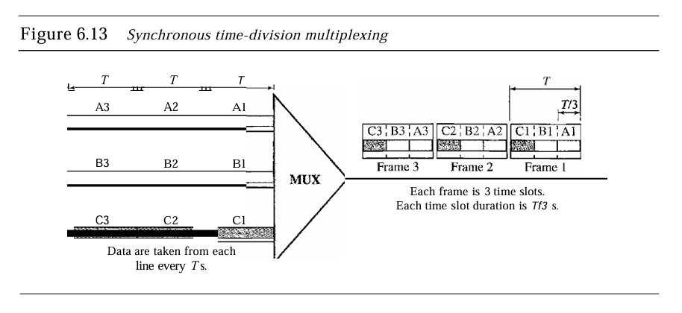

**Key Features of Synchronous TDM:**

* **Fixed Time Allocation:** Each channel has a predetermined time slot in each cycle. For example, if there are three channels, they might share time slots in a repetitive sequence such as Time 1, Time 2, and Time 3. This ensures that each channel can send data periodically, even if it doesn't always have data to send.
* **Potential for Wasted Bandwidth:** Since time slots are fixed, if a channel has no data to transmit during its time slot, that time is wasted. This can lead to inefficient bandwidth utilization, especially if the data transmission is bursty or sporadic.
* **Example of Usage:** Synchronous TDM is often used in traditional telephony systems, where fixed bandwidth must be allocated to ensure consistent call quality.

**2-Statistical TDM**

Statistical TDM (also known as asynchronous TDM) is a more dynamic approach to multiplexing. Instead of allocating fixed time slots for each source, Statistical TDM assigns time slots based on the actual traffic demand from each source. If a source has no data to send, its time slot can be assigned to another source that does.

**Key Features of Statistical TDM:**

**Dynamic Time Slot Allocation:** Time slots are assigned based on demand. If a source has data to send, it can use its slot; if not, the slot can be allocated to another active source. This flexibility optimizes bandwidth utilization since it reduces the number of wasted time slots.

**Addressing Requirement:** Since time slots are not fixed to specific sources, each packet must contain addressing information to indicate its source and destination. This allows the system to route the data correctly even if the transmission order changes.

**Higher Efficiency:** Statistical TDM generally provides better bandwidth efficiency compared to Synchronous TDM, especially in scenarios where traffic is bursty or unpredictable.

**Time Division Multiplexing (TDM)** is a crucial technique for managing the transmission of data across a single communication medium. It enhances bandwidth efficiency by allowing multiple data streams to coexist without interference. Synchronous TDM offers a straightforward, predictable approach with fixed time slots for each source, but it may lead to underutilization of bandwidth. In contrast, Statistical TDM optimizes bandwidth use by dynamically allocating time slots based on current data traffic, making it more suitable for applications with variable transmission demands.

### 24. Explain various generations in Cellular telephony.

### 

**Generations in Cellular Telephony**

Cellular telephony has undergone significant advancements over the years, evolving through various generations that have transformed mobile communications. Each generation is characterized by improvements in technology, capabilities, and services offered to users. Below is a detailed explanation of each generation of cellular telephony:

**1. First Generation (1G)**

First Generation cellular systems were introduced in the late 1970s and early 1980s, marking the beginning of mobile telephony. The defining feature of 1G systems was the use of analog technology, which laid the foundation for cellular communication.

**Key Features:**

* **Analog Transmission:** 1G utilized analog signals to transmit voice calls. This meant that the audio signals were converted into continuous waveforms for transmission. Although this enabled basic voice communication, the quality was often poor, and the systems were susceptible to interference and noise.
* **Frequency Division Multiple Access (FDMA):** 1G systems employed FDMA to allocate distinct frequency bands to each call. This allowed multiple calls to occur simultaneously within the same geographical area, although the number of concurrent users was limited due to the finite number of frequencies available.
* **Limited Capacity and Coverage:** 1G systems had low capacity and limited geographical coverage, primarily due to the analog nature of the technology. Calls were often dropped, and the call quality degraded with distance from the base station.
* **Examples:** The Advanced Mobile Phone System (AMPS) was one of the first commercial 1G systems widely adopted in North America. It operated in the 800 MHz band and allowed users to make calls but did not support features like SMS or data services.

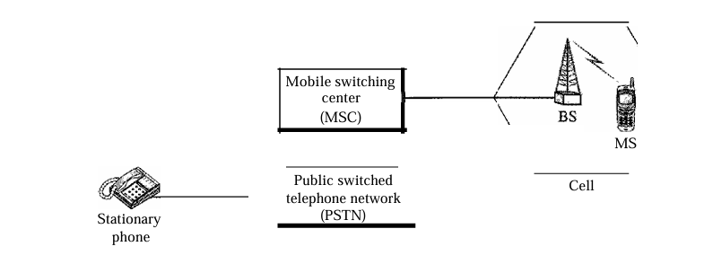

**2-Second Generation (2G)**

Second Generation systems began to emerge in the early 1990s, transitioning from analog to digital technology. This shift greatly enhanced the quality of voice calls and introduced new services, significantly improving the overall user experience.

**Key Features:**

* **Digital Transmission:** 2G systems converted voice signals into digital format, resulting in improved call clarity, reduced noise, and enhanced security through encryption techniques.
* **Multiple Access Techniques:** 2G systems introduced different multiple access technologies, including:
* **Time Division Multiple Access (TDMA):** Allocates time slots for each user on the same frequency channel. This method enhances capacity and allows multiple users to share the same channel without interference.
* **Code Division Multiple Access (CDMA):** Uses unique codes to differentiate between users sharing the same frequency channel, allowing for higher capacity and more efficient use of the available bandwidth.
* **Services:** In addition to voice calls, 2G systems introduced services like SMS (Short Message Service), enabling users to send text messages. Data services were also limited, allowing for basic mobile internet access.
* **Improved Capacity:** 2G systems had a significantly larger capacity compared to 1G systems, allowing for more simultaneous users and better call quality.
* **Examples:** Global System for Mobile Communications (GSM) became the dominant 2G standard globally, while IS-95 (CDMA) was widely adopted in North America.

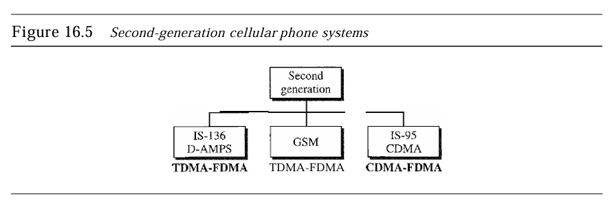  
**3. Third Generation (3G)**

Third Generation systems were developed in the early 2000s, focusing on enhancing data services and enabling mobile broadband capabilities. The introduction of 3G marked a significant leap in the mobile telecommunications industry.

**Key Features:**

* **Higher Data Rates:** 3G systems provided much higher data rates, with typical speeds reaching up to 2 Mbps for stationary users and 384 kbps for mobile users. This allowed for a wide range of data services, including video streaming and mobile internet access.
* **Packet-Switched and Circuit-Switched Services:** 3G systems supported both packet-switched (for data) and circuit-switched (for voice) services, allowing for more efficient use of network resources.
* **Always-On Connectivity:** Users could maintain a continuous internet connection without the need to dial in for a session, making mobile browsing and data access more convenient.
* **Multimedia Services:** 3G enabled services such as video calls, mobile TV, and high-speed web browsing, significantly enhancing the user experience and expanding the range of applications available on mobile devices.
* **Examples:** The International Telecommunication Union (ITU) defined the IMT-2000 framework, leading to various 3G technologies, including WCDMA (Wideband Code Division Multiple Access) and CDMA2000.

### 25. Explain the IPv6 address space and how it differs from IPv4 address space?

**IPv6 Address Space**

IPv6 (Internet Protocol version 6) was developed to address the limitations of its predecessor, IPv4, particularly in terms of address space. While IPv4 uses a 32-bit address scheme, which allows for approximately 4.3 billion unique addresses, IPv6 utilizes a 128-bit address scheme, vastly expanding the number of available addresses to 2^128 or approximately 340 undecillion (3.4 x 10^38). This increase ensures that the growing number of devices connected to the Internet can be accommodated without the threat of address exhaustion.

**Structure of IPv6 Addresses**

An IPv6 address is structured as follows:

* Total Length: 128 bits (16 bytes)
* Representation: To make IPv6 addresses easier to read, they are typically expressed in hexadecimal colon notation, which divides the 128 bits into eight groups of 16 bits (or four hexadecimal digits), separated by colons.
* Abbreviation: IPv6 addresses can be abbreviated by omitting leading zeros within each group and replacing consecutive groups of zeros with a double colon (::) once in an address.

**Types of IPv6 Addresses**

IPv6 addresses can be categorized into several types, based on their intended use:

* **Unicast Addresses:** These identify a single interface on a network. There are two main types:
  + Provider-Based Unicast Addresses: Used for general internet access.
  + Geographically-Based Unicast Addresses: Assigned based on geographic locations.
* **Multicast Addresses:** These are used to send packets to a group of interfaces, allowing for efficient data distribution, such as streaming media to multiple users simultaneously.
* **Anycast Addresses:** These allow for packets to be delivered to the nearest interface identified by the address, useful for load balancing and efficient routing in distributed networks.

Differences Between IPv4 and IPv6 Address Spaces

**1. Address Length**:

IPv4: 32 bits, resulting in approximately 4.3 billion addresses.

IPv6: 128 bits, allowing for approximately 2^128 unique addresses.

**2. Address Representation:**

IPv4: Commonly represented in dotted-decimal format (e.g., 192.168.1.1).

IPv6: Represented in hexadecimal colon notation, making it longer but more structured.

**3. Header Complexity:**

* **IPv4**: Has a variable-length header with fields that can complicate routing and processing.
* **IPv6**: Utilizes a simplified header format, improving processing efficiency in routers.

**4. Routing Efficiency:**

* **IPv4**: Suffers from address depletion and routing table overflow due to its limited address space.
* **IPv6**: Allows for hierarchical address allocation, enhancing routing efficiency and reducing the size of routing tables.

**5. Support for Security:**

* **IPv4**: Security features are optional and not integrated.
* **IPv6**: Designed with built-in security features, including IPsec, to provide encryption and authentication.

The introduction of IPv6 addresses not only resolves the limitations of IPv4 in terms of address space but also enhances the overall functionality, efficiency, and security of network communications. With the continuous growth of the Internet and the number of connected devices, IPv6's expansive address space is essential for accommodating future developments in network technology and ensuring seamless connectivity

# 2023-QP

## 2 Mark Questions

### 1. What do you mean by telecommunication?

Telecommunications technology development is moving faster than the ability of standards committees to ratify standards. Standards committees are procedural bodies and by nature slow-moving. To accommodate the need for working models and agreements and to facilitate the standardization process, many special-interest groups have developed forums made up of representatives from interested corporations. The forums work with universities and users to test, evaluate, and standardize new technologies. By concentrating their efforts on a particular technology, the forums are able to speed acceptance and use of those technologies in the telecommunications community. The forums present their conclusions to the standards bodies.

### 2. Define the term about attenuation.

Attenuation means a loss of energy. When a signal, simple or composite, travels through a medium, it loses some of its energy in overcoming the resistance of the medium. That is why a wire carrying electric signals gets warm, if not hot, after a while. Some of the electrical energy in the signal is converted to heat. To compensate for this loss, amplifiers are used to amplify the signal.

### 3. What is the purpose of the spread spectrum?

Multiplexing combines signals from several sources to achieve bandwidth efficiency; the available bandwidth of a link is divided between the sources. In spread spectrum (88), we also combine signals from different sources to fit into a larger bandwidth, but our goals are somewhat different. Spread spectrum is designed to be used in wireless applications (LANs and WANs). In these types of applications, we have some concerns that outweigh bandwidth efficiency. In wireless applications, all stations use air (or a vacuum) as the medium for communication. Stations must be able to share this medium without interception by an eavesdropper and without being subject to jamming from a malicious intruder (in military operations, for example). To achieve these goals, spread spectrum techniques add redundancy; they spread the original spectrum needed for each station.

### 4. What is the difference between single mode fiber and multi mode fiber ?

Multimode is so named because multiple beams from a light source move through the core in different paths. How these beams move within the cable depends on the structure of the core.

Single-mode uses step-index fiber and a highly focused source of light that limits beams to a small range of angles, all close to the horizontal. The singlemode fiber itself is manufactured with a much smaller diameter than that of multimode fiber, and with substantially lower density (index of refraction).

### 5. Which are the different phases in a virtual circuit network?

Three phases in a virtual-circuit network: setup, data transfer, and teardown. In the setup phase, the source and destination use their global addresses to help switches make table entries for the connection. In the teardown phase, the source and destination inform the switches to delete the corresponding entry. Data transfer occurs between these two phases. We first discuss the data transfer phase, which is more straightforward; we then talk about the setup and teardown phases.

### 6. Show and explain how the hamming distance between the words 10000 and 11010 is calculated?

The Hamming distance (10000, 11010) is 2 because 10000 XOR 11010 is 01010 (two 1s)

### 7. What do you mean by flow control?

Flow control refers to a set of procedures used to restrict the amount of data that the sender can send before waiting for acknowledgment and is one of the most important duties of the data link layer. In most protocols, flow control is a set of procedures that tells the sender how much data it can transmit before it must wait for an acknowledgment from the receiver.

The flow of data must not be allowed to overwhelm the receiver.

### 8. Explain how the energy level in the channel can be used for collision detection by CSMA/CD?

In CSMA/CD (Carrier Sense Multiple Access with Collision Detection), devices monitor the energy level in the communication channel before and during transmission.

**Carrier Sensing:** Before transmitting, a device checks the channel's energy level. If it detects low energy (indicating no ongoing transmission), it proceeds to send data.

**Collision Detection:** While transmitting, the device continuously monitors the energy level. If a collision occurs (when two devices transmit simultaneously), the combined signals result in a higher energy level than expected. The device detects this change and immediately stops transmitting, sends a jamming signal, and then attempts to retransmit after a random backoff period.

This mechanism ensures efficient data transmission and minimizes data loss in the network.

### 9. What is a transparent bridge?

A transparent bridge is a bridge in which the stations are completely unaware of the bridge's existence. If a bridge is added or deleted from the system, reconfiguration of the stations is unnecessary. According to the IEEE 802.1 d specification, a system equipped with transparent bridges must meet three criteria:

1. Frames must be forwarded from one station to another.
2. The forwarding table is automatically made by learning frame movements in the network.
3. Loops in the system must be prevented.

### 10. List the names of reserved addresses in IPv6?

1. Unspecified
2. Loopback
3. Compatible
4. Mapped

### 11. What is MTU?

Each data link layer protocol has its own frame format in most protocols. One of the fields defined in the format is the maximum size of the data field. In other words, when a datagram is encapsulated in a frame, the total size of the datagram must be less than this maximum size, which is defined by the restrictions imposed by the hardware and software used in the network.

The value of the MTU depends on the physical network protocol.

### 12. Define Generic domain?

The generic domains define registered hosts according to their generic behavior. Each node in the tree defines a domain, which is an index to the domain name space database.

## 5 Mark Questions

### 13. Explain the process of line coding in digital-to-digital conversion.

Line coding is the process of converting digital data into digital signals for transmission over a physical medium. Digital data, which typically consists of sequences of bits (0s and 1s), needs to be translated into a form that can be propagated as a signal through a communication medium. Line coding enables this by ensuring that data is represented by a digital signal that can be easily decoded at the receiver. This process is essential for transmitting information in systems like computers, networks, and other digital communication devices.

**Characteristics of Line Coding**

Several characteristics define the efficiency and suitability of a line coding scheme:

* **Signal Element vs. Data Element:** A data element represents the smallest unit of information (a bit), while a signal element is the shortest unit (timewise) of a digital signal. The goal of line coding is to transmit the data elements using the fewest possible signal elements to reduce bandwidth requirements.
* **Data Rate vs. Signal Rate:** The data rate (measured in bits per second, or bps) defines the number of bits transmitted per second. The signal rate (measured in baud) represents the number of signal elements transmitted per second. The objective is to maximize the data rate while minimizing the signal rate to optimize bandwidth usage.

**Common Line Coding Schemes**

* **Unipolar Scheme**

In a unipolar scheme, the voltage level is on one side of the time axis, either positive or zero. For example, the Non-Return to Zero (NRZ) encoding scheme uses a positive voltage to represent a bit "1" and zero voltage to represent a bit "0". However, unipolar schemes are costly in terms of power and are prone to DC component issues, making them less efficient.

* **Polar Scheme:**

Polar schemes use two voltage levels on both sides of the time axis (positive and negative). Two popular variations of polar encoding include NRZ-L (Non-Return to Zero-Level) and NRZ-I (Non-Return to Zero-Invert):

* + In NRZ-L, the level of voltage determines the bit value. A positive voltage indicates "1", and a negative voltage indicates "0".
  + In NRZ-I, a transition in voltage (from positive to negative or vice versa) represents a "1", while no change in voltage represents a "0.
* **Bipolar Scheme:**

In bipolar schemes, there are three voltage levels: positive, negative, and zero. The most common bipolar scheme is AMI (Alternate Mark Inversion), where a bit "0" is represented by zero voltage, and consecutive "1"s are represented alternately by positive and negative voltages. This alternating polarity helps eliminate the DC component and ensures better synchronization.

* **Multilevel Schemes:**

To increase the data rate while reducing the signal rate, multilevel schemes like 2B1Q (Two Binary One Quaternary) are used. These schemes encode a group of bits (e.g., 2 bits) into one signal element. This reduces the number of signal transitions needed and minimizes bandwidth requirements.

**Synchronization and Error Detection**

Some line coding schemes provide built-in synchronization capabilities to ensure that the receiver can correctly interpret the beginning and end of signal elements. Additionally, schemes like block coding introduce redundancy to enhance error detection and improve transmission reliability.

### 14. What do you mean by Digital to analog conversion?

Digital-to-analog conversion refers to the process of changing one of the characteristics of an analog signal based on the information in the digital data. This conversion is essential when digital data needs to be transmitted over an analog medium, such as radio waves or telephone lines. The process involves modulating a carrier signal (an analog sine wave) to encode the digital information onto it. The three key characteristics of an analog sine wave that can be altered for modulation purposes are amplitude, frequency, and phase.

**Modulation Techniques**

There are four main digital-to-analog conversion techniques:

1. **Amplitude Shift Keying (ASK):** In this method, the amplitude of the carrier signal is varied to represent the binary data. The frequency and phase remain constant. ASK is simple but more susceptible to noise, as changes in amplitude can be easily distorted.
2. **Frequency Shift Keying (FSK):** Here, the frequency of the carrier signal is altered based on the digital data. For example, a binary '1' could be represented by a high frequency, and a binary '0' by a low frequency. FSK is less prone to noise compared to ASK because changes in frequency are less affected by amplitude noise.
3. **Phase Shift Keying (PSK):** In PSK, the phase of the carrier signal is changed to represent the data. It offers better resistance to noise than ASK and FSK because phase changes are not easily affected by external interference.
4. **Quadrature Amplitude Modulation (QAM):** This is a combination of both ASK and PSK. QAM modulates both the amplitude and the phase of the carrier signal, making it more efficient in terms of bandwidth utilization compared to ASK, FSK, or PSK individually. It is widely used in applications like digital TV, Wi-Fi, and LTE.
   * **Bit Rate and Baud Rate:** The bit rate refers to the number of bits transmitted per second, while the baud rate is the number of signal elements transmitted per second. The baud rate can be less than or equal to the bit rate depending on how many bits are carried per signal element.
   * **Carrier Signal:** This is the continuous analog signal that gets modulated to carry the digital data. It is characterized by its amplitude, frequency, and phase, and serves as the base on which the digital data is encoded.

**Practical Applications**

Digital-to-analog conversion is used in numerous communication technologies, including:

* Modems, where digital computer data is converted into analog signals for transmission over telephone lines.
* Radio Communications, where digital signals (such as digital audio or video data) are converted into modulated analog signals for broadcast.

### 15. What are the features of infrared waves?

1. **Short-range communication:** Infrared waves are typically used for communication over short distances. Due to their high frequency, they are unable to penetrate walls, which limits their range. However, this characteristic is beneficial in preventing interference between systems operating in adjacent rooms. For instance, when using an infrared remote control, there is no interference with other remote controls in neighboring rooms.
2. **Line-of-sight propagation:** Since infrared waves cannot pass through walls or other solid objects, their transmission depends on a direct, unobstructed path between the transmitter and receiver. This is known as line-of-sight propagation. Devices using infrared communication, such as infrared data ports on computers and peripherals, must face each other to ensure proper communication.
3. **Interference from sunlight:** Infrared waves cannot be effectively used for outdoor communication because sunlight contains infrared waves. This makes outdoor infrared communication impractical, as the infrared waves from the sun interfere with the communication signals.
4. **High data rate potential:** The infrared band, which has a wide bandwidth of nearly 400 THz, offers excellent potential for high-speed data transmission. This wide bandwidth enables the transmission of digital data at very high rates. For example, the Infrared Data Association (IrDA) standard initially allowed data transmission at 75 kbps for distances up to 8 meters, and newer standards have pushed this speed to 4 Mbps.
5. **Applications:** Infrared technology is commonly used in wireless communication between devices such as keyboards, mice, printers, and PCs. Many of these devices include an infrared port that enables them to communicate without physical connections. Infrared technology is also used in consumer electronics, such as remote controls for televisions and other devices.

### 16. Explain sender side and receiver side algorithm for stop and wait protocol.





**The Stop-and-Wait** Protocol is a fundamental flow control protocol used in data communication. In this protocol, the sender transmits one frame (or packet) of data, and then waits for an acknowledgment (ACK) from the receiver before sending the next frame. If the sender does not receive an acknowledgment within a specified time, it retransmits the frame.

The Stop-and-Wait protocol is simple but inefficient for high-latency networks, as it only allows one frame to be in transit at any given time. Let's discuss how both the sender and receiver handle the process.

**Sender-Side Algorithm:**

1. **Send a Data Frame:**
   * The sender transmits a frame to the receiver and waits for an acknowledgment. Each frame is uniquely numbered (sequence number).
2. **Wait for Acknowledgment:**
   * After sending the frame, the sender starts a timer and waits for an acknowledgment from the receiver. The timer is used to handle situations where the acknowledgment is lost or the frame is not received.
3. **If Acknowledgment is Received:**
   * Upon receiving a valid acknowledgment (ACK), the sender stops the timer, assumes the frame was successfully received, and proceeds to send the next frame.
4. **If Acknowledgment is Not Received (Timeout):**
   * If the acknowledgment is not received within the timeout period, the sender assumes the frame was lost and retransmits the frame. This process repeats until an acknowledgment is received.

**Receiver-Side Algorithm:**

1. **Receive a Data Frame:**
   * The receiver listens for incoming frames. Upon receiving a frame, it checks the sequence number to determine whether it is the expected frame.
2. **Send an Acknowledgment:**
   * If the frame is received correctly and in the expected order, the receiver sends an acknowledgment (ACK) back to the sender, indicating that it successfully received the frame.
3. **Ignore Duplicate Frames:**
   * If the receiver receives a duplicate frame (i.e., a frame it has already acknowledged), it simply discards the duplicate and sends an acknowledgment again. This can happen if the sender times out and retransmits a frame unnecessarily.

### 17. What is hands off? Differentiate hard handoff and soft handoff

Handoff is a process used in mobile communication where a mobile station (MS) transitions from one cell to another while maintaining a continuous communication session. This process is vital to ensure that mobile users can continue their calls or data sessions without interruption as they move across different regions or cells covered by different base stations.

**Hard Handoff:**

In a hard handoff, the MS can only communicate with one base station at a time. When a user moves from one cell to another, communication with the current base station is broken before establishing a new connection with the next base station. This type of handoff requires the MS to switch frequencies and reconnect, which can result in a noticeable delay or even dropped calls if not managed properly.

**Features:**

* Communication is temporarily broken with the old base station before a connection is made with the new one.
* The handoff occurs quickly but can create a "rough" transition, leading to potential disruptions.
* This type is more common in early cellular systems and in systems using Frequency Division Multiple Access (FDMA) or Time Division Multiple Access (TDMA) technologies.

**Soft Handoff:**

A soft handoff allows the MS to communicate with two (or more) base stations simultaneously during the transition between cells. The MS maintains communication with the old base station until it has successfully established communication with the new one. This results in a smoother transition, with less risk of dropped calls or noticeable interruptions.

**Features:**

* The MS communicates with multiple base stations during the transition, ensuring continuous communication.
* The call or session continues with the new base station before terminating communication with the old one.
* This method is often used in systems based on Code Division Multiple Access (CDMA), where multiple base stations can use the same frequency without interference.

**Differences:**

* **Connection Handling:**
  + Hard handoff breaks the connection with the old base station before establishing a new one.
  + Soft handoff maintains connections with both the old and new base stations until the transition is complete.
* **User Experience:**
  + Hard handoffs may cause brief interruptions or dropped calls.
  + Soft handoff provides a smoother user experience with minimal disruptions.
* **Technologies:**
  + Hard handoff is typical in FDMA and TDMA systems.
  + Soft handoff is used in CDMA-based systems​

### 18. List the classes in classful addressing and what are the purpose of each class?

In classful addressing, the IP address space is divided into five classes: A, B, C, D, and E. Each class is designed for a specific purpose, and the classes differ in the range of addresses they cover, the number of hosts per network, and their intended application.

**Classes and Their Purpose:**

1. **Class A:**
   * **Address Range:** 0.0.0.0 to 127.255.255.255
   * **Netid-Hostid Format:** 1 byte for the netid and 3 bytes for the hostid.
   * **Purpose:** Designed for very large networks, such as large corporations or national-scale networks. Each network in Class A can support millions of hosts.
   * **Application:** Unicast communication.
   * **Number of Networks and Hosts:** There are 128 networks available in Class A, with each network supporting up to 16,777,216 hosts.
2. **Class B:**
   * **Address Range:** 128.0.0.0 to 191.255.255.255
   * **Netid-Hostid Format:** 2 bytes for the netid and 2 bytes for the hostid.
   * **Purpose:** Intended for medium-sized networks such as universities or large businesses. Each network can support thousands of hosts.
   * **Application:** Unicast communication.
   * **Number of Networks and Hosts:** Class B provides 16,384 networks, each of which can support 65,536 hosts.
3. **Class C:**
   * **Address Range:** 192.0.0.0 to 223.255.255.255
   * **Netid-Hostid Format:** 3 bytes for the netid and 1 byte for the hostid.
   * **Purpose:** Designed for smaller networks, such as small businesses or home networks. Each network can only support a limited number of hosts.
   * **Application:** Unicast communication.
   * **Number of Networks and Hosts:** There are 2,097,152 networks in Class C, with each network supporting up to 256 hosts.
4. **Class D:**
   * **Address Range:** 224.0.0.0 to 239.255.255.255
   * **Purpose:** Reserved for multicast communication. Class D addresses are not used for identifying individual hosts; instead, they are used for sending data to a group of destinations in a multicast group.
   * **Number of Networks and Hosts:** Class D has a block size of 268,435,456 addresses.
5. **Class E:**
   * **Address Range:** 240.0.0.0 to 255.255.255.255
   * **Purpose:** Reserved for future use or for experimental purposes. These addresses are not available for general use and are intended for specific, controlled experiments.
   * **Number of Networks and Hosts:** Like Class D, Class E has a block size of 268,435,456 addresses​

### 19. What is UDP? Explain

UDP (User Datagram Protocol) is a connectionless, unreliable transport protocol that offers minimal services beyond those provided by IP (Internet Protocol). The core purpose of UDP is to enable process-to-process communication, unlike IP, which provides host-to-host communication. UDP is designed to transfer small amounts of data efficiently by using a simple, low-overhead approach.

**Here are the main features of UDP:**

* **Connectionless Service:** UDP is connectionless, meaning there is no setup of a virtual connection before data is sent. Each packet, called a user datagram, is independent and can travel on different paths to its destination. There is no need to establish or terminate a connection, which differs from connection-oriented protocols like TCP (Transmission Control Protocol).
* **Unreliable Transport:** UDP does not guarantee the delivery of messages. It lacks mechanisms for error recovery, retransmission of lost packets, and acknowledgment of received packets. The only form of error checking is the optional checksum, which detects errors in the header and data. If errors are found, the packet is discarded silently, and no error message is returned.
* **Minimal Overhead:** UDP uses minimal overhead, which makes it ideal for applications where quick transmission of small messages is more critical than reliability. It doesn't have the heavy error-checking and recovery mechanisms of TCP, resulting in faster communication.
* **No Flow Control:** There is no flow control in UDP. The protocol does not provide mechanisms to prevent a receiver from being overwhelmed by too many incoming packets, which can lead to buffer overflow and the discarding of user datagrams if the receiving buffer becomes full.
* **Use Cases:** UDP is typically used for simple, short request-response communications, where reliability can be managed by the application itself if needed. Examples include multicasting, SNMP (Simple Network Management Protocol), RIP (Routing Information Protocol), TFTP (Trivial File Transfer Protocol), and applications like streaming services where fast delivery is more critical than perfect reliability.

### 20. Explain the different type of request type in HTTP protocol

In the Hypertext Transfer Protocol (HTTP), various request types (or methods) define the action the client requests from the server. Below are the main request types:

1. **GET:**
   * This method requests a document or resource from the server.
   * It retrieves data without modifying anything on the server.
   * Example: Fetching a web page, image, or any other file.
2. **HEAD:**
   * Similar to GET, but it only requests the headers from the server, not the content of the document.
   * This method is often used to check if a resource is available or to verify document status without downloading the entire content.
3. **POST:**
   * Used to send data to the server, usually in the body of the request.
   * Commonly employed to submit forms or upload data.
   * This method may modify the server's state.
4. **PUT:**
   * Sends data to the server to create or replace an existing resource.
   * Often used for file uploads.
5. **TRACE:**
   * This method echoes back the received request, useful for diagnosing and debugging network issues.
6. **CONNECT:**
   * Reserved for use with proxies that can dynamically switch to a tunnel-like connection, usually used for SSL tunneling.
7. **OPTIONS:**
   * Used to query the server about the communication options or capabilities for a specific resource or the entire server.

### 21. Explain the different section of Domain Name Space

The Domain Name Space is organized into a hierarchical, tree-like structure, which is divided into three main sections:

1. **Generic Domains:**
   * These domains define registered hosts based on their generic behavior or type of organization.
   * Examples include .com (commercial organizations), .edu (educational institutions), and .gov (government entities).
   * Generic domains are widely used across various industries to categorize domains based on their functions or types
2. **Country Domains:**

* Country domains are assigned based on two-character country abbreviations, such as .us for the United States, .uk for the United Kingdom, and .ca for Canada.
* These domains can also use organizational or more specific subdivisions, like states within the U.S. (e.g., .ca.us. for California).
* The country domain system ensures that each country has its designated top-level domains, often used for national or local purposes.

1. **Inverse Domain:**

* The inverse domain is used for address-to-name mapping (also known as a PTR query). This is the reverse of the usual name-to-address lookup.
* It is particularly helpful in situations where a server receives a request from a client and needs to verify the client's identity by mapping the provided IP address back to a domain name.
* The domain labels are inverted in this section to accommodate this reverse lookup, with labels like in-addr.arpa. used to handle IP addresses.

## 15 Mark Questions

### 22. Explain different types of addresses used in TCP IP Protocol suite.

The TCP/IP protocol suite employs four types of addresses to ensure effective communication across different layers and networks: physical addresses, logical addresses, port addresses, and specific addresses. Each type corresponds to a particular role within the architecture, and these addresses allow various types of data to be correctly routed and delivered.

**1-Physical Address (Link Address)**

The physical address, also called the link address, is used to uniquely identify a node on a local network (LAN or WAN). It operates at the data link layer of the TCP/IP model and is included in the frame header used for node-to-node communication. This is the lowest level of addressing and is typically burned into the hardware, such as the network interface card (NIC). The size and format of physical addresses depend on the underlying network technology. For instance, Ethernet networks use a 48-bit physical address called the MAC address, while other technologies like LocalTalk might use dynamically assigned addresses.

Physical addresses are local to the network, meaning they only have authority within the specific LAN or WAN in which they operate. When a frame is sent across a physical medium, only physical addresses are required. For example, if two devices on an Ethernet network communicate, the physical addresses identify the source and destination at the link layer.

**2-Logical Address (IP Address)**

The logical address operates at the network layer and serves to identify a device globally. This address is crucial for internetworking, which means that it enables communication across different physical networks. In the context of TCP/IP, the most widely used logical address is the IP address. The logical address is essential because the physical address is limited to a single network, while the logical address ensures that devices can communicate across multiple interconnected networks.

In the Internet, each device (host or router) is identified by a unique 32-bit IP address in the case of IPv4 or a 128-bit address in IPv6. The logical address helps routers determine the path data should take to reach its final destination. Logical addresses remain constant along the entire path, even as the data passes through different physical networks where the physical addresses change at each hop.

**3-Port Address**

The port address exists at the transport layer and is used to identify specific processes or applications running on a device. While an IP address identifies the device itself, the port address pinpoints the specific application or service within that device. For example, when multiple applications or services are running on the same machine, the port number ensures that the data is delivered to the correct application.

TCP/IP defines port numbers as 16-bit integers, ranging from 0 to 65535. Certain well-known port numbers are assigned to specific services, such as port 80 for HTTP or port 25 for SMTP. Applications operating at the transport layer, such as TCP (Transmission Control Protocol) and UDP (User Datagram Protocol), use port addresses for process-to-process communication.

**4-Specific Address (Application-Specific Address)**

Specific addresses are used by applications at the application layer. These addresses are designed to be user-friendly and are typically converted to port and logical addresses by the software. Examples of specific addresses include email addresses (e.g., forouzan@domain.com) and URLs (e.g., www.mhhe.com). These addresses are meaningful to users, but they need to be translated by applications into more technical forms such as IP addresses and port numbers for the underlying network to process and route the data correctly.

### 23. Explain circuit switching in detail.

Circuit switching is one of the key methods of switching, used predominantly in traditional telephone networks and some other types of communication networks. It operates by establishing a dedicated communication path between two devices for the duration of a session. The process of communication in a circuit-switched network is divided into three key phases: setup, data transfer, and teardown. Let's explore each of these phases in detail.

**1-Setup Phase**

In a circuit-switched network, before the actual communication can begin, a dedicated path must be established between the source and the destination. This path is formed by reserving a channel on each link that connects the two devices. The setup process involves a series of steps:

* The source device sends a connection request to the nearest switch, specifying the address of the destination device. This request travels through various intermediate switches until it reaches the destination switch.
* Each switch along the path reserves a channel for the communication and forwards the connection request to the next switch in the path. This process continues until the request reaches the destination.
* Once the destination device receives the request, it sends an acknowledgment back through the same switches to the source. Each switch confirms that a channel has been reserved on the link between itself and the next switch.
* Once the acknowledgment reaches the source, the connection is established, and the path is reserved for the duration of the communication.

This phase is critical because no data can be transmitted until the path is established. During the setup phase, the resources required for the communication (such as bandwidth and buffers) are reserved at each switch, ensuring that no other communication session can use these resources while the path is active.

**2-Data Transfer Phase**

Once the dedicated path is established, the actual data transfer can take place. The devices begin to communicate by sending data over the reserved path. Unlike in packet-switched networks, the data in a circuit-switched network is not packetized. Instead, it is sent as a continuous stream, often in the form of a digital signal.

One key feature of circuit-switched networks is that there is no need for addressing during the data transfer phase. Since the path is already established, each switch knows which channel to use for forwarding the data. The data flows seamlessly from the source to the destination without any delays caused by routing decisions.

The data transfer phase continues for as long as the communication session lasts. However, during this phase, the dedicated path is reserved exclusively for the communicating devices, which means that no other data can use the reserved resources, even if there is no data being transmitted at a particular moment (e.g., during periods of silence in a voice call).

**3-Teardown Phase**

Once the communication is complete, the circuit must be released so that the reserved resources can be made available for other communication sessions. The teardown phase begins when one of the communicating devices sends a signal to terminate the session.

**The teardown process involves:**

* The initiating device sends a teardown request to the nearest switch, which then releases the reserved channel on the link to the next switch. This process continues down the path until all switches release their reserved channels.
* Once all switches have released the resources, the circuit is considered to be torn down, and the path is no longer reserved.
* This process ensures that the network resources are efficiently managed, as the resources are freed up as soon as the communication is complete, making them available for other devices that may need to establish a new connection.

**Efficiency of Circuit-Switched Networks**

Circuit-switched networks are often less efficient than packet-switched networks because the resources are reserved for the entire duration of the communication session, regardless of whether data is actually being transmitted. This means that if there are periods of silence (such as in a voice call), the reserved bandwidth remains unused, but cannot be allocated to other users.

However, one of the key advantages of circuit-switched networks is the minimal delay during data transfer. Since the path is pre-established and resources are dedicated, there is no need for switches to make routing decisions during the data transfer phase, resulting in a consistent and predictable flow of data. This makes circuit switching particularly well-suited for real-time applications like voice communication, where low latency is critical.

**Example of Circuit Switching: Traditional Telephone Networks**

One of the most common examples of a circuit-switched network is the traditional telephone system. When you make a phone call, a dedicated path is established between your phone and the phone of the person you are calling. This path remains active for the duration of the call, ensuring a continuous and reliable communication channel. Once the call is complete, the path is released, and the resources are made available for other users.

While circuit-switched networks have historically been the backbone of telecommunication systems, they have some limitations, especially in terms of efficiency and scalability. As a result, many modern communication systems are moving towards packet-switched networks, which offer better resource utilization and are more adaptable to different types of data, such as voice, video, and text​

### 24. What do you mean by Bluetooth technology? Explain various bluetooth layers with a neat diagram.

Bluetooth is a wireless technology designed to enable short-range communication between various devices such as phones, computers, and peripherals. It operates in the 2.4 GHz ISM band and provides a data rate of up to 1 Mbps. Bluetooth uses frequency-hopping spread spectrum (FHSS) to avoid interference and supports up to 8 devices in a network called a piconet. It can also form a larger network known as a scatternet by connecting multiple piconets.

**Bluetooth Architecture**

The Bluetooth protocol stack is divided into several layers, each performing specific functions. These layers are tailored to support the requirements of wireless communication, including device discovery, connection management, and data exchange. The Bluetooth protocol stack does not align perfectly with the OSI or TCP/IP models, but it consists of layers that handle radio transmission, baseband processing, link management, and application support.

**Bluetooth Layers**

1. **Radio Layer (Physical Layer)**
   * The radio layer is equivalent to the physical layer in the OSI model. It deals with radio transmission and defines parameters such as frequency, modulation, and power. Bluetooth operates in the 2.4 GHz ISM band, using FHSS to minimize interference. This layer ensures that devices can transmit and receive signals over short distances (up to 10 meters, extendable with higher power).
2. **Baseband Layer**
   * The baseband layer functions similarly to the MAC layer in LANs. It manages time-division multiplexing (TDM) communication using time slots. Bluetooth communication is organized into slots of 625 microseconds, with devices alternating between sending and receiving data
   * Bluetooth uses TDD-TDMA (Time-Division Duplex), a half-duplex communication system where the primary and secondary devices communicate in alternate time slots. This layer ensures that devices synchronize and manage their connections efficiently.
3. **Link Manager Protocol (LMP)**
   * The LMP is responsible for managing link setup, authentication, encryption, and control of Bluetooth connections. It handles tasks such as power control and link quality monitoring, ensuring that devices maintain a stable connection.
4. **Logical Link Control and Adaptation Protocol (L2CAP)**
   * The L2CAP layer corresponds to the LLC layer in LAN protocols. It provides services such as multiplexing, segmentation and reassembly, QoS, and group management. It ensures that higher-level protocols can send larger data packets by breaking them into smaller chunks, which are reassembled at the receiving end.
   * L2CAP can manage multiple connections at once and assigns unique channel IDs (CIDs) for each virtual channel.
5. **Service Discovery Protocol (SDP)**
   * The SDP allows Bluetooth devices to discover what services other devices support. When devices come into proximity, SDP enables them to negotiate connections for specific tasks such as file transfer or audio streaming.
6. **RFCOMM**
   * RFCOMM is a transport protocol that emulates RS-232 serial communication, allowing applications to use Bluetooth for tasks traditionally done over serial ports. This layer is particularly useful for legacy applications that expect serial connections but can operate over wireless links.
7. **Profiles (Application Layer)**
   * At the highest layer, Bluetooth defines profiles that specify the functionalities supported by various devices. Each profile is designed for a particular application, such as file transfer, audio streaming, or device synchronization. Examples include the Hands-Free Profile (HFP) for voice calls and the Advanced Audio Distribution Profile (A2DP) for high-quality audio streaming.

### 

### 

### 25. Distinguish between open loop and closed loop congestion control techniques.

**Open-Loop Congestion Control**

Open-loop congestion control aims to prevent congestion from occurring by applying predetermined policies. In this approach, congestion control is handled by the source or the destination. The idea is that once the data is in the network, the system has no control over it. Thus, open-loop policies are implemented before the congestion happens.

**Policies used in open-loop congestion control:**

* **Retransmission Policy:**

If a packet is lost or corrupted, the sender needs to retransmit it. However, retransmission increases the network's load. A good retransmission policy helps prevent congestion. For instance, using optimized timers for retransmission reduces unnecessary retransmissions, thereby preventing congestion.

* **Window Policy:**

The window size at the sender affects congestion. The Go-Back-N window protocol, for example, resends multiple packets when a timeout occurs, worsening congestion. In contrast, Selective Repeat only retransmits lost packets, reducing the load and preventing congestion.

* **Acknowledgment Policy:**

The acknowledgment policy used by the receiver can impact congestion. For example, instead of acknowledging every packet, the receiver may acknowledge fewer packets, thereby reducing the load on the network and preventing congestion.

* **Discarding Policy:**

Some data, such as audio packets, can tolerate the loss of less important packets without significant degradation in quality. A good discarding policy allows routers to discard less critical packets when congestion threatens to occur.

* **Admission Policy:**

Admission control determines whether new traffic flows should be allowed into the network based on its current load. If the network is nearing its capacity, the admission policy may reject new connections, preventing congestion from worsening.

**Closed-Loop Congestion Control**

Closed-loop congestion control mechanisms respond to congestion after it happens. These mechanisms aim to detect congestion and alleviate it by taking action within the network.

**Techniques used in closed-loop congestion control include:**

* **Backpressure:**

This technique works by having a congested node signal upstream nodes to slow down. This signal propagates backward towards the source, ensuring that incoming traffic is reduced, thus alleviating congestion. Backpressure can only be used in virtual circuit networks like X.25 because each node knows its immediate upstream neighbors.

* **Choke Packet:**

A choke packet is a message sent from a congested router directly to the source to inform it of the congestion. Unlike backpressure, which works hop-by-hop, the choke packet method directly notifies the sender, bypassing intermediate routers. The sender can then reduce its transmission rate.

* **Implicit Signaling:**

In implicit signaling, there is no direct communication between the source and the congested nodes. Instead, the source infers congestion by detecting increased delays or missing acknowledgments and adjusts its transmission rate accordingly.

* **Explicit Signaling:**

Explicit signaling works by setting a congestion bit in packets to signal congestion either to the source (backward signaling) or to the destination (forward signaling). In backward signaling, the source is notified to reduce its transmission rate, while in forward signaling, the destination can delay acknowledgments to slow down the source.